Harsha Vardhan Dampuri
Azure Data Engineer
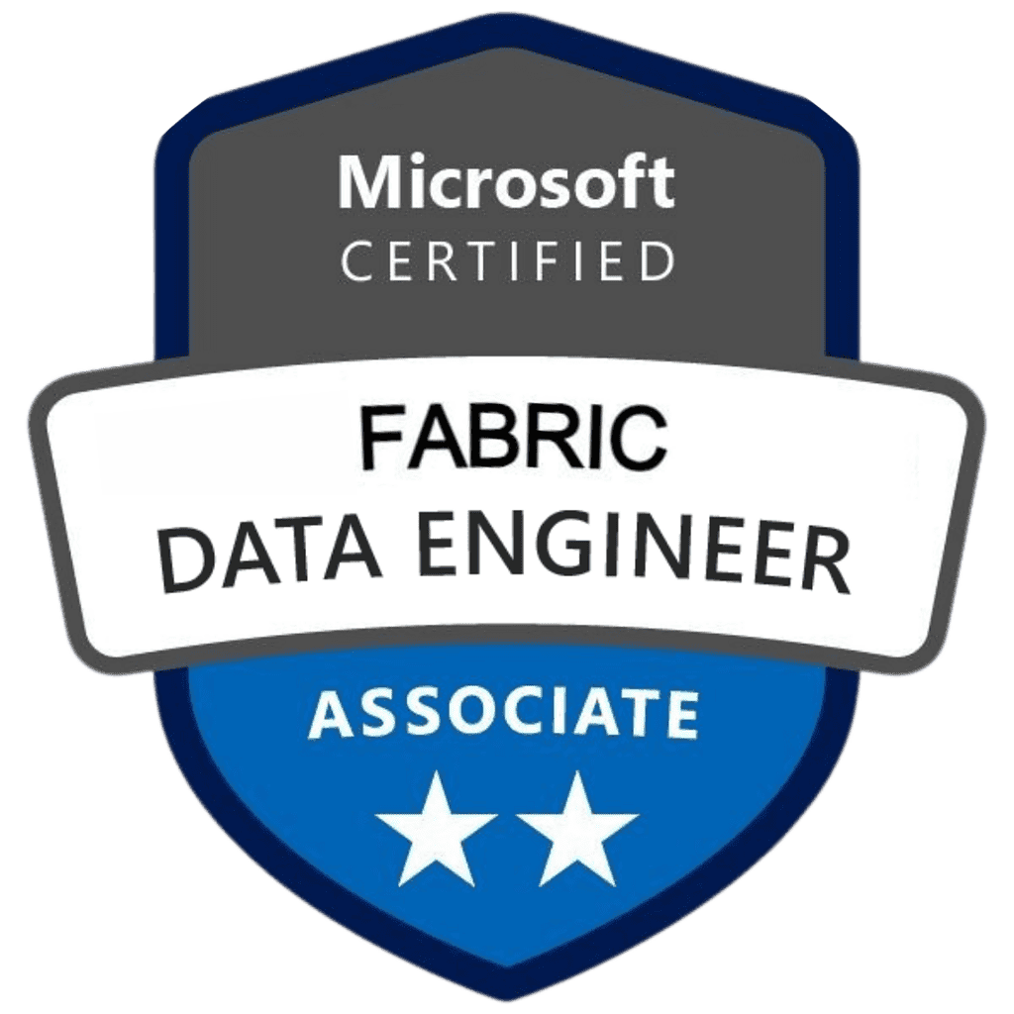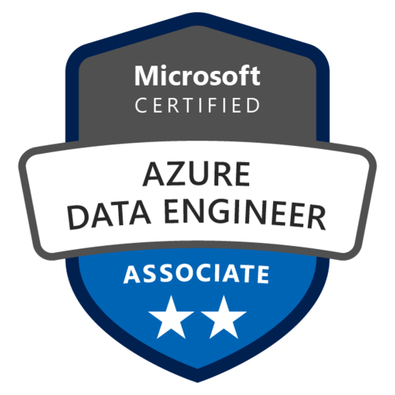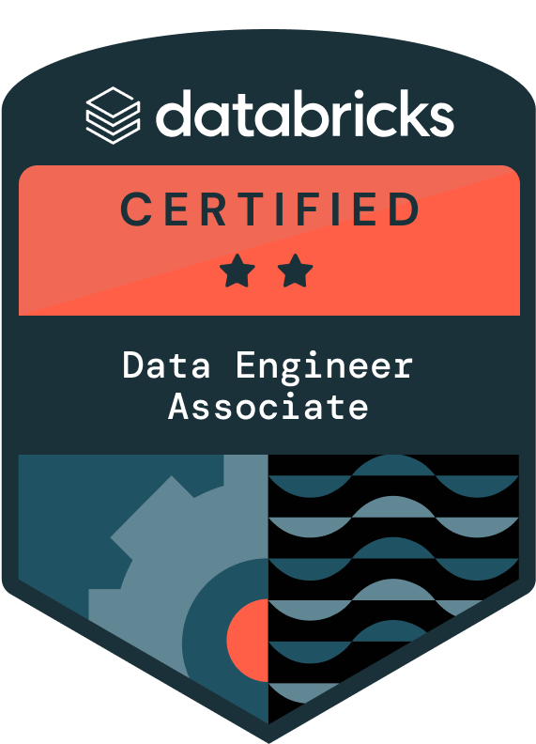

Mobile: +1 (913) 390 3978
E-Mail: harshav0224@gmail.com
LinkedIn: linkedin.com/in/harsha-vardhan-dampuri-37a9531a1

PROFESSIONAL SUMMARY:
- Over 11 years hands-on IT experience in Data Engineering specializing in data architecture, analysis, design. Built scalable data pipeline development using Azure Data Factory and advanced analytics platforms transforming raw data into actionable business insights.
- Extensive experience with Microsoft Azure cloud ecosystem including Azure Data Factory, Azure Databricks, Azure Synapse Analytics, Azure Logic Apps, Azure Functions. Designed secure, scalable enterprise-level solutions utilizing Azure DevOps, Azure Analysis Services, Azure Purview for advanced analytics capabilities.
- Built complex ETL/ELT pipelines using Azure Data Factory orchestrating data flows and integrating on-premise cloud-based data sources. Transformed data at scale with Python automation scripts leveraging built-in Data Factory activities like copy, lookup, filter with parameterization and triggers.
- Designed Spark-based data processing pipelines using Scala and PySpark within Azure Databricks enabling large-scale data transformation. Delivered real-time analytics for enterprise applications with Scala-based streaming supporting critical business use cases through exploratory data analysis and statistical computations.
- Utilized Azure Synapse Analytics for unified data integration, warehousing, analytics workloads implementing Databricks notebooks for advanced data science workflows. Delivered end-to-end solutions combining big data with relational models using high-volume data processing, performance tuning, complex querying operations.
- Architected modern data lakehouse solutions using Microsoft Fabric for unified analytics integrating Azure Data Lake Storage Gen2 with Blob Storage. Migrated on-premises data to cloud efficiently using Data Factory pipelines implementing structured zones (raw, curated, gold) for maintainable scalable architectures.
- Developed advanced Python applications for data processing automation integrating Azure Logic Apps with Azure Functions for serverless workflow orchestration. Automated critical tasks like file processing, system notifications, RESTful API calls using Python scripts significantly reducing manual dependencies and improving operational efficiency.
- Implemented comprehensive data governance strategies with Microsoft Fabric and Azure Purview enabling advanced data cataloging, lineage tracking, regulatory compliance. Ensured consistency and visibility into data assets across multi-cloud environments while maintaining enterprise-level security and access controls through Azure Active Directory integration.
- Engineered high-performance data transformation solutions using Databricks collaborative notebooks and optimized PySpark code for large-scale distributed computing environments. Created reusable Python libraries and PySpark functions enhancing code maintainability and accelerating development cycles for complex analytical workloads.
- Designed real-time streaming architectures using Event Hub ingestion, Azure Synapse Analytics pipelines combined with Databricks structured streaming for low-latency processing. Built robust event-driven systems using Python-based microservices processing millions of records daily while maintaining data quality and consistency.
- Orchestrated enterprise data workflows using Data Factory with advanced scheduling and monitoring capabilities integrating seamlessly with Databricks compute clusters. Implemented comprehensive error handling and retry mechanisms using Python exception handling ensuring reliable data pipeline execution across distributed systems.
- Optimized query performance in Azure Synapse Analytics through strategic indexing, partitioning, distribution strategies while leveraging PySpark for memory-efficient transformations. Applied advanced performance tuning techniques reducing processing times by 70% and improving overall throughput of critical data pipelines.
- Built comprehensive data quality frameworks using Microsoft Fabric data profiling capabilities and custom Python validation scripts for automated anomaly detection. Implemented data lineage tracking and impact analysis tools providing end-to-end visibility into data transformations and dependencies across complex multi-source environments.
- Worked extensively with Snowflake for cloud-based data warehousing including table creation, data loading, performance optimization using automated Python scripts. Utilized Snowpipe and custom Python connectors automating real-time data ingestion and transformation workflows from various source systems.
- Created interactive dashboards and visual analytics in Power BI and Tableau converting raw data into actionable insights and KPIs. Utilized complex DAX functions, custom Python visualizations, advanced Power BI data models supporting comprehensive business performance monitoring with real-time analytics capabilities.
- Developed logical and physical data models using Star and Snowflake schema designs optimized for analytical and transactional workloads. Ensured scalable, normalized, query-efficient database structures for OLAP and OLTP systems while maintaining data integrity and performance standards.
- Implemented comprehensive big data solutions using Hadoop ecosystem technologies including HDFS, Hive, Tez, MapReduce, distributed PySpark processing across multi-node clusters. Delivered fault-tolerant distributed data processing solutions with high availability and automatic failover capabilities for mission-critical enterprise applications.
- Designed and maintained CI/CD pipelines using Azure DevOps and Jenkins with automated testing and deployment strategies for data engineering solutions. Implemented Infrastructure as Code (IaC) principles and automated quality gates ensuring reliable and consistent deployment across development, staging, production environments.
- Applied advanced machine learning techniques using Python scientific libraries (pandas, scikit-learn, numpy) integrating ML models into production data pipelines. Developed automated model training and evaluation frameworks continuously improving prediction accuracy and providing real-time insights for business optimization.
- Architected multi-cloud data integration solutions seamlessly connecting Azure, AWS, on-premises systems using standardized APIs and secure data transfer protocols. Implemented comprehensive monitoring and alerting systems providing real-time visibility into data pipeline health, performance metrics, and system resource utilization.
- Led cross-functional teams implementing Agile methodologies and participated in complete Software Development Life Cycle (SDLC) processes for large-scale data engineering projects. Collaborated with stakeholders, data scientists, business analysts in sprint planning, retrospectives, daily standups delivering incremental value and ensuring project success.
- Established data security best practices using Azure Key Vault, managed identities, role-based access control (RBAC) for enterprise-grade data protection. Implemented end-to-end encryption, data masking, compliance frameworks meeting industry standards including GDPR, HIPAA, SOX requirements.
- Optimized cloud resource costs through strategic use of auto-scaling, spot instances, resource scheduling while maintaining high performance and availability standards. Achieved up to 40% cost reduction in cloud infrastructure spending through intelligent resource management and efficient data storage strategies.
- Specialized in Azure Stream Analytics and Apache Kafka for real-time data processing enabling high-throughput message ingestion from diverse sources. Implemented streaming analytics solutions using PySpark structured streaming and Event Hub partitioning strategies for scalable real-time data pipeline architectures.
- Mastered Unity Catalog implementation for centralized data governance across multiple Azure Databricks workspaces providing unified access control and metadata management. Established comprehensive data lineage tracking and automated data discovery processes using Azure Purview integration with custom Python cataloging scripts.
- Expert in Microsoft Fabric ecosystem leveraging OneLake storage architecture for unified data lake implementation supporting both structured and unstructured data. Designed Medallion architecture patterns with Bronze, Silver, Gold layers enabling data mesh principles and domain-driven analytics approaches.
- Advanced proficiency in Delta Lake technology for ACID transactions, time travel capabilities, and schema evolution supporting both batch and streaming workloads. Implemented Delta Live Tables for automated data quality validation and continuous data pipeline monitoring with built-in expectation management.
- Extensive experience with Azure Cosmos DB for globally distributed NoSQL database solutions supporting multi-model data APIs including document, key-value, graph, column-family. Integrated Cosmos DB with Azure Synapse Analytics using PolyBase and Spark connectors for hybrid transactional analytical processing.
- Specialized in Azure HDInsight cluster management for distributed computing using Apache Spark, Hadoop, Kafka, HBase across multi-node environments. Optimized cluster performance through intelligent resource allocation, auto-scaling policies, and cost-effective spot instance utilization strategies.
- Expert in Databricks Asset Bundles for Infrastructure as Code deployment enabling version-controlled data engineering workflows across development, staging, production environments. Implemented CI/CD automation using Azure DevOps pipelines with automated testing, deployment strategies, and environment promotion processes.

EDUCATION
- Bachelor’s in computer science from QIS College of Engineering and Technology, May 2011
- Master’s in computer science from the University of Central Missouri, Dec 2013

CERTIFICATIONS
- Microsoft Certified: Azure Data Engineer Associate
- Microsoft Certified: Fabric Data Engineer Associate
- Databricks Certified: Data Engineer Associate

TECHNICAL SKILLS
Azure Services: Azure Data Factory (ADF), Azure Data Lake Storage (ADLS Gen2), Azure Blob Storage, Azure Databricks, Azure SQL Database, Azure Analysis Services, Azure Synapse Analytics, Logic Apps, Azure Functions, Azure Monitor, Azure HDInsight, Azure Active Directory, Azure Key Vault, Snowflake, Azure DevOps.
Big Data Technologies: MapReduce, Hive, Flume, PySpark, Kafka, Spark streaming, Sqoop, Oozie, Zookeeper.
Hadoop Distribution: Cloudera, Hortonworks.
Programming Languages: SQL, PL/SQL, Python, HiveQL, Scala, Pig.
Data Visualization Tools: Power BI, Tableau, Cognos.
Operating Systems: Windows (XP/7/8/10/11), UNIX, Linux, Ubuntu, CentOS.
Build Automation tools: Maven, Jenkins, Ant.
Version Control: GIT, Bitbucket, GitHub.
Methodology: Agile, Scrum, Waterfall.
Project Management Tools JIRA, Confluence.
IDE &Build Tools, Design: Eclipse, Visual Studio.
File Formats: JSON, CSV, Parquet, Avro, JSON, ORC.
Databases: MS SQL Server 2016/2014/2012/2008, MS Excel, MS Access, Oracle, Cosmos DB.

PROFESSIONAL EXPERIENCE
Optum, Eden Prairie, MN July 2023- Current
Azure Data Engineer
Responsibilities:
- Designing, developing, maintaining end-to-end ETL pipelines using Azure Data Factory managing large-scale data workflows with advanced orchestration capabilities. Ensuring pipeline reliability and data integrity through continuous validation, monitoring, troubleshooting across distributed cloud environments.
- Migrated data from on-premises Microsoft SQL Server to Azure Data Lake Storage Gen2 for scalable cloud storage using optimized Python migration scripts. Handled complex schema transformations and storage optimization during migration while maintaining data quality and performance standards.
- Integrating heterogeneous data sources including MySQL, Cassandra, Azure SQL DB, Blob Storage using Azure Data Factory pipelines ensuring seamless ingestion transformation. Applying custom business logic and transformation rules using Python scripts to standardize incoming data from multiple source systems.
- Building robust custom data processing workflows using Azure Functions, Azure Databricks notebooks, PowerShell scripts enabling dynamic scalable data transformations. Implementing advanced error handling and retry mechanisms using Python exception management ensuring reliable data processing operations.
- Leveraged Azure Databricks collaborative workspace and Data Factory orchestration capabilities delivering high-performance data transformations automating complex ingestion processes. Delivered end-to-end data movement pipelines powering real-time and batch analytics using optimized PySpark transformations and Python-based automation.
- Enhanced business decision-making utilizing Synapse Analytics dedicated SQL pools, Azure Monitor, Azure Purview for comprehensive data visibility, lineage, compliance, monitoring. Implemented advanced analytics using PySpark within Databricks notebooks for large-scale distributed data processing and machine learning workloads.
- Created deployed sophisticated pipelines in Data Factory loading data into Azure SQL DB and ADLS Gen2 with automated scheduling and dependency management. Configured activities such as Copy, Lookup, Metadata, Stored Procedure, For Each using Python parameterization enabling complex workflow orchestration.
- Configured managed Linked Services and datasets within Azure Data Factory integrating with various cloud and on-premises systems using secure authentication protocols. Ensured efficient data flow between compute and storage resources while implementing comprehensive monitoring using Python-based logging frameworks.
- Applied analytical, proactive approach solving data problems utilizing Synapse Analytics serverless pools, Analysis Services, Data Factory with custom Python solutions. Delivered production-ready pipelines aligned with enterprise data strategy and governance requirements for data quality validation.
- Conducted Exploratory Data Analysis (EDA) and optimized pipeline performance using profiling and debugging tools within Azure cloud services. Created comprehensive data quality rules and incorporated anomaly detection logic using advanced statistical methods and machine learning algorithms.
- Developed semantic data models using Azure Analysis Services supporting scalable analytical workloads with Microsoft Fabric integration for unified analytics experiences. Implemented role-based security and partition strategies using Python automation to optimize query performance and resource utilization.
- Developed optimized complex data transformation jobs using Scala within Azure Databricks notebooks enabling high-performance processing of large-scale datasets. Wrote complex Spark-SQL queries and utilized Spark Data Frames within Azure Databricks and ADF creating efficient ETL transformations and validations.
- Performed advanced analytics and data processing using Python scientific libraries (NumPy, Pandas, Matplotlib, Seaborn) in Azure Databricks Notebooks. Enabled real-time visualization and root cause analysis for large datasets while implementing Delta Live Tables concept for streaming data processing.
- Built sophisticated PySpark scripts within Azure Databricks performing statistical analysis on Unity Catalog datasets with Delta Live Table implementation. Improved user experience and product performance through insightful data patterns while leveraging Databricks Asset Bundles for cost-effective cluster management.
- Monitored managed workflows using Azure Logic Apps with custom Python connectors ensuring smooth automation of repetitive business processes. Resolved data flow issues with Logic App diagnostics and logging while implementing comprehensive error handling and notification systems.
- Created serverless ETL tasks using Azure Functions with Python runtime extracting data from databases, APIs, file systems with advanced authentication mechanisms. Streamlined ingestion processes using timer triggers, queues, durable functions while implementing Microsoft Fabric Lakehouse architecture for unified data storage.
- Used Azure Purview for metadata scanning, classification, lineage tracing across multiple data sources with automated Python scripts for data discovery. Enabled comprehensive data stewardship and compliance across departments while maintaining data governance standards and regulatory requirements.
- Implemented Azure Monitor for performance tracking including query execution times, resource utilization, data refresh rates using custom Python-based monitoring solutions. Set up intelligent alerts for proactive issue resolution and automated incident response workflows.
- Architected real-time streaming data pipelines using Event Hub ingestion, Synapse Analytics and Databricks structured streaming with Delta Live Tables. Implemented event-driven architectures using Python-based microservices processing millions of records daily while maintaining data consistency and quality standards.
- Developed advanced machine learning models using PySpark MLlib within Databricks notebooks for predictive analytics and automated decision-making systems. Implemented Delta Live Tables concept for feature engineering pipelines automatically maintaining data freshness and quality for ML model training.
- Optimized cloud resource costs strategically implementing Databricks Asset Bundles and intelligent auto-scaling policies using Python-driven resource management scripts. Leveraged Databricks Asset Bundles achieving significant cost reductions while maintaining high performance and availability across all data processing workloads.
- Implementing comprehensive data security frameworks using Azure Key Vault and managed identities with Python-based encryption services for sensitive data protection. Establishing role-based access control (RBAC) and data masking strategies complying with GDPR, HIPAA, industry security standards while maintaining optimal performance.
- Built real-time streaming solutions using Event Hub for high-throughput message processing integrated with Event Hub partitioning strategies and consumer group management. Leveraged Event Hub for event-driven architecture processing millions of messages daily while maintaining low-latency performance requirements.
- Leading cross-functional collaboration with data scientists and business stakeholders translating complex business requirements into scalable technical solutions. Facilitating agile development practices and sprint planning sessions while delivering high-quality data products driving strategic business decisions.
- Developing automated data quality monitoring systems using Python frameworks integrated with Synapse Analytics and Microsoft Fabric for real-time anomaly detection. Creating comprehensive alerting mechanisms and self-healing pipelines automatically remediating common data issues without manual intervention.
- Optimizing cloud infrastructure costs through intelligent resource management using Databricks cluster policies, auto-scaling configurations, PySpark memory optimization techniques. Achieving 35-40% cost reduction while maintaining high-performance standards through strategic implementation of spot instances and scheduled scaling policies.
- Mentoring junior team members and establishing data engineering best practices including code review processes, documentation standards, Python coding conventions. Leading knowledge transfer sessions on advanced PySpark optimization techniques, Delta Live Tables implementation, Azure Data Factory design patterns.
- Architected enterprise-wide data mesh solutions using Microsoft Fabric OneLake storage enabling domain-driven data architecture with decentralized data ownership models. Implemented data product development frameworks supporting self-serve analytics capabilities while maintaining centralized governance and security standards.
- Specialized in Azure Synapse Spark pools optimization for large-scale distributed computing workloads implementing dynamic resource allocation and intelligent caching strategies. Developed custom PySpark optimization techniques reducing job execution times by 60% while minimizing compute costs through efficient resource utilization.
- Advanced implementation of Delta Lake ACID transactions and time travel capabilities supporting complex data versioning and rollback scenarios. Built automated data quality validation frameworks using Delta Lake expectations and constraints ensuring data integrity across Bronze, Silver, Gold layers.
- Expert in Unity Catalog fine-grained access controls implementing attribute-based access control (ABAC) and dynamic data masking for sensitive data protection. Established comprehensive audit logging and compliance reporting mechanisms meeting SOX, GDPR, HIPAA regulatory requirements across multi-workspace environments.
- Designed sophisticated Event Hub namespace architectures supporting high-throughput real-time data ingestion with partition key strategies and consumer group optimization. Implemented Azure Stream Analytics with complex event processing (CEP) for real-time pattern detection and anomaly identification.
- Built comprehensive Microsoft Fabric data pipeline orchestration using Data Factory integration enabling unified data movement across OneLake, Azure Data Lake Storage Gen2. Implemented automated data lineage tracking and impact analysis providing complete visibility into data transformations and business logic dependencies.
- Advanced proficiency in Databricks Workflows and Jobs API for programmatic pipeline orchestration enabling dynamic job scheduling and dependency management. Developed custom Python frameworks for automated pipeline deployment, monitoring, alerting across multiple Databricks workspaces and environments.
Environment: ADF, Databricks, ADLS Gen2, Blob Storage, Azure SQL DB, Logic Apps, Azure Functions, Azure Analysis Services, Synapse Analytics, Azure Monitor, Azure Purview, Microsoft Fabric, Event hub, Unity Catalog, Scala, Databricks Asset Bundles, Delta Live Tables, DAX, Power BI, Azure Key Vault, Active Directory, Snowflake, SnowSQL, MySQL, Python, PySpark, JIRA, GIT, Bitbucket, Jenkins.

Bank of America, Charlotte, NC March 2018 - June 2023
Azure Data Engineer
Responsibilities:
- Demonstrated extensive experience ingesting large-scale enterprise data into Azure services: Azure Data Lake Storage, Azure SQL Database, Azure Synapse Analytics with advanced automation capabilities. Followed comprehensive ingestion processes with sophisticated data processing using Azure Databricks collaborative notebooks supporting critical analytical and reporting needs.
- Applied hands-on expertise with various Azure services for end-to-end data solutions including HDInsight Clusters, Blob Storage, Azure Data Factory orchestration, Logic Apps integration. Ensured scalable and fault-tolerant data pipelines capable of processing terabytes of data daily while maintaining enterprise-grade reliability and performance standards.
- Contributed to multiple proof-of-concept (POC) initiatives involving Azure Databricks to assess performance, scalability, use cases for advanced analytics and machine learning workloads. Demonstrated the platform's transformative potential in improving data workflows and reducing processing times by up to 60% compared to legacy systems.
- Successfully migrated complex on-premises SQL Server databases to cloud platforms including Azure Data Lake Storage, Azure SQL, Azure Databricks, Azure Synapse with zero data loss. Utilized Azure Data Factory pipelines and configured Linked Services with Self-hosted Integration Runtimes (SHIR) for secure seamless integration across hybrid environments.
- Managed comprehensive access controls and user permissions across Azure data services, ensuring robust governance and compliance throughout data migration and transformation lifecycle. Implemented enterprise security frameworks that maintained data integrity while enabling self-service analytics capabilities for business users.
- Developed sophisticated Spark and Spark SQL transformations in Azure Databricks to execute complex business logic with optimal performance and reliability. Focused on building reusable and high-performance ETL pipelines that reduced development time and improved code maintainability across multiple projects.
- Created advanced PySpark scripts to perform complex transformations and integrated diverse structured and semi-structured data sources from multiple enterprise systems. Optimized PySpark and Spark jobs using advanced techniques such as dynamic partitioning, intelligent caching, and broadcast joins to achieve maximum throughput.
- Diagnosed and resolved critical performance bottlenecks in Spark jobs and data pipelines through systematic analysis and optimization strategies using Python profiling tools. Improved overall system throughput by 45% and reduced processing time significantly while maintaining data quality and accuracy standards.
- Designed and implemented robust dimensional data models in Azure Synapse Analytics to support enterprise reporting and self-service BI initiatives across the organization. Applied advanced partitioning, bucketing, and indexing strategies to optimize query performance and reduce resource consumption costs.
- Leveraged PolyBase in Azure Synapse to efficiently move and query massive datasets from various sources with minimal latency and maximum throughput. Enabled seamless integration across cloud storage and databases while maintaining data consistency and implementing comprehensive error handling mechanisms.
- Transferred batch data into Delta Lake architecture to improve data reliability, scalability, and compatibility with various analytics engines in Azure cloud environment. Supported structured streaming capabilities and time travel features for advanced data versioning and historical analysis requirements.
- Built and managed resilient HDInsight clusters on Azure for distributed data processing workloads with automatic scaling and cost optimization features. Ensured high availability through multi-zone deployment and implemented cost-effective resource scaling based on workload patterns and business requirements.
- Ingested and processed high-throughput real-time data using Azure Event Hubs with advanced Python streaming applications for continuous data processing. Developed sophisticated event-driven pipelines to support real-time analytics, monitoring, and alerting systems across multiple business domains.
- Integrated Azure Stream Analytics with custom Python scripts to process streaming data in real-time with sub-second latency requirements. Delivered actionable business insights with minimal latency while implementing comprehensive data quality checks and automated anomaly detection capabilities.
- Established comprehensive CI/CD pipelines using Azure Pipelines and Jenkins to automate the deployment of Python applications and PySpark jobs across multiple environments. Ensured reliable and consistent delivery to development, testing, and production environments while implementing automated testing and rollback strategies.
- Enabled unified querying across diverse data sources by integrating PolyBase with other Azure services for seamless data federation capabilities. Streamlined data access across ADLS, SQL Pools, and external systems while maintaining optimal performance and security standards.
- Implemented and managed Databricks Unity Catalog to provide a unified governance solution for data, analytics, and AI assets across multiple workspaces. Ensured centralized access control and data lineage while establishing comprehensive audit trails and compliance reporting mechanisms.
- Implemented enterprise-grade Medallion architecture using Bronze, Silver, and Gold layers in Azure Data Lake Storage with automated data quality validation. Enabled organized, scalable, and efficient data processing pipelines that support both batch and real-time analytics workloads.
- Applied advanced partitioning and bucketing techniques to enhance performance and reduce query latency within data lake containers by up to 70%. Supported cost-effective data management strategies while implementing intelligent data lifecycle policies and automated archiving processes.
- Designed comprehensive cloud data architecture tailored to enterprise needs within the Azure Data Lake ecosystem with focus on security and governance. Focused on scalability, availability, and accessibility while ensuring compliance with industry regulations and data privacy requirements.
- Developed sophisticated telemetry data ingestion pipelines from IoT devices via Azure IoT Hub with real-time processing capabilities using Python microservices. Processed and stored large volumes of sensor data in Cosmos DB and Azure Blob Storage while implementing advanced analytics for predictive maintenance.
- Built advanced Databricks-based architecture using containerization and CI/CD for deploying machine learning models with automated monitoring and retraining capabilities. Supported real-time prediction of equipment failures using IoT data and achieved 95% accuracy in failure prediction models.
- Integrated and secured data from Azure SQL Database, Cosmos DB, and Synapse SQL Pools using SQL Server Management Studio (SSMS) with enterprise authentication. Enabled comprehensive reporting and analysis while implementing row-level security and data masking for sensitive information protection.
- Automated end-to-end data pipelines using Apache Airflow and complex DAGs with advanced error handling and retry mechanisms using Python orchestration. Included sophisticated data extraction, transformation, and loading processes across multiple cloud services with comprehensive monitoring and alerting.
- Created interactive Power BI dashboards by connecting to various Azure services with real-time data refresh capabilities and advanced analytics features. Delivered actionable business insights through sophisticated visualization and analytics that supported executive decision-making processes.
- Implemented comprehensive monitoring and logging mechanisms across all data pipelines with automated alerting and notification systems using Python frameworks. Performed systematic root cause analysis and implemented proactive corrective actions to ensure data reliability and system availability.
- Architected enterprise-wide data governance frameworks using Azure Data Catalog and custom Python validation services to ensure data quality and regulatory compliance. Established automated data lineage tracking and impact analysis systems that provided complete visibility into data flows and dependencies.
- Designed and implemented advanced machine learning pipelines using PySpark MLlib within Databricks notebooks for predictive analytics and automated business intelligence solutions. Built sophisticated feature engineering frameworks that processed structured and unstructured data sources while maintaining model performance standards above 92%.
Environment: ADF, Azure Blob Storage, ADLS, Azure Databricks, Polybase, Azure SQL Database, Azure Logic Apps, Unity Catalog, Stream Analytics, Apache Airflow, Azure Pipelines, SSMS, Azure Data Catalog, Medallion, Architecture Azure Functions, Azure Synapse, Azure Cosmos DB, Azure HDInsight, Azure Event Hubs, Azure IoT Hub, MS SQL Server, SQL, Python, Spark, PySpark, Power BI, GitHub, Jenkins.

MetLife, New York, NY July 2015 - March 2018
Big Data Engineer
Responsibilities:
- Managed ingestion and storage of structured and unstructured data from multiple sources into Hadoop Distributed File System (HDFS). Handled HDFS maintenance, ensuring optimal performance and data availability while implementing data replication strategies across distributed clusters.
- Successfully migrated large datasets from Netezza, Oracle, and SQL Server databases into Hadoop ecosystem ensuring minimal downtime and data integrity. Utilized PL/SQL to perform efficient data extraction, transformation, and loading (ETL/ELT) within Oracle environments maintaining high-quality data pipelines.
- Implemented data replication and backup strategies across HDFS clusters to ensure disaster recovery and business continuity. Enabled fault tolerance within the Hadoop ecosystem, including HDFS, YARN, and MapReduce components while tuning cluster performance by monitoring key metrics.
- Built complete data pipeline using tools like Flume, Sqoop, Pig, Kafka, Oozie, and MapReduce to load and process behavioral data in HDFS. Enabled near real-time data ingestion and processing while importing data from MySQL to HDFS using Sqoop.
- Ingested log and streaming data into HDFS using Flume and Kafka ensuring reliable and scalable integration of high-velocity data. Worked across Hadoop distributions including Hortonworks and Cloudera gaining deep experience in distributed computing environments and enterprise-grade big data platforms.
- Used Apache Spark and Scala to perform large-scale data aggregations landing the transformed data into Hive warehouses for downstream reporting and analytics. Applied Apache HBase for real-time, low-latency data access within Hadoop designing and optimizing HBase tables.
- Translated SQL queries into HiveQL while maintaining business logic consistency building and optimizing Hive queries to replicate MapReduce functionality. Integrated HBase with Hive in Analytics Zone to enhance data querying and storage capabilities.
- Designed Hive tables with partitioning and bucketing strategies to improve performance using bucketed Hive joins to support complex analytical queries. Developed Pig Latin scripts for filtering, transforming, and aggregating data applying built-in Pig functions.
- Conducted cluster analysis and troubleshooting using Hive and MapReduce ensuring reliable operation of large-scale batch processing tasks. Used Java MapReduce for data pre-processing, cleaning, and modeling ensuring high data quality.
- Configured fault tolerance by setting redundancy and replication levels at both file system and execution layers minimizing data loss and job failures. Used Spark Streaming to process real-time data by segmenting input into micro-batches.
- Deployed and managed Kafka clusters, handling topic creation and maintenance building producers and consumers to stream data into real-time pipelines. Created end-to-end streaming data pipelines using Kafka, Spark, and Hive.
- Leveraged Oozie for managing and scheduling workflows across the Hadoop ecosystem streamlining job dependencies and improving workflow reliability. Configured Zookeeper to manage distributed services and maintain synchronization across nodes.
- Wrote PySpark scripts to execute data manipulation, transformation, and analytical operations utilizing Spark's distributed computing capabilities for efficient processing. Executed SQL-like queries using Spark SQL for data analysis and exploration.
- Developed YAML scripts to automate CI/CD pipelines, supporting code build, test, and deployment processes enabling rapid and reliable software delivery. Managed job scheduling and workload automation using Control-M integrating third-party tools.
- Coordinated closely with the team to diagnose and resolve JVM-related issues, ensuring the stability and performance of Hadoop-based applications. Implemented comprehensive monitoring and alerting mechanisms for proactive system maintenance and optimization.
- Specialized in Apache Kafka cluster architecture and administration including broker configuration, topic partitioning strategies, and replication factor optimization for high-availability messaging. Implemented Kafka Connect for real-time data integration between heterogeneous systems while maintaining exactly-once processing semantics.
- Expert in Apache HBase schema design and performance tuning for NoSQL database implementation supporting CRUD operations at scale. Developed custom HBase coprocessors and filters for server-side data processing while implementing row-key design patterns optimizing read/write performance.
- Advanced proficiency in Apache Oozie workflow engine for complex job scheduling and dependency management across Hadoop ecosystem components. Built sophisticated workflow DAGs integrating MapReduce, Spark, Hive, Sqoop, and shell actions with conditional logic and error handling mechanisms.
- Comprehensive expertise in Apache Sqoop for efficient data transfer between Hadoop and relational databases implementing incremental imports and parallel processing. Developed custom Sqoop connectors and optimized data transfer performance through partitioning strategies and compression techniques.
- Mastered Cloudera Manager and Hortonworks Ambari for enterprise Hadoop cluster management including service configuration, monitoring, and troubleshooting. Implemented cluster security using Kerberos authentication, HDFS encryption, and role-based access controls meeting enterprise compliance requirements.
- Specialized in MapReduce optimization techniques including combiner functions, partitioning strategies, and custom Input/Output Format implementations for performance enhancement. Developed complex MapReduce algorithms for large-scale data processing workflows while minimizing resource consumption and job execution times.
Environment: Hadoop, HDFS, MapReduce, YARN, Apache Spark, PySpark, Spark SQL, Scala, Hive, Hive Query Language (Hive QL), HBASE, Pig, Cloudera, Hortonworks, Kafka, Sqoop, Zookeeper, Oozie, MYSQL, PL/SQL, MongoDB, Spark Streaming, YAML scripts, Control-M.

Siemens, Plano, TX Feb 2014 - June 2015
Data Warehouse Developer
Responsibilities:
- Developed complex stored procedures, efficient triggers, and user-defined functions in SQL Server creating indexes and indexed views to significantly improve query performance. Monitored SQL Server performance metrics and implemented tuning strategies to optimize overall database operations and resource utilization.
- Worked as SQL Server Analyst/Developer/DBA across various SQL Server versions managing end-to-end tasks from design and development to database maintenance. Created and managed SQL Server Agent jobs, configured SQL Mail, set up alerts, and scheduled SSIS packages for automated ETL operations.
- Used Informatica client tools such as Source Analyzer, Warehouse Designer, and Mapping Designer to handle data integration and transformation processes. Extracted data from diverse sources and built robust staging area to cleanse, validate, and standardize data prior to transformation and loading.
- Leveraged Informatica PowerCenter to transform and load heterogeneous data into Master Data Management (MDM) repository, ensuring accuracy and consistency. Designed dimensional data models by identifying fact and dimension tables implementing Slowly Changing Dimensions (SCD), including Type 2, to manage historical changes effectively.
- Applied expertise in Star and Snowflake schema design to optimize data warehouse structures for reporting and analytics. Wrote T-SQL scripts, including stored procedures and triggers, to support backend database logic while maintaining physical database structures and optimizing queries for performance.
- Designed complex SSIS data flows, built mappings, and created workflows for extracting, transforming, and loading data from SQL Server and Excel sources. Built and maintained SSIS packages with multiple transformations to automate data migration and cleansing, supporting business and reporting needs.
- Developed SSAS Cubes to support multidimensional analytics, including creation of KPIs, measures, partitions, and aggregations implementing predictive data mining models. Deployed and processed SSAS objects to production environments, optimizing their performance and supporting business intelligence solutions.
- Created custom and ad-hoc reports using advanced SQL queries within SSRS configuring Report Server settings to streamline and secure reporting delivery. Wrote and optimized MDX queries for multidimensional analysis, delivering insightful metrics from complex data models aligned with business needs.
- Demonstrated proactive, adaptable work ethic by aligning deliverables with evolving client requirements and contributing to project success. Implemented comprehensive data quality validation frameworks using SSIS transformations and custom validation logic ensuring data integrity across all ETL processes.
- Specialized in SQL Server Integration Services (SSIS) package development including complex control flow, data flow transformations, and event handling mechanisms. Built robust error handling and logging frameworks using SSIS logging providers and custom audit tables for comprehensive ETL monitoring and troubleshooting capabilities.
- Expert in SQL Server Analysis Services (SSAS) multidimensional and tabular model development supporting enterprise-scale OLAP solutions. Implemented advanced cube partitioning strategies, aggregation design, and MDX calculations optimizing query performance while managing storage requirements for large-scale analytical workloads.
Environment: SQL Server 2008/2012 Enterprise Edition, Data Marts, SSRS, SSIS, SSAS, Informatica, Informatica PowerCenter, Informatica Workflow Manager, Master Data Management (MDM), T-SQL, Star Schema, Snowflake Schema, Slowly Changing Dimensions (SCD), MDX Query, Tableau, MS Visual Studio, SharePoint

