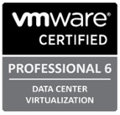
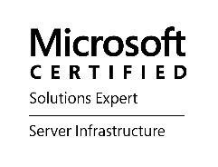
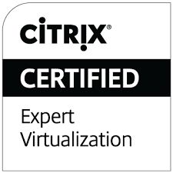
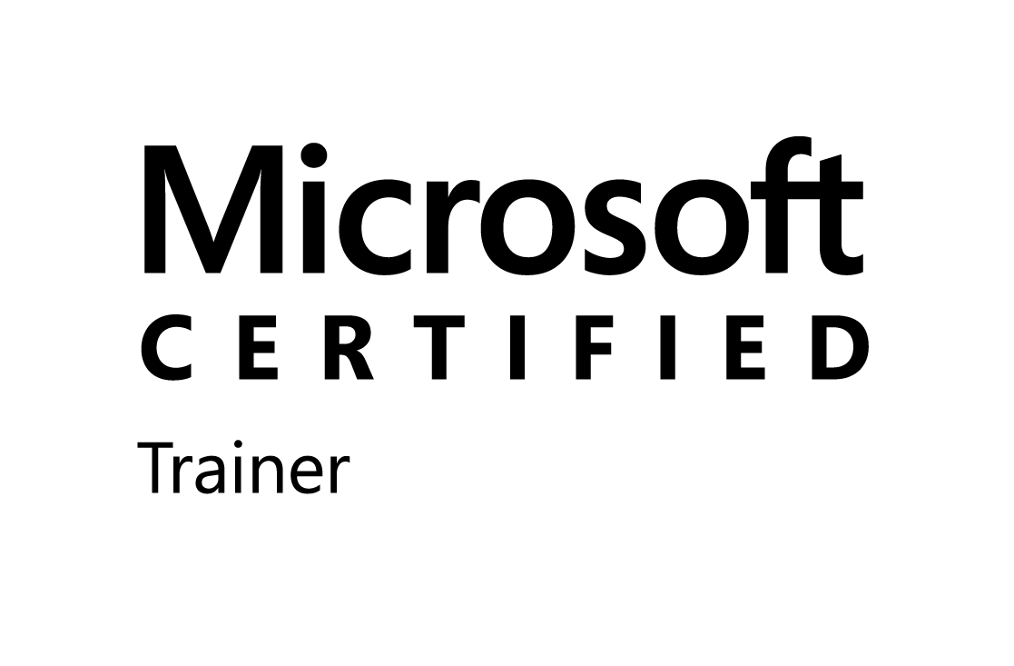
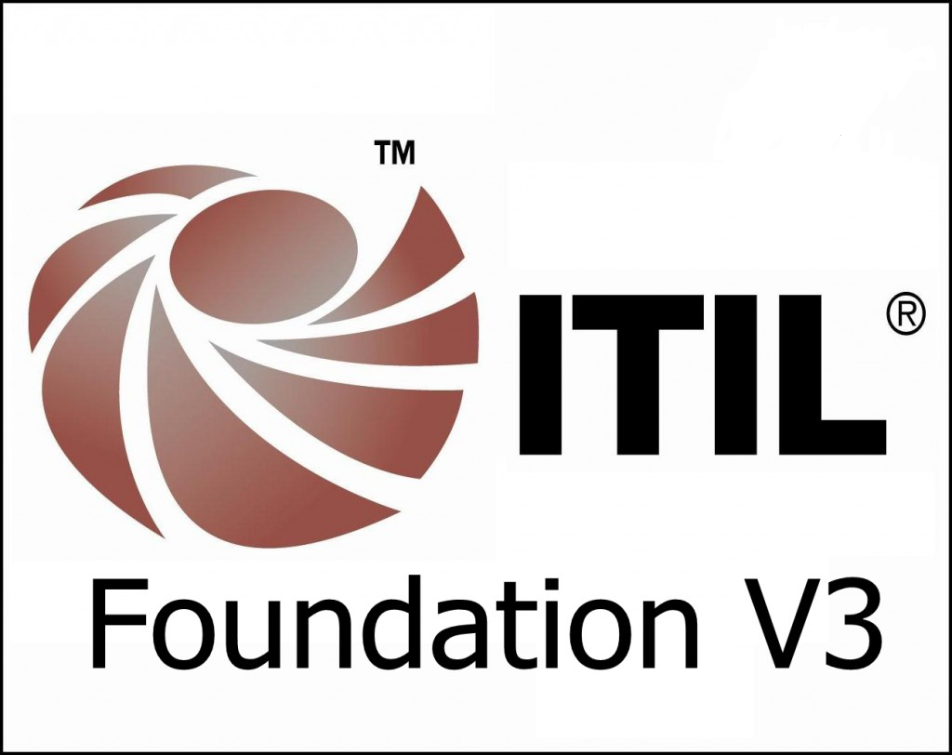
Ayzed Hassan
Cell: 716-775-7940
Email: rk@cleoconsult.com (K. Ramesh)

Seasoned IT Professional with 15+ years’ progressive experience complemented by nuanced subject matter expertise covering design, development, implementation, migration and troubleshooting for technologies including Citrix, VMware, Microsoft, Active Directory, SCCM, Quest solutions and Cloud Solutions.
Summary
- Designed, developed and managed Active Directory multi-forest/site/datacenter solutions to meet business requirements, efficiency and optimal performance
- Immense knowledge of deployment and maintenance of Microsoft technologies DNS, DHCP, DFS, DFS-R, FSRM, WDS, WSUS, LDAP, Kerberos, GPOs, IIS, RDS and Windows Clustering technology
- Extensive experience in the area of Virtualization with VMware vSphere, ESXi 4.1, 5.0, 5.5 servers, vCenter server and vConverter, VMware Orchestrator vCO , vCenter Operations Manager vOps , vSphere Replicator, VMWare NSX
- Proven skills deploying VMware ESXi 5/5.5/6 hosts with expertise in vCenter Server (including appliance) installations, configuring host and storage clusters, and designing baselines for vSphere HA, DRS, and virtual machine FT
- Strong technical, consulting and engineering background in designing, deploying and managing Citrix XenApp, XenDesktop, NetScaler, Director and other Citrix products.
- Management of end points through SCCM (Software deployment, OS deployment, licensing, patching and inventory)
- Deep Knowledge of Quest tools (Active Roles Server (ARS), Change Auditor for AD, Change Auditor for File Servers)
- Proven ability to create and deliver solutions that meet corporate objectives tied to business and technology performance
- Client focused; competent; excellent communicator; analytical and problem solver
- Experienced in root cause analysis process for Problems leading to strategic resolution Work on ITIL Change Management, Problem Management and Incident Management
- Authored technical documents, such as Installation guides, Built Books
- Quick learner, team player, adapt to prioritize, track and complete tasks to accomplish project goals
Certification
- Microsoft Certified Trainer | - MS Certified Solutions Expert 2012
- MCSA: Windows Server 2012 | - MCSA: Windows Server 2008
- MCSE: Desktop Infrastructure | - Microsoft Certified Solutions Expert: Private Cloud
- Microsoft Certified Solutions Expert: Server Infrastructure | - MCTS Windows Server 2008 R2, Server Virtualization
- MCTS: Windows Server 2008 R2, Desktop Virtualization | - MCITP: Enterprise Administrator on Windows Server 2008
- MCITP: Server Administrator on Windows Server 2008 | - MCITP: Virtualization Administrator on Windows Server
- VCP 6: Data Center Virtualization (VCP5-DCV) | - VCP 5: Data Center Virtualization (VCP5-DCV)
- VMware Certified Professional 5: Desktop (VCP5-DT) | - VMware Certified Associate Data Center Virtualization
- VMware Certified Associate - Cloud | - VMware Certified Associate - Workforce Mobility
- Citrix Certified Enterprise Engineer: Virtualization | - Citrix Certified Administrator: XenApp 5 for Windows 2008
- Citrix Certified Advanced Administrator: XenApp 6 | - CCAA: XenApp 5 for Windows 2008
- Citrix Certified Administrator: XenDesktop | - Implementing Microsoft Azure Infrastructure Solutions
Technical Skills
Windows Server 2003 Citrix XenApp 4.5/5.0/6/6.5/7.6 SMS 2003/SCCM 2007/2012
Windows Server 2008 R2 AppV 4.5/5.0 Microsoft SharePoint
Windows Server 2012 R2 Citrix XenDesktop Microsoft SQL Server 2005/08
Microsoft Lync Server VMware ESX 5.0/5.5/6.0 Symantec Endpoint Protection
Microsoft Exchange 2003/2007 Microsoft Hyper V Tivoli
Education
Bachelor of Science (Computer Science) 2004
University of Windsor
Advance Diploma (Computer Science) 2002
University of Cambridge Local Examination Syndicate
Diploma (Computer Science) 2001
University of Cambridge Local Examination Syndicate
Professional Experience
Citrix/VMware Consultant Nov 2018 – Present
Ottawa Hospital, Ottawa
- Design planned and migrated from VMware V-Center (Windows) to VCSA 6.7 Update 1 with embedded PSC for enhanced linked mode.
- Deployed VMware vRealize operations manager suite (VROPS) cluster with remote collectors and configured custom and NOC dashboards along with automatic reporting for environment configured to use a shred repository
- Designed new environment for XenApp and XenDesktop 7.15 LTSR CU3 environment on Windows Server 2016 for EPIC
- Created PowerShell scripts to automate image sealing process and day to day Citrix tasks
- Installed and Imprivata application for SSO Tap-n-Go on workstations
- POC setup to upgrade Cerner applications, vOasis, Mosaiq etc on 7.15 site
- Customized/Rebranding Citrix NetScaler gateway and Storefront page for internal and external users.
- Deployed and configured high density cluster for Citrix environment; Deployed new VM using TOH templates
- Engineered high-quality solution as per Citrix and Microsoft leading practices for a high available environment
- Coordinated with TOH architects, application SME and Vendors, Management, Citrix, Performance testing teams and the line of business to successfully migrate existing applications running on Citrix XenApp 6.5 environment
- Created new vCenter with dedicated ESX cluster for new environment to support 5700 concurrent users.

Windows/Citrix Consultant Dec 2018 – Present
Finance Canada, Ottawa
- Completed Health assessment of Citrix environment running XenApp 6.5 and provided recommendations for Citrix upgrade 7.15
- Provided complete Citrix Design with XenApp and XenDesktop 7.15 CU3 solution with G-On servers
- In-Place upgrade of Citrix License Server, Storefront, Delivery controllers and VDAs to XenApp 7.15 LTSR CU3

Sr. Windows Consultant July 2017 – Oct 2018
TD Bank, Toronto
- Active Directory Domain and Forest Migration from Server 2008 to Server 2012 using ADMT
- Manage Incident, Problem, Change, Asset Management, Service Level Reporting, Process Improvement and ITIL tool functions including providing leadership for global clients
- POC project completed to upgrade Quest Active Roles 6.9 to Active Roles 7.2
- Install and configure Event collector subscription for critical servers with only set event types.
- Document and implement changes to technical standards as required
- Upgraded Domain Controllers from Windows 2008R2 to 2012R2, raised Domain and Forest functional level
- To meet security requirements, Introduced PSOs (Fine Grained Password Policy) to specify password control
- Consolidated Active Directory Group Policies; Moved from QA to Production environment.
- Created highly detailed client deliverables such as Infrastructure Assessment, Issue resolutions, Proof of Concepts, Issues lists and Run books.

Citrix Consultant Sep 2018 – Dec 2018
Children’s Aid Society, Hamilton
- Completed Health assessment of Citrix environment running XenApp 7.8 and provided recommendations for Citrix
- In-Place upgrade of Citrix License Server, Storefront, Delivery controllers and VDAs to XenApp 7.15 LTSR CU3
- Upgraded NetScalers servers in a HA pair from 11.0 to latest version 12.1; Introduced Director server in the environment for monitoring

Sr. Citrix/VMware Consultant Jun 2016 – Jun 2017
TD Bank, Toronto
- Migrated over 2800 applications from XenApp 5.0 to XenApp 6.5 environment both local and AppV packages
- Build, configured and Administered XenApp 6.5 server and joined to existing farm
- Installed and configured XenApp and XenDesktop 7.x POC environment in Dev for complete application testing
- Designed and Implemented New Storefront servers and planned complete user migration from WI to storefront
- Used PowerShell to automate application migration
- Provided input to and helped 3rd party testing teams by troubleshooting/resolving issues, monitoring performance and generating reports within Citrix Edge Sight for Stakeholder review
- Managed and supported existing Citrix XenApp 5.0 environment with over 30000 concurrent users.
- Consolidated Active Directory Group Policies; Moved from QA to Production environment.
- Created highly detailed client deliverables such as Infrastructure Assessment, Issue resolutions, Proof of Concepts, Issues lists and Run books.

VMware and Citrix Consultant Oct 2017 – Mar 2018
Mutual Fund Dealership Association, Toronto
- Designed, Installed and configured XenApp and XenDesktop 7.15 LTSR environment on Windows Server 2016
- Build and configured high available NetScaler VPX deployment on ESX environment
- Installed and configured Storefront Servers, License Server, SQL Server, Delivery Controller and VDA servers.
- Engineered high-quality solutions as per Citrix and Microsoft Best Practices and Quality Assurance
- Created GPOs and Citrix policies to control and lockdown systems

VMware and Citrix Consultant Nov 2016 – Mar 2017
MHI Aerospace, Toronto
- Designed, Installed and configured XenApp and XenDesktop 7.11 environment on Windows Server 2012 R2
- Build and configured high available NetScaler VPX deployment on ESX environment
- Installed and configured Storefront Servers, License Server, SQL Server, Delivery Controller and VDA servers.
- Engineered high-quality solutions as per Citrix and Microsoft Best Practices and Quality Assurance
- Created GPOs and Citrix policies to control and lockdown systems

Infrastructure Consultant Aug 2013 – Jun 2016
Hydro One, Barrie
- Installed and Managed ESX and ESXi servers on HP and DELL hardware; installation of vCenter Server
- Migration of ESXi host and VM's across datacenters; Upgraded from vSphere 4.1 to vSphere 5.0
- Day to day administration, support and monitoring of the virtual environment hosted on VMware ESXi hosts running VMware ESXI 5.5 and 6.0
- Created and managed resource pools and adding the VM’s into the pools
- Used tools such as VMware Converter and PlateSpin PowerConvert for the P2V conversions.
- Managed and supported existing Citrix XenApp and XenDesktop infrastructure.
- Installed and configured XenApp 6.5 environment. Built License Server, SQL Server, XenApp, Provisioning servers
- Responsible for managing existing VDI infrastructure running XenDesktop
- Installation, Configuration and administration of directory Services - Active Directory, GPO design, administration, DHCP, DNS, Role Based Services rights delegation
- Deployed Windows Server 2003/2008 VMs following Hydro One best practice
- Patched new Citrix XenApp 6.5 environment using Shavlik and WSUS
- Build and configure Citrix Provisioning servers and deployed desktops and XenApp Servers
- Managed and built new HP Servers (Blade Chassis, BL460, DL380/580); Installed and configured multiple 2005 and SQL 2008 instances
- Used ImageX to create Windows 7 Images and deployed images to 40+ clients using Windows Deployment Services (WDS) with an unattended answer file; used DISM to inject drivers and patches.
- Worked closely with Team lead and created new decommissioning process.

Technical Trainer and Career Coach July 2009 – April 2015
NetSoft Communication Inc., Mississauga

- Providing high quality training while leveraging real-world experience to diverse groups of students both new to IT, and seasoned IT Professionals
- Primarily focusing on delivering VMware vSphere, VMware View, Citrix XenApp training, and Microsoft Windows courseware
- Responsible for delivering course material, building and maintaining course labs

Active Directory/Citrix Consultant Jun 2013 – Aug 2013
CGI, Markham
- Managed and supported Citrix XenApp 5.0 farm; Implemented and configured Citrix XenApp 6.5 environment
- Tested applications and publish on new farm;

Infrastructure Consultant Jan 2013 – Jun 2013
Thales/ Quartet Services Inc., Toronto
- Managed and supported Windows (2003, 2008) infrastructure; Managed and troubleshooting existing SCCM 2007 environment
- Setup and configured SCCM Operating System Deployment (OSD) for Windows XP and Windows 7, this also included managing all task sequences/images for the different HALs on XP as well as Windows 7
- Provided best practice guidance on setting up and maintaining a solid patching solution using SCCM
- Implemented and configured Application delivery using 2X Application on Windows Server 2008 R2 platform; Installed mission-critical application to 2X platform, working closely with business unit
- Installed, configured and deployed BlackShield server for two factor authentications
- Based on business security needs configured new fine-grained password policies
- Build Run and Build Books for all assigned projects

Citrix Consultant Jun 2012 – Jan 2013
IBM, Markham
- Managed and supported Citrix Presentation Server 4.5 environment with 500+ servers
- Monitored, optimized and troubleshoot published applications, printing and Citrix policies
- Dealing with access problems, diagnosing and troubleshooting all incidents related to Citrix issues
- Installed and configured Web Interface and created XenApp Web Site and also XenApp Services site
- Implemented and configured Citrix XenApp 6.5 farm on Windows Server 2008 R2 platform

Citrix Consultant Nov 2011 – July 2012
Fulcrum, Waterloo
- Implemented and configured Citrix XenApp 6.5 farm on Windows Server 2008 R2 platform
- Installed and published applications using AppCenter and assigned published resources to users
- Installed and configured License server, Delegated administrators in License Administration console
- Configured Citrix policies using policy rules, policy template also integrated AD policies
- Responsible for 2000 users as third level support of 30 applications in PS 4.5
- Moved Users from old Presentation Server 4.0 to new XenApp 6.5 farm

VDI Consultant Jan 2012 – April 2012
IBM, Markham
- Implemented and configured VDI infrastructure
- Utilized Citrix XenDesktop 5.5 Citrix Provisioning Services 6.0 on virtual Windows 2008 R2 platform
- Build and configured underlying platform on Vmware ESX 4.1
- Used Citrix best practices to control user desktop experience
- Build run books for Citrix XenDesktop, Provisioning Services and License server

Technical Trainer October 2011 – November 2011
HiTech Institute, Toronto
- Providing high quality training for Microsoft Official Curriculum for Windows Server 2008 R2
- Designed and prepared course materials, teaching aids, skill evaluations.

Citrix/Windows Analyst November 2010 – September 2011 Gibraltar, Mississauga
- Assisted Virtualization team in Assessments, consolidation estimates and TCO/ROI model for Virtualization Project
- Documented procedure to create Virtual machines via VMware console
- Developed operational *runbooks* for VMware ESX 2.5 and 3.0
- Provided 3rd tier support for the production sites and services - troubleshoot technical problems as they arose
- Implemented and configured Citrix XenApp 5.0 farm in a network load balanced model
- Published business application in multi farm infrastructure; Defined Citrix policies such as printing, session reliability
- Performed Citrix stress test, monitored application utilization using Load Runner and fine-tuned Citrix servers for excessive demand.

VMware/Windows Analyst Oct 2010 – April 2011
TD Bank, Mississauga
- Deployed Windows Server 2003/2008 VMs using MDT Lite Touch deployment and configured as per TD best practices
- Performed P2V using VMware Converter and cleaned up the VMs to ensure no hardware specific services/applications/drivers were present
- Updated asset information in VMware vCentre, Shutdown physical servers to be decommissioned
- Deployed Windows Server 2003/2008 using MDT on HP/IBM Servers, Created RAID1/RAID5 and configured hard drive online spare
- Configured IBM RSA and HP ILO, Configured NIC teaming to provide network fault tolerance
- Worked with HP Server (DL380/G4/G6/DL580G5/G6/G7, Blade 460)

Wintel Technical Analyst July 2009 – Oct 2010
Canadian Tire, Toronto
- Implemented and designed Active Directory 2003; Installed domain controllers using DCPromo
- Created Forests and Domains and raised functional levels; Created trust relationships
- Managed, created, deleted Local groups, Global groups and Universal groups.
- Installed and configured Windows Server 2008 standard and core operating system
- Upgraded Windows Server 2003 Domain Controller to Windows Server 2008 Domain Controller
- Administered and managed SCCM 2007 environment
- Performing on-site assessments and infrastructure analysis
- Configured and maintained collections based on reporting requirement.
- Distributed monthly customized security updates using WSUS
- Used Microsoft Deployment Toolkit for Lite Touch and Zero Touch Installation
- Deployed Windows 7 using imaging tools, such as SCCM, WDS, WINPE, WIM, DISM
- Managed Symantec Antivirus 10; installed and configured new environment for Symantec Endpoint Protection 11

Senior Technical Analyst Jan 2008 – July 2009
IBM Global Services, Markham
- Created and managed computer, user and group accounts in Active Directory environment
- Managed local, roaming, and mandatory profiles; troubleshooting and account lockout resolution
- Provided Windows 2000/2003 Server and Active Directory administration and maintenance
- Provided Active Directory administration of user and server accounts, trustee groups, and file permissions
- Administered changes to Active Directory accounts and streamlined (clean up) the environment

IT Technical Analyst/Server Support Specialist Dec 2004 – Jan 2008
DuRock Alfacing International Limited
Woodbridge, Canada
- Installed, configured, performed troubleshooting for Windows Server 2003
- Configured automatic updates for network clients by using Group Policy
- Configured, managed and troubleshooting Remote Desktop and Remote Assistance
- Installed and configured Norton Antivirus Server to prevent client networks from viruses
- Ensure incidents logs are kept up to date with all pertinent information explaining each steps /analysis performed and other involved to get the incidents resolved

