Jimmy Lei
lei.jm24@gmail.com
415-423-0445

Professional Summary

Seven plus years of total professional experience
Four plus years of Android development
Passionate about developing Android Applications with a demonstrated expertise in Android App development using Android SDK and Android Studio
Certifying Pac Link Bluetooth adapter in depth knowledge of standards for J1939
Familiar with various Android libraries including Fragments, Web View, Layouts, Camera
Familiar with third party libraries including Google Maps API, Facebook API, Google API etc.
Experienced in Agile and iterative environments including frequent changes and change management
Experience in developing apps using TDD approach.
integrated and implemented 3rd party eBook framework to resolve EPub file with Kotlin
Experienced in the utilization of the Android UI Toolkit and Layout Managers
Demonstrated proficiency in Android Application Framework and Android SDK Tools
Expert in the use of local database files management using SQLite
Experienced in architectural design, development, testing and implementation of software applications
Expert knowledge of the Android Kernel, HIDL and Android NDK
Expertise in Object Oriented Architecture, Design and Programming from design to implementation
Expertise in Kotlin and Java
Experience using version control tool such as GIT
Excellent team member
Proven ability to multi-task
Demonstrated ability of success in the coordination of various project team members

Software Skills Summary

Android SDK, Java, Material Design, REST APIs, JSON, SQLite, MySQL, Bug Tracking Tools like JIRA, GitHub, BitBucket, Slack, Trello, Adobe XD, InDesign, Windows, Ubuntu, Crashlytics, JavaScript, KOTLIN, HTML, CSS, XML, Android Studio, Retrofit, Glide, ButterKnife, Maps, Firebase, Analytics, Push Notifications, Experience in Java and Android Testing

Professional Experience

Delta Airlines – Hapeville, GA July 2018 to November 2018
Android Developer

Worked on the Fly Delta app using mac OS/bash shell, Gradle, and Android Studio 3.0+
Used Git and GitHub extensively for source control and GoCD for continuous integration delivery
Utilized both versions of the cross-platform framework, Calatrava
Leveraged Java, JavaScript, and HTML frequently and in tandem to solve defect issues
Devised a solution to extend custom dialog box features while retaining legacy code via jQuery
Written in Kotlin
Debugged the code using TDD and eliminated the occurrence of expectations.
Removed defect in platform-shared code that made the Android version unresponsive in seat maps feature
Developed custom Java and Kotlin UI libraries for use by third-party app development vendor
Reported on how to rename the views used by Recycler View, View Holders at runtime
Addressed the limits of their Web View objects and back button behavior with multiple solutions while fixing an issue with custom dialog box hyperlinks
Cleaned up code smells using Sonar Qube
Led integration of Kotlin into codebase and documented training and performance observations
Read and responded to code coverage reports by Jacoco and Istanbul
Wrote JUnit unit tests and behavior-driven Jasmine tests
Independently discovered Spoon Expresso reports that were unknow were being generate

Other technologies: Jira, Fabric, Calabash and Cucumber
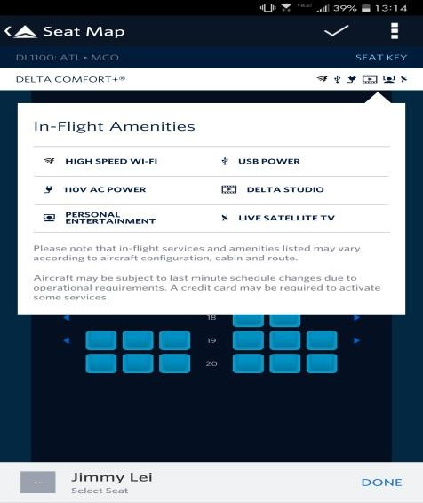
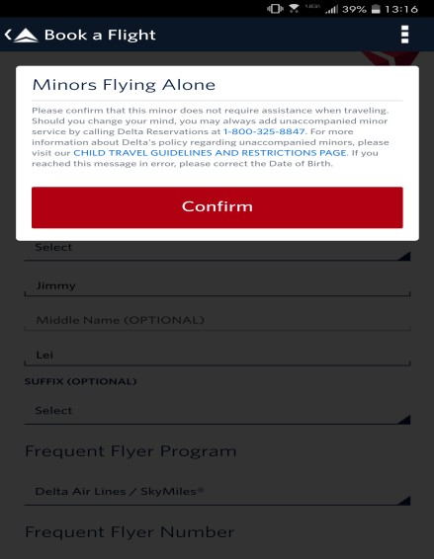

Studio 99, Columbus, OH June 2014 – Present
Android Developer

Worked on developing two Android mobile applications with Unity , both scripted using MonoDevelop in C#
“Harp Seal Heroes” responsibilities included project management, animation, testing,
concept, game design, and programming
Concept explored gameplay of two players on the same touch device, in order to facilitate more human interaction
Expert at JAVA SDK design functionality, including the full activity lifecycle.
Worked with Smart Dog Media on a now canceled TV show pilot for independent game designers
Project “ARCA” responsibilities are similar and include UX design.
Gameplay concept is minimalist, expanding boxes randomly distributed on screen, to cover as much area as possible without being “caught”
Managed migration project moving from Unity to Android Studio, utilizing Material Design and GIT for source code management
Efficient coding practice, followed coding standards and guidelines, retained development functionality close to Requirement Specifications.
Team meetings, discussions, documentation updates for future reference
Tested the app across different versions of Android and Android phones to assure quality and performance
Weekly Build Deployment, Application testing using various Android devices, Documentation updates, Status meetings
URL:https://www.youtube.com/watch?v=-NFy6GJ9sD

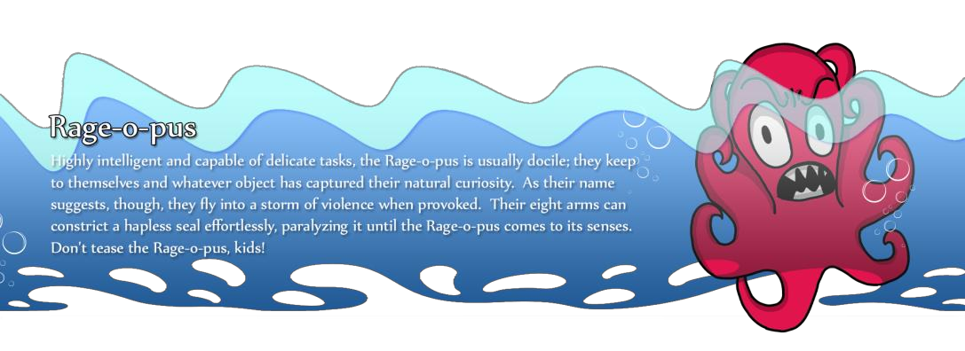

 | 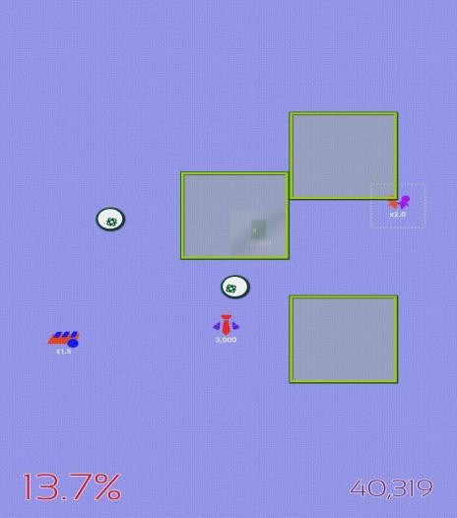

IMV, Medical Information Division,Arlington, VA Sept 2013 - May 2014
Market Researcher

Consistently exceeded negotiating goals with technicians/doctors for interviews during work hours
Documented and formatted interview result data

Soul Fire Software, Columbus, OH Feb 2010 – Sept 2013
Game Designer/Programmer

Worked with a team of seven engineers to create an Xbox 360 indie game using the SCRUM Agile method and test-driven development (TDD)
Stepped in as the project lead from concept to alpha build testing
Designed the levels and final battle sequence, implemented the final battle, including battle progression and AI
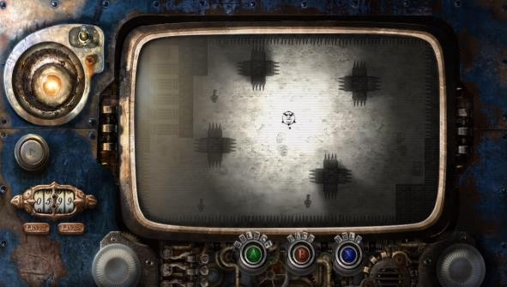

Education

University of Illinois Urbana - Bachelor of Computer Science, College of Engineering

