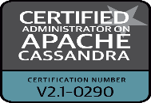
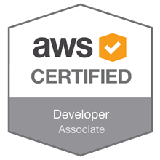
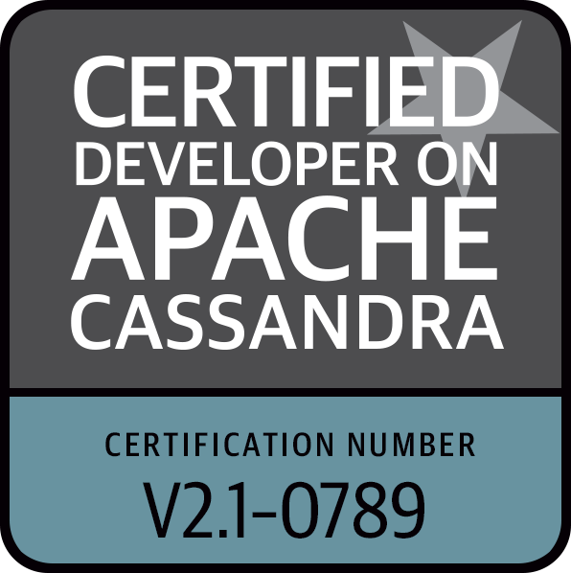
Gurumoorthy Masilamani
E-mail: gurumasi749@gmail.com
Phone: 248-939-4124

Professional Summary

- 8 years of Professional work experience with 5 years of NoSQL experience which includes Cassandra DB and MongoDB. 3 years of experience in DB2 and Oracle database Administration.
- Experience on Designing, Planning, Administration, Installation, Configuring, Troubleshooting, Performance monitoring and Fine-tuning of Cassandra cluster.
- In depth knowledge about Cassandra internal architecture.
- Proficient in compaction strategies in Cassandra system.
- Knowledge of managing and scheduling backup and restore operations.
- Strong experience and knowledge of real time data streaming using Spark Streaming and Kafka
- Experience in setting up Amazon Web Services like EC2, S3 bucket, EBS, ELB, Auto-Scaling, AMI, IAM through AWS console and API Integration.
- Experience on DevOps essential tools like Ansible, Docker, Kubernetes, GIT, Jenkins, Maven.
- Performed Database Cloning from production to Test and Development instances to test & simulate few technical challenges, coordinate with testing and development teams.
- Extensively involved in Session monitoring included identifying Long Idle sessions and High Active sessions, High CPU consuming sessions, long running sessions, blocking sessions and resolving them without affecting the performance.
- Good knowledge in the principles and best practices of Software Configuration Management (SCM) in Agile, SCRUM, Waterfall methodologies.

Technical Skills

- Programming Languages: Java, C, PL/SQL, Python, Scala, XHTML, HTML5, PHP, CSS3.
- Databases: Apache Cassandra, DSE, DSE Solr, MySQL, MongoDB, Oracle 10g/11g, SQL Server.
- Big Data Technologies: HDFS, MapReduce, YARN, Spark, Hive, Sqoop, Flume, Oozie, Zookeeper, Kafka, Apache Solr, Ambari.
- Tools and Utilities: OpsCenter, DevCenter, Maven, Log4j, Eclipse, Jenkins, Tableau, Jira, Putty, Winscp, Toad, SQL Developer, VMware, Vnc-Viewer, DBCA, ADDM, RMAN, AWR, FileZilla.
- Cloud Infrastructure: AWS (S3, EC2, EMR), Google Cloud Platform.
- Version Control Systems: GItHub, SVN
- Operating Systems: Linux, Windows 2000/NT/XP/7/8/10, Unix.

Education

- Bachelors in Mechanical engineering from PRIST University Thanjavur, India in 2012

Certifications

- Datastax Certified Cassandra Administrator
- Datastax Certified Cassandra Developer
- AWS Certified Developer – Associate
- Architecting with Google Cloud Platform, a 6-course specialization by Google Cloud

Professional Experience

Client: Cengage Learning. Farmington Hills, MI
Role: Cassandra Consultant July 2018 – Till date

Cengage is an educational content, technology, and services company for the higher education, K-12, professional, and library markets worldwide. Cengage has operations in more than 20 countries around the world. Cengage offers print and digital textbooks, instructor supplements, online reference databases, distance learning courses, test preparation materials, corporate training courses, career assessment tools, materials for specific academic disciplines, and custom solutions.The company's product lines include: 4LTR Press, Aplia, Cengage Learning PTR, Chilton, Education To Go, Gale, Milady, MindTap,CNOWv2 and National Geographic Learning.

Responsibilities:

- Responsible for availability and performance of CXP, SSO, Cassandra shared Prod and lower environments.
- Created 36 node Cassandra cluster for online SSO (SingleSignOn) and CXP (covalent xtreme performance and grade assessment engine) with Cassandra DSE-5.1.8.
- Designed Cassandra data model for Single sign on application.
- Enabled Backups of cassandra data on opscenter to the S3 buckets as a part of disaster recovery.
- Forwarded the cassandra system logs and gc logs to splunk and configured the dashboards and alerts for cassandra on it.
- Enabled spark on Separate datacenter on CXP cluster to run data analytics on cassandra data
- Performed performance testing and load testing on Lower environments before pushing the changes to the production.
- Coordinated with teams to update cassandra DSE 5.1 upgrade from DSE 4.8.12 on all non-prod and prod nodes.
- Deployed DSE solr in search nodes for ad-hoc analytics use cases.
- Modified solr schema based on the requirement and performed tuning on the filtercache.
- Managing and monitoring the performance of cassandra on 200 nodes (120 production and 80 no-prod nodes).
- On all prod clusters updated the data centers to aws multiple AZ’s to minimise the risk of single AWS AZ failure.
- Moved the cassandra data from old cluster to new cluster on production and lower environments with minimal application downtime.
- Raised C4.4xlarge AWS ec2 instances with Provisioned IOPS EBS volumes(io1) for cassandra nodes and for cassandra data storage.
- Used Ansible scripts for Cassandra automation
- Configured, Documented and Demonstrated inter node communication between Cassandra nodes and client using SSL encryption.
- Worked on implementing Spark clusters for distributed data processing and analysis.
- Perform capacity planning related activities on database storage and performance.

Client: Just Energy, Mississauga, Canada
Role: Cassandra Consultant Jan 2016 - Jun 2018

- Responsible for creating the Cassandra database across all the environments namely Development, Pre-Production, UAT and Production.
- Created a 36 node Cluster in Production with 2 Data Centers in US-East and US-West to handle the daily loads of incoming transactional data which has millions of records coming from third party vendors.
- Built an infrastructure capable of handling incoming updates every 30 minutes with information with regards to the power consumption of the customers.
- Involved in designing multiple data models for various teams across the Enterprise Infrastructure team.
- Migrated tables from SQL Server to Cassandra which are being used actively till date.
- Upgraded all Cassandra nodes across all platforms from DSE 4.6.7 to DSE 4.7.2 to DSE 4.8.9
- Designed and implemented 15 (9 nodes for incoming data and 6 nodes for Analytics) node cluster on AWS using Apache Cassandra 3.0.11.
- Designed and implemented Spark cluster to Analyze Data in Cassandra.
- Developed the Scala Jobs to generate summaries on consumer usage.
- Created scripts which could automate repairs, snapshots.
- Implemented dual center setup across various environments which included Spark nodes as well.
- Implemented spark solution to transfer the data from production cluster to lower environment.
- Perform capacity planning related activities on database storage and performance.
- Used Cloud Formation Templates (CFT) and Ansible on AWS to build a cluster or even a datacenter and join them into an existing datacenter.
- Used GitHub repository to save all the scripts being deployed across various environments.
- Migrated all Cassandra servers from ELB to EBS volumes as part of a requirement coming from Management.
- Used Zabbix as a monitoring tool for Cassandra.
- Provided support for the database depending upon the need over the weekends.

Client: BCBSM, Detroit, MI
Role: Database Administrator Oct 2014 – Dec 2015

Responsibilities:

- Managing multiple Production and Development DB2 LUW Applications environments of different releases.
- Database server Installation, Database Creation, Maintenance, Backup, Recovery & Performance Tuning
- Migration of UDB databases from 8.x to 10.1.
- Migration of Oracle databases from 9.2.0.7 to 11g.
- Involved in creating logical data models for various applications using Erwin.
- Converted logical models into physical models.
- Implementation of high availability and disaster recovery of databases through DB2 HADR in production environment
- Developing shell scripts for database monitoring and maintenance.
- Restore and recover corrupted databases.
- Written stored procedures to implement business functionality.
- Research and resolve database issues.
- Verifiable record for achievement of Exceeding Expectations, as a Database Administrator.

Client: IVY Comptech Pvt Ltd,
Hyderabad, India, May 2012 - Oct 2014

Bwin.party gaming – Developer (Java, DB2 9.1, Oracle 10g)
IVY Comptech develops a platform for partypoker.com and partygaming.com. Also provides interface for online gaming for more than 30 million users in various countries. With many affiliates joining bwin.party and a lot of distributed environments, need for a truly consolidated and highly secure platform for backend operations and configurations arose. The platform is a truly global product which provides a one stop portal for anything ranging from game configurations to hosting game tournaments for users and third parties.
Responsibilities:
- Requirement gathering, analysis and estimation.
- Implemented upload functionality using java.
- Involved in Data Modelling (Creating data dictionary, Logical Data Model and Physical Data Model)
- Wrote shell script to invoke Java implementation
- Implemented password encryption /decryption using AES Algorithm
- Implemented log4 for logging
- Wrote unit test cases using Junit.

