PROFESSIONAL SUMMARY
Skills Summary
- Languages: Java, Kotlin, C, C#, PHP, PL/ SQL, PL/SQL, JavaScript
- Databases: SQLite, MySQL, Firebase DB
- IDE: Eclipse, Android Studio,
- Design Patterns:MVP, MVC, MVVM
- Development: TDD, JIRA, Continuous Integration, Confluence, Git, GitHub, SVN, SourceTree, BitBucket
- RESful Web Services: REST, SOAP, XML, JSON, GSON
- Threading: Loopers, Loaders, AsyncTask, Intent Service, RxJava
- Android Dev: Schematic, SmartTV, , Certificate Pinning, RxJava, MonkeyRunner, Bluetooth Low Energy, ExoPlayer, SyncAdapters, Volley, IcePick, Circle-CI, Samsung SDK, Glide, VidEffects, JUnit, Ion, GSON, ORMLite, Push Notifications, Kickflip, SpongyCastle, Parse, Flurry, Twitter, FloatingActionButton, , Espresso, Fresco, Moshi, Jenkins, UIautomator, Parceler, Dependency Injection, EventBus, , Dagger, Crashlytics, Mixpanel, Material Dialogs, RxCache, Retrofit, Marshmallow, Loaders, Jitpack, JobScheduler, ParallaxPager, XmlPullParser, Google Cloud Messaging, LeakCanary

- Web Dev: jQuery, HTML, CSS, JavaScript, Google Web Toolkit

- 5 published apps in the Google Play Store
- 8+ years of experience in the IT field
- 5+ years of experience in Android Mobile App Development
- Expert programming in Java and Kotlin to develop Android applications.
- Network calls and background multithreading using RxJava, Retrofit, Volley and AsyncTask.
- Worked in an Agile environment with strong SCRUM and pair programming fundamentals.
- Strong leadership and communication skills in an Agile environment SCRUM, Kanban, and XP.
- Google Maps API, GPS Location data for pinpointing the user location, finding locations nearby the user and displaying maps and directions.
- Creation of unit and integration testing suites developed with Mockito and Espresso for use in Android development.
- Configured and initialized multiple cloud integration services including Parse, Firebase and Google Cloud Messaging for Android projects.
- Ability to coordinate with various team members involved in the project.
- Experience with consuming third-party APIs in Android development projects.
- Experience with multi-threading and memory management specific to mobile devices
- Guide decisions on architecture and technical strategy.
- Well versed in the most modern Android third party libraries such as Volley, Retrofit, Picasso, YouTube, Location API, Maps View, Google View, Google Maps, PayPal, Stripe, Android pay, QR Droid, Butter Knife, Dagger, Google Wallet payments, Android Annotations.
- Continuously delivered a complete analysis regarding problems on the client’s side, having in mind various factors like deadlines, budget, scope, and risks.
- Experience with Push Notifications, Google Maps, Navigation, and GPS.
- Experience developing mobile to cloud and mobile to embedded device communications.
- Fluent in Android SDK/NDK and device driver development.
- Worked with an internal QA team on system, performance, and acceptance testing.
- Android UI Toolkit and Layout Managers. Proficient in Android Application Framework and Android SDK Tools.
- Android Push Notifications, Google Maps, Navigation, GPS
- Followed best practices for architecture and programming.
- Implementation of dependency injection with Dagger to sped up the unit testing process.
PROFESSIONAL EXPERIENCE

ANDROID ENGINEER March 2018 – Present
Directed Electronics/Viper Smart Start Vista, CA
https://play.google.com/store/apps/details?id=com.directed.android.viper
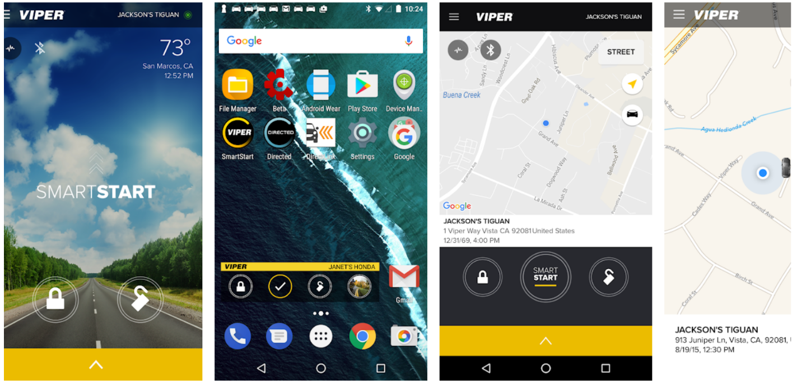
An Android Mobile App that brings you the cloud connected car, and this app is compatible with all Android devices. The app provides realtime updates and feedback from your car systems and lets you remote lock, unlock and start. With the release of its all-new 4th generation Viper SmartStart app, control your car from your Android Wear smart watch.

Responsibilities:
- Used custom views to easily reuse UI components built to UI/UX design specifications.
- Used server to handle all data storage and follow invitation requests.
- Used the Android watch API to develop a watch face capable of displaying the status indicators and messages from the car.
- Android Studio used as IDE in Android application development.
- Developed new features in Kotlin to reduce codebase with data classes and extension functions.
- Used Kotlin Coroutines to perform asynchronous tasks for optimized thread management
- The Android project team used Bamboo cloud-based continuous integration tool.
- Dagger 2 was the library for dependency injection for readability and clean code.
- Cipher encryption secured data as it was being passed to the server and watch, staying in compliance with security standards.
- Involved in working on Restful Web service with JSON.
- Collaborated with the web application development team to ensure proper integration between mobile application and web application.
- Also used GSON converter to convert the retrofit JSON response to the java object.
- Worked with Git and I managed the Git repository, multiple branches.
- Helped mentor junior developer in adapting to Android from his background in Java.
- jUnit and Mockito used to create unit tests although the testing was primarily handled by the V&V department.
- Android application architecture was MVC, but looking to refractor into MVP in the future.
- Implementing Google Cloud Messaging for instant alerts for the customers.
- Asynchronous Programming Android (such as Thread pool, Tasks and Services).
- Programming on the Android project included both Java and JavaScript.
- Only supported the Samsung J3 device, the BYOD program was scheduled for a later release of the Android application.
- Services and broadcast receivers for performing network calls to the server.
- Bluetooth LE connection implemented to send data from the Simplicity Application to the watch face for easy access.
- As features were added to the application, the V&V team ensured that everything worked properly before the Jira ticket could be closed.
- One of the biggest challenges was managing the information being sent to the server for retention purposes. Every 5 minutes a glucose reading was recorded and with the length of the program being over the course of a few months, the amount of data being saved for each person got to be very large.
- Kept track of current and backlogged tasks using Jira.
- Documentation was done using an SDS template provided by Dexcom, which has been used on all the applications they have had developed.
- Followed Agile methodology with daily standups, monthly team meetings, sprint grooming meetings and sprint planning meetings.
- Team consisted of 3 senior level developers (myself included), 2 junior level developers and a project manager.

ANDROID MOBILE DEVELOPER February 2017 – March 2018
Ulta Beauty Bolingbrook, IL
https://play.google.com/store/apps/details?id=com.ulta&hl=en_US
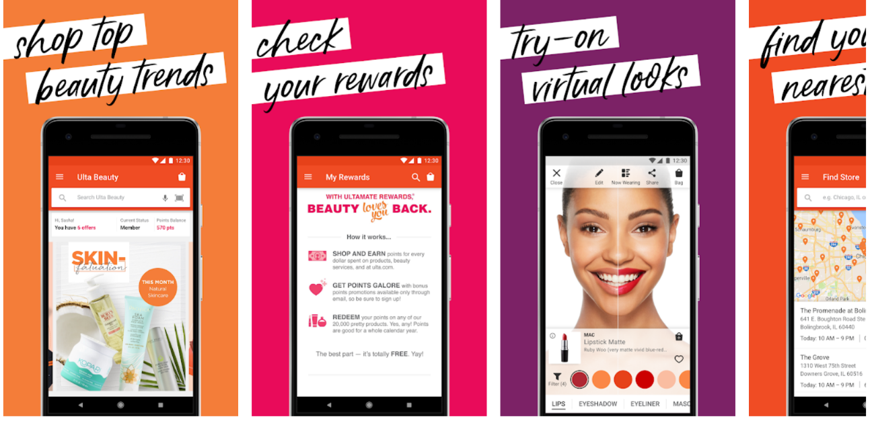
An Android ecommerce app has rich features such as the GLAMlab, our virtual beauty try-on experience. Book an appointment at your nearest Ulta Beauty Salon. Filters allow users to shop by category, filter by brand, price, best sellers, new arrivals. Find a product using our barcode scanner to view product info, ratings, reviews & save your favorites; QR codes supported. Use voice search to search for a brand or product, simply by speaking its name. All of this in addition to standard shopping features such as account management, rewards program, location finder, order and ship or pick-up, favorites, and more.

Responsibilities:
- Conducted SCRUM meetings and acted as liaison with the upper management to make everything work faster by removing all blocking situations the team was facing
- Added the Parcelable interface to pass custom objects between components quickly via Intents.
- Used Espresso for instrumentation testing using Assertions, Matchers and Actions.
- Worked with LRU Cache to increase the performance of ListView scrolling.
- Updated the look and feel following Material Design guidelines, and implemented several Fragments for the UI.
- Ensured excellent form factor integration by creating multi-panel activities with Fragments.
- Improved the layout rendering by saving and optimizing the view hierarchy in all the resources.
- Supervised the creation of the unit, integration and stress test cases with JUnit, Espresso, and MonkeyRunner.
- Actively worked with the back-end team to improve the RESTful API to include new features.
- Developed compound views to present information to the user depending on its preferences.
- Managed private Git code repositories with SourceTree.
- Created custom animations and transitions to improve the user experience.
- Made a distinction between development and production versions of the app each with their distinct credentials and settings in the backend using Urban Airship.
- Ability to manage competing priorities in a complex environment and maintain high productivity.
- Used the View Pager Indicator to provide feedback to the user about the background processing status.
- Implemented IcePick when building references to track them in an easier way and avoid memory leaks.
- Used custom views to easily reuse UI components built to UI/UX design specifications.
- Implemented Google Analytics and Firebase for various analytics.
- Utilized the Android Studio IDE to develop and code the application in Java.
- Contributed value to a cross-functional engineering teams (back-end development, front-end development, UI/UX designers, QA, Product Management, etc.).

ANDROID DEVELOPER November 2015 – February 2017
WellStar Health System, Inc. Atlanta, GA
WellStar: https://play.google.com/store/apps/details?id=org.wellstar.physicianfinder
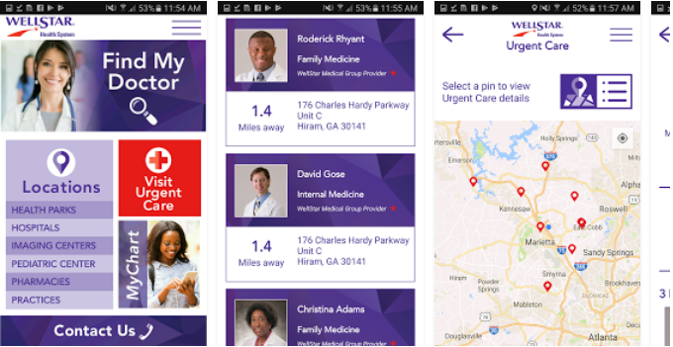
WellStar Health System, Georgia, known nationally for innovative care models. The Android app for WellStar is part of that innovation, using the app to improve on quality of care and accessibility. The app can find service locations, physician finder, and used GPS location and map services. To make assessibility easier, users can schedule appointment on the Android app. Patients also have access to their patient records and customer care communication.
Responsibilities:
- Implemented user login screens and designed context menus based on the Android Menu Navigation, Tabbed Navigation control, and Action Bar Control.
- Tied mobile client applications to critical server-side APIs.
- Involved in requirement gathering and outlining.
- Worked in databases using native Android API and server-side MS SQL server database.
- Responsible for developing the Android UI layouts (Linear Layout, Relative Layout).
- Implemented two versions of unique UI. Created a lot of prototypes for different UI elements.
- Introduced optimal caching mechanism into SQLite, to avoid unnecessary queries.
- Involved in writing application logic in Android Studio.
- Integrated communication with backend services using Retrofit and RxJava, parsing JSON objects with GSON.
- Worked in different phases of the project cycle like design, development, and testing.
- Worked in the Use case requirements, analysis, design, and development phase.
- Worked with Custom Frameworks and Custom Templates for building this application.
- Implemented Frame Layout method to show background images of the app.
- Individual implementation of Google Map and Location service.
- Implemented OAuth and authentication tokens.
- Implemented entire feature using Fragments and Custom Views.
- Implemented Toast, Dialog notifications for alerts.
- Implemented Singleton Object class for managing 3rd party API to access the information in various modules of the application.
- Worked on the SQLite database to minimize the size of the application and increase the performance.
- Used Android XML in design and development of user interfaces.

SENIOR ANDROID DEVELOPER September 2014 – November 2015
Wydham Hotels and Resports Parsippany-Troy Hills, NJ
Wyndham Rewards: https://play.google.com/store/apps/details?id=com.wyndhamhotelgroup.wyndhamrewards&hl=en_US
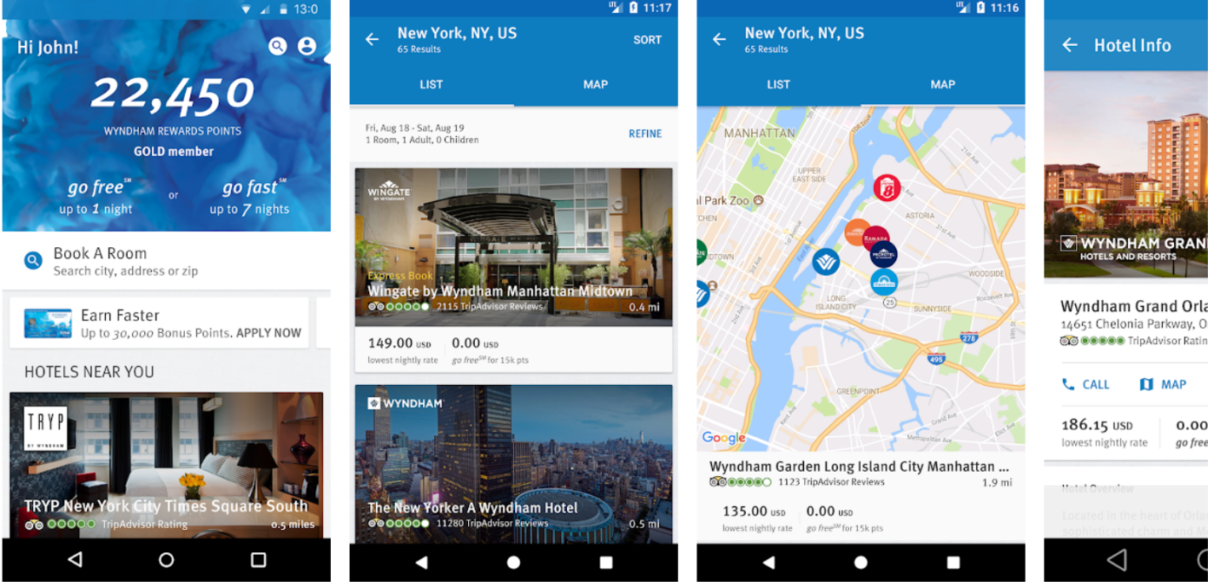
Wyndham Android can book your hotels, make travel plans and capture your rewards. Use Booking Magic feature to have an associate phone you and handle the reservation even while driving. After you book your hotel, you can view upcoming stays and find restaurants or attractions nearby at the touch of a button.

Responsibilities:
- Implemented unique design for portrait and landscape mode.
- Organized & improved global widgets and UI controls.
- Designed screens related to categories and detail pages for this application. Registered the Broadcast Receivers for the Android system announcements.
- Git was the source control tool being used to manage the application development
- Responsible for the design, development, testing and publishing of the application
- Parsed JSON files to obtain data returned from web services
- Utilized Navigation Drawer and Tabs to provide quick and easy navigation
- Upgraded the SQLite database to add various extra features to the app
- Implemented Crittercism to monitor crashes and exceptions and user app analytics data
- Communicated with RESTful web services to obtain insurance companies information using Retrofit, OkHttp and Jackson.
- Adapted Agile methodology to meet requirements on time
- Performed automated testing by using Robolectric
- Tracked the debugging process using Android Studio DDMS, CI Tools like Jenkins, TDD, and JIRA.
- Tested the app across different versions of Android to assure quality and performance.
- Involved in Agile activities such as iteration planning, grooming feature dive-ins, sprint retrospectives.
- Took part in Native application development using the prebuilt libraries.
- Used multiple threads running in the background using Rx Java for high performance and efficiency, and implemented Google cloud messaging (GCM) for enabling push notification.
- Implemented back-end integration using Retrofit and OkHttp to parse JSON data converted with GSON.

SENIOR ANDROID DEVELOPER January 2014 – September 2014
Citibank, N.A. Sioux, SD
Citi Mobile: https://play.google.com/store/apps/details?id=com.citi.citimobile
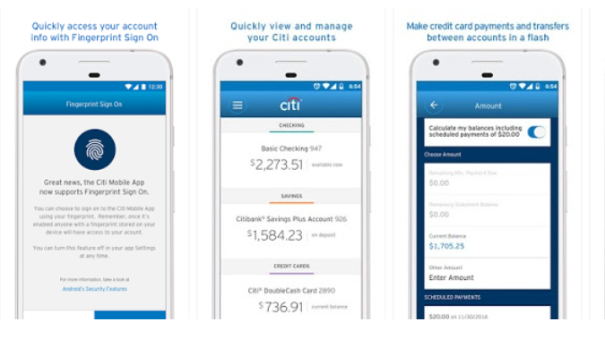
Android for Citi Mobile project included many feature updates, improved performance and app maintenance. This Android app is secure for managing credit card and sensitive information. Users can reset debit card PIN or lock a credit card from the app for increased security. The basic feature includes account management, transactions and payments. From everyday account activities to helping you track spend, the app is there for you. There are transaction search and filter options, custom notifications, and Fingerprint Sign-On.

Responsibilities:
- Worked on Retrofit RxJava call adapter service to update the ListView screen.
- DDMS (Dalvik Debug Monitor Server) and TraceView for debugging and detecting memory leaks.
- Worked with SDLC process like Agile methodology, and implemented MVP architecture, which is derived from MVC (Model View Controller) pattern.
- Implemented communication with RESTful services and used Rx java to add a number of classes.
- Involved in entire software development process for all assigned android application development projects: requirement specification, design, implementation, testing and maintenance
- Implemented scheduler that schedules an Observable on a given Android Handler thread, particularly the main UI thread.
- Profiling, tuning, & optimizing Android apps and branching, pushing & merging codes with remote repository GIT.
- Interacted with existing development team to understand the native Android features required by the application.
- Provided subsequent releases which included feature changes, enhancements and bug fixes.
- Contributed in production release deployment, certifying release features, monitoring production logs and fixing production issues on demand.
- Used SVN for version controlling and for integration of the code.
- Responsible for developing the user login screens and design the Context menus based on the Android Menu Navigation, Tabbed Navigation control and Action Bar Control.
- Configured multiple analytic tools to get valuable information on a post-install state: Crashlytics, Mixpanel, Flurry, Answers.

PROGRAMMER January 2010 – January 2014
Blaze Pizza. Knoxville, TN
- In charge of the implementation, security and user-accessibility of our site's login system; utilized Express-Session and MVC architecture.
- Project-based web development experience using the full LAMP stack (Linux, Apache, MySQL, PHP) and an ability to make immediate contributions as a junior web developer.
- Strong foundation in both front end and back end web development with working knowledge of OOP, MVC frameworks, and Agile methodologies (SCRUM).

SQL PROGRAMMER January 2010 – January 2014
Radio Systems Corp Knoxville, TN
- In charge of the implementation, security and user-accessibility of our site's login system; utilized Express-Session and MVC architecture.
- Analyzed requirements for and created new stored procedures/packages.
- Conducted user interviews to gather requirements.
- Worked with BI team to create views to be accessed by Cognos.
- Troubleshot/analyzed/documented existing stored procedures/packages.
- Saved the company and indeterminable amount of time and money by bringing the existence and importance of editioning in R12.2.4 to the company’s attention.

EDUCATION
Associate of Applied Science, Computer Science
Pellissippi State Technical Community College,

Bachelor of Science, Mathematics
University of South Carolina Upstate
Greenville Technical College

Honors and Associations
President's Honor List, 2004
Dean's List, 2006
Gamma Beta Phi
Math Club, President 2006-7

