Tic Tac Toe

Vertical Win:

Horizontal win:

Right Diagonal:

Left Diagonal:

Draw:

Connect Four:

Vertical win:

Horizontal Win:

Diagonal Win:

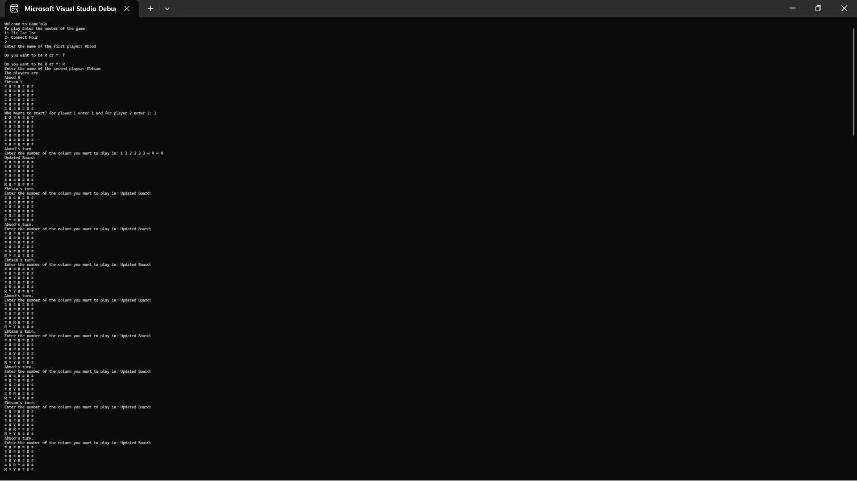

Draw:

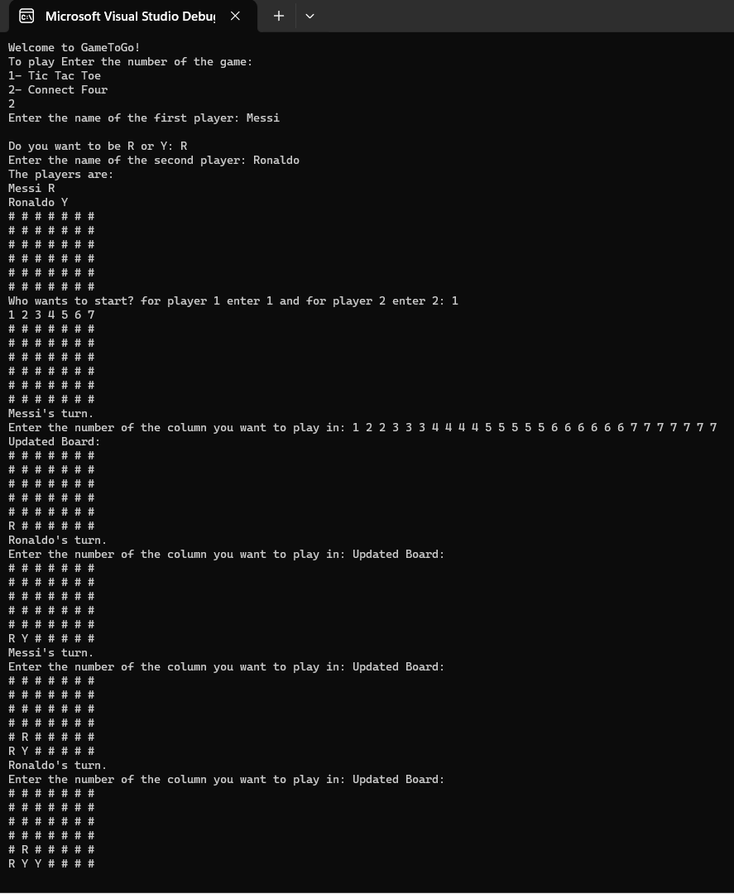

Remarks:

* All the cases of Tic Tac Toe have been tested.
* Most of the cases of Connect Four have been tested, however there are too many possibilities.
* I used the player object as a playing object. I am not sure if it makes sense, but it was the optimal way for me.
* The graphics are not that good, but the time is limited.
* I have considered most of the validations, but I may have left some unintentionally.
* The overloading operator << for the player class is implemented and used in the game classes.
* I used maps and pairs for ease and simplicity of playing, but they are not essential.
* I didn’t need vectors or iterators in the main function.

It’s supposedly working properly. I hope it still does :)

Thank you.