1 - first column without name, I suppose it is an ID given that it is unique

2 - duplicate columns: remaining_min_1 smallint, power_of_shot_1 tinyint, knockout_match_1 tinyint, remaining_sec_1 smallint, distance_of_shot_1 tinyint

- Be careful about the duplicate columns! One strategy to manage missing values is to get the value from the first column (for example remaining_min) and if it is a null take the value from the second column (for example remaining_min_1), or viceversa. But we decided to adopt another strategy for missing values given that it seems that the duplicated column doesn't contain the right value. For example:

Id = 4 is a missing value, and the value of remaining_min_1 is equal to 43. It is obviously not correct given should be a number between 6 and 9. Furthermore, there are decimal values for the duplicated columns#2 but this is not correct because, for example remaining_min_1 should be an integer and the seconds should go in remaining_sec_1, the same for power of shot should be a range between 1 and 7 rather than a decimal value:

So, we decided just to drop the columns that ends with _1 because data seems not to be correct

3 - the column lat/lng contains commas (csv separator) and to resolve it is possible to use FIELD_OPTIONALLY_ENCLOSED_BY = '"' during the creation of file format

4 - be careful to game_season "2000-01" considered as a string but should be a date

5 – IN 1999 Ronaldo dindn’t played for Manchester United

6 – Manchester United always play home? Never Away?

7 - missing values

**FIRST ROUND**:

- ID, OK

- MATCH_EVENT_ID, we can't do nothing given that is an FK

- SHOT_ID_NUMBER, the same as MATCH_EVENT_ID

- LOCATION_X, LOCATION_Y filled with 0

- REMAINING_MIN, we compute an average for a specific match between previous and next row

- POWER_OF_SHOT, we use the most frequent value in the table (MODE)

- GAME_SEASON, we can retrieve the value given that we verified that the same value is unique for each match_id.   
 For the NULL we just take the information from another row.

- REMAINING_SEC, we do something of similar as REMANING_MIN but considering not only the single match

but also the minute.

* AREA_OF_SHOT, in this case, we decide to leave null values and connect to the dimensions using the dummy row
* SHOT_BASICS, also in this case, we manage null with dummies
* RANGE_OF_SHOT studying other data, we defined the following ranges:

For this we also create another column called RANGE_OF_SHOT_IN_FEETS

* TEAM_NAME, according to transfert market we defined the following range:

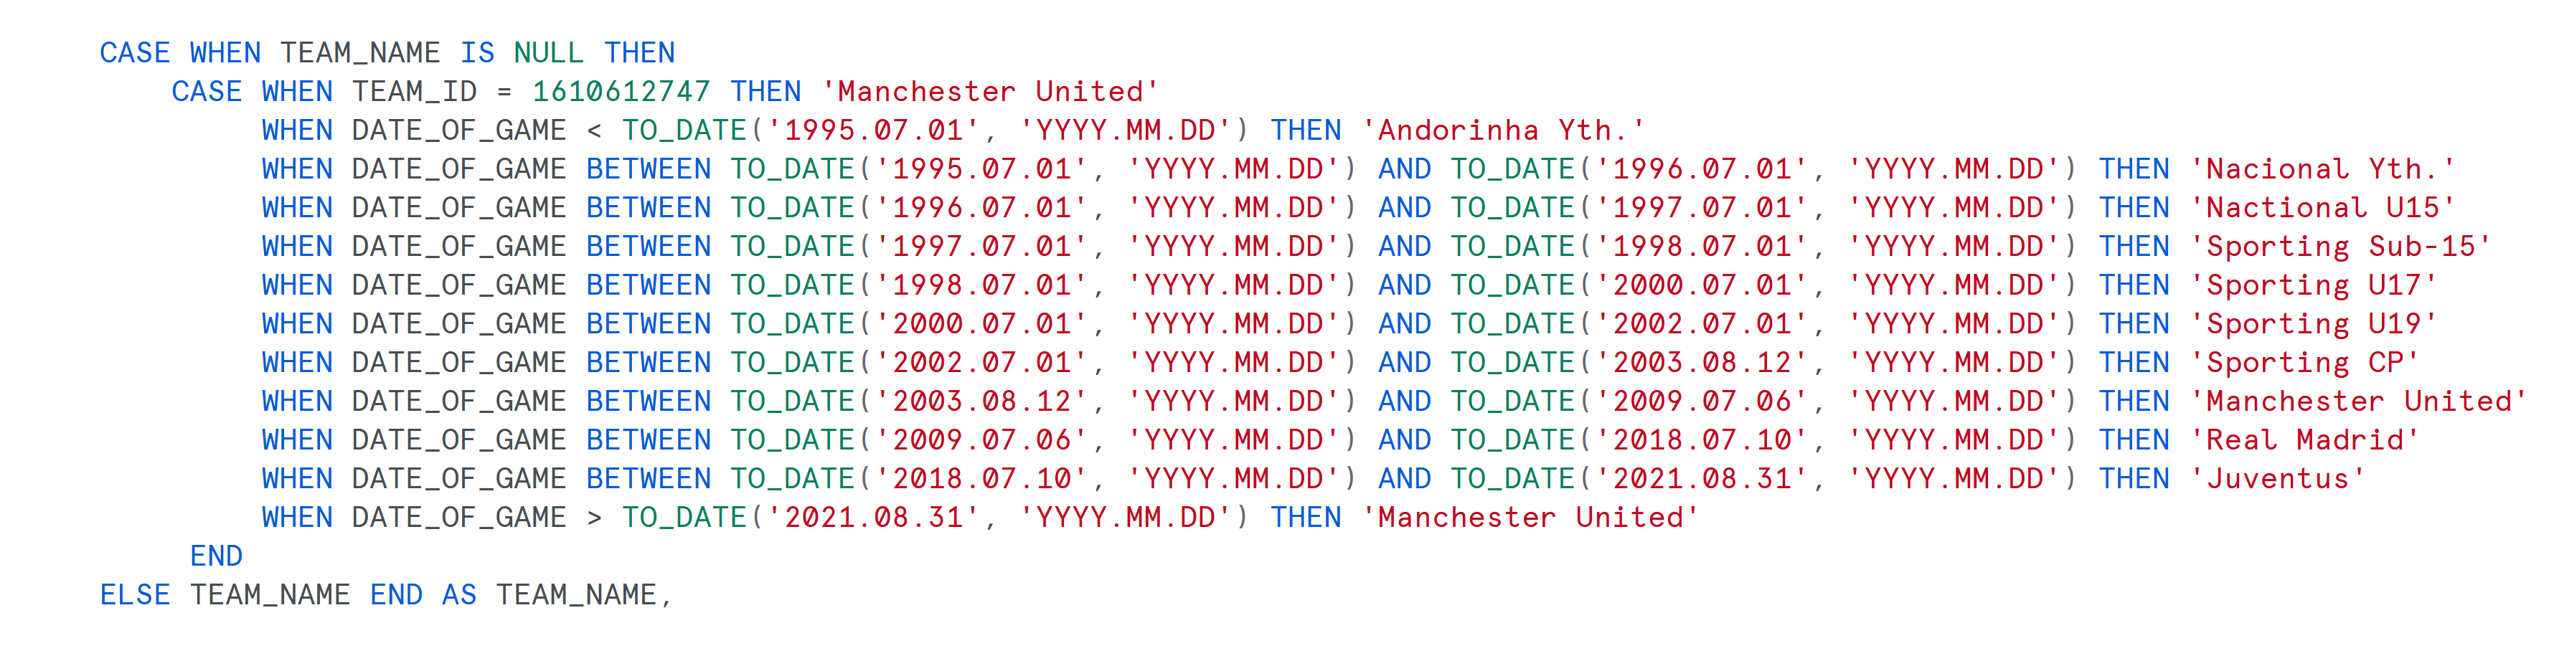

* DATE_OF_GAME is always populated in other rows but one (match id = '29600031'). So we can get the same info from other rows
* LAT_LNG:
  + - We created LATITUDE column
    - And LONGITUDE column
* TYPE_OF_SHOT and TYPE_OF_COMBINED_SHOT is merged in one column called TYPE_OF_SHOT and we created a flag (column IS_COMBINED). This because we verified that a Shot can’t be both combined and not combined
* MATCH_ID and TEAM_ID are always populated
* KNOCKOUT_MATCH Same logic of Date of game, we can retrieve the information from another row
* DISTANCE_OF_SHOT, we use the most frequent value in the table (MODE)
* HOME_AWAY Same logic of Date of game, we can retrieve the information from another row

**SECOND ROUND**

* Integration of team names in two different columns (home and away) from home_away. Team names comes from excel file
* Game season
* EXTERNAL FILE FOR TEAMS AND FOR IS_GOAL (REGRESSION)