# Design of the Datawarehouse

In the realm of data management, design a Datawarehouse system that meets the requirements defined in the previous step (*1_requirements_analysis*), is a multifaceted task. It involves a meticulous process that unfolds in three distinct phases: **conceptual**, **logical** and **physical design**. These levels of design are crucial in creating a DWH that not only captures the essence of the data but also ensures its integrity, efficiency and security.

Conceptual Design

The conceptual design is the highest level of abstraction in the Datawarehouse design process. At this stage, designers focus on understanding the problem domain and defining the overall structure of the database without getting into technical implementation details. The primary goal is to create a clear and comprehensive representation of the data and its hierarchies.

For this purpose, we decided to use the so called “*DFM, Dimensional Fact Model*” which represents a graphical formalism specifically devised to support the conceptual modelling phase in a data warehouse project. DFM is extremely intuitive because it can be used by analysts, technical users, non-technical users and customers. It is used to realize a clear and exhaustive representation of multidimensional concepts (e.g., attributes, measures and hierarchies).

In order to understand the schema, we must have a clear understanding of what is exactly a fact, a measure and a dimension:

* A *fact* is a concept relevant to decision-making processes. It typically models a set of events taking place within a company. An example of facts in the Foreign Exchange is the *F_FX_EXCHANGE_RATE* table.
* A *measure* is a numerical property of a fact that describes a quantitative attribute, relevant for the analysis. For example, in the *F_FX_EXCHANGE_RATE* table example of measures can be current *rate*, and *change* *%*.
* A *dimension* is a property that describes an analysis coordinate of the fact. A fact generally has multiple dimensions that define its minimum representation granularity. Typical dimensions for the context are dates and currency.

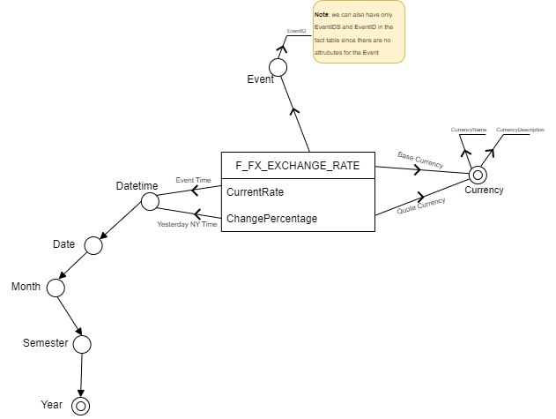

Figure 1- Dimensional Fact Model, F_FX_EXCHANGE_RATE

**Business Logic for measures**:

* The “*CurrentRate*”, according to the requirements, is computed as follows: we want to consider only active rates. A rate is considered active if and only if it’s the last one received for a given currency couple AND it’s not older than 30 seconds.
* The “*ChangePercentage*” instead, is computed by dividing the *CurrentRate* with the yesterday’s rate at 5PM New York time. The latter is computed by checking the most recent rate starting from yesterday at 5PM NY Time back to the past. If there is no correspondence, we consider the less recent row starting from yesterday at 5PM NY Time going to the future.

Logical Design

The logical design bridges the gap between the conceptual and physical levels. In this phase we want to translate the conceptual model into a more detailed representation, in the Datawarehouse design, this coincides with the definition of the star schema or snowflake schema. In the star schema the fact tables and dimension tables are contained. In this schema fewer foreign-key join is used. This schema forms a star with fact table and dimension tables. Snowflake schema is also a type of multidimensional model which is used for data warehouses. This schema forms a snowflake with fact tables, dimension tables as well as sub-dimension tables.

According to the conceptual model, it’s better in this phase to translate the DFM to a star schema since there aren’t lot of sub dimensions.

Physical Design