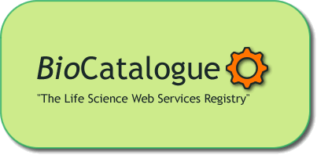

BioCatalogue questionnaire

Any data you provide will be treated in strict confidence and used solely for the purpose of setting users’ requirements for BioCatalogue.

1- Name (optional): _________________________________________

2- E-mail (optional): _________________________________________

3- Institution (optional): ______________________________________

4- Please select your disciplinary background (please tick all that apply):
Biology
Chemistry
Computer Science
Bioinformatics
Mathematics
Physics
Other (please specify)_________________________________________

5- Do you know what Web Services are?
Yes
No (please use the BioCatalogue brochure to find out more)

6- If you have been using Web Services, which ones are you most familiar with?
BioMart
BioMoby
CDK
NCBI
EBI
DDBJ
KEGG
Other (please specify)_________________________________________

7- If you have been using Web Services, how did you find out about them?
Google
Registry (please specify)______________________________________
Literature
Colleagues
Other (please specify) ________________________________________

8- Web Services are hard to find using for example Google. The BioCatalogue project aims at providing a central registry for Web Services in the Life Sciences.
On a scale of 1-5 how important are the following criteria when searching for Web Services? (1= not important at all; 3= important; 5 = very important; N/O = no opinion)
Provider
Functionality
Reliability
Popularity
History of use
Others (please specify)________________________________________

9- The BioCatalogue aims to provide additional annotation for Web Services.
On a scale of 1-5 how important do you consider the following types of annotation? (1= not important at all; 3= important; 5 = very important; N/O = no opinion)
Free text description
Controlled vocabulary (ontology) terms
Technology types (SOAP/REST/DAS)
Other (please specify)_________________________________________

Thank you for your inputs, The BioCatalogue team

