

Fact sheet 6: For people with disability and their families

Housing and Living Supports

The panel’s vision
Good housing and living supports are the foundation for greater social, economic and community participation. Everyone should have a safe, secure and accessible home in their community. We want to make sure decisions about housing and living are fair and consistent. Participants with similar levels of need should get similar amounts of funding.
Housing and living supports should strengthen connections to family, friends and community and encourage independence. We want people to have more flexible budgets and support to find and try options that will work well for them.
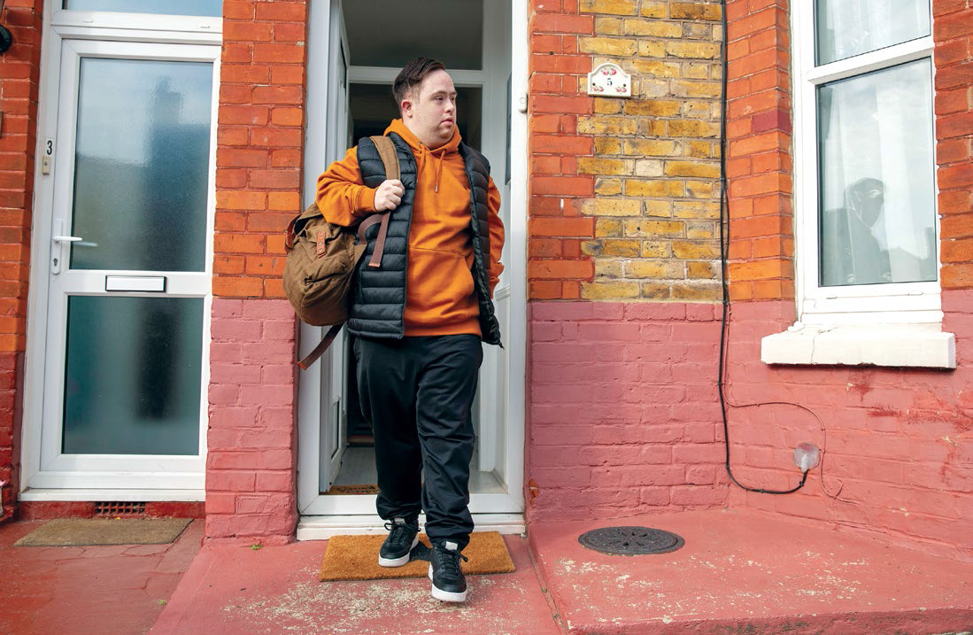

What is the problem?
You told us many participants with NDIS housing and living supports still have little or no choice about where they live, who supports them and who they live with. Many people still live in large or small group homes where they can’t choose their housemates or their service providers.
Planning decisions don’t seem to consider housing and support in a connected way - and decisions are not always clear and consistent. Participants with similar levels of need and circumstances often don’t receive similar levels of funding.
Participants and families worry about the future. They feel there is no certainty that housing and living support will continue.
Few people are supported to explore different options. There has not been much innovation in housing and living support design. There are not enough Specialist Disability Accommodation (SDA) homes to meet people’s needs. Many old, large and poorly designed houses need to be redeveloped or replaced.

What is the solution?
We want participants to have more choice about their living arrangements. Funding decisions should be fair, consistent and based on the needs of participants.

Fairer, consistent housing and living supports that encourage choice
- The budget for housing and living support should be set after a support needs assessment. It should include funds for home modifications if necessary. The housing and living budget would be separate from the flexible budget for other supports.
- Once a budget has been set, a specialist housing and living navigator should help people find options that work for them. People could trial alternative housing solutions.
- Participants who need 24/7 living supports would generally be funded at a 1:3 support ratio.
- Sharing supports does not mean people have to share a home if they don’t want to. We want to encourage new and better ways to enable people to live the way they want while still sharing support.
- There will be exceptions to the 1:3 support ratio. Sometimes participants can’t share supports. They might need more support because they have higher individual needs or are in more complex circumstances.
- Participants who share their home with other people will have access to a new shared support facilitator, whose job will be to help everyone to have a say in how the house and support is organised.

Reforms to SDA to better meet needs
- SDA categories and design standards should be reviewed to ensure they meet needs, remove the “Improved Liveability” category and create a new “Shared Living Support” category.
- SDA and living supports should be from separate providers.
- State and territory governments should agree to upgrade or repurpose ageing SDA accommodation and transition participants to housing in line with their needs and preferences. The NDIA should change its policies to reduce the bedroom count of ageing SDA dwellings.

Who will this benefit?
Participants with similar levels of need and in similar circumstances should have a similar budget for their housing and living needs. Participants who need 24/7 living supports should be able to trial new living arrangements before they commit to them.
Housing and living navigators would help participants and families find housing and support options that work for them. This should help people exercise more control and choice. Clear rules and consistent decision making should enable new and better housing and support arrangements.
Families should be confident that supported housing and living will be stable, safe and secure and enable connection with community, friends and family.

What happens next?
We know these are big changes. That’s why we have recommended that changes should be introduced gradually to make sure everyone has time to get ready.
No one will be forced to move from their current living arrangement. We strongly recommend that people with disability, their families and representative organisations should be closely involved in designing and testing changes to make sure they work well.

Sarah, 25 years old and moving out for the first time

How the future NDIS participant experience could work

Case Study
Sarah is a 25-year-old NDIS participant who would like to move out of the family home in the next six months.

Sarah is supported by her navigator Jak to think about her goals and her options. Jak helps Sarah apply for a change of circumstances review. Sarah will participate in a comprehensive needs assessment with the NDIA needs assessor to identify the disability supports she will need to live independently.
Based on her needs assessment, Sarah receives a housing and living budget that has shared supports. She can choose where she lives and who she lives with, within her budget.
Sarah’s navigator Jak helps her understand how to create a spending plan for her budget. Sarah also gets support from Ash, a specialist Housing and Living navigator. Ash knows local housing and living options, and helps Sarah find a few different options that fit her budget and her preferences.
Sarah is most interested in a ground-level 3 bedroom private rental villa which two participants are sharing, one of whom Sarah knows. They are looking for a third housemate. Sarah and the existing housemates think it is a good fit. Sarah’s budget pays for her to try the arrangement before committing to it. A shared support facilitator helps the three housemates make decisions about their shared living arrangements. Their provider delivers a mix (or bundle) of supports that everyone is happy to share, such as assistance with meal preparation and house and garden maintenance.
After a short trial Sarah and her housemates find the arrangement is working well. They know that they can talk to their shared support facilitator to work through any issues with their shared living arrangements, and get help with finding future housemates.
The three housemates continue to share their home. When one of the housemates moves out to live with her partner, Sarah and the remaining housemate ask their shared support facilitator to help them find a new housemate. They find another participant, Morgan, who is looking specifically for an accessible home. They agree to Morgan moving in for a short trial. Because of the home modifications that Sarah installed, Morgan can move in straight away.
Want more information? Read the final NDIS Review report and recommendations, NDIS Review Guide, NDIS Review fact sheets and FAQ at www.ndisreview.gov.au

