New framework planning – Working out a reasonable and necessary budget for a participant
This fact sheet explains how information from a participant’s support needs assessment is used to help determine their reasonable and necessary budget under new framework planning.


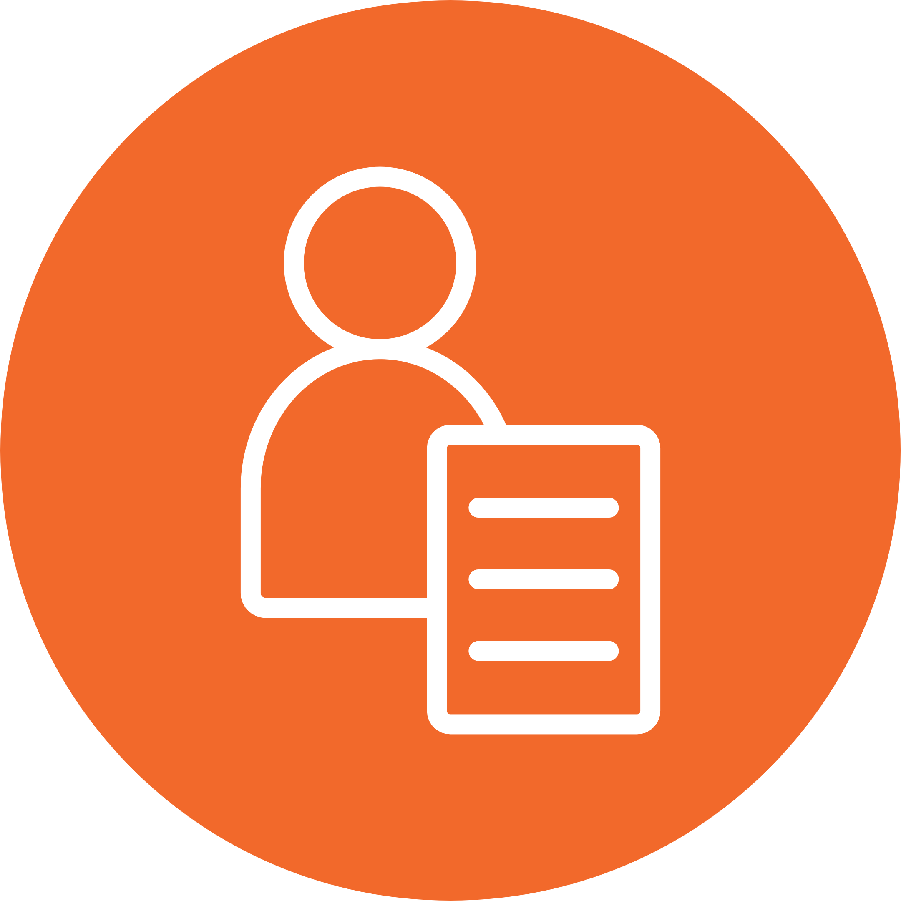

What is a budget?
A participant’s budget is the funding available in their NDIS plan to spend on the NDIS supports they need. Under new framework planning, a participant's reasonable and necessary budget is determined by applying information from their support needs assessment report with the NDIS budget method rules. These are rules that must be followed by NDIA staff when deciding a participant’s budget in new framework planning. The budget method rules help ensure NDIS budgets are determined in an individualised, transparent and consistent way.

When does this start?
The transition to new framework planning will start from April 2027 and roll out gradually over several years.
The NDIA will let participants know when it’s time for them to move to new framework planning. Participants will get information and support to them to help prepare.

What does the support needs assessment have to do with a participant’s budget?
The support needs assessment is the first part of the new framework planning process. You can find out more about the Support Needs Assessment in the Support needs assessment factsheet.

A trained and accredited NDIA assessor will complete a support needs assessment with a participant to understand their disability supports needs. The information collected goes into a Support Needs Assessment Report. This information is considered against the budget method rules to help work out a participant’s reasonable and necessary budget.

What is the budget method?
The budget method is a set of rules used to work out a participant’s reasonable and necessary budget. The rules apply information from the support needs assessment report in a consistent and transparent way.
The budget method describes the steps that must be followed to calculate funding for each group (or category) of NDIS supports based on the Support Needs Assessment Report.
Details from the report that are used in the budget method to include information on the type of support a person needs, how often this is needed, and the amount or intensity of the support needed.
- The budget method rules will outline the steps needed to work out the funding for each group of supports.
- The funding amount for each stated support will be provided in the stated supports budget.
- The funding amount for each group of flexible supports is then added together to produce a total funding amount for a flexible budget that can be used as needed on flexible supports by the participant.
- The total plan budget will be made up of flexible and stated supports budgets combined.
There will also be some adjustments to funding for example, if a participant lives in a rural or remote location, there will be an adjustment to make sure they have the right amount of funding for their situation.
Why is there a new budget method?
The budget method designed for new framework planning makes sure that:
- Every participant has their budget worked out in the same way based on their individual support needs
- Budgets are worked out using similar sources of information based on the Support Needs Assessment report for that person.
- There is greater transparency about how budgets are determined and participants with similar support needs should receive similar planning outcomes.
What are the categories of supports used in the budget method?
Similar support items are grouped together in categories of NDIS supports for new framework planning.
Each category of NDIS supports has its own set of steps to work out funding in the budget method. The steps are different because the considerations are different for each category.
For example, funding calculations for assistive technology may refer to a quote from an allied health report, while funding calculations for support co-ordination will refer to the NDIS Pricing Schedule.
The detail about the budget method rules are currently being developed and tested. There are broadly 5 ways in which funding will be determined:
Mechanism* | How funding amount is determined | Example of categories of supports using this mechanism
1. A direct estimate of the hours of support the participant needs | Volume of support (number of effective hours) can be directly determined from assessed needs, multiplied by cost per hour applied to determine total funding | In-home supports  Disability Related Health Supports (DRHS)
2. A relative estimate of the support the participant needs | Assessment outcomes will develop relative needs levels which are mapped to final budgets | Community Supports  Employment Supports*  Support Coordination  Therapy*  Interpreting and translating
3. Quote / benchmark | Funding amount is based on an approved quote or benchmark pricing | Assistance Animals  Assistive Technology (AT) - Assets  Home Modifications  DRHS Consumables
4. Policy decision | Funding amounts are determined by policy decisions and reflected in the NDIS Pricing schedule | Behavioural Supports  AT other  Private Vehicle Transport  Short Term Accommodation*  Specialised Disability Accommodation*
5. Single level | Eligibility for these categories of supports has a single funding amount | Medium Term Accommodation  Plan Management  Specialised Driver Training
*These support categories have been classified according to the dominant funding determination mechanism. Some categories have multiple mechanisms and have been listed based on the main mechanism used to determine funding for the category of supports.
The categories also separate supports in the flexible budget from supports that are in the stated supports budget.
- The flexible budget can be spent on items across the flexible supports categories and may have some restrictions and requirements applied to the spending. The flexible budget includes these categories:
In-home and community supports; Nursing; Therapy; Consumables for disability-related health supports; Assistive technology – other; Interpreting and translating; Employment supports; Specialised driver training.
- Funding for stated supports must be used only for those specific supports.
- The stated supports budget includes these categories:
Assistive technology assets; Assistance animals; Support co-ordination; Short term respite; Behaviour supports; Specialist disability accommodation; Home modifications; Medium term accommodation; Private vehicle transport and Plan Management.
For more information on Building a Plan and how flexible and stated supports work, please see: New Framework Planning Rules - Building a plan and New Framework Planning Spending Rules - Explanatory Document.

How will a participant know what is in their plan budget?
A participant’s budget is included in their NDIS plan so they can clearly see how much funding they have available to spend on NDIS supports. Participants will receive information about:
- their support needs assessment
- their budget
- how to use their plan.
Participants can also have a plan implementation discussion to help them understand and use their plan.

