New framework planning rules:

Step 1. Preparing for a support needs assessment
January 2026
We are making changes to the NDIS to improve the experience for participants. This will also make sure the NDIS is fairer, more transparent, sustainable and person-centred.

To put these changes into action, some existing rules will be updated, and new NDIS rules will be made. NDIS rules set out how the NDIS Act works in practice.

We are working with the National Disability Insurance Agency (NDIA), state and territory governments, and the disability community to develop rules to enable a new approach to planning. The new approach is called new framework planning. The new framework planning process will likely include four steps. This fact sheet is about step one.

About Step 1. Preparing for a support needs assessment

This process replaces the current planning process. A person must be a participant in the NDIS before they start a new framework plan.

A participant is contacted by the NDIA to tell them they are moving to a new framework plan. The NDIA will explain the support needs assessment process including a Notice of Impairments and Notice to have a new framework plan. Further details on these notices can be found below. Participants will continue using their current NDIS plan until they receive a new plan.

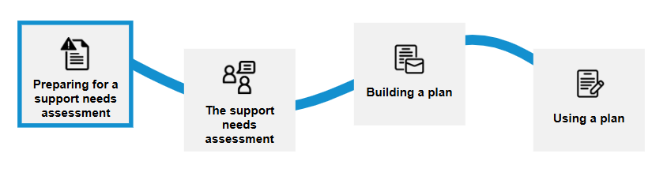

Related rules

Notice of Impairments

A Notice of Impairments is a written document provided to NDIS participants by the NDIA to inform them about the category or categories of impairments for which they meet access to the Scheme.

Notice of Impairments have been provided to participants who have met access to the Scheme from 1 January 2025.

A new rule will allow the NDIA to provide a Notice of Impairments to participants who met access to the Scheme before 1 January 2025. The rule will help participants know when the NDIA can make changes to their Notice of Impairments and tell participants when they can request a variation to their Notice of Impairments.

A participant will generally receive a Notice of Impairments as part of the transition to new framework planning.

To see further details on the notice of impairments rules, please visit: Explanatory document – Notice of impairments (PDF)

Notice to have a new framework plan
This rule will help participants know when they will receive a new framework plan.
All NDIS participants must have a new framework plan within a five-year transition period as referenced in section 32C of the NDIS Act.
The new planning approach will start mid-2026 for some participants over the age of 16. Participants who will be part of the change will know well before it happens and have support from the NDIA. More details will be provided by the NDIA in the coming months.
To see further details on the transition to new framework plans rules, please visit: Explanatory document – Transition to new framework plan (PDF)
Current  (old framework plans) | How it may work in the future  (new framework plans)
Existing participants have old framework plans. | The NDIA will contact a participant to prepare for the support needs assessment.  The NDIA will:  - explain the support needs assessment process including Notice of Impairments and Notice to have a new framework plan  Participants will continue using their current NDIS plan until they receive a new plan.

To learn more visit New framework planning | Australian Government Department of Health, Disability and Ageing.

