New framework planning rules:

Step 2. The support needs assessment
January 2026
We are making changes to the NDIS to improve the experience for participants. This will also make sure the NDIS is fairer, more transparent, sustainable and person-centred.

To put these changes into action, some existing rules will be updated, and new NDIS rules will be made. NDIS rules set out how the NDIS Act works in practice.

We are working with the National Disability Insurance Agency (NDIA), state and territory governments, and the disability community to develop rules to enable a new approach to planning. The new approach is called new framework planning. The new framework planning process will likely include four steps. This fact sheet is about step two.

About Step 2. The support needs assessment
An NDIA Assessor will meet with a participant to understand their daily life, disability support needs and preferences. Participants will have the option for their nominee, family member or advocate (if required) to attend when they complete a support needs assessment.

The NDIA Assessor will check the information with the participant, and their nominee, family member or advocate if in attendance, to make sure it is correct. The outcomes of the assessment will be documented in a support needs assessment report. This report will be sent to the NDIA delegate to make sure it is complete. The participant will get a copy of their support needs assessment report. This can be shared with a nominee, family member or advocate if needed. If a participant has any concerns about the assessment report, the NDIA delegate will work with the participant to decide whether a replacement assessment is needed.

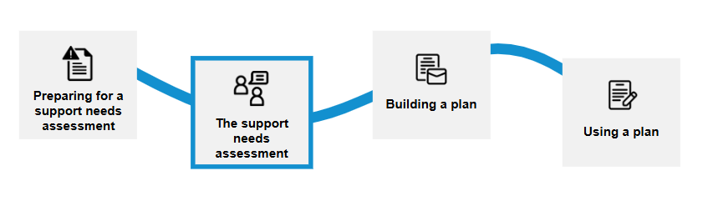

Related rules

Support needs assessments
The NDIS Review recommended a new support needs assessment process that is consistent, holistic and person-centred.
This process will be a new way to gather information about a participant’s disability support needs. This is called the support needs assessment process. New support needs assessment rules will include:
- Support needs assessment process and relevant assessment tools (s32L(2)
- Support needs assessment report, including content and structure (s32L(6))
- Replacement needs assessment (s32L(7A))
Section 32L of the NDIS Act can be found here.
The support needs assessment will consist of:
- the core needs assessment tool
- a personal and environmental circumstances questionnaire
- the targeted assessment processes (for example, assessments from an allied health professional for assistive technology, home and vehicle modifications and disability-related health supports).
The NDIA Assessor will use the support needs assessment tool to identify the participant’s disability support needs. The questionnaire will help the NDIA Assessor understand the participant’s circumstances and preferences.
The targeted assessment process will use information a participant may already have from their treating health professional. Where additional information may be required, funding may be provided in a participant’s plan to cover any out-of-pocket costs.
There will be different assessment tools for children and adults.
Current  (old framework plans) | How it may work in the future  (new framework plans)
- There is no support needs assessment.  - There is a series of questions a NDIS delegate asks a participant at their planning meeting.  - Participants need to bring information and reports about their disability support needs. | - All participants will complete a needs assessment with a NDIA assessor to better understand their daily life, disability support needs and preferences.

Support needs assessment report
This rule says what information must be in a support needs assessment report. For example, it will include:
- information about a participant’s disability related support needs
- other important information gathered during the assessment.
The NDIA Assessor must prepare a support needs assessment report and give it to the NDIA delegate as soon as possible after the assessment is finished. This report will be used to inform the budget in a participant’s new NDIS plan using the method that will be set out in the NDIS Rules. The NDIA delegate will provide the participant with a copy of the report.
The NDIA is currently working with participants and the disability community to develop a draft report through a series of workshops, forums and design testing. This approach ensures lived experience is central to the design of the report.
Further consultations will be undertaken by the NDIA to ensure the report meets participant’s needs, including consultation with the Participant Reference Group (PRG), Disability Representative and Carers Organisations (DRCO), the Independent Advisory Council (IAC) and other advisory groups.
Current  (old framework plans) | How it may work in the future  (new framework plans)
- There is no formal report outlining the information used to develop a participant’s budget. | - A support needs assessment report will outline the supports the NDIS can provide funding for and other information gathered during the assessment.

Replacement needs assessment
This rule will be about what the NDIA delegate must or must not consider when deciding if a replacement needs assessment should be completed.
Current  (old framework plans) | How it may work in the future  (new framework plans)
- There is no needs assessment or structured reassessment process.  - When an approved NDIS plan is received a participant can ask for an internal review of decision/s made in the plan. | - A replacement assessment can only be requested before a plan is approved.  - NDIA delegates will make the decision on whether to undertake a replacement assessment or not.  - Rules will be clear on what the NDIA delegate must consider when deciding if a replacement needs assessment should be completed.
To learn more visit New framework planning | Australian Government Department of Health, Disability and Ageing.

