New framework planning rules:

Step 3. Building a plan
January 2026
We are making changes to the NDIS to improve the experience for participants. This will also make sure the NDIS is fairer, more transparent, sustainable and person-centred.

To put these changes into action, some existing rules will be updated, and new NDIS rules will be made. NDIS rules set out how the NDIS Act works in practice.

We are working with the National Disability Insurance Agency (NDIA), state and territory governments, and the disability community to develop rules to enable a new approach to planning. The new approach is called new framework planning. The new framework planning process will likely include four steps. This fact sheet is about step three.

About Step 3. Building a plan
A participant’s reasonable and necessary budget will be determined by using information in the support needs assessment report using a method set out in the new budget method rules.

A participant’s budget will have 2 parts:
- Flexible funding – money that can be used for different supports
- Stated supports funding – money for specific supports that must be used as planned.

The majority of participant supports will be flexible.

The NDIA delegate uses the information and preferences from the support needs assessment to consider:
- how long the plan will last
- how the plan will be managed
- requirements for how funding can be used to buy or get supports
- any limits on how flexible funding can be spent.

The NDIA delegate then checks the plan, including the budget, and approves it.
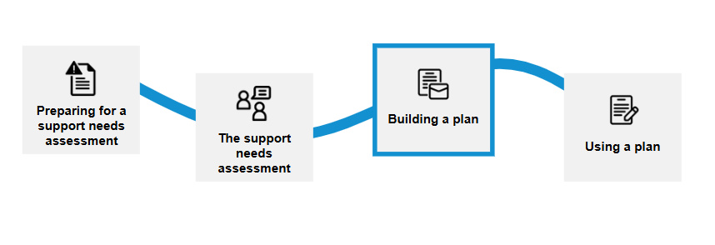

Related rules

Method for calculating total funding amount for flexible funding and stated supports
To work out how much funding a person needs, the NDIA will use the information gathered during the support needs assessment and a set of calculations outlined in the budget method rules.
The budget method rules will be technical as they will cover:
- the steps the NDIA will apply when working out total funding amounts for flexible and stated supports funding including how informal supports available to a participant are reflected, and
- a set of calculations to determine total funding amounts and any adjustments required. Examples of adjustments include remoteness loadings or compensation payments.
The NDIA delegate will review the budget as part of approving a participant’s plan.
The budget method rules will clearly outline how the NDIA works out a participant’s funding.
More information on the budget method steps will be published to support this consultation process.
Examples of types of flexible budget | Examples of types of stated supports budget
Assistive technology – general | Assistance animals
Consumable products | Assistive technology assets
Disability-related nursing supports | Behaviour support
Employment supports | Home modifications
General allied health supports | In-kind supports
In-home and community supports | Medium term accommodation
Interpreting and translation supports | Periodic private vehicle transfer
Physical and allied health related supports | Plan Management
Social allied health supports | Residential Aged Care
Specialist driver training | Short term respite
 | Specialist disability accommodation
 | Support Coordination
Some of these supports may also need external quotes before the funding is released for purchase.
Example
Jin uses short-term respite twice a year. This gives her parents a break from their usual caring responsibilities and helps them continue to support Jin in the long term.
Short-term respite is listed as a stated support, which means it can only be used to purchase respite services and no other supports. If the funds are not used in this way, Jin’s support needs may not be met, and it could compromise Jin’s parents’ ability to continue to support her in the longer term. Having it as a stated support ensures funding is available to meet the respite needs of Jin and her family.
To see further details on stated supports rules, please visit: Explanatory document – Stated supports (PDF)

Restrictions on flexible funding
Funding is designed to be flexible so participants can use it for a wide range of NDIS supports. However, there are some exceptions.
Restrictions may be used to ensure funds are available for important supports throughout the duration of the plan. Restrictions may be used if:
- the participant could experience physical, mental or financial harm without the restriction
- the participant cannot manage their funding set out in their plan, such as situations where the participant is at risk of financial exploitation or fraud.
For example, a restriction may be placed on a portion of flexible funding to be used for therapy supports to obtain an assessment for an assistive technology item the participant has been assessed as needing. Participants can also request their funding be restricted, so they set aside a flexible support to be available later in the plan.
Example
Tina experienced fraudulent behaviour from a provider in a previous plan which resulted in her running out of funds early and not having enough support for the duration of her plan.
Tina does not have other safeguards in place, such as informal supports, and she is worried she will be at risk of further fraud or financial exploitation. Tina asks the NDIA to restrict a portion of her flexible funding for therapy supports to ensure she can access the physiotherapy supports she needs and not run out of funds early.
The NDIA restricts a part of Tina’s flexible funding and if Tina’s situation changes and she needs more therapy support; she can use her flexible funding to purchase more.
Current  (old framework plans) | How it may work in the future  (new framework plans)
- There is flexibility within core and capacity building budgets.  - There is no specific flexible funding budget. | - Flexibility will be the standard approach subject to stated supports.  - Restrictions on an individual case-by-case basis.  - A portion of the participant’s flexible funding may be set aside for a specific support.  - Participants can request restrictions on their flexible funding.

Requirements for receiving a service or buying supports
In some cases, the NDIA will set conditions for funding. This means a participant must meet certain requirements to access funds.
For example, conditions may apply when:
- a quote is required before the service or support can start
- support must be provided by an appropriately qualified provider/professional (of a participant’s choosing) for example, when home modifications or specialist mobility equipment is required
- a specified process has to be followed.
Example
Reza needs a new wheelchair with several specialist modifications so he can access his home and community independently. His NDIS plan lists the wheelchair as an assistive technology item in his stated supports budget. A requirement is noted in his plan to make sure an allied health professional conducts an assessment and prescribes the right modifications for Reza’s safety.
The plan will include funding in Reza’s flexible budget which is restricted for an occupational therapist to assess and prescribe the wheelchair. The therapist will provide the NDIA with a recommendation report and a quote for review and approval. Once the NDIA approves the request, the funding will be added to his plan and Reza can purchase his new wheelchair.
Current  (old framework plans) | How it may work in the future  (new framework plans)
- The NDIA currently use different processes similar to a requirement, e.g. direct commissioning and quote processes. | For stated and flexible funding, requirements may be used in the following situations: ​  - use of qualified and registered professionals​  - following NDIA quote processes​  - direct commissioning in thin markets ​  - provider panel arrangements ​  - assistive technology and home modifications.

Funding periods
Funding periods are applied to the flexible and stated budgets for new framework plans like they are currently. Some NDIS supports will not have funding periods. For example, one-off purchases.
To see further details on new framework plan spending rules, please visit: Explanatory document – New framework plan spending rules (PDF)
Current  (old framework plans) | How it may work in the future  (new framework plans)
- Funding periods can be set at 1, 3, or 6 months (no longer than 12 months). ​. | - More flexible approach to funding. ​  - Funding periods can be set at 1, 3, or 6 months (no longer than 12 months). ​

To learn more visit New framework planning | Australian Government Department of Health, Disability and Ageing.

