New framework planning rules:

Step 4. Using a plan
January 2026
We are making changes to the NDIS to improve the experience for participants. This will also make sure the NDIS is fairer, more transparent, sustainable and person-centred.

To put these changes into action, some existing rules will be updated, and new NDIS rules will be made. NDIS rules set out how the NDIS Act works in practice.

We are working with the National Disability Insurance Agency (NDIA), state and territory governments, and the disability community to develop rules to enable a new approach to planning. The new approach is called new framework planning. The new framework planning process will likely include four steps. This fact sheet is about step four.

About Step 4. Using a plan
Participants can have an implementation meeting with an NDIA delegate to:
- understand their new budget and requirements
- connect with providers.

Regular check-ins can also be made to support a participant move to their new plan.

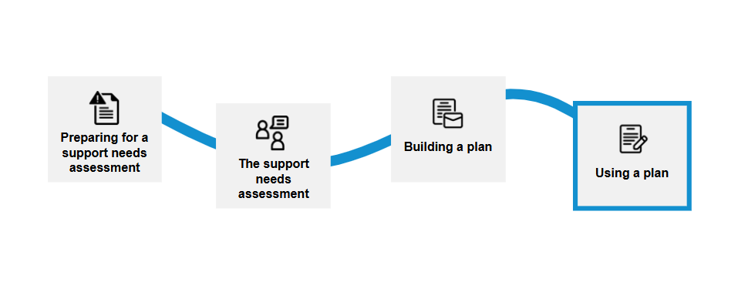

Related rules

Plan variations
The rules help participants know when the NDIA can vary a participant’s plan without needing to complete a new needs assessment. The rule will set out circumstances when this can occur, for example:
- providing emergency or crisis funding due to significant change in support needs for a short period of time.
- adding funding for repairs, replacement or maintenance of Assistive Technology
- changes to a participant’s employment supports due to minor changes to participant work hours
- changes in aged care needs for younger people in residential aged care.
NDIS supports

The NDIS supports rules makes it clear what types of supports and services NDIS funding can be used for. The NDIS supports rule was created to be clearer about what supports participants can spend their NDIS funds on.

A list of the current NDIS supports list is available on the NDIS website: Our Guidelines | NDIS.

To learn more visit New framework planning | Australian Government Department of Health, Disability and Ageing.

