Electronic Health Records

An Electronic Health Record (EHR) is an electronic version of a patients medical history, that is maintained by the provider over time, and may include all of the key administrative clinical data relevant to that persons care under a particular provider, including demographics, progress notes, problems, medications, vital signs, past medical history, immunizations, laboratory data and radiology reports

App Idea

Another important benefit of EHR is that they allow further processing of digital information, for example, for scientific research or statistics purposes. This process takes place with patients’ consent, and data is depersonalized and analyzed in bulk.

widespread type of software used in hospitals around the world

The main advantage of digital health records is the reduced paperwork and easy transfer of data across different medical institutions.

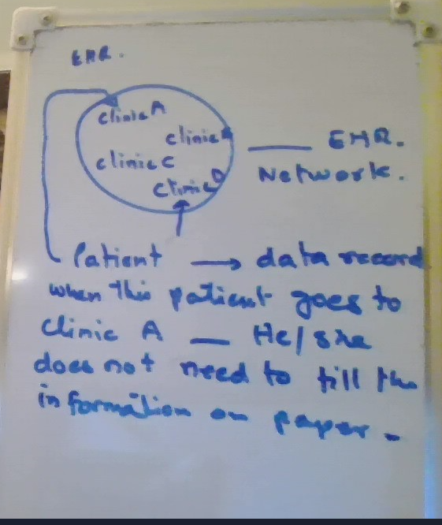

 Patients do not have to fill in the same information in a paper form whenever they come to a new clinic that belongs to the same healthcare provider network

Electronic health records are also potentially more secure in terms of protecting confidential data, especially in comparison with hand-written paper charts. This is ensured by government-enforced regulations, such as HIPAA compliance, as well as advanced digital security technologies.

EHR is helpful in the case of an emergency when a patient is unresponsive and doctors cannot obtain information directly from them. In such situations, medical staff can use accessible information on a patient’s ID to try and retrieve their health records, including medical history, known allergies, and so on.

This type of medical software prevents data tampering and allows using encryption and backup means for additional protection of confidential information.

Primary Functions:

**Comprehensive Patient Data Management:**

* EHR systems store detailed patient health records, including medical history, medications, diagnoses, allergies, immunization dates, lab results, and more. They serve as a central repository for all patient-related information.

**Care Coordination:**

* EHRs facilitate coordination among healthcare providers by enabling the sharing of patient data across various departments, specialists, and healthcare facilities. This ensures continuity of care.

**Clinical Decision Support (CDS):**

* EHRs provide healthcare providers with tools to support decision-making, such as alerts for drug interactions, reminders for preventive care, and recommendations based on clinical guidelines.

**Electronic Prescribing (e-Prescribing):**

* EHR systems often integrate with e-prescription software, allowing providers to electronically prescribe medications directly to pharmacies. This minimizes errors associated with manual prescriptions.

**Patient Engagement:**

* Many EHR systems include patient portals that allow patients to access their health records, schedule appointments, request medication refills, and communicate with their healthcare providers.

**Regulatory Compliance and Reporting:**

* EHRs help healthcare organizations meet regulatory requirements, such as HIPAA (Health Insurance Portability and Accountability Act) in the U.S. They also assist with reporting to public health agencies and participating in value-based care programs.

**Billing and Coding Support:**

* EHRs often include features to automate medical coding, billing, and claims submission processes, ensuring accurate reimbursement and reducing administrative burdens.

Key Features:

**Key Features:**

1. **Patient Records Management:**
   * Stores and organizes all patient data, including demographics, medical history, treatment plans, and progress notes.
   * Provides easy access to longitudinal records, enabling a holistic view of patient care over time.
2. **Interoperability:**
   * EHRs are designed to exchange data with other healthcare systems, such as lab systems, imaging centers, pharmacies, and insurance companies, promoting seamless communication across platforms.
   * Supports health information exchange (HIE) and integrates with external systems, like E-prescription and EHRs from other providers.
3. **Order Entry and Results Management:**
   * Provides a computerized system for entering physician orders, such as lab tests, imaging studies, and treatment plans.
   * Allows clinicians to track and review test results, reducing delays and improving decision-making.
4. **Clinical Decision Support Tools:**
   * Includes tools such as alerts for allergies, potential drug interactions, duplicate therapies, and critical lab values.
   * Offers evidence-based guidelines and clinical protocols to assist in patient care.
5. **Charting and Documentation:**
   * Provides templates for structured documentation of patient encounters, allowing physicians to quickly input notes, diagnoses, and treatment plans.
   * Supports voice recognition and handwriting input for ease of use.
6. **Security and Access Controls:**
   * EHRs include robust security features to protect sensitive health information, such as encryption, role-based access, audit logs, and user authentication.
7. **Patient Portals:**
   * Enables patients to access their medical records, view test results, schedule appointments, and communicate with their providers through a secure platform.
8. **Analytics and Reporting:**
   * EHRs offer reporting tools that allow healthcare providers to generate reports on patient outcomes, treatment effectiveness, and population health.
   * Supports quality improvement initiatives and value-based care programs by providing data-driven insights.
9. **Mobile Access:**
   * Many EHR systems offer mobile applications, enabling providers to access patient data and manage care on the go.
10. **Integrated Billing and Claims Management:**
    * Automates the process of coding, billing, and submitting insurance claims, reducing administrative workloads and errors.
    * Tracks claims status, reimbursements, and patient payments.

Additional Features:

* Telemedicine Integration: Some EHRs support virtual consultations through telemedicine platforms, linking patient records to virtual visits.
* Customizable Workflows: EHRs often provide the ability to customize workflows for different specialties or departments within a healthcare facility.
* Remote Monitoring Integration: Some EHR systems can integrate with remote patient monitoring devices to collect and store health data from wearable or home devices.

In summary, EHR systems serve as the backbone of modern healthcare data management, enabling efficient, secure, and comprehensive care delivery across healthcare settings.