Assignment No – 5

Batch: 2 Roll No:

To create a simple web service and write any distributed application to consume the web service.

//CalculatorWS.java

/*

* To change this license header, choose License Headers in Project Properties.

* To change this template file, choose Tools | Templates

* and open the template in the editor.

*/

package org.me.calculator;

import javax.jws.WebService;

import javax.jws.WebMethod;

import javax.jws.WebParam;

import javax.ejb.Stateless;

/**

*

* @author ADMIN

*/

@WebService(serviceName = "CalculatorWS")

@Stateless()

public class CalculatorWS {

/**

* Web service operation

*/

@WebMethod(operationName = "add")

public int add(@WebParam(name = "i") int i, @WebParam(name = "j") int j) {

//TODO write your implementation code here:

int k = i + j;

return k;

}

}

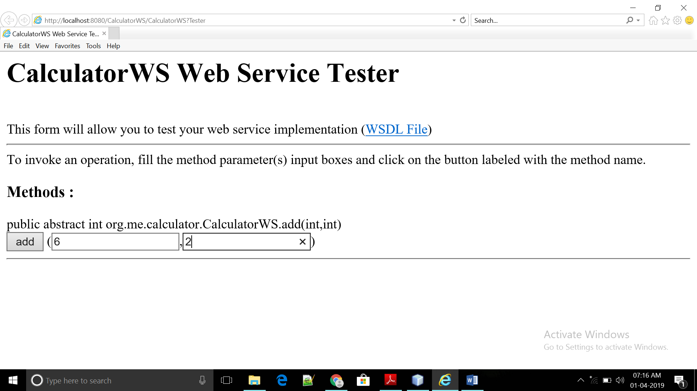

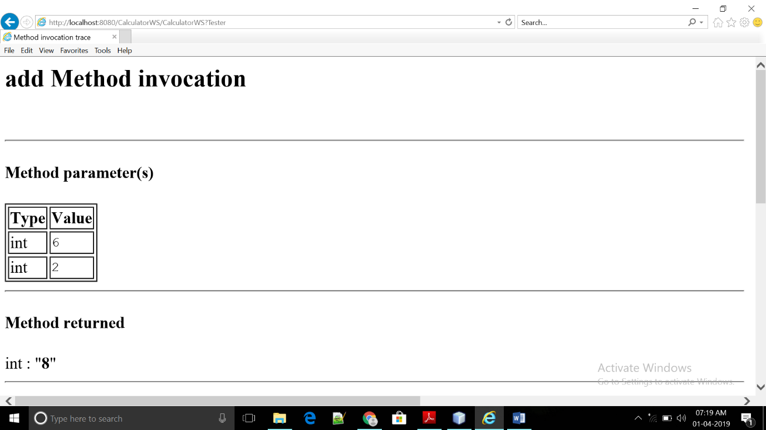

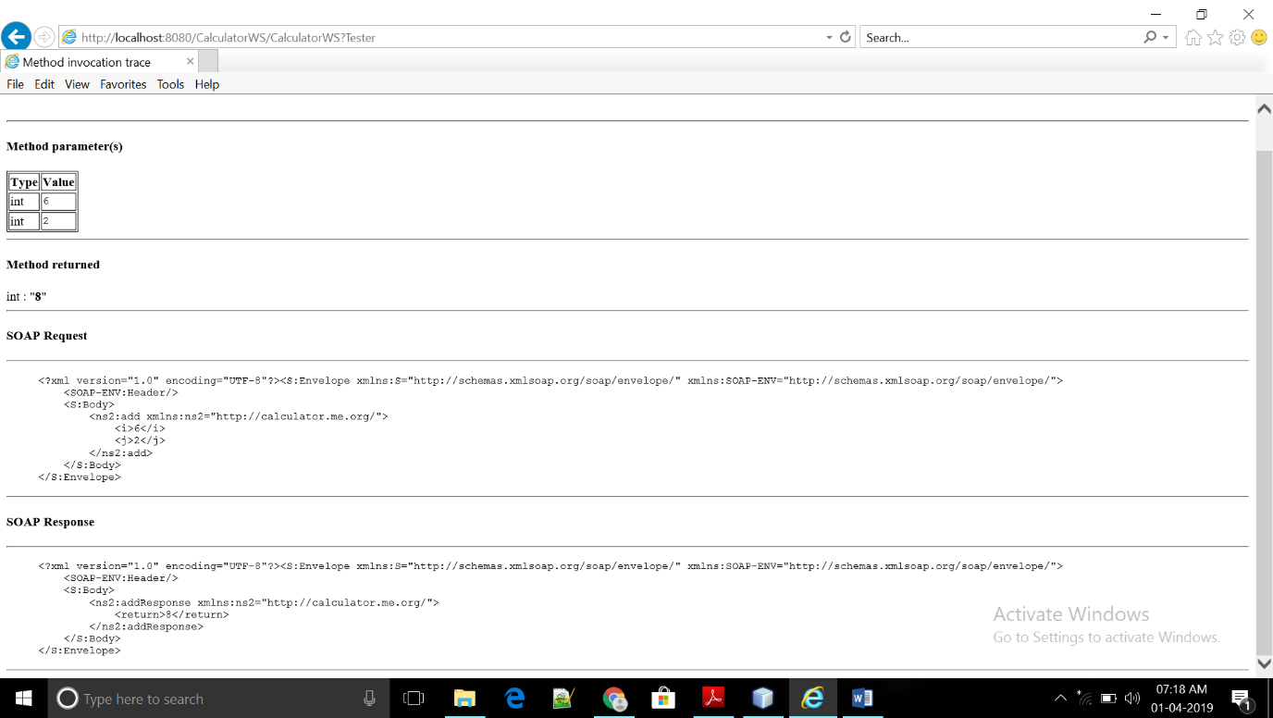

// CalculatorWS_Client_Application

/*

* To change this license header, choose License Headers in Project Properties.

* To change this template file, choose Tools | Templates

* and open the template in the editor.

*/

package calculatorws_client_application;

/**

*

* @author ADMIN

*/

public class CalculatorWS_Client_Application {

/**

* @param args the command line arguments

*/

public static void main(String[] args) {

// TODO code application logic here

try{

int i = 10;

int j = 20;

int result=add(i,j);

System.out.println("Result = "+result);

} catch (Exception ex){

System.out.println("Exception: "+ex);

}

}

private static int add(int i, int j) {

org.me.calculator.CalculatorWS_Service service = new org.me.calculator.CalculatorWS_Service();

org.me.calculator.CalculatorWS port = service.getCalculatorWSPort();

return port.add(i, j);

} }

