FCT User Guide

May 13, 2020

Version 1.00

Document Revisions

|  |  |  |  |  |  |
| --- | --- | --- | --- | --- | --- |
| Date | Version Number | Change Record | Author | Review | Approval |
| 05/13/2020 | 1.00 | Initial Draft | Lorence |  | N/A |
|  | 1.10 |  |  | Irene |  |
|  | 1.20 |  |  | Maurizio |  |
|  |  |  |  |  |  |
|  |  |  |  |  |  |
|  |  |  |  |  |  |
|  |  |  |  |  |  |
|  |  |  |  |  |  |
|  |  |  |  |  |  |

Table of Contents

# Introduction

# Business Workflow Overview

# Step-by-step Instructions

# Introduction

## Purpose of This Document This is a step-by-step instruction for internal testing and/or user training purpose. It’s not a user guide of commercial release.

## Project Background and Scope

## FCT integration project has been split into two phases and kicked off in September 2019 based on LDD business decision.

## Phase 1 - Basic Integration. In phase 1, we’re aiming at the most fundamental features including: - Order Creation - SSO (Single sign-on) - Order Submission - Data Return - Fee Charge (in progress)

## Phase 2 (not started yet) - Increased Integration To deal with additional questions as well as text items where required, including fields/items that are not in RWEB. Phase 2 also tries to establish a global approach of order completion that can be easily deployed for other title insurance companies in the future. Meanwhile, all integration development in RWEB should be easily migrated to LDD New Platform.

# Business Workflow Overview

## As a prerequisite,  a Purchase or Mortgage file needs to be well prepared in RWEB and make sure all mandatory fields are filled in. In RWEB file, select “First Canadia Title” (aka FCT) as the insurance provider and it will bring the user to the FCT order creation screen automatically. User need to review and complete all the missing items and submit the order in FCT screen. FCT will then generate a “FCT Reference Number” for this order if the submission is successful. Then all the required data/value will be automatically returned to RWEB file in the backend.

# Step-by-step Instructions

## Log in to RWEB https://lh4.googleusercontent.com/wgdYP-aZHEQ13L_P9OjqH839JA3nGB9ZrVSkyvH3R8-MrDVk7zJxe-XfWQlOlpiC55iNZEtK1ZmzrY53JiLvT0a3UfD6URLJ9jieliFyCGe1vNiBZcjydEuwfNEbkxEfY0-rL1lB

## Pick a Purchase or Mortgage file from the list

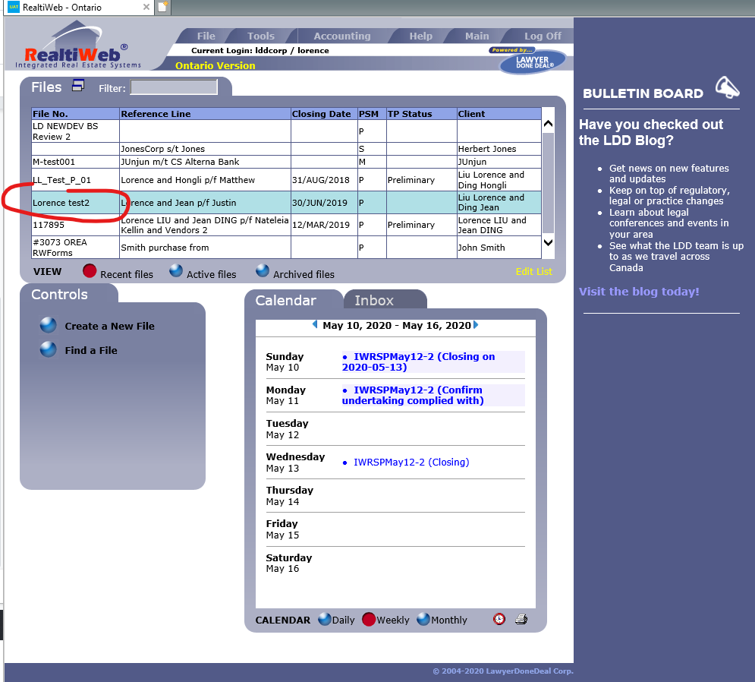

## Scroll down to the bottom of the Basic Tab screen and select FCT as the  title insurance provider, an extra button will show up automatically to allow the user to create a policy order on FCT side.

## https://lh4.googleusercontent.com/-uEIe7cads-fQQF2UbQk5E1wto9dQS2vYvl7BxpohJHkgldAEl2jTzJ9DCSjPYcW-TFZz7WCbJYbVQO0P8AR18TiZ1PrubDTlcsMA-Cvs4EX9v98sHfsP2bV3VFELx6gGdnE1RaR

## If user clicks the “submit Order” button in RWEB file, it will switch user to the FCT screen. Notice that if this is the first time user submit order from RWEB file, FCT will ack for login credentials. Make sure click “YES” to allow browser to remember the login credential so user will no longer being asked next time.

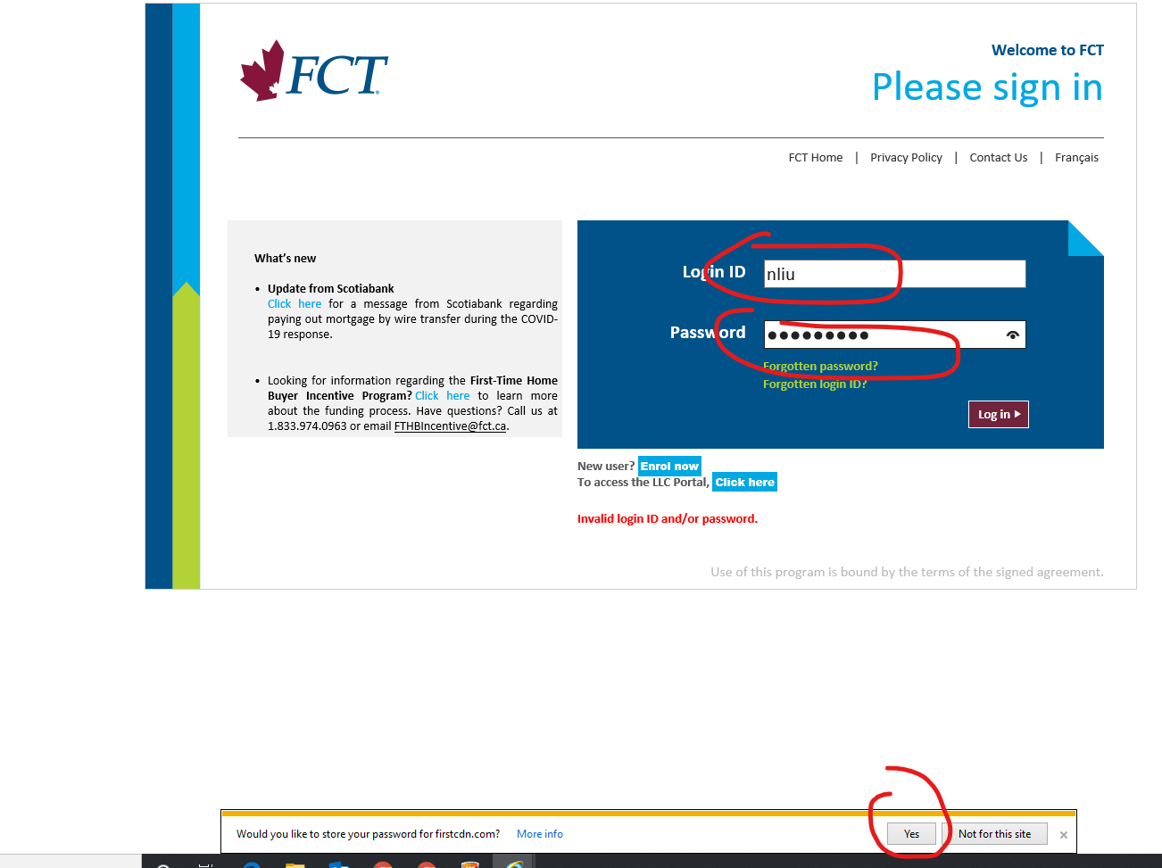

## Once logged in, FCT system will create the policy order based on the date transferred from RWEB file through API. Don’t refresh or close the screen until it’s done.

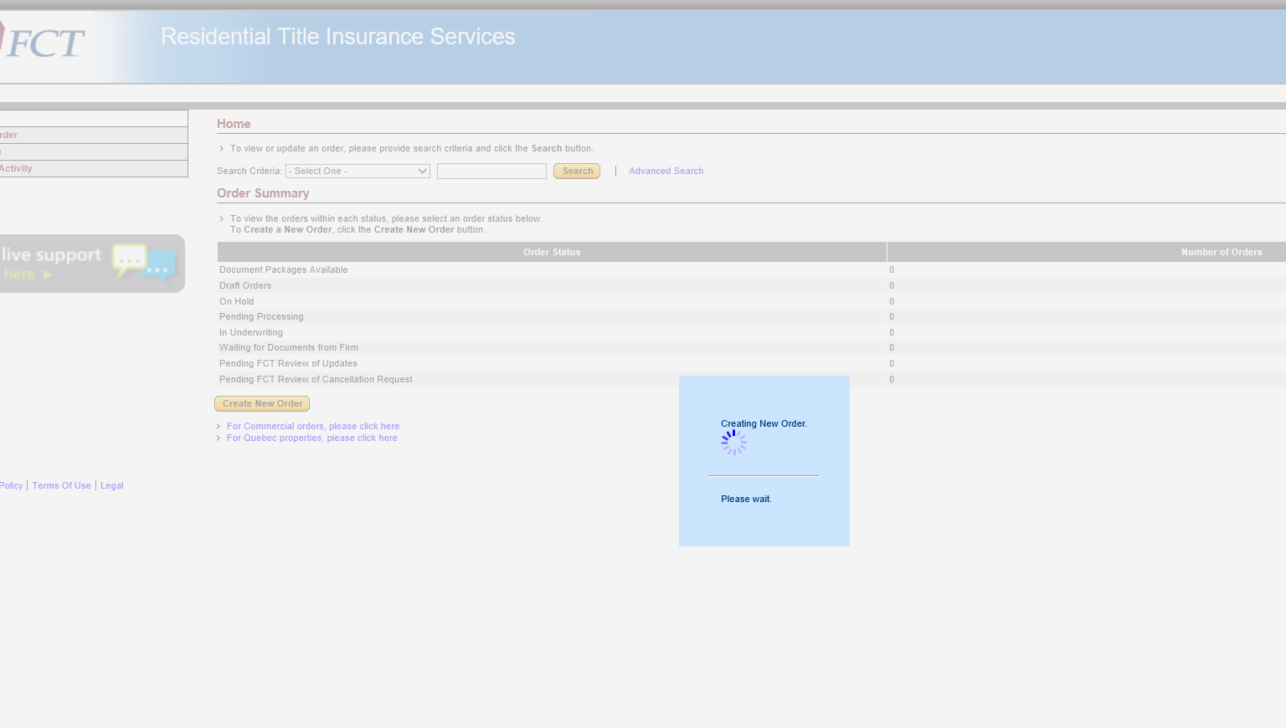

## Once the order has been created, user will be asked to verify all information. Any mandatory fields that not yet been filled will be marked as Missing in RED, user must complete all mandatory fields one by one.

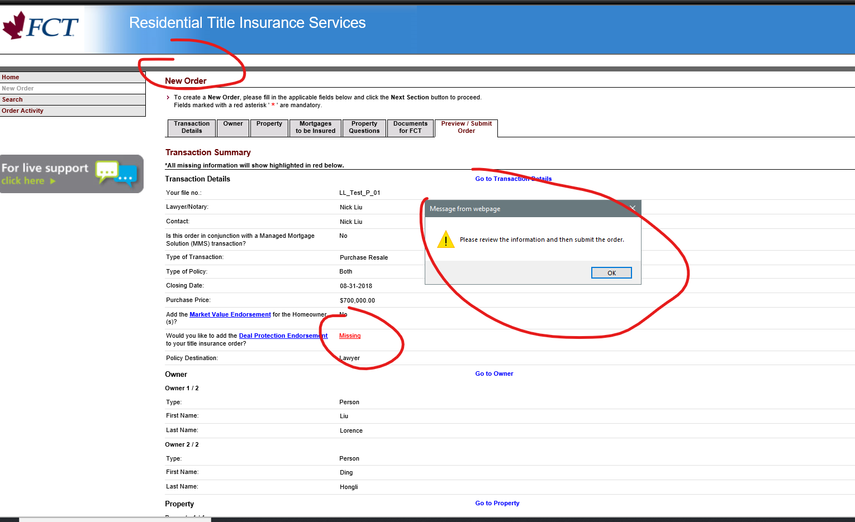

## The “Submit Order” button will be activated once validation is done, which means user now is able to submit the order. Meantime, a summary of the policy shows up on the screen as well.

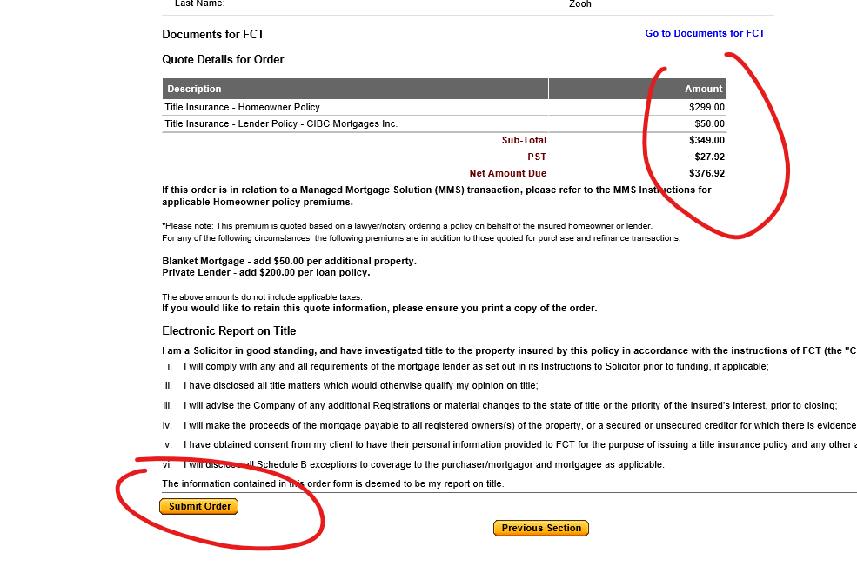

## As a final reminder, the system will double check with user if there any attachment missed before submission.

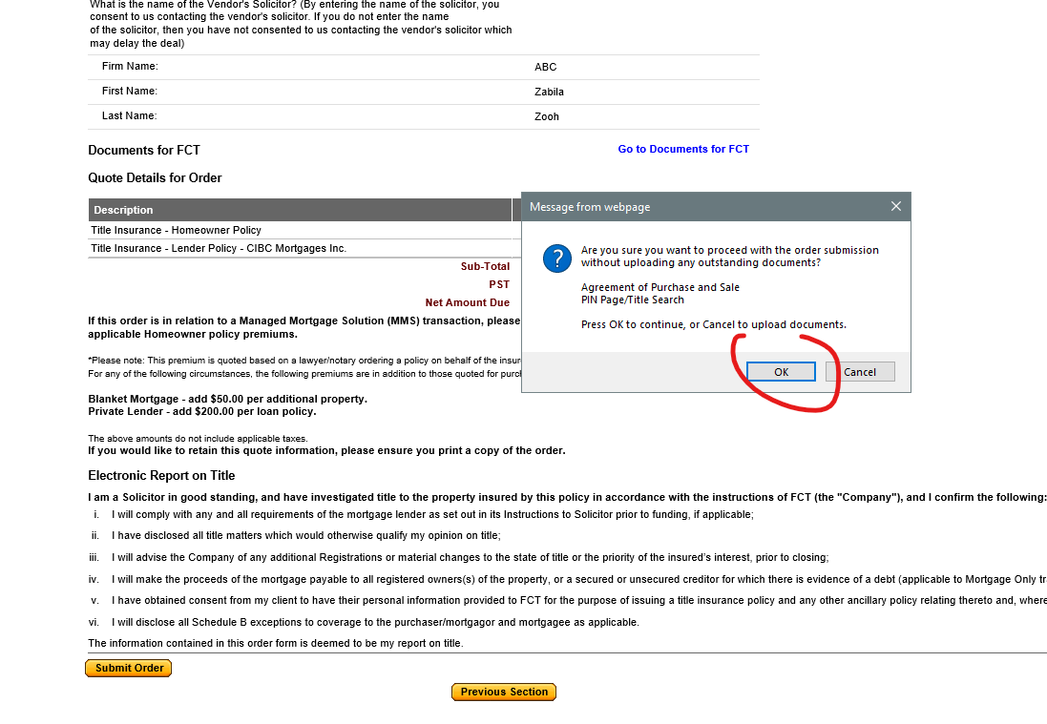

## Once submitted, a “FCT Reference No” will be generated.

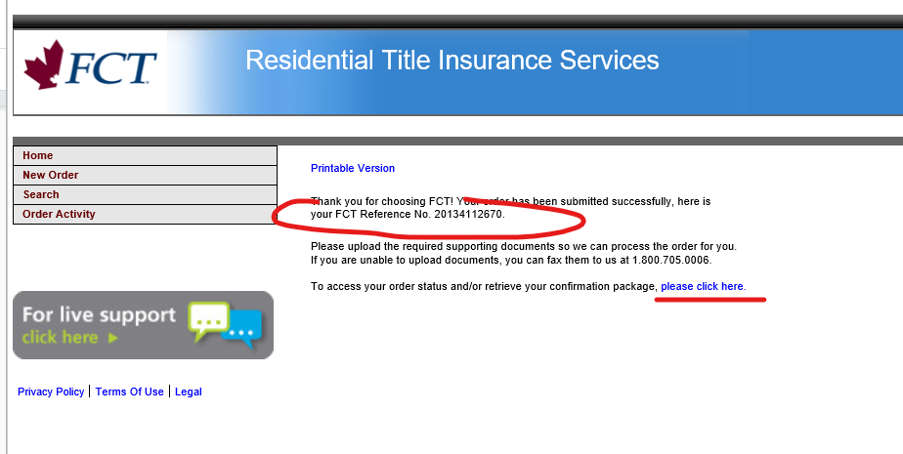

## Now, user is able to review the status of the order.

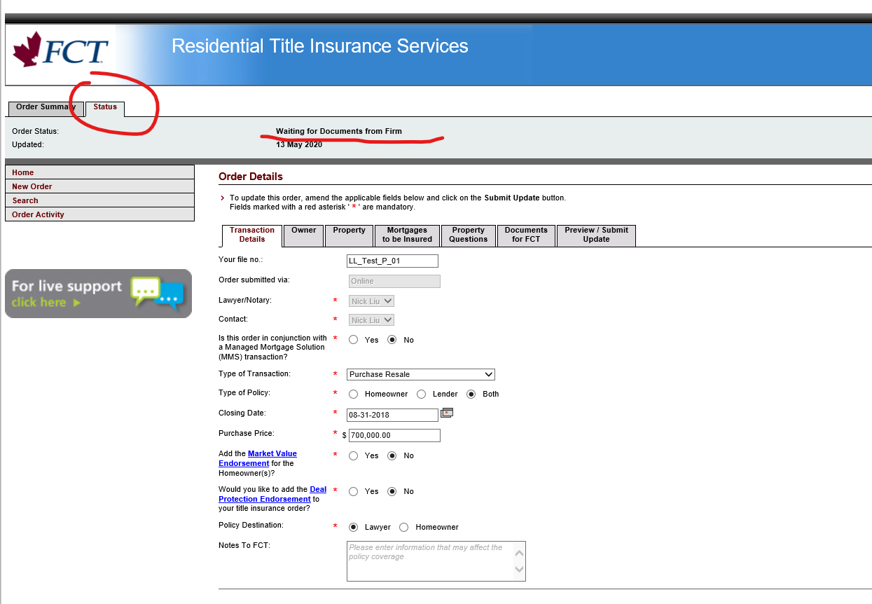

## On RWEB end, the “FCT Reference No” will be automatically  retrieved together with those data returned: - Order Status - Premium Quote - Total Premium - Title Insurance Premium - PST ON Premium Also, the “Submit Oder” button in RWEB screen turned into “Refresh Status” button

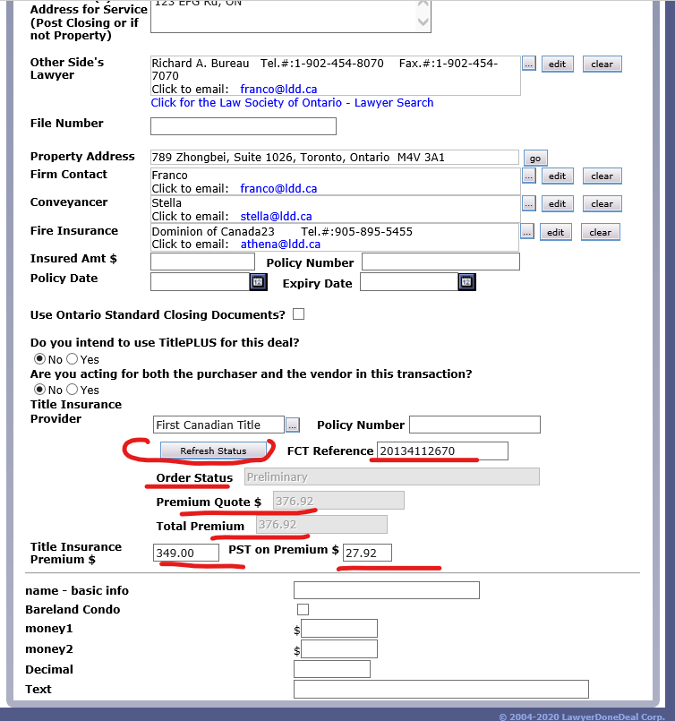

## Now user is able to click “Refresh Status” button to update order status at any time.

## https://lh6.googleusercontent.com/RGGBT1hNjMhoeXpECBF4PK1mXaxGfpuTAhcEQOEx9UHD53XFEgrtxWIEPouG-ktYMGyCFYOES6YFas-2m64C9xf3ktix5yBLWmc0nzAz1kD6RXFtJDQp-8mmsbAZnnaaeH8OosWA

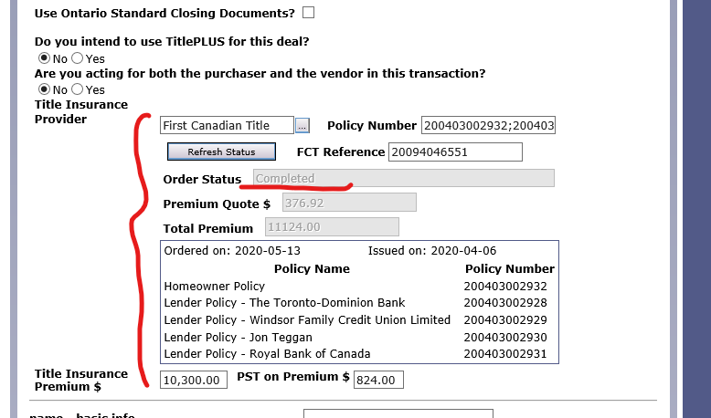

# Appendix

## [TBD]

## 

# Index

## [TBD]