**Homework 3: Test cases for HW2**

**Assignment Description:**

For this third assignment, we'll practice writing the test cases of kotlin syntax with some popular interview questions. You already converted 4 problems (1.6, 3.1, 11.5, 11.1) using kotlin syntax. Now it is time to write your own Unit test cases. All the problems are given from the book “cracking the coding interview” by Gayle Laakmann McDowell.

If you want help, please feel free to show your code to others or ask for help in our online discussion forum. If you work on your solution for a few hours and are still not done, you can turn it in, and we will award you credit. You can do it!

**In order to complete this activity, you need to take following steps:**  
1. You will need to create a project name HW3_YourName in android studio.

2. Create four classes in the folder com.example.HW3_YourName with name problem1, problem2, problem3, problem4.

3. In each class you can copy all your functions for HW2 and make member functions of problem1, problem2, problem3, problem4 classes.

4. Create four classes in the folder com.example.HW3_YourName(test) with name problem1Test, problem2Test, problem3Test, problem4Test.  
5. Write as much as possible test cases.  
**6. It is expected to write 10 or more unique cases for problem 1, 16 or more unique cases for problem 2, 10 or more unique cases for problem 3, 10 or more unique cases for problem 4. You can write test cases for input/output validation, proper variable/object creation, all the corner cases (where may fail) in your program.**

**Submission and Grading:**

This homework will be due on **April 27 11:59 pm**. The students with **DSS** will get extended time according to university policy.   
  
For uploading the project, you have to follow two steps:  
1. make src folder as zip and upload it to cougar course.   
2. Upload your full android project in this link. First make HW3_YourName as zip, then upload in the google form. You have to login to the gmail account to upload files here.   
  
Submit full code here: <https://forms.gle/z6DN5RNXjig1h5CA9>

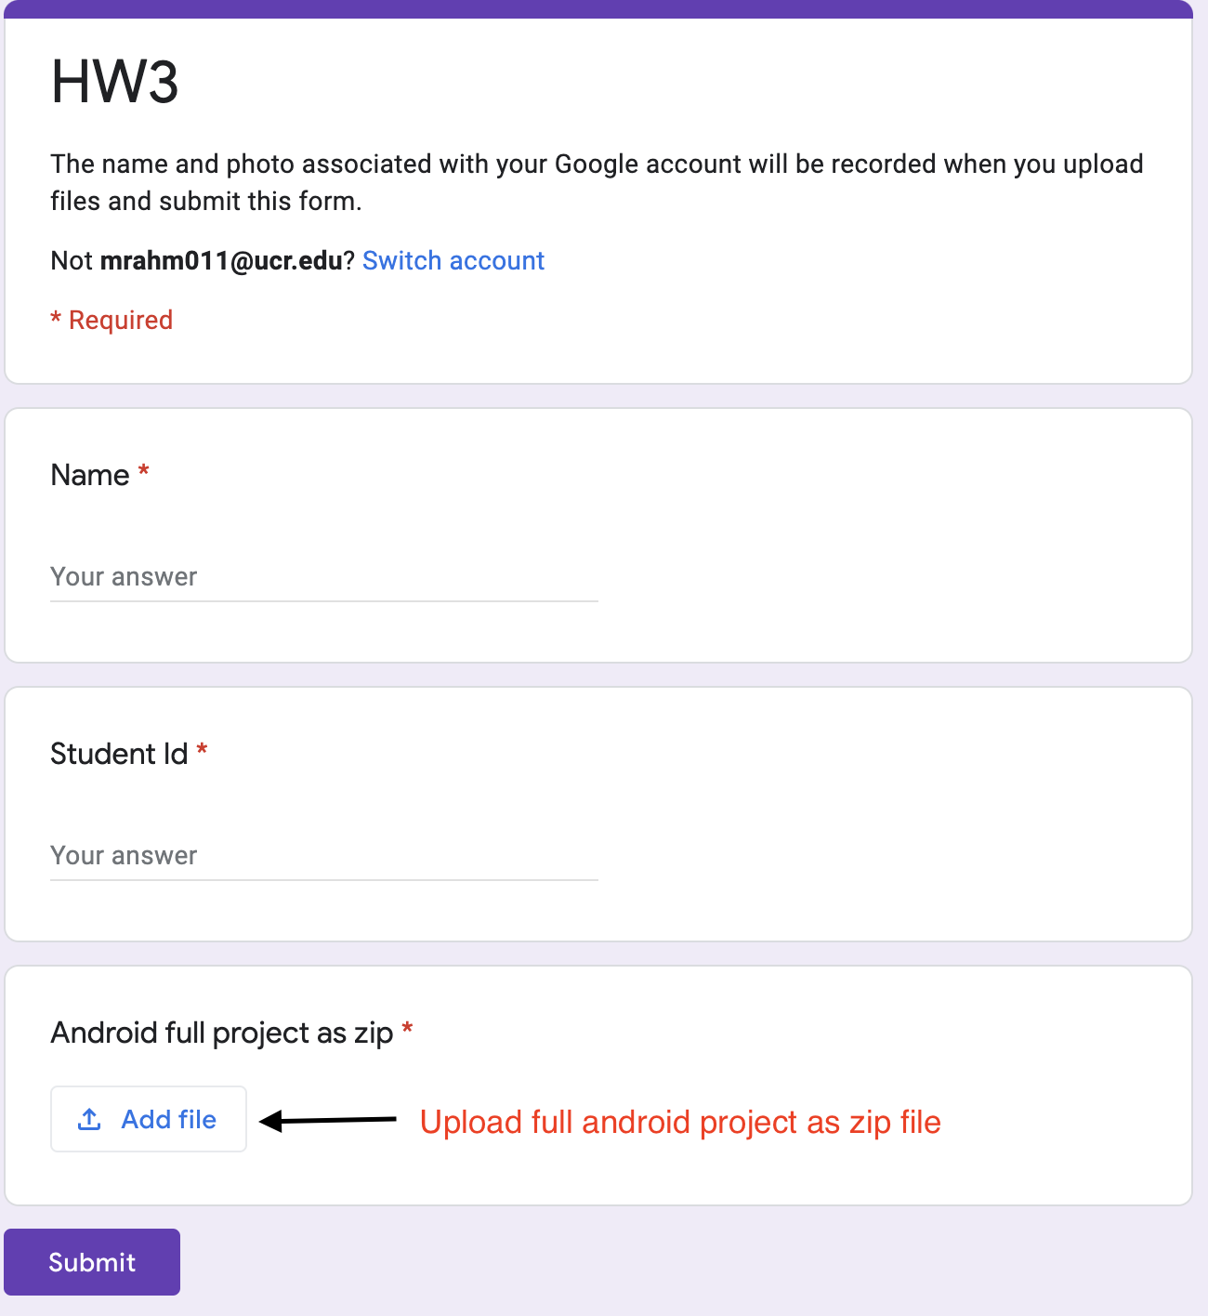

Your submission will be graded quickly by simply running it and evaluating its functionality. It does not need to be perfect or bug-free to receive credit. Your code will not be graded on style, but we still encourage you to follow good overall coding style for your own sake.   
  
**If you have any confusion, please raise this issue before the class. I will try to clarify as much as possible.**