low: 1549
high: 78093

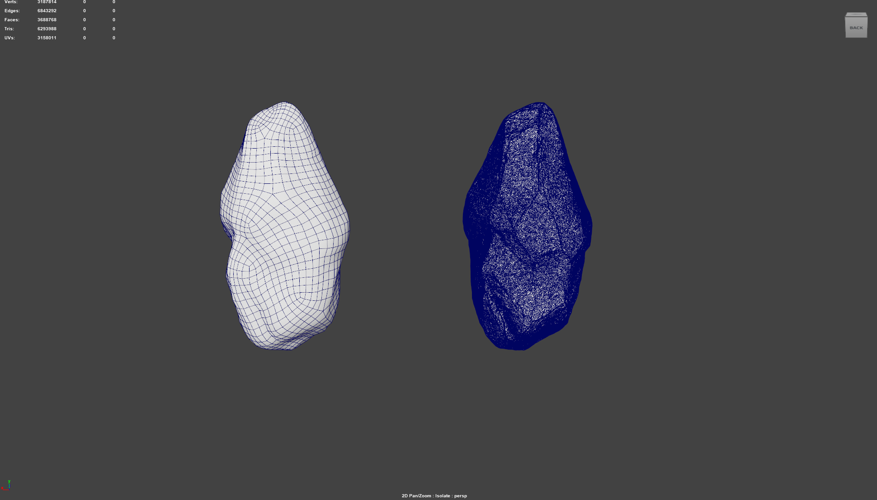
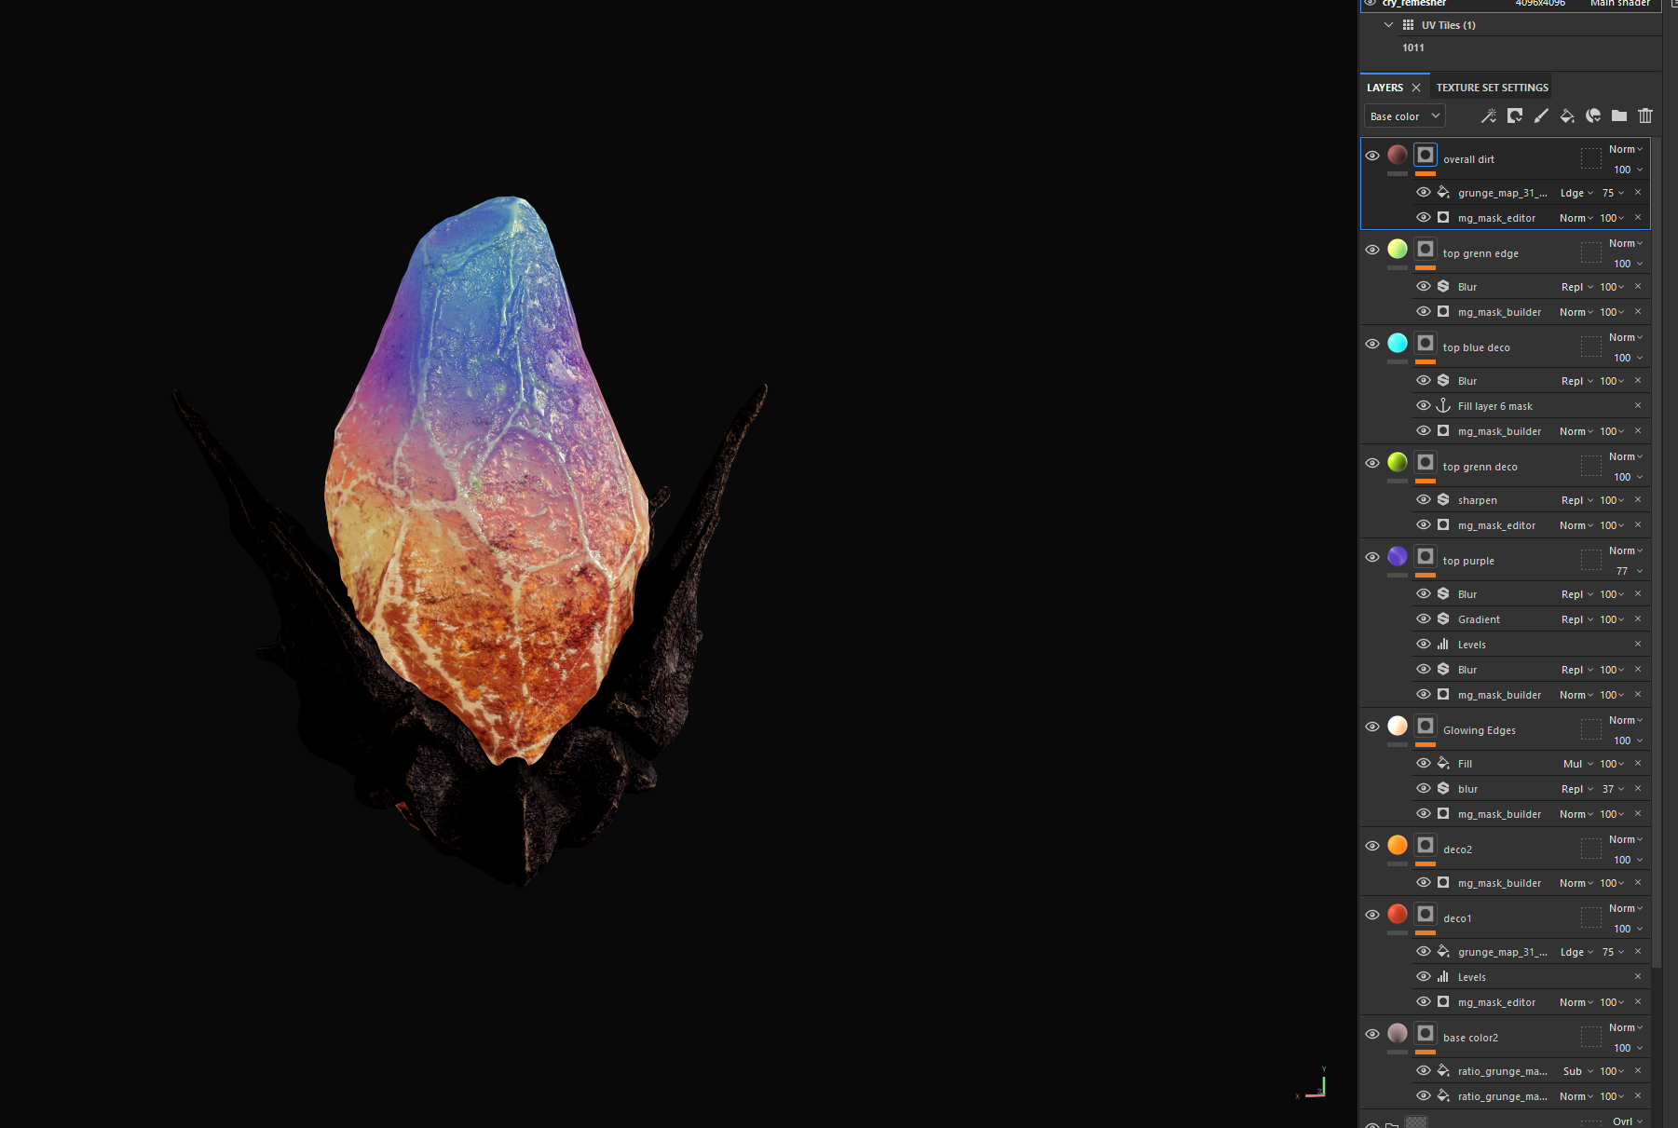
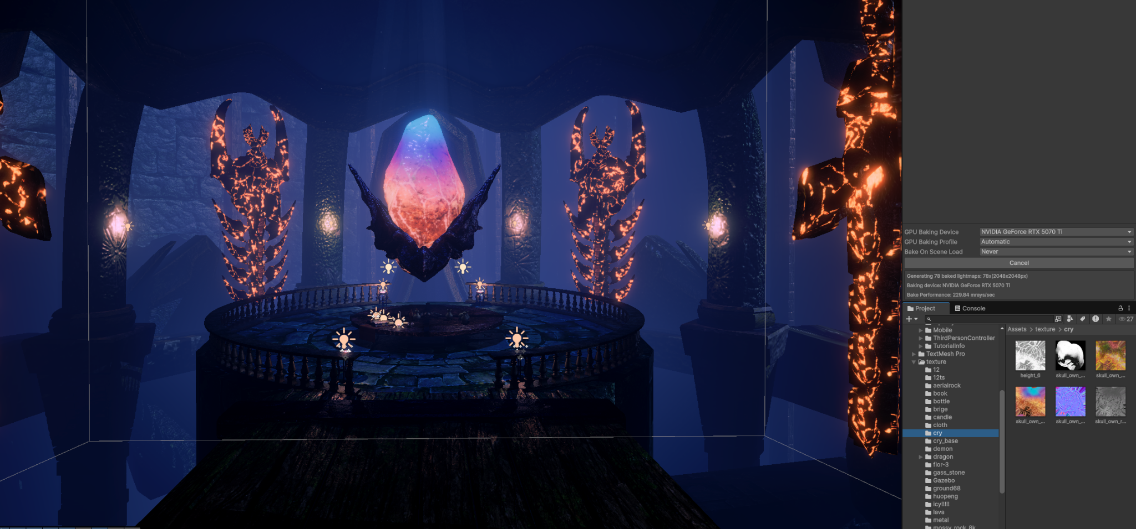

credit:
polyheaven
https://polyhaven.com/a/brown_mud_leaves_01
https://polyhaven.com/a/coast_sand_rocks_02
https://polyhaven.com/a/fabric_leather_02
https://polyhaven.com/a/concrete_block_wall
https://polyhaven.com/a/aerial_grass_rock

sp:
https://substance3d.adobe.com/community-assets/assets/c231ccc62cb241753caf7fc1aeeaacddbd3d8466
https://substance3d.adobe.com/community-assets/assets/7915a5dfb637e4d579b4b171954ee135e831a7cf
https://substance3d.adobe.com/community-assets/assets/d9e74172e5402d6b54b55e37769913da85ca04e9

