**Prerequisites tools:**

1. Docker desktop.
2. Spring Tool Suite 4
3. Postman.

**Testing steps:**

**Using terminal, start zookeeper and Kafka using**

Command : docker-compose run



Run Employee_REST application as Spring boot App

Using Postman:

1. Select Get method, and enter URL: <http://localhost:8080/Employees> to get existing employees:

With the following result JSON :

[

    {

        "name": "Amro",

        "age": 12,

        "estate": "ADDED",

        "cinfo": "Full Time"

    },

    {

        "name": "Ashraf",

        "age": 10,

        "estate": "APPROVED",

        "cinfo": "Full Time"

    },

    {

        "name": "Sherif",

        "age": 7,

        "estate": "INCHECK",

        "cinfo": "OutSource"

    },

    {

        "name": "Ahmad",

        "age": 20,

        "estate": "ACTIVE",

        "cinfo": "Part Time"

    }

]

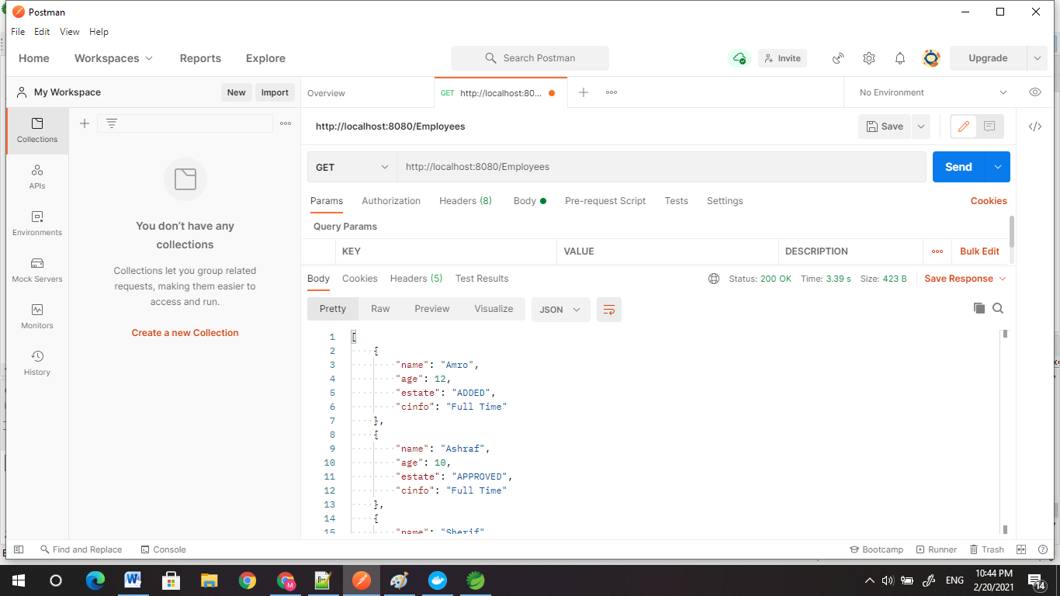

1. Select POST method, enter URL: <http://localhost:8080/publish> to create a new Employee, and pass Employee data in body:

{

    "name": "Khaled",

    "age": 10,

    "estate": "APPROVED",

    "cinfo": "Full Time"

}

Then if you query Employees again, it will show the new Employee with initial status:

[

    {

        "name": "Amro",

        "age": 12,

        "estate": "ADDED",

        "cinfo": "Full Time"

    },

    {

        "name": "Ashraf",

        "age": 10,

        "estate": "APPROVED",

        "cinfo": "Full Time"

    },

    {

        "name": "Sherif",

        "age": 7,

        "estate": "INCHECK",

        "cinfo": "OutSource"

    },

    {

        "name": "Ahmad",

        "age": 20,

        "estate": "ACTIVE",

        "cinfo": "Part Time"

    },

    {

        "name": "Khaled",

        "age": 10,

        "estate": "ADDED",

        "cinfo": "Full Time"

    }

]

1. Select PUT method, enter URL: http://localhost:8080/ChangeINCHECK to modify an Employee, and pass Employee data in body:

{

    "name": "Khaled",

    "age": 10,

    "estate": "APPROVED",

    "cinfo": "Full Time"

}

Then query the Employees again using GET method, it will show the modified entry for Employee “Khaled”:

[

    {

        "name": "Amro",

        "age": 12,

        "estate": "ADDED",

        "cinfo": "Full Time"

    },

    {

        "name": "Ashraf",

        "age": 10,

        "estate": "APPROVED",

        "cinfo": "Full Time"

    },

    {

        "name": "Sherif",

        "age": 7,

        "estate": "INCHECK",

        "cinfo": "OutSource"

    },

    {

        "name": "Ahmad",

        "age": 20,

        "estate": "ACTIVE",

        "cinfo": "Part Time"

    },

    {

        "name": "Khaled",

        "age": 10,

        "estate": "INCHECK",

        "cinfo": "Full Time"

    }

]

1. Select PUT method, enter URL: <http://localhost:8080/ChangeINCHECK/Amro> to change the state of an employee, and pass Employee name in message:

So Amro data will be as follows:

    {

        "name": "Amro",

        "age": 12,

        "estate": "ADDED",

        "cinfo": "Full Time"

    },

Use the following URL to get the API Contract: <http://localhost:8080/swagger-ui.html>

