1.decompress file 15146310.zip

2.all the files should be in the same directory. Which must be placed in www directory in wamp64 directory like following address C:\wamp64\www

Let’s say you have named the directory with decompressed files [assignment].

3.My local host is port 8080 unlike most of other’s default port 80. So if you want to start my login webpage, you should type url : <http://localhost:8080/assignment/login.php>

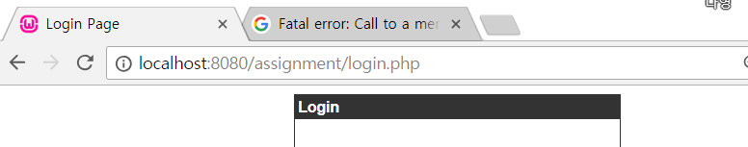

Like above!

4.With the link, you will be able to see the login page. To see the valid users’ information, you can simply click the button ‘user management’

5. user management page lists every users’ information of username, userID, password, email, and phonenumber. You can search users’ information by typing some part of their userID or phone number. Result will be shown right below.

6.you can update current user information. In textbox under “update user information”, type their userid and password and click confirm. You can put in or not put in new information to newly appeared form. If you are done, click the button “update” below the writing ”confirm original user information”. Information update is finished and you can check the modified data at the lists of users.

7. you can insert new user information by typing them into the form under “insert user information” and clicking the button “insert”.

8. to delete user, you can click the button ‘delete’ under each user information listed in the page. You can make it clear with the userID shown left of the delete button.

9. you can go back to the login page by typing it’s url again which was <http://localhost:8080/assignment/login.php> You can type any valid user ID and password and then click the submit button to reach success page. Success page shows every existing document title of users in the database with a welcome message for particular user’s ID that logged in.

10. you can sign out and go back to login page by clicking the link “sign out” or move to document management page by clicking the button “modify” under the user documents list.

11. every document list is again, shown in document management page. However edit and delete button only exists for the currently logged in user. So you cannot delete or edit other users’ document.

\*in document management page, you cannot change or delete your email and userID.

12. to make new documents, click the button “new document” under the list of users’ documents. Form for the new document will appear at the end of web page. Type the document title and information in to the form. If you don’t like what you wrote, you can click “reset document” button and reset the form. If you want to upload the document, click “upload” button and you will go back to the initial log in page. If you log in again, you will be able to see new document uploaded at the success page.

13. to edit the document, click the delete button at the document you hope to edit. At the end of the page you will see the form to edit your document with it’s previous information in the form. You can edit the title and the contents as you like and then click edit complete button.

14. to delete the document, you can click the delete button at the document that you want to delete. With the alert that you deleted the document, you will go back to the initial log in page. If you log in again, you will be able to see new document uploaded at the success page.

15. Thank you:>!