Mondo Yamaguchi

9/24/15

Assignment 0924

PS4 vs Xbox One

**Introduction:**

In this project, my team has examined efficiency, error, and satisfaction of the most popular video game consoles, Sony’s PlayStation 4 and Microsoft’s Xbox One. We asked random eleven people to complete three tasks: starting a game, searching for *Destiny*, and starting Netflix. We first explained and showed the exemplars how to complete the tasks, and then we timed how long they took to complete each task and counted number of incidents that something users did, which is not what they expected. After they finish the task, we asked for their satisfaction on a scale of 1 to 10. This report analyzes and determines based on our data, which console communicates with users better.

1. Usability Metrics

**Three Tasks:**

1. Starting a game
2. Searching for Destiny
3. Starting Netflix

**Three Metrics:**

1. Efficiency – measured by timing how long users took to complete the task.
2. Errors – measured by counting number of errors.
3. Satisfaction – measured by users on a scale of 1 to 10.

**Data:**

1. Starting a game

Table 1: Efficiency (in seconds)

|  |  |  |  |  |  |  |  |  |  |  |  |  |
| --- | --- | --- | --- | --- | --- | --- | --- | --- | --- | --- | --- | --- |
| User # | #1 | #2 | #3 | #4 | #5 | #6 | #7 | #8 | #9 | #10 | #11 | Avg. |
| PS4 | 12 | 7 | 8 | 8 | 5 | 20 | 6 | 8 | 4 | 15 | 8 | 9.18 |
| Xbox One | 107 | 6 | 15 | 16 | 6 | 9 | 6 | 19 | 8 | 53 | 19 | 24 |

Table 2: Errors

|  |  |  |  |  |  |  |  |  |  |  |  |  |
| --- | --- | --- | --- | --- | --- | --- | --- | --- | --- | --- | --- | --- |
| User # | #1 | #2 | #3 | #4 | #5 | #6 | #7 | #8 | #9 | #10 | #11 | Avg. |
| PS4 | 0 | 0 | 0 | 0 | 0 | 0 | 0 | 0 | 0 | 0 | 0 | 0 |
| Xbox One | 3 | 0 | 0 | 0 | 0 | 0 | 0 | 0 | 0 | 0 | 0 | 0.27 |

Table 3: Satisfaction

|  |  |  |  |  |  |  |  |  |  |  |  |  |
| --- | --- | --- | --- | --- | --- | --- | --- | --- | --- | --- | --- | --- |
| User # | #1 | #2 | #3 | #4 | #5 | #6 | #7 | #8 | #9 | #10 | #11 | Avg. |
| PS4 | 10 | 9 | 8 | 9.5 | 7 | 7 | 6 | 9 | 5 | 10 | 9 | 7.86 |
| Xbox One | 9 | 7 | 9 | 9 | 7 | 10 | 9 | 2 | 5 | 9 | 6 | 7.45 |

2. Searching *Density*

Table 4: Efficiency (in seconds)

|  |  |  |  |  |  |  |  |  |  |  |  |  |
| --- | --- | --- | --- | --- | --- | --- | --- | --- | --- | --- | --- | --- |
| User # | #1 | #2 | #3 | #4 | #5 | #6 | #7 | #8 | #9 | #10 | #11 | Avg. |
| PS4 | 32 | 24 | 25 | 45 | 20 | 32 | 43 | 66 | 20 | 67 | 61 | 39.6 |
| Xbox One | 46 | 26 | 31 | 44 | 15 | 23 | 22 | 35 | 27 | 48 | 30 | 31.6 |

Table 5: Errors

|  |  |  |  |  |  |  |  |  |  |  |  |  |
| --- | --- | --- | --- | --- | --- | --- | --- | --- | --- | --- | --- | --- |
| User # | #1 | #2 | #3 | #4 | #5 | #6 | #7 | #8 | #9 | #10 | #11 | Avg. |
| PS4 | 0 | 0 | 0 | 0 | 2 | 0 | 0 | 1 | 1 | 1 | 0 | 0.55 |
| Xbox One | 1 | 0 | 0 | 0 | 0 | 0 | 0 | 0 | 0 | 0 | 0 | 0.09 |

Table 6: Satisfaction

|  |  |  |  |  |  |  |  |  |  |  |  |  |
| --- | --- | --- | --- | --- | --- | --- | --- | --- | --- | --- | --- | --- |
| User # | #1 | #2 | #3 | #4 | #5 | #6 | #7 | #8 | #9 | #10 | #11 | Avg. |
| PS4 | 10 | 9 | 8 | 7.5 | 8 | 8 | 5 | 4 | 9 | 6 | 5 | 7.5 |
| Xbox One | 10 | 8 | 8 | 8 | 7 | 9 | 9 | 5 | 10 | 9 | 9 | 8.36 |

3. Starting Netflix

Table 7: Efficiency (in Seconds)

|  |  |  |  |  |  |  |  |  |  |  |  |  |
| --- | --- | --- | --- | --- | --- | --- | --- | --- | --- | --- | --- | --- |
| User # | #1 | #2 | #3 | #4 | #5 | #6 | #7 | #8 | #9 | #10 | #11 | Avg. |
| PS4 | 77 | 53 | 65 | 72 | 35 | 40 | 40 | 90 | 39 | 67 | 61 | 57.3 |
| Xbox One | 107 | 91 | 91 | 159 | 68 | 132 | 101 | 122 | 58 | 138 | 97 | 106 |

Table 8: Errors

|  |  |  |  |  |  |  |  |  |  |  |  |  |
| --- | --- | --- | --- | --- | --- | --- | --- | --- | --- | --- | --- | --- |
| User # | #1 | #2 | #3 | #4 | #5 | #6 | #7 | #8 | #9 | #10 | #11 | Avg. |
| PS4 | 0 | 0 | 1 | 0 | 0 | 0 | 0 | 0 | 0 | 0 | 0 | 0.09 |
| Xbox One | 0 | 0 | 0 | 3 | 1 | 2 | 0 | 1 | 0 | 0 | 1 | 0.73 |

Table 9: Satisfaction

|  |  |  |  |  |  |  |  |  |  |  |  |  |
| --- | --- | --- | --- | --- | --- | --- | --- | --- | --- | --- | --- | --- |
| User # | #1 | #2 | #3 | #4 | #5 | #6 | #7 | #8 | #9 | #10 | #11 | Avg. |
| PS4 | 9 | 9 | 8 | 9 | 7 | 9 | 5 | 4 | 8 | 10 | 9 | 7.82 |
| Xbox One | 7 | 8 | 8 | 8 | 6 | 5 | 9 | 3 | 8 | 10 | 8 | 7.27 |

**Analysis:**

On the first task, users were asked to start any game installed on each console. Nine out of eleven exemplars had no trouble completing this task, but two of them struggled to find the games tab on the Xbox One. Table 1 through Table 3 shows that the PS4 beats the Xbox One on all three categories. Surprisingly, there is more than ten seconds gap between the average times with this simple task. Six users had higher satisfaction with the PS4, two users had exactly the same satisfaction on both consoles, and three users had higher satisfaction with the Xbox One.

On the second task, we asked to users to search the game called *Destiny* using the search bar on each console. The Xbox One beats the PS4 on all three categories on this one. The problem with the PS4 is very clear since most of the users complained and did not like the keyboard. The PS4’s new keyboard uses different method, which can instantly display results after each letter is typed, and also the characters are lined vertically. Most of them were not familiar with the keyboard and had some difficulties typing “destiny.” On the other hand, the Xbox One has traditional keyboard and no-one had trouble using it. As a result, the Xbox One has nine seconds faster average time, nine times less errors, and better satisfaction.

On the last task, we asked users to start the Netflix and sign in with our given usersame and password. Table 7 shows that the average time of PS4 is about 50 seconds faster than the Xbox One. The Netflix application on both consoles do not have any differences, except the one on the Xbox One seems a little bit darker bacuase they use darker black on the background. Every user simply took more time finding the app on the Xbox One, and finding an app on the PS4 seemed much easier. In fact, the PS4 beats the Xbox One on all three categories.

Image 1: Search bar on the PS4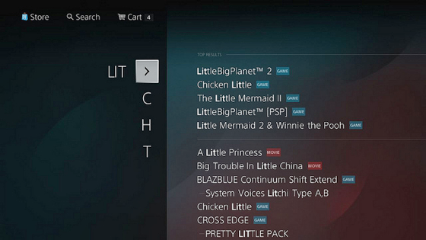

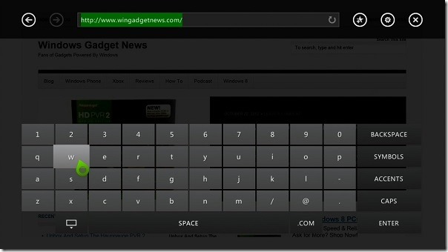 Image 2: Search bar on the Xbox One

1. Heuristic Evaluation:

The second part of report explores the effectiveness or appropriateness of the predominant interaction style used by the system. The analysis will follow the Interaction Design Basics document on <http://www.usability.gov/what-and-why/interaction-design.html>.

**Interacting with the Interface:**

The PS4 and the Xbox One both have indirect manipulations such as switching between apps and games by double tapping the home button on the PS4 or bringing up a mini menu for quick navigation while in game by tapping 2x on the Xbox One. On the second task, the exemplars could used some short cuts, but only one used a short cut, which deletes by pressing x button on the controller, instead of tapping delete on the keyboard. Deleting with x button or using search history on the Xbox could have improved efficiency if the users managed to use it. The PS4’s keyboard could be very effective if users can get used to the vertical keyboard and know that it displays result on the right side of the screen.

**Give Users Clues about Behavior before Actions are Taken:**

Two users struggled to find the games tab on the Xbox One. The games tab is neatly displayed in the left side, but it does not provide to let a user know what will happen before they perform an action, whereas the PS4’s games tab is bigger and include meaningful label with a picture. The size and the picture helped the users to find easily and improved the effectiveness.

**Anticipate and Mitigate Errors:**

The Poka-Yoke Principle says, “placing the constraints forces the user to adjust behavior in order to move forward with their intended action.” However, the fact our tasks were simple enough, both consoles did not have anything to prevent errors and was not needed since all exemplars were able to finish the task within the limited time.

**Consider System Feedback and Response Time:**

Both consoles responded quickly with the pop messages to acknowledge the action and to let the user know what he/she did. Also, the response time was immediate (less than 0.1 second) for every task.

**Simplify for Learnability:**

The PS4 challenged to not use the familiar formats on their keyboard. Even after some practices users were not able to handle them well and it affected the decision time. However, for the third task, the PS4 simplified and removed complexity better than the Xbox One. The PS4 only had two steps to open the Netflix and the Xbox One had four steps, and the two steps difference made 50 seconds gap between the consoles.

**Conclusion:**

Based on the data and the analysis, the PS4 communicates with the user better than the Xbox One because the PS4 have faster overall average time, much less errors, and better satisfactions. Also, it managed to simplify the systems, and included meaningful labels, which made easier for the users to complete the tasks.