

OS algorithms and problems

Process and Disk Scheduling Algorithms with Process Synchronization Problems



December 13, 2020

Submitted to: Dr. Raheel Ahmed Memon

Group Members:

Muhammad Yamin (021-19-0029)

Wasid Khan (021-19-0022 )

M Fahad Shahzad (051-19-0003)

Irfan Ullah (051-19-0008)

Muhammad Akram(051-19-0033)

Contents

Title: 2

Abstract: 2

Descriptive Figure for the Proposed Project 2

Expected Outcome 3

Tools to be used 4

Group Members 4

# Title:

Operating System Algorithms and Problems (Disk & Process Scheduling with Process Synchronization)

# Abstract:

The project **Operating System Algorithms and Problems** provides time efficient solutions to various techniques of executing processes, storing and manipulating data in OS. The techniques include **Disk Scheduling, Process Scheduling and Process Synchronization**. In Process Scheduling Algorithms, the data fetched will be processed through one of the execution methodologies implemented **i.e., FCFS, SJB, RR, LJF etc.** Similarly, after execution here comes **Disk Scheduling Algorithms** which will store data in efficient manners. The **Disk Scheduling Algorithms** that are implemented includes C Scan, Shortest Seek Time First, LOOK, and Scan. The third technique implanted in the project is **Process Synchronization** Where on the basis of **Semaphores and Peterson’s Solution** various methodologies has been adopted which includes **Dinning Philosophers Problem, Producer Consumer Problem, and Reader Writers Problem. The** techniques are well protected for use and makes the data processing very fast. The various tools used for implementation are mentioned in **Tools** Section.

# 

# Descriptive Figure for the Proposed Project

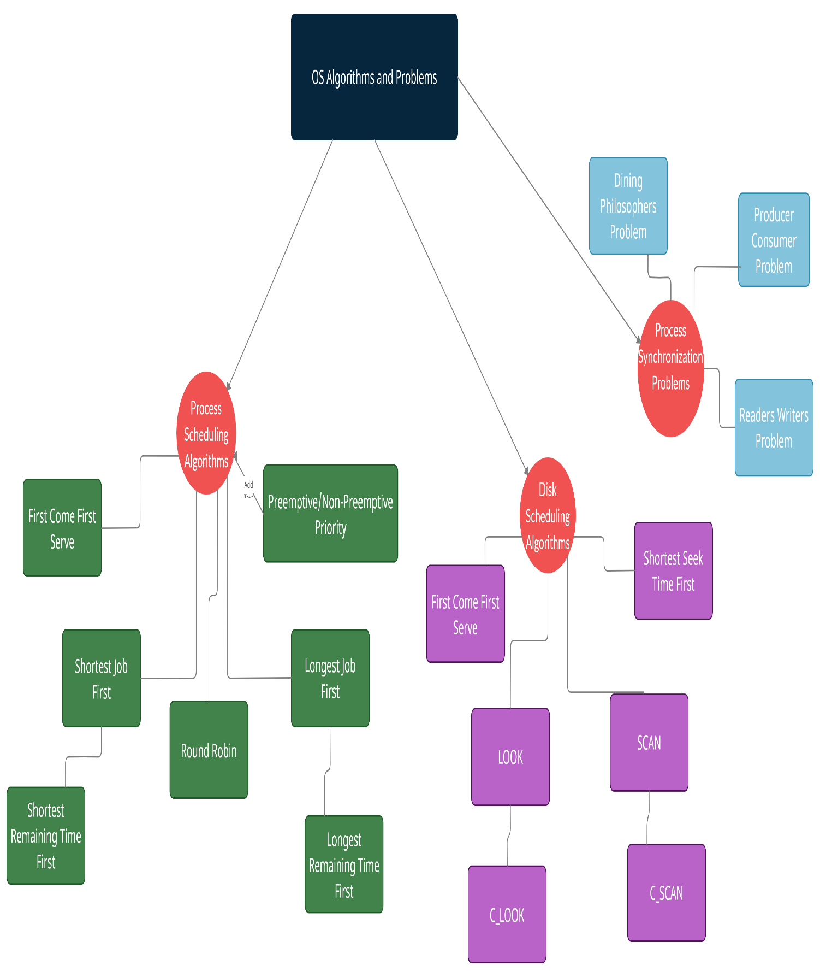

# Expected Outcome

The expected output of this project is the implementation of 9 different process scheduling algorithms, 6 disk scheduling algorithms and solution of 3 process synchronization problems.

# Tools to be used

1. C language
2. Semaphores
3. Threading
4. Multiple libraries
5. GCC compiler
6. Peterson’s solutions

# Group Members

1. Muhammad Yamin
2. Irfan Ullah
3. Muhammad Akram
4. Wasid Khan
5. Muhammad Fahad Shahzad