## Problem 1

Given rankings:

[4, 7, 3, 1] & [2, 6, 8, 5]

When put into one ranking:

[4, 2, 6, 8, 5, 7, 3, 1]

## Problem 2 (In Python with the matrix)

X = None

M = [[X,0,0,0,0,0,0,1],

[1,X,0,0,0,1,1,0],

[1,1,X,0,0,1,0,1],

[1,1,1,X,1,1,1,1],

[1,1,1,0,X,0,1,0],

[1,0,0,0,1,X,1,1],

[1,0,1,0,0,0,X,0],

[0,1,0,0,1,0,1,X]]

array_a = [4, 7, 3, 1]

array_b = [2, 6, 8, 5]

def Beat(L, R):

if M[L - 1][R - 1]:

return True

return False

def Merge(A, B):

p = len(A)

q = len(B)

i, j = 0, 0

c = [0] * (p+q)

while (i + j) < (p + q):

if (i == p):

c[i + j] = B[j]

j = j + 1

elif (j == q):

c[i + j] = A[i]

i = i + 1

elif Beat(A[i], B[j]):

c[i + j] = A[i]

i = i + 1

elif Beat(B[j], A[i]):

c[i + j] = B[j]

j = j + 1

return c

print('Pre-Ranked Array A Players: ' + str(array_a))

print('Pre-Ranked Array B Players: ' + str(array_b))

print('Post-Ranked Players: ' + str(Merge(array_a, array_b)))

## Problem 3 (In Python with the matrix and rank function added)

X = None

M = [[X,0,0,0,0,0,0,1],

[1,X,0,0,0,1,1,0],

[1,1,X,0,0,1,0,1],

[1,1,1,X,1,1,1,1],

[1,1,1,0,X,0,1,0],

[1,0,0,0,1,X,1,1],

[1,0,1,0,0,0,X,0],

[0,1,0,0,1,0,1,X]]

def Beat(L, R):

if M[L - 1][R - 1]:

return True

return False

def Merge(A, B):

p = len(A)

q = len(B)

i, j = 0, 0

c = [0] * (p+q)

while (i + j) < (p + q):

if (i == p):

c[i + j] = B[j]

j = j + 1

elif (j == q):

c[i + j] = A[i]

i = i + 1

elif Beat(A[i], B[j]):

c[i + j] = A[i]

i = i + 1

elif Beat(B[j], A[i]):

c[i + j] = B[j]

j = j + 1

return c

def Rank(n):

A = M[:len(M)//2]

B = M[len(M)//2:]

if(len(A) > 1):

A = Rank(A);

if(len(B) > 1):

B = Rank(B);

return Merge(A, B)

array_c = [1,2,3,4,5,6,7,8]

print('Unranked Players: ' + str(array_c))

print('Post-Ranked Players: ' + str(Rank(array_c)))

## Problem 4

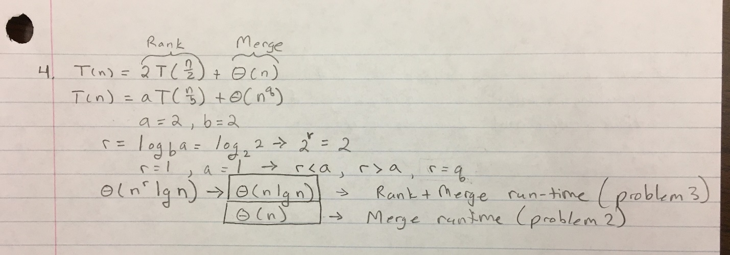

## Problem 5

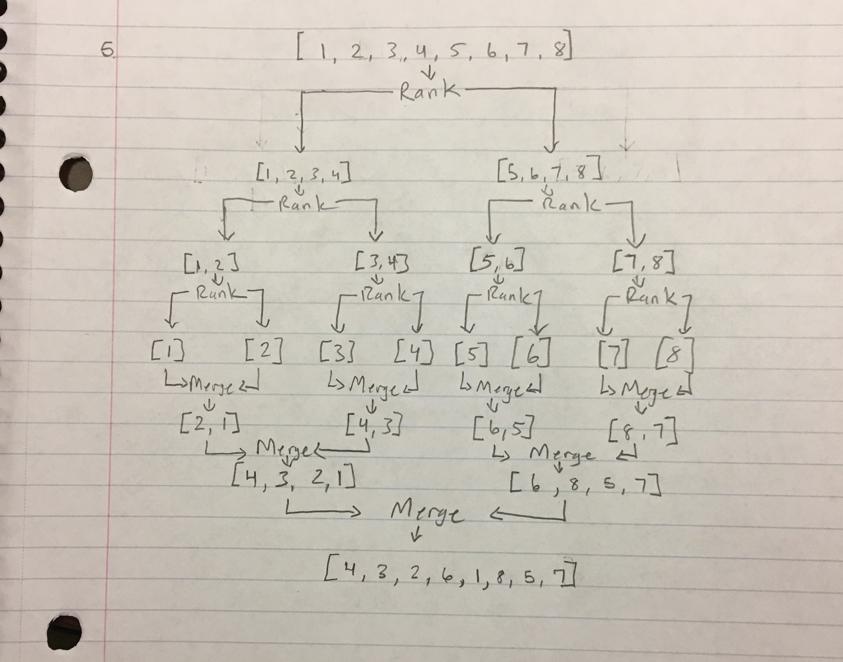

## Problem 6

