1. Download the executable (.exe) from here: <http://www.softpedia.com/get/Programming/Debuggers-Decompilers-Dissasemblers/JAD.shtml>

Save the file (the README too, it has good instructions) somewhere in the file system, for example in C:\Program Files\JadDecompiler\

1. Download the JAD Eclipse plugin (.jar) from http://jadclipse.sf.net/update
2. Copy the downloaded jar file to the plugins folder of Eclipse, for example C:\dev\eclipse\plugins (net.sf.jdtdecompiler.jad_3.4.0.v20090220)
3. Restart Eclipse (for the plugin to take effect)
4. In Eclipse, Click **Window –> Preferences –> Java –> Jadclipse** and enter for example:

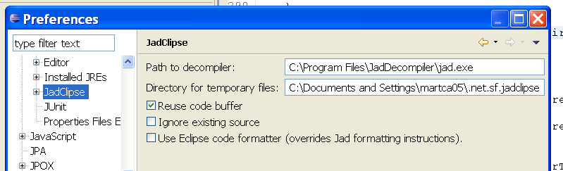

Done.