**RESUME**

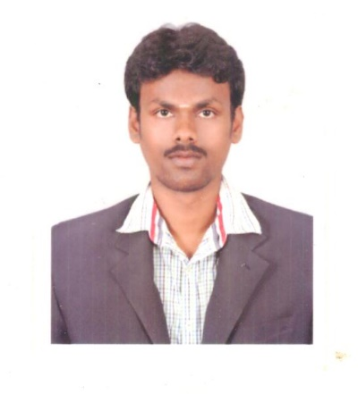

**G.LEELAKRISHNAN**

Contact: **7904671434**

[**krishglk007@gmail.com**](mailto:krishglk007@gmail.com)

Present Address:

D/O NO: 63, T. Nagar,

Vilankuruchi.

Coimbatore- 641035.

|  |
| --- |
| Career Objective |

**Seeking assignments in Design & Detail Engineering in Instrumentation with an organization of high repute.**

To pursue a career with an organization, which energizes me towards highest individual and professional growth in a manner that I can prove myself as an asset to the organization and the society with I am associated.

|  |
| --- |
| Education |

Bachelor of Engineering in **INSTRUMENTATION A*ND CONTROL ENGINEERING*** Stream**.**

**(**Affiliated to **Anna University, 2009 - 2013)** R.V.S COLLEGE OF ENGINEERING, DINDIGUL.

|  |
| --- |
| Courses and training attend |

**& Trainings Attended**

* Received **“INDUSTRIAL AUTOMATION TRAINER”** Certificate at I-MAX Automation Center.
* Undergone an Work shop actively participated in VLSI DESIGN at RAMANATHAN ENGG. COLLEGE in TIRUPUR.
* Undergone an Industrial Visit in CHETTINAD CEMENT, karur for one day.

|  |
| --- |
| Software exposures |

* Smart plant instrumentation **INTOOLS** (V9)
* Auto cad
* Micro station
* Software Exposure in MS word, MS Excel, Power Point, MS Access,

|  |
| --- |
| WORKING EXPERIENCE- 4+ yrs. |

**INSTRUMENTATION ENGINEER -** From JUNE 2013 To Till now.

**VETRI ENGINEERS,** COIMBATORE, INDIA**.**

Nature of the Job:

I have the following responsibilities as Project Engineer.

* Design and Documentation expert with strength in Engineering Software includes, **Smart Plant Instrumentation (V9) software,** **AutoCAD Ver.2011**
* Enhancing the Intools deliverables using Index, Browser, Specification and wiring modules (ESL Generation) with most equivalent outputs resulting in reduced deviations.
* Assisted in the SPI Administration like backup and restoring the database.
* Design and detailed engineering as per project requirements.
* Plan the Instrumentation Datasheets as per client regarding (Transmitter, Gauges, valves,) Projects, revamping and schematic works in control station, wiring to junction box and loop drawing using ESL in Intools.
* Coordinated with the vendors and participated in Client meetings, assisted in reviewing the design for the Project.

## *PROJECT DETAILS:*

**OIL AND GAS**

PROJECT: WASIT GAS PLANT **(INTOOLS)**

CLIENT : **SAUDI ARABIAN OIL COMPANY (ARAMCO)**, Saudi Arabia.

Area of Responsibilities:

* Associated in preparation of Instrument Index module in Smart Plant Instrumentation (V9) software.
* Import data to SPI & Report Customization in ESL.
* Preparation of Instrument index & I/O list’s.
* Preparation of Specification sheets
* Preparation of Wiring Deliverables.

**WATER TREATMENT PLANT**

PROJECT : LINK LINE BETWEEN HPT-A AND HPT-B

Client : **SWCC**, Al-jubail

Area of Responsibilities:

* Review the entire project documents, existing datasheets and survey reports for bid proposal.
* Preparation of bidding documents, including assistance for the preparation of bids, verification of submitted bids regarding etc.
* Analyze blueprints, project documents and specifications to prepare accurate and efficient materials and labor estimates on all project stages and project related works.

PROJECT: RAW WATER WELL FIELD DISTRIBUTION

Client :  **MA’ADEN**, Saudi Arabia.

Area of Responsibilities:

* Review the entire project documents, existing datasheets and survey reports for bid proposal.
* Analyze blueprints, project documents and specifications to prepare accurate and efficient materials and labor estimates on all project stages and project related works.
* Monitors and Coordinates with subcontractors and suppliers for get successive process report.
* Develop and verify MTOs, equipment and bulk quantities against P&IDs and drawings.
* Plan the Instrumentation Projects, revamping and schematic works in control station, wiring to junction box, loop drawing.

**Personal details**

* **Father’s name** : N.R .GOVINDARAJ
* **Age & DOB** : 24 & 30-08-1991
* **Sex** : Male
* **Marital status** : Single
* **Nationality** : Indian
* **Languages known** : TAMIL, TELUGU, ENGLISH
* **Passport** : M4009785

**Declaration**

I hereby declare that the above-mentioned particulars are true for the best of my knowledge.

Signature G.LEELAKRISHNAN