MOBILE PROGRAMMING LAB 1
Vo Thi Tra My_1931200017

Question 3. Create Expo CLI apps

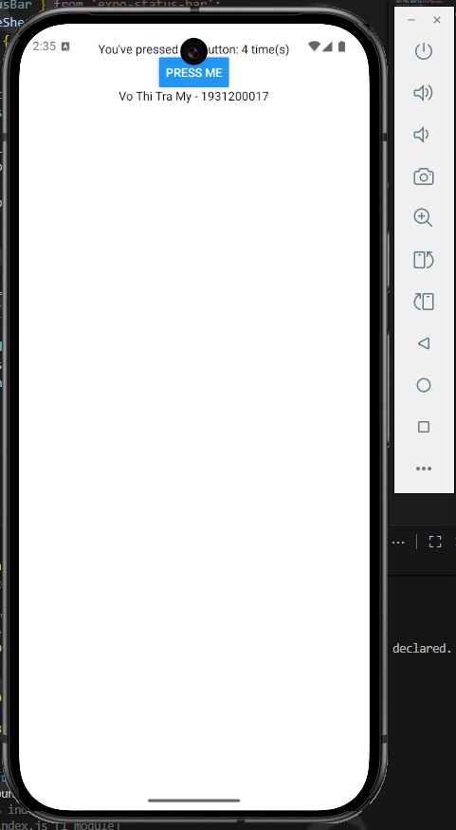

Question 4. Create React native CLI apps

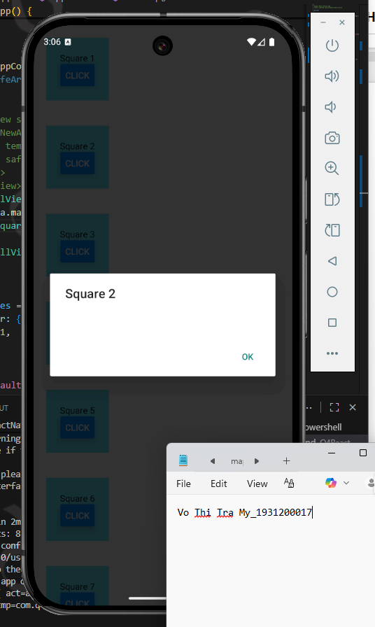

Question 5. Publishing

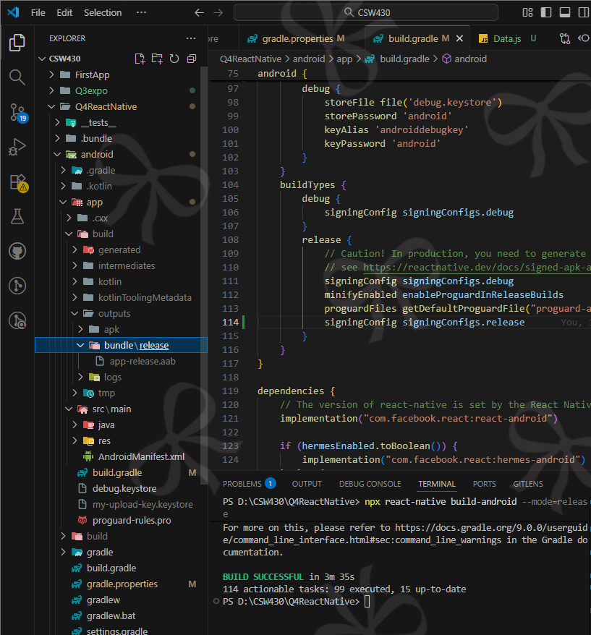

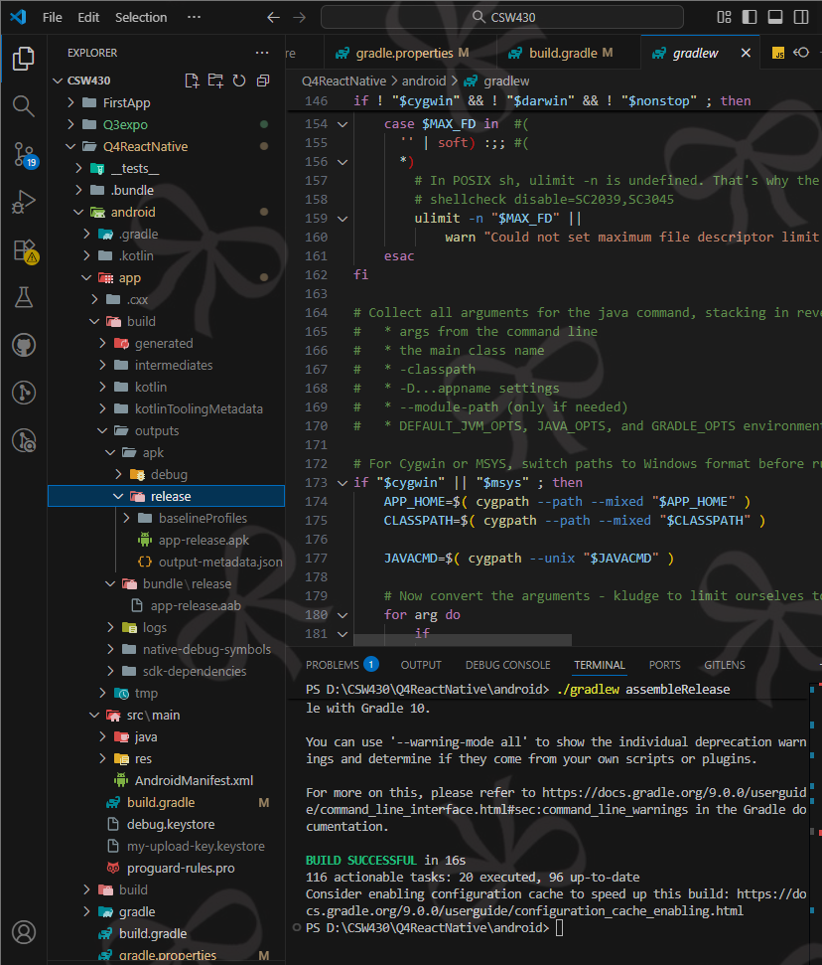

Question 6. Build apps with props and state.

