Lab 4: REDUX TOOLKIT& ASYNCSTORAGE & REACT NAVIGATIO

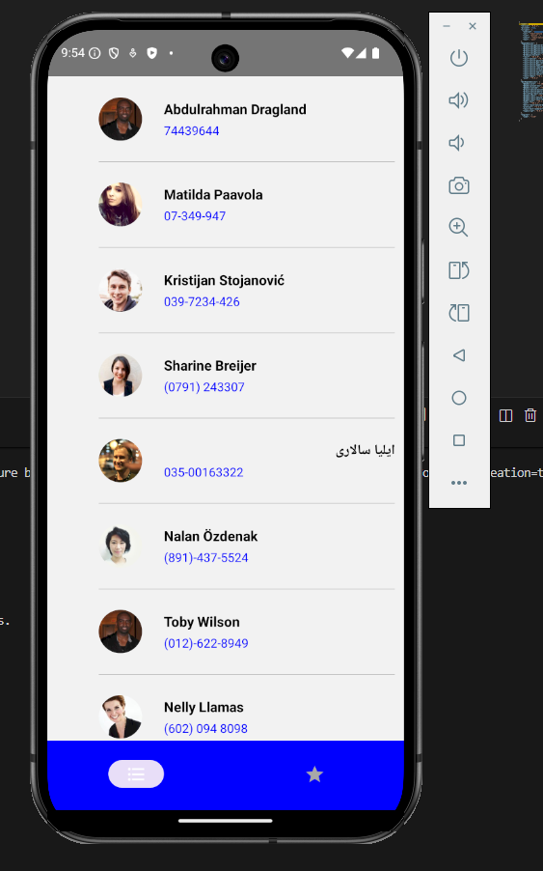
Screen 1
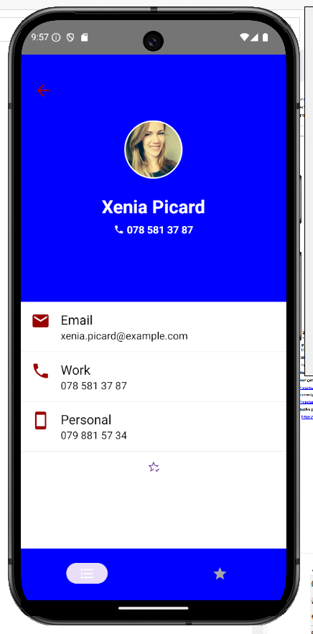
Screen 2
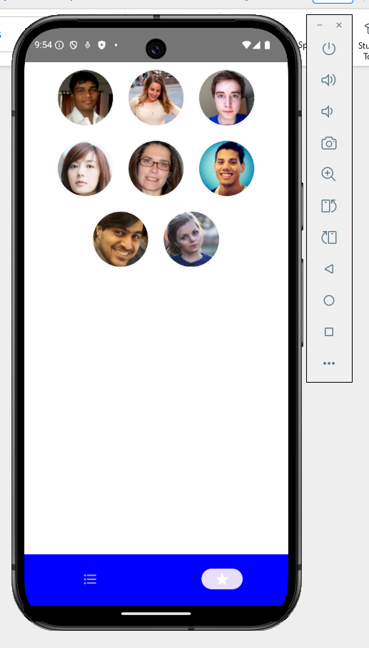
Screen 3
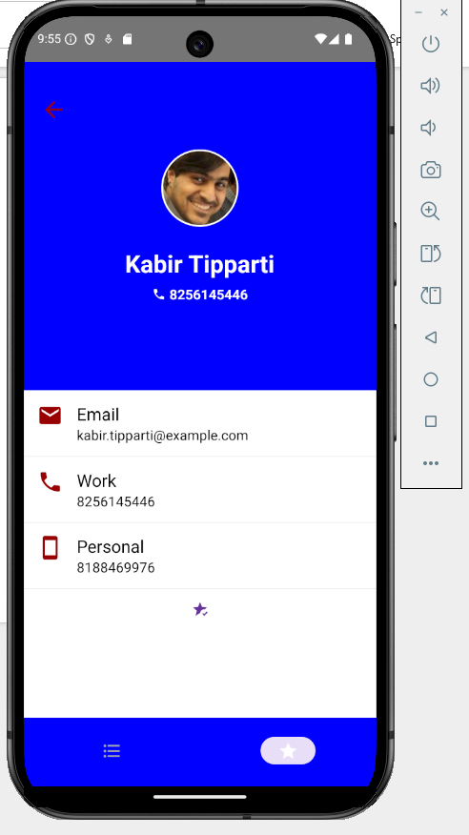
Screen 4

