

OFFER LETTER

Date: temp2

To,

# Mr. temp2fullname

**Subject: Property Rental Offer Letter**.

Dear Sir,

Further to your recent enquiry for leasing in Abu Dhabi, on behalf of our client, we are pleased to offer you required property on following terms and conditions.

# PROPERTY DETAILS

Unit No : temp2

Area/Zone : temp2

Unit Type : temp2utype

Annual rent : temp2

Security Deposit : temp2

Agency Fee : temp2 Payable to Property Square Real Estate

**Remarks** 1) Rental Amount to be paid in 1 installment

1. The Duration of Lease term will be 12 Months.
2. Contract starting date will be 20th April 2023

If you required any further details, please do not hesitate to contact us on # 0501141618

Please sign the Offer Letter and send it back to us. Unit booking will be confirmed after receiving the security deposit.

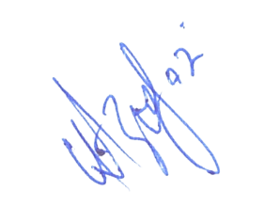

Manager Leasing Accepted by, Client Name:

Aazib Ejaz Ahmed Signature: Date:

