WI-ESP32 Snakebot: Real-Time Surveillance
and Remote Operation

PROJECT REPORT
Submitted by

MOHAMMAD YASIN (NCE20MC018)
To

the APJ Abdul Kalam Technological University
in the partial fulfilment of the requirements for the award of the Degree of
Bachelor of Technology
In
Mechatronics Engineering



DEPARTMENT OF MECHATRONICS ENGINEERING
NEHRU COLEGE OF ENGINEERING AND RESEARCH CENTRE
PAMPADY, THIRUVILWAMALA, THRISSUR -680588
(Approved by AICTE, ISO 9001:2015 certified, NAAC ’A’ ACREDITED, NBA ACCREDITED)
JUNE 2023
WI-ESP32 Snakebot: Real-Time Surveillance
and Remote Operation

PROJECT REPORT
Submitted by

MOHAMMAD YASIN (NCE20MC018)
To

the APJ Abdul Kalam Technological University
in the partial fulfilment of the requirements for the award of the Degree of
Bachelor of Technology
In
Mechatronics Engineering

DEPARTMENT OF MECHATRONICS ENGINEERING
NEHRU COLEGE OF ENGINEERING AND RESEARCH CENTRE
PAMPADY, THIRUVILWAMALA, THRISSUR -680588
(Approved by AICTE, ISO 9001:2015 certified, NAAC ’A’ ACREDITED, NBA ACCREDITED)
JUNE 2023

DECLARATION

We undersigned hereby declare that the project report “ESP32 Snakebot: Real-Time Surveillance and remote operation “submitted submitted for partial fulfilment of the requirements for the award of degree of bachelor of Technology of the APJ Abdul Kalam Technological University, Kerala is a Bonafide work done by us under supervision of MR.ANSHAD V This submission represents our ideas in our own words and where ideas or words of others have been included; we have adequately and accurately cited and referenced the original sources. We also declared that we have adhered to ethics of academic honesty and integrity and have not misrepresented or fabricated any data or idea or fact or source in my submission. We understand that any violation of the above will be a cause for disciplinary action by the institute and/or the university and can also evoke penal action from the sources which have thus not been properly cited or from whom proper permission has not been obtained. This report has not been previously formed the basis for the award of any degree, diploma or similar title of any other university.

Place: Pampady MOHAMMAD YASIN
Date:

DEPARTMENT OF MECHATRONICS ENGINEERING
NEHRU COLEGE OF ENGINEERING AND RESEARCH CENTRE
(Approved by AICTE, ISO 9001:2015 certified, NAAC ’A’ ACREDITED, NBA ACCREDITED)

PAMPADY, THIRUVILWAMALA, THRISSUR



CERTIFICATE

This is to certify that the final project report entitled “ESP32 Snakebot Real Time Surveillance and remote operation ” is a bonafide record of the project submitted by MOHAMMAD YASIN to the APJ Abdul Kalam Technological University in partial fulfillment of the requirements for the award of the Degree of Bachelor of Technology in Mechatronics Engineering is a bonafide record of the Final Project report carried out by them under our guidance and supervision. This report in any form has not been submitted to any other University or Institute for any purpose.

Internal Supervisor(s) External Supervisor(s)

Project coordinator Head of department

ACKNOWLEDGEMENT

Our endeavour stands incomplete without dedicating our gratitude to everyone who has contributed a lot towards the successful completion of our project work. First of all, we offer our thanks to our parents for their blessings. We are indebted to God Almighty for blessing us with his grace and taking our endeavour to a successful culmination. We submit this project work at the lotus feet of Late Shri. P.K. Das, Founder Chairman, Nehru Educational and Charitable Trust. We express our profound gratitude to Adv. Dr. P. Krishnadas, Managing Trustee, Nehru Educational and Charitable Trust. We express our sincere thanks to Dr. P Krishnakumar, CEO and Secretary. Nehru Educational and Charitable Trust. We are also grateful to Prof. Dr. Ambika Devi Amma T, Principal of Nehru College Of Engineering And Research Centre for giving us proper directions. We are also thankful to Dr. N D Bobby, HOD, Department of Mechatronics Engineering for supporting us all along. We express our sincere thanks to our internal guide Mr.ANSHAD V, Asst. Professor, for the guidance given to us and steering us. We finally, thank our friends and all our mentors who had supported us directly and indirectly during our project work.

MOHAMMAD YASIN(NCE20MC018)

ABSTRACT

The integration of the ESP32 microcontroller with WiFi capabilities into snake robots has marked a significant advancement in robotics, particularly in the field of search and rescue. These robots, designed to navigate through complex environments, utilize the ESP32’s WiFi functionality to detect human presence by analyzing signal strength and propagation patterns. The addition of a PS3 controller as an interface allows for precise and user-friendly control over the robot’s movements. Furthermore, the ESP32CAM module equips the robot with real-time video streaming capabilities, providing visual feedback to the operator. This combination of technologies enables the snake robot to perform efficient search and rescue operations in areas that are otherwise inaccessible or hazardous for humans. The ESP32’s processing power and connectivity options make it an ideal choice for such applications, offering a new level of interaction and functionality in robotic systems designed for human assistance
The keywords related to the abstract on the snake robot using ESP32, WiFi for human detection, PS3 controller for control, and ESP32CAM for the camera are as follows:
These keywords capture the essential aspects of the snake robot’s design and functionality, including its communication, control, and vision capabilities

CONTENTS

ACKNOWLEDGEMENT……………………….…………………………………….……….. i
ABSTRACT……………………………………………………..………….…………………... ii
CHAPTER 1………………………………………………..………………………………..…....9
INTRODUCTION…………………………...………………………………………..…..……...9
CHAPTER 2……….…………………………………..…………………………………….…...10
LITERATURE SURVEY…………………………………………………………...……….......10
CHAPTER 3……………………….……...…………………………………..................….........15
HARDWARE AND SOFTWARE REQUIREMENTS …………………………………..…..15
- Arduino Nano ESP32…………………………………….….……..………………...…............15
- Esp32 cam…………………………………….…………………………………………..….…..16
- LM2596S DC-DC Buck Converter Power Supply…………………………………….….……16
- GPS………………………………………………………………………………………………..17
- TowerPro MG995 Metal Gear Servo Motor (180° Rotation):…………...……..………….…17
- Adafruit PCA9685 16-Channel Servo Drive…..………………………………….....…….......18
- Laptop Charger for Dell P/N PA-12 19.5V 3.34A Laptop Adapter:……………………….....19
- The PlayStation 3 (PS3) controller............…………………….………………..……....….......19
SOFTWARE REQUIREMENTS ………………………………………………..……….......20
CHAPTER 4…………………………………………………………………….……..….…...21
WORKING………………………………………………………………………….….............22
CHAPTER 6…………………………………………………………………………..….…...23
SCHEMATIC DIAGRAM …………………………………………………………......……23
CHAPTER 7………………………………………………………………………..…...….…26
RESULT…………………………………..………………………………..............................28
CHAPTER 8……………………………………………………………………....………......27
FUTURE SCOPE……………………………………………………………….....….............27
CHAPTER 9……………………………………………………………………..……….…...28
CONCLUSION………………………………………………………………...….…………..28
REFERENCES………………………………………………………………..……….…..….29

CHAPTER 1

INTRODUCTION

The integration of the ESP32 microcontroller in snake robots has ushered in a new era of search and rescue capabilities, offering a beacon of hope in disaster-stricken environments. The ESP32, with its WiFi prowess, is the brain behind these serpentine machines, enabling them to detect human presence through sophisticated signal analysis. Coupled with the ESP32CAM, the robot provides real-time visual feedback, allowing for an unprecedented level of situational awareness. The choice of a PS3 controller as the interface marries the familiarity of gaming with the precision of robotics control, ensuring that the operator can maneuver the robot with both comfort and accuracy. This snake robot is not just a marvel of technology; it is a testament to human ingenuity. Its ability to slither through the rubble, sense the breath of life amidst chaos, and relay critical information back to its human counterparts is nothing short of extraordinary. The ESP32’s dual-core processor and rich peripheral set facilitate the seamless transmission of control commands and sensor data, making the robot an extension of the rescuer’s own senses. As it navigates through tight spaces and hazardous environments, the snake robot stands as a sentinel of safety, a guardian angel forged from circuits and code. Its deployment could mean the difference between life and death, as it reaches where humans cannot, to bring back hope from the brink of despair. In the face of calamity, this ESP32 WiFi-enabled snake robot is not just a tool; it is a lifeline, a symbol of the resilience and adaptability that define the future of robotics and humanitarian aid.

CHAPTER 2

LITERATURE SURVEY

- Wi-fi signal-based through-wall sensing for human presence and fall detection using esp32 moduleSahoo Ajit Kumar, K Akhil, Siba K UdgataIntelligent Systems: Proceedings of ICMIB 2021, 459-470, 2022
Device-free Wi-Fi sensing has gained much attention due to its simplicity, low cost, and it requires no additional hardware. The main advantages of Wi-Fi sensing are, it is unobtrusive, can operate through walls, work without lighting, is ubiquitous, and does not require users to carry any additional wearable devices. These Wi-Fi signals can be exploited to detect the event and recognize various human activities. This paper proposes a device-free Wi-Fi sensing system to track human presence and fall activity detection across the wall using the Channel State Information (CSI) values extracted from the received Wi-Fi signals. The received signal characteristics changes with the presence of the human beings, and their activities influence the signal propagation, resulting from reflection and scattering.
The activities can be recognized by analyzing the CSI values corresponding to different subcarriers of the received signal. CSI values contain fine grain information such as amplitude and phase to achieve better sensing accuracy with a unique pattern that can be observed corresponding to each activity. We developed the transmitter and receiver hardware modules together with the necessary software for capturing the CSI from Wi-Fi signals using low-power and low-cost ESP32 module. Multiple experiments are conducted for human presence and fall detection activities in indoor environments. The proposed model finds the best time window size to detect the activities instead of considering the usual fixed time window size. This helped to increase the detection accuracy. The results show the effectiveness of the proposed method with accurate event detection.
- Wifi csi-based long-range through-wall human activity recognition with the esp32Julian Strohmayer, Martin Kampelnternational Conference on Computer Vision Systems, 41-50, 2023
WiFi Channel State Information (CSI)-based human activity recognition (HAR) is an unobtrusive method for contactless, long-range sensing in spatially constrained environments while preserving visual privacy. Despite the presence of numerous WiFi-enabled devices around us, few expose CSI to users, resulting in a lack of sensing hardware options. Recently, variants of the Espressif ESP32 have emerged as potential low-cost, easy-to-deploy solutions for WiFi CSI-based HAR. In this work, we evaluate the ESP32-S3’s long-range through-wall HAR capabilities by combining it with a 2.4GHz directional biquad antenna. The experimental setup uses a transmitter-receiver configuration spanning 18.5m across five rooms. We assess line-of-sight (LOS) and non-line-of-sight (NLOS) performance using CNN HAR models trained on CSI spectrograms. CSI HAR datasets used in this work consist of 392 LOS and 384 NLOS spectrograms from three activity classes and are made publicly available. The gathered results clearly demonstrate the feasibility of long-range through-wall presence detection and activity recognition with the proposed setup.
- ShikWi-ESP—A tool for CSI-based Device-Free Wi-Fi Sensing (DFWS) Muhammad Atif, Shapna Muralidharan, Heedong Ko, Byounghyun YooJournal of ComputationalDesignandEngineering,Volume7,Issue5,October2020,Pages644=656,https://doi.org/10.1093/jcde/qwaa048 Published: 15 May 2020
Recent progress in Device-Free Wi-Fi Sensing (DFWS) has established the use of wireless signals like Wi-Fi not only to communicate but also as a tool to enable device-free sensing. As an emerging technique, DFWS has many capable applications such as sensing activity and gesture and fall detection, monitoring elderly, surveillance, and many more applications while waiving out the necessity to mount devices on the object. A wide range of applications can use the channel state information (CSI) from commercial Wi-Fi devices pervasively for ubiquitous sensing. Existing CSI tools, such as the Intel 5300 network interface controller tool or the Atheros 9390 tool, have limitations when deployed in large-scale systems due to their high deployment costs and limitations in the resolution of CSI measurements. Due to these shortcomings, DFWS applications need an alternative CSI tool in order to perform efficiently. In this paper, we present ESP32-based Wi-ESP as a CSI gathering tool that can report detailed CSI measurements based on 802.11n standards. The proposed Wi-ESP tool works as a complete device by collecting the CSI measurements as well as processing further for DFWS applications. Wi-ESP can work as standalone device, unlike other CSI tools, and can offer large-scale deployment to many DFWS applications. In this paper, we have explored the options of Wi-ESP as a tool for CSI measurements and processing and propose it as a tool for DFWS.
- Implementation of Employability Skills: Making of Robot Transporter Trainer with DualShock Control 3 Base on ESP32 Article Edy Sulistiyol, Isfandiar Naufal Farisi, Muhammad Syariffuddien Zuhrie, Setya Chendra Wibawa, Agus Dwi Ramdhani
As the industrial era 4.0 signs of progress and technology advances, particularly in the field of robots, the world of education must adapt to these changes, particularly in Vocational High Schools. The purpose of the research is to create a trainer learning media and a robot transporter module using dual shock 3 control based on ESP32 that is feasible to use based on the results of observations made on the expertise of Industrial Electronics Engineering at Vocational High State Schools (SMK) Negeri 1 Kalianget Sumenep Madura. The validity, practicality, and efficacy of the medium are used to determine the level of media feasibility. Pre-experimental research design with One-Shot Case Study design using the research technique R&D (Research and Development)
- SV. M. Senthilkumar, M.Siva Ramkumar, P Velrajkumar, T Kamalavalli, V G Pratheep, Kavitha S, M. Sivaramkrishnan, "Model-based Controller Design for Automatic Two Wheeled Self Balancing Robot", 2023 International Conference on Inventive Computation Technologies (ICICT), pp.1418-1425, 2023.
ISelf balancing robot is developed from automatic control technology and dynamics technology, which can sense the external environment and make decisions. It has a wide application prospect. This paper designs a two wheeled self balancing robot based on esp32. The robot collects inertia data through mpu9250 and motor data through Hall encoder. PID algorithm is used to control motor to realize robot balance. At the same time, the upper computer software is designed, which can change the PID parameters of the robot in real time, obtain the pitch angle and velocity of the robot in real time, and control the motion state of the robo
- INMOOV PROJECT CONTROLLED BY ROBOT OPERATING SYSTEM (ROS) L Formanek, A Tupy, L Cechovic, P Sarafin… - EDULEARN23 …, 2023 - library.iated.org
“TInMoov is an open-source humanoid robot that can be, for the most part, printed on a 3D printer. It was designed by French sculptor and designer Gael Langevin. It is possible to control the robot by voice commands and can utilize face detection cameras or Kinect. InMoov can be controlled by repeating a movement of a human body that it detects. It also contains a conversational bot that can be talked to or given commands. By default, the control is handled by the MyRobotLab (MRL) program that was created in the Java language. The movement of the robot is ensured by servomotors, which are controlled by Arduino Mega2560. The experience of building the robot and using the MRL system will be presented in this article. The limits of using the MRL control system in an academic scenario, such as safety issues during classes where students could via program testing potentially cause hardware damage, have been identified. Another necessary functionality that MRL does not fully support is a simple way to control the robot and create various gestures without programming. This resulted in using the Robot Operating System (ROS), an open-source framework, that will be presented in this paper.
- ”Wi-Fi Sensing for Human Identification Through ESP32 Devices: An Experimental Study F Gaiba, L Bedogni, G Gori, A Melis… - 2024 IEEE 21st …, 2024 - ieeexplore.ieee.org
WRecent studies explore the possibility of detecting events in a room via Wi-Fi Sensing. This practice exploits the interaction between waves carrying Wi-Fi signals and the elements present in an environment. These interactions are called Channel State Information (CSI) and can be analyzed and exploited to infer information about the environment, such as “device-free” Human Activity Recognition, Human Identification, and more. Considering identification, we recently saw an increasing trend in the usage of low-end devices such as ESP32. Being small and low-power, they are cheap and versatile, however, the quality of the collected data is inferior. In this work, we use state-of-the-art tools to perform Human Identification using the ESP32. Software is created to act as an interface between the collected data and the algorithms suitable for Wi-Fi Sensing. To evaluate the final design, we performed a data collection in acontrolledenvironment. The experiments show an accuracy of 95% in distinguishing two users while 74% in distinzuishing three.
- A Design of Robotic Snake with ESP 32 CAM and Arduino R Chauhan, S Bandopadhaya, M Dev… - 2021 19th OITS …, 2021 - ieeexplore.ieee.org
The present study proposes a robotic snake design using ESP 32 CAM and arduino. The robotic snake with an extended reach with locomotion has wide applications in surveillance, maintenance, rescue and spying through a narrow passage and in an adverse environment etc. The proposed design of robot is a bio-mimic camouflage of snake. The prototype of the robot is made which consists of one head unit followed by five cells that are capable of moving through any narrow passage. The head unit comprises of arduino based centralized controlling unit and ESP 32 CAM module. The camera module, video streams the front view of the robot using the remotely located control panel. Based on the front view of the robot, an operator can control the locomotion of the robot via the arduino of the central control unit. The proposed design has many real-life applications
- A survey of snake-inspired robot designsJames K Hopkins1, Brent W Spranklin1 and Satyandra K Gupta1Published 22 January 2009 • 2009 IOP Publishing LtdBioinspiration & Biomimetics, Volume 4, Number 2Citation James K Hopkins et al 2009 Bioinspir. Biomim. 4 021001
Body undulation used by snakes and the physical architecture of a snake body may offer significant benefits over typical legged or wheeled locomotion designs in certain types of scenarios. A large number of research groups have developed snake-inspired robots to exploit these benefits. The purpose of this review is to report different types of snake-inspired robot designs and categorize them based on their main characteristics. For each category, we discuss their relative advantages and disadvantages. This review will assist in familiarizing a newcomer to the field with the existing designs and their distinguishing features. We hope that by studying existing robots, future designers will be able to create new designs by adopting features from successful robots. The review also summarizes the design challenges associated with the further advancement of the field and deploying snake-inspired robots in practice.
- A robot snake to inspect broken buildingsKL Paap, T Christaller, F Kirchner - Proceedings. 2000 IEEE …, 2000 - ieeexplore.ieee.org
We build a snake-like robot for the inspection of areas that are difficult or dangerous to be accessed by human. Pictures from a camera at the robot's head are sent to a remote screen and can be monitored by a human operator. This human operator can also control the robot's motion, but not every single body part. Thus the operator only gives general directives and the robot will then able to follow autonomously the given directives. This is the semi-autonomous behavior of the robot. However, the robot must also be able to act fully autonomous when the contact to the operator is lost. After a short description of the robot we present a method which makes the operator control easy and also allows the robot to act fully autonomous. The autonomous motion control of the robot moving in a sewer pipe has been implemented

CHAPTER 3

HARDWARE AND SOFTWARE REQUIREMENTS

HARDWARE USED

Arduino board

Arduino boards are the hardware platforms that form the core of the Arduino ecosystem. They consist of a microcontroller, input/output pins, and various other components that enable you to interact with electronic devices and create projects

- The Arduino Nano ESP32:

The Arduino Nano ESP32 is a compact and powerful development board that brings together the capabilities of the ESP32-S3 microcontroller and the user-friendly Arduino programming environment. It features the NORA-W106 module, which houses the ESP32-S3 chip, offering robust processing power for various applications. The board supports Wi-Fi and Bluetooth 5.0 connectivity, making it an excellent choice for IoT projects. It also boasts 16 MB of Flash memory for storing your programs. Whether you’re a hobbyist or a professional, the Arduino Nano ESP32 provides a versatile platform for your

- Esp32 cam:

The ESP32-CAM is a compact, highly integrated development board ideal for IoT projects. It combines an ESP32-S3 microcontroller** and an **OV2640 camera**, providing robust processing power and advanced imaging capabilities. The board also includes a **microSD card slot** for data storage. With support for Wi-Fi and Bluetooth 5.0, it's perfect for applications like video streaming, surveillance cameras, face recognition, and more. The ESP32-CAM is not

only affordable but also user-friendly, making it a popular choice for both hobbyists and professionals. Its versatility and power have revolutionized the possibilities for creative coding and IoT development

- LM2596S DC-DC Buck Converter Power Supply
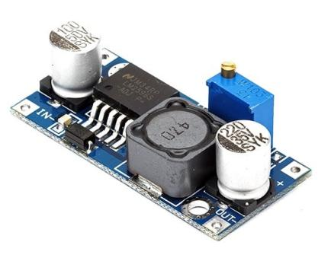
DC-DC Buck Converter Step Down Module LM2596 Power Supply is a step-down(buck) switching regulator, capable of driving a 3-A load with excellent line and load regulation. These devices are available in fixed output voltages of 3.3 V, 5 V, 12 V, and an adjustable output
version.The LM2596 series operates at a switching frequency of 150kHz, thus allowing smaller sized filter components than what would be required with lower frequency switching regulators.s.

- GPS:

This is a complete GPS module that is based on the NEO 6M GPS. This unit uses the latest technology to give the best possible positioning information and includes a larger built-in 25 x 25mm active GPS antenna with a UART TTL socket. A battery is also included so that you can obtain a GPS lock faster. This is an updated GPS module that can be used with ardupilot mega v2. This GPS module gives the best possible position information, allowing for better performance with your Ardupilot or other Multirotor control platform.The GPS module has serial TTL output, it has four pins: TX, RX, VCC, and

GND. You can download the u-center software for configuring the GPS and changing the settings much more. It is really good software

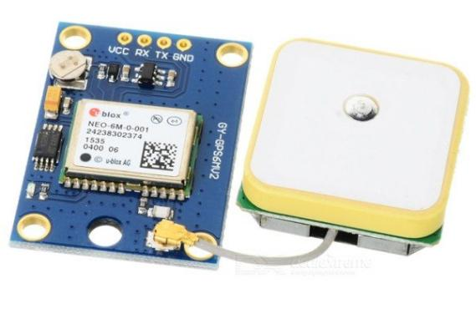

- TowerPro MG995 Metal Gear Servo Motor (180° Rotation):

The TowerPro MG995 Metal Gear Servo Motor is a high-speed digital servo motor that offers a 180° rotation⁴⁵. Here are some key features:
- Model: MG995¹.
- Weight: 55 gm¹.
- Operating voltage: 4.8V~ 7.2V¹.
- Servo Plug: JR¹.
- Stall torque @4.8V: 10 kg-cm¹.
- tall torque @6.6V 12 kg-cm¹.
- Gear Type: Metal gear².
- Rotational Degree 180º¹.
- Servo Plug: JR².
- Cable Length (cm): 30¹.
This servo motor is suitable for a wide range of applications, including RC aircraft, automobiles, and robotics¹. It's known for its high resolution, accurate positioning, fast control response, and excellent holding power¹. Please note that there are many counterfeit servos of TowerPro from China dealers selling on various websites². It's recommended to purchase from authorized dealers to ensure reliable quality and after services².
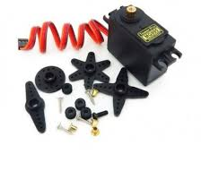

- Adafruit PCA9685 16-Channel Servo Driver:
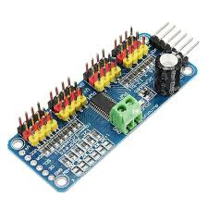
Node MCU is an open source firmware for which open source prototyping board designs are available. Node MCU is an open source firmware for which open source prototyping board designs are available Node MCU is a low-cost open source IoT platform. It initially included firmware which runs on the ESP8266 Wi-Fi SoC from Espress if Systems, and hardware which was based on the ESP-12 module. Later, support for the ESP32 32-bit MCU was added. The ESP8266 WiFi Module is a self contained SOC with integrated TCP/IP protocol stack that can give any microcontroller access to your WiFi network .

- Laptop Charger for Dell P/N PA-12 19.5V 3.34A Laptop Adapter:
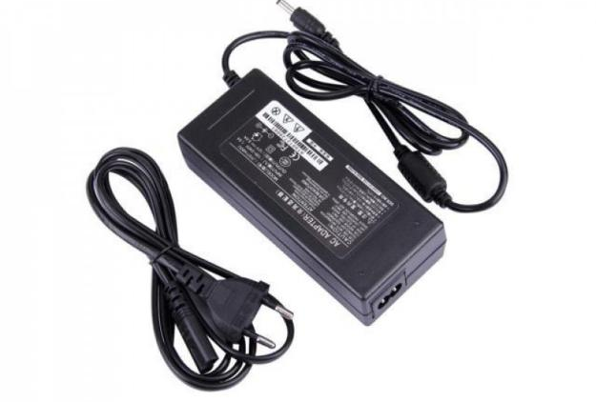
The Laptop Charger for Dell P/N PA-12 is a reliable and efficient power adapter designed for Dell laptops12. It operates at an input voltage of 100-240V, 50-60Hz, and provides an output of 19.5V, 3.34A, delivering 65W of power13. The charger comes with a power cord and features a pin size of 7.4mm x 5.0mm13. It’s equipped with safety features such as short circuit protection, over voltage protection, and over temperature protection14. This charger is compatible with various Dell laptop models and is an ideal choice for keeping your device powered and charged .
- The PlayStation 3 (PS3) controller:
officially known as the DualShock 3, is an iconic gaming peripheral renowned for its ergonomic design and advanced features. It boasts a symmetrical layout with two analog sticks, a digital D-pad, four face buttons (triangle, circle, cross, square), four shoulder buttons (L1, L2, R1, R2), a Start button, a Select button, and a PlayStation button for system navigation.The DualShock 3 utilizes Bluetooth connectivity to wirelessly connect to the PS3 console, providing players with freedom of movement during gameplay. Its rechargeable lithium-ion battery ensures extended gaming sessions without the need for frequent replacements. The controller's design incorporates vibration feedback, known as DualShock technology, which enhances immersion by simulating in-game actions and events through tactile sensations.Additionally, the DualShock 3 features motion-sensing capabilities, allowing for interactive experiences through tilt and motion controls. This functionality is leveraged in various games to introduce intuitive gameplay mechanics, such as steering vehicles, aiming projectiles, or performing gestures for in-game actions.

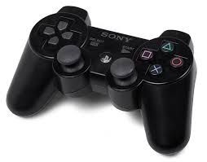

SOFTWARE USED

One of the most difficult task is selecting software for the system, once the system requirements is found out then we have to determine whether a particular software package fits for those system requirements. The application requirement:
Operating System : Windows 11
- HTML
- C
- IDE : Arduino

Arduino IDE
The Arduino IDE is free and open-source software, available for Windows, macOS, and Linux operating systems. It provides a beginner-friendly environment for programming Arduino boards and is widely used by hobbyists, students, and professionals for developing interactive projects, prototypes, and electronic systems. The Arduino IDE (Integrated Development Environment) is a software application that provides a programming platform for developing and uploading code to Arduino boards. It offers a user-friendly interface and a set of tools to simplify the process of writing, compiling, and uploading code to the Arduino microcontroller.
- Code Editor:
The IDE provides a text editor where you can write your Arduino code. It offers features like syntax highlighting, auto-completion, and code indentation to help with code readability and writing.
- Library Manager:
Arduino libraries are pre-written code modules that provide additional functionality and simplify programming tasks. The IDE includes a Library Manager that allows you to easily browse, install, and manage libraries in your projects

3.Serial Monitor:
The Serial Monitor is a built-in tool that enables communication between your Arduino board and the computer. It allows you to send and receive data through the serial port, which is useful for debugging and monitoring sensor readings or program output.
4.Board Manager:
Arduino supports a variety of microcontroller boards with different architectures and specifications. The IDE includes a Board Manager that enables you to select and install the appropriate board definitions for the specific Arduino board you are using.
5.Code Compilation and Upload:
Once you have written your Arduino code, the IDE compiles it into machine code that can be understood by the Arduino board’s microcontroller. It then facilitates the uploading of the compiled code to the board via a USB connection.

CHAPTER 5

WORKING

A “Snake Robot Using Wi-Fi to Detect Humans” is a specialized robotic system. It mimics the serpentine movements of a snake, leveraging Wi-Fi signals to detect human presence. This technology can be crucial in search-and-rescue missions, surveillance, and inaccessible terrains, enhancing safety and efficiency
ROBOT SIDE
Integrating the versatility of snake robots with the ESP32 microcontroller and the ergonomic design of a PS3 controller opens up a new realm of possibilities for robotics enthusiasts. The ESP32's robust processing capabilities and built-in Bluetooth functionality make it an ideal choice for controlling a biomimetic snake robot. When paired with a PS3 controller, which offers a familiar and intuitive interface complete with joysticks and pressure-sensitive buttons, the user gains precise control over the robot's movements. This setup allows for real-time manipulation of the snake robot's segments, enabling it to navigate complex environments and perform tasks with unprecedented agility. The PS3 controller's motion-sensing technology can be harnessed to add another layer of interaction, allowing the user to guide the robot with natural hand movements. By leveraging open-source libraries and platforms, hobbyists can program the ESP32 to interpret the PS3 controller's inputs, translating them into fluid, snake-like locomotion. This combination of hardware and software paves the way for innovative applications, such as remote inspections in hazardous areas or complex surgical procedures, where the snake robot's ability to reach confined spaces can be fully utilized
WI-ESP32 CSI
The ESP32 module, a compact and versatile microcontroller, has been pivotal in advancing Wi-Fi signal-based through-wall sensing technologies for detecting human presence and falls. This innovative approach leverages the Channel State Information (CSI) extracted from Wi-Fi signals to monitor indoor environments without the need for invasive cameras or wearable sensors. The ESP32's ability to process CSI data enables it to discern subtle changes in signal patterns caused by human movement or falls, even through obstacles like walls. Researchers have developed algorithms that analyze these patterns, providing real-time alerts and insights into human activity within a space. The system's non-intrusive nature, coupled with the ESP32's low power consumption and cost-effectiveness, makes it an ideal solution for smart homes, elderly care, and security applications. By utilizing existing Wi-Fi infrastructure, it offers a seamless integration into our daily lives, ensuring safety and well-being without compromising privacy. The potential of this technology extends beyond simple detection; it could revolutionize how we interact with our living spaces, making them more responsive to our needs and behaviors

ROBOT SIDE

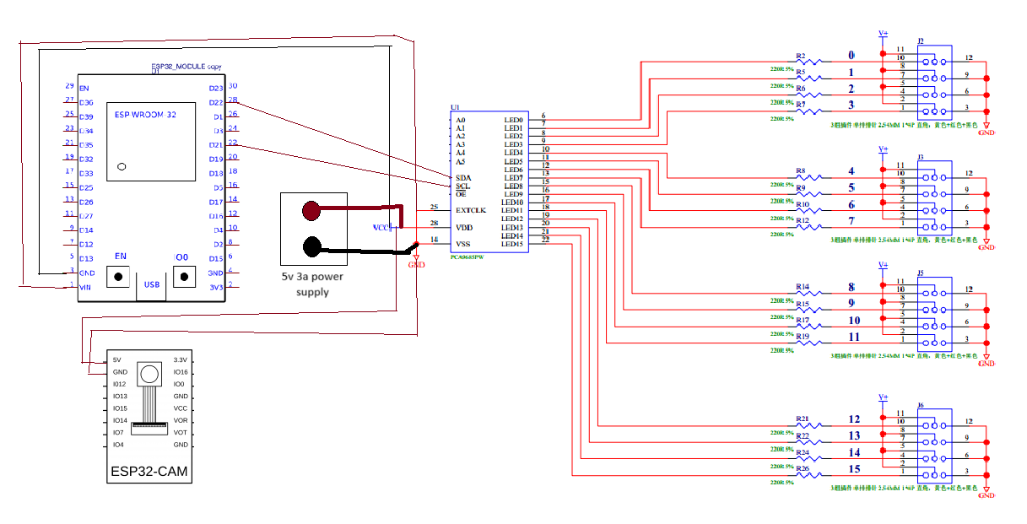

WI-ESP32 CSI
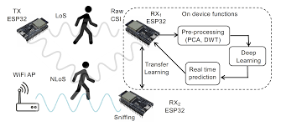

CHAPTER 6

SCHEMATIC DIAGRAM

ROBOT SIDE
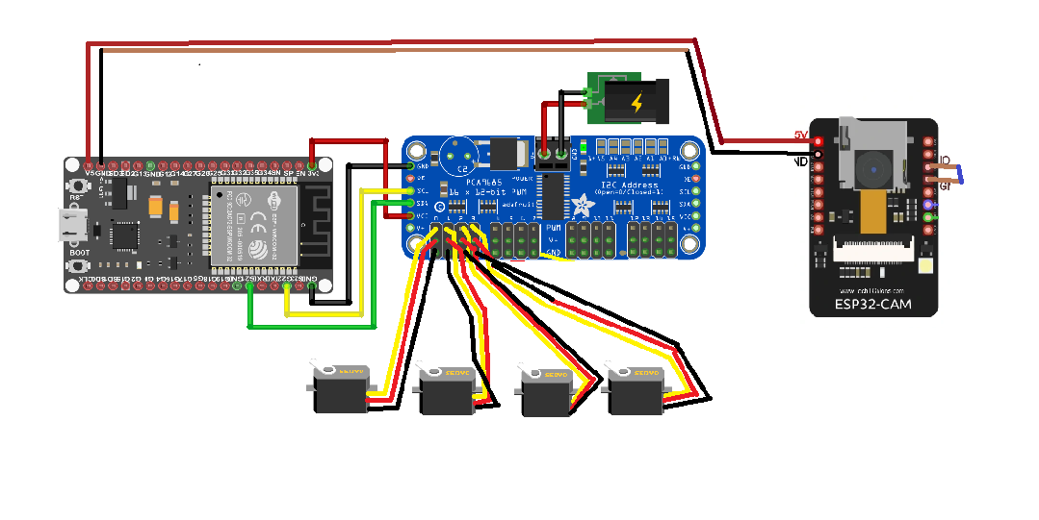

WI-ESP32 CSI
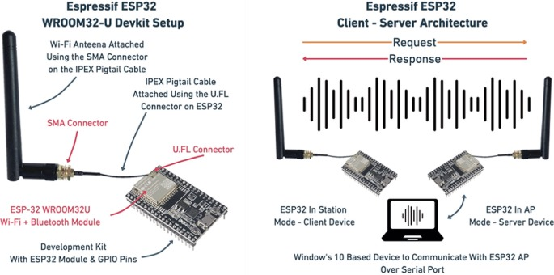

CHAPTER 7
RESULT

ROBOT SIDE
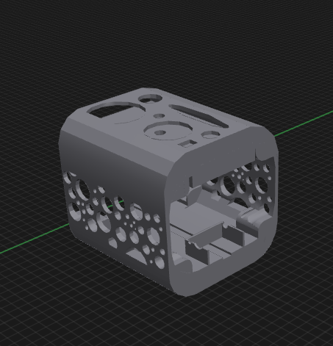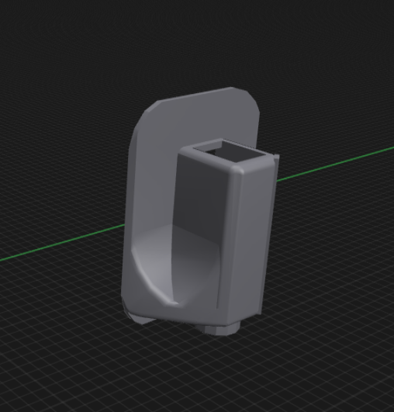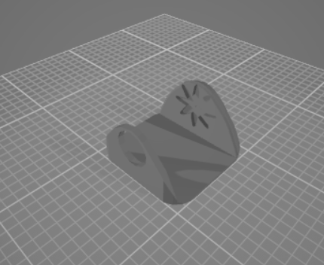
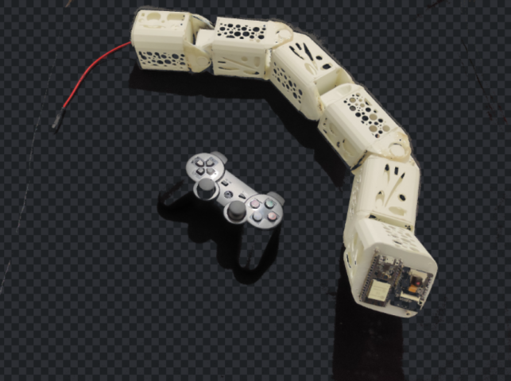
Prototype 1

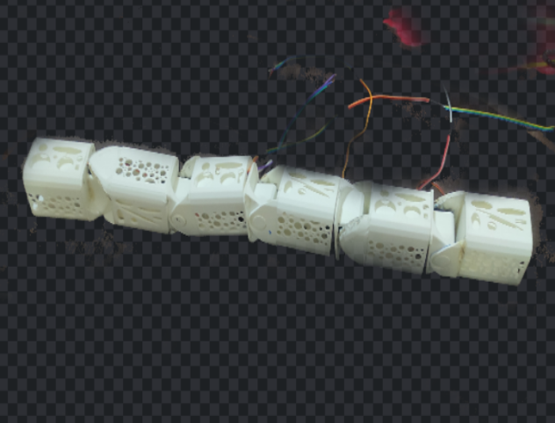

Prototype 2

CHAPER 8

FUTURE SCOPE

Creating an ESP32 Snakebot for real-time surveillance and remote operation is a fascinating project with many potential future advancements. Here are some future scope ideas for enhancing Snakebot:
- 1. AI Integration: Integrate artificial intelligence algorithms for autonomous navigation and object recognition. This can help the Snakebot identify and react to different objects or situations without human intervention.
- 2. Sensor Upgrades: Enhance the sensor suite with additional sensors like LiDAR (Light Detection and Ranging) for 3D mapping and obstacle avoidance, thermal cameras for night vision, or gas sensors for environmental monitoring.
- 3. Communication Protocols: Implement advanced communication protocols such as MQTT (Message Queuing Telemetry Transport) or WebSocket for more efficient and secure data transfer between the Snakebot and the remote operator.
- 4. Cloud Integration: Connect the Snakebot to cloud platforms like AWS or Azure for data storage, analytics, and remote management. This can enable features like historical data analysis, prdictive maintenance, and firmware updates over-the-air (OTA).
- 5. Machine Learning for Behavior: Train machine learning models to learn and adapt Snakebot behavior based on user feedback and environmental data. This can lead to improved decision-making and responsiveness in different scenarios.
- 6.Swarm Robotics: Explore swarm robotics concepts by coordinating multiple Snakebots to work together collaboratively on tasks such as search and rescue operations or environmental monitoring over a large area.
- 7.Augmented Reality (AR) Interface: Develop an AR interface for the remote operator to visualize the Snakebot's surroundings in real-time, overlaying information like sensor data, waypoints, and alerts onto the live video feed.
- 8.Energy Efficiency: Optimize power consumption through energy-efficient hardware components, sleep modes, and smart charging solutions to extend the Snakebot's operating time in the field.
- 9. Security Features: Implement robust security measures such as encryption, authentication, and intrusion detection to protect the Snakebot from unauthorized access or tampering.
- 10. Collaborative Applications: Explore collaborative applications where the Snakebot can work alongside human operators or other robotic systems, such as assisting in construction projects or providing support in hazardous environments.

CHAPER 9

CONCLUSION

In conclusion, the ESP32 Snakebot represents a cutting-edge solution for real-time surveillance and remote operation. By leveraging the power of the ESP32 microcontroller, this system seamlessly integrates wireless communication, sensor data processing, and motor control, making it an ideal platform for various applications.
One of the key strengths of the ESP32 Snakebot is its ability to provide live video streaming, enabling users to monitor remote locations in real time. This feature is particularly valuable for security purposes, as it allows for immediate response to potential threats or emergencies. Additionally, the Snakebot's compact and agile design allows it to navigate through tight spaces and difficult terrain, expanding its usability in diverse environments.
Moreover, the remote operation capabilities of the Snakebot empower users to control its movements and functionalities from anywhere with an internet connection. This functionality opens up opportunities for remote inspections, surveillance, and even interactive demonstrations.
Overall, the ESP32 Snakebot demonstrates the convergence of robotics, IoT, and remote communication technologies, offering a versatile and efficient solution for surveillance and remote operation needs. Its adaptability, real-time capabilities, and user-friendly interface make it a valuable asset in various industries, from security and surveillance to education and research.

REFERENCE

- mplementation of Employability Skills: Making of Robot Transporter Trainer with DualShock Control 3 Base on ESP32 Article Edy Sulistiyol, Isfandiar Naufal Farisi, Muhammad Syariffuddien Zuhrie, Setya Chendra Wibawa, Agus Dwi Ramdhani

- SV. M. Senthilkumar, M.Siva Ramkumar, P Velrajkumar, T Kamalavalli, V G Pratheep, Kavitha S, M. Sivaramkrishnan, "Model-based Controller Design for Automatic Two Wheeled Self Balancing Robot", 2023 International Conference on Inventive Computation Technologies (ICICT), pp.1418-1425, 2023.
- SV. M. Senthilkumar, M.Siva Ramkumar, P Velrajkumar, T Kamalavalli, V G Pratheep, Kavitha S, M. Sivaramkrishnan, "Model-based Controller Design for Automatic Two Wheeled Self Balancing Robot", 2023 International Conference on Inventive Computation Technologies (ICICT), pp.1418-1425, 2023.
- INMOOV PROJECT CONTROLLED BY ROBOT OPERATING SYSTEM (ROS) L Formanek, A Tupy, L Cechovic, P Sarafin… - EDULEARN23 …, 2023 - library.iated.org
- ”Wi-Fi Sensing for Human Identification Through ESP32 Devices: An Experimental Study F Gaiba, L Bedogni, G Gori, A Melis… - 2024 IEEE 21st …, 2024 - ieeexplore.ieee.org

- A Design of Robotic Snake with ESP 32 CAM and Arduino R Chauhan, S Bandopadhaya, M Dev… - 2021 19th OITS …, 2021 - ieeexplore.ieee.org
- A survey of snake-inspired robot designsJames K Hopkins1, Brent W Spranklin1 and Satyandra K Gupta1Published 22 January 2009 • 2009 IOP Publishing LtdBioinspiration & Biomimetics, Volume 4, Number 2Citation James K Hopkins et al 2009 Bioinspir. Biomim. 4 021001
- A robot snake to inspect broken buildingsKL Paap, T Christaller, F Kirchner - Proceedings. 2000 IEEE …, 2000 - ieeexplore.ieee.org

APPENDIX 1
PROGRAM

1.ROBOT SIDE
#include <Wire.h>
#include <Adafruit_PWMServoDriver.h>
#include <Ps3Controller.h>

int player = 0;
int battery = 0;

#define PCA9685_ADDRESS 0x40 // Default I2C address of PCA9685
#define SERVO_MIN_PULSE_WIDTH 110 // Minimum pulse width for the servo
#define SERVO_MAX_PULSE_WIDTH 610 // Maximum pulse width for the servo
#define SERVO_MIN_ANGLE 0 // Minimum angle for the servo
#define SERVO_MAX_ANGLE 180 // Maximum angle for the servo
#define SERVO_CHANNEL 0
// PCA9685 channel connected to the servo

Adafruit_PWMServoDriver pwm = Adafruit_PWMServoDriver();
void notify(){

if( battery != Ps3.data.status.battery ){

battery = Ps3.data.status.battery;
Serial.print("The controller battery is ");
if( battery == ps3_status_battery_charging ) Serial.println("charging");
else if( battery == ps3_status_battery_full ) Serial.println("FULL");
else if( battery == ps3_status_battery_high ) Serial.println("HIGH");
else if( battery == ps3_status_battery_low) Serial.println("LOW");
else if( battery == ps3_status_battery_dying ) Serial.println("DYING");
else if( battery == ps3_status_battery_shutdown ) Serial.println("SHUTDOWN");
else Serial.println("UNDEFINED");
}}
void onConnect(){
Serial.println("Connected.");
}

void setup() {
Serial.begin(9600);

Ps3.attach(notify);
Ps3.attachOnConnect(onConnect);
Ps3.begin("00:00:00:00:00:00");

Serial.println("Ready.");

pwm.begin();
pwm.setPWMFreq(60); // Set PWM frequency to 60 Hz

delay(10);
}

void loop() {
///esp(0);
//esp(180);

int angle;
int pulse_width = map(angle, SERVO_MIN_ANGLE, SERVO_MAX_ANGLE, SERVO_MIN_PULSE_WIDTH, SERVO_MAX_PULSE_WIDTH);

if(!Ps3.isConnected())
return;
//-------------------- Player LEDs -------------------
if( Ps3.event.button_down.right )
{
servo4(45);
}
if( Ps3.event.button_down.left )
{
servo4(125);
}
if( Ps3.event.button_down.up ){
servo5(45);
}
if( Ps3.event.button_down.down ){
servo5(125);
}
if( Ps3.event.button_down.start )
{
moveservo(90);
}
if( Ps3.event.button_down.circle )
{
moveservo(125);
delay(500);
moveservo(90);
delay(500);
moveservo(45);
delay(500);
moveservo(90);
delay(500);
moveservo(125);
delay(500);
moveservo(90);
delay(500);
moveservo(45);
delay(500);
moveservo(90);
delay(500);
}
if( Ps3.event.button_down.square ) {
moveservo(45);
delay(500);
moveservo(90);
delay(500);
moveservo(125);
delay(500);
moveservo(90);
delay(500);
moveservo(45);
delay(500);
moveservo(90);
delay(500);
moveservo(125);
delay(500);
moveservo(90);
delay(500);
moveservo(45);
delay(500);
moveservo(90);
delay(500);
moveservo(125);
delay(500);
moveservo(90);
delay(500);

}
if( Ps3.event.button_down.triangle )
{
servo5(45);
delay(500);
servo3(45);
delay(500);
servo1(125);
delay(500);
servo5(90);
delay(500);
servo3(90);
delay(500);
servo1(90);
delay(500);
}
if( Ps3.event.button_down.triangle ){
servo1(125);
delay(500);
servo3(40);
delay(500);
servo5(45);
delay(500);
servo1(90);
delay(500);
servo3(90);
delay(500);
servo5(90);
delay(500);
}
}

void servo1(int angle) {
int pulse_width = map(angle, SERVO_MIN_ANGLE, SERVO_MAX_ANGLE, SERVO_MIN_PULSE_WIDTH, SERVO_MAX_PULSE_WIDTH);
pwm.setPWM( 0, 0, pulse_width);
Serial.print("Moving servo to ");
Serial.print(angle);
Serial.println(" degrees");
}
void servo3(int angle) {
int pulse_width = map(angle, SERVO_MIN_ANGLE, SERVO_MAX_ANGLE, SERVO_MIN_PULSE_WIDTH, SERVO_MAX_PULSE_WIDTH);
pwm.setPWM( 2, 0, pulse_width);
Serial.print("Moving servo to ");
Serial.print(angle);
Serial.println(" degrees");
}
void servo4(int angle) {
int pulse_width = map(angle, SERVO_MIN_ANGLE, SERVO_MAX_ANGLE, SERVO_MIN_PULSE_WIDTH, SERVO_MAX_PULSE_WIDTH);
pwm.setPWM( 3, 0, pulse_width);
Serial.print("Moving servo to ");
Serial.print(angle);
Serial.println(" degrees");
}
void servo5(int angle) {
int pulse_width = map(angle, SERVO_MIN_ANGLE, SERVO_MAX_ANGLE, SERVO_MIN_PULSE_WIDTH, SERVO_MAX_PULSE_WIDTH);
pwm.setPWM( 4, 0, pulse_width);
Serial.print("Moving servo to ");
Serial.print(angle);
Serial.println(" degrees");
}
void moveservo(int angle) {
int pulse_width = map(angle, SERVO_MIN_ANGLE, SERVO_MAX_ANGLE, SERVO_MIN_PULSE_WIDTH, SERVO_MAX_PULSE_WIDTH);
pwm.setPWM( 0, 0, pulse_width);
pwm.setPWM( 1, 0, pulse_width);
pwm.setPWM( 2, 0, pulse_width);
pwm.setPWM( 3, 0, pulse_width);
pwm.setPWM( 4, 0, pulse_width);
pwm.setPWM( 5, 0, pulse_width);
pwm.setPWM( 6, 0, pulse_width);
Serial.print("Moving servo to ");
Serial.print(angle);
Serial.println(" degrees");
}
void esp(int angle) {
int pulse_width = map(angle, SERVO_MIN_ANGLE, SERVO_MAX_ANGLE, SERVO_MIN_PULSE_WIDTH, SERVO_MAX_PULSE_WIDTH);
pwm.setPWM( 5, 0, pulse_width);
pwm.setPWM( 6, 0, pulse_width);
Serial.print("Moving servo to ");
Serial.print(angle);
Serial.println(" degrees");
}

