Matthew Yaswinski and Josh Del Toro

Dr. Kimm

Networking

21 March 2019

The Banking App

This project is going to be a banking app mainly geared toward mobile use, as well as use at an ATM once more features are added. A user will be shown a GUI where he or she will have two accounts: Checking and Savings. The interface will be filled with text fields and buttons for people to display values and enter values. Some of the buttons include Balance, which will display the balance of either the Checking account or the Savings account. The balance will be displayed in a text field just above the button. Another button is the Freeze Credit Card button. This will freeze a user’s credit card when the button is pressed. Another button is the Transfer to… button. This will allow for funds to be transferred between the user’s Checking and Savings account, and the user can specify where the want the funds being transferred to, which means that money will be taken out of the other one. A GUI is shown below.

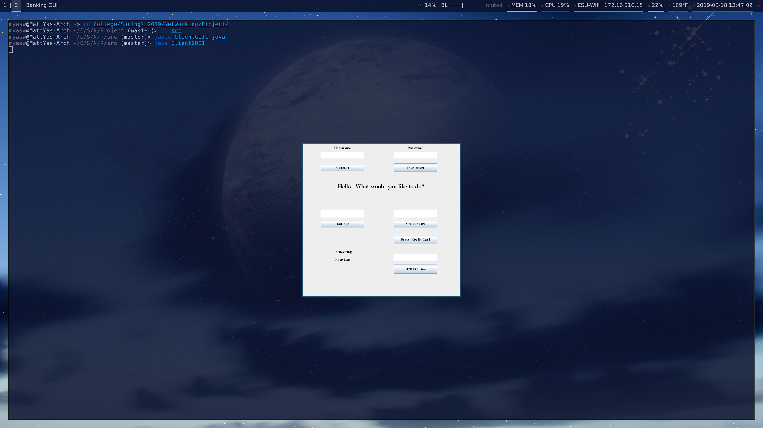

The user will be able to log in with the Username and Password at the top of the GUI. Once this is done, a message below these boxes saying “Hello [name]. What would you like to do?”

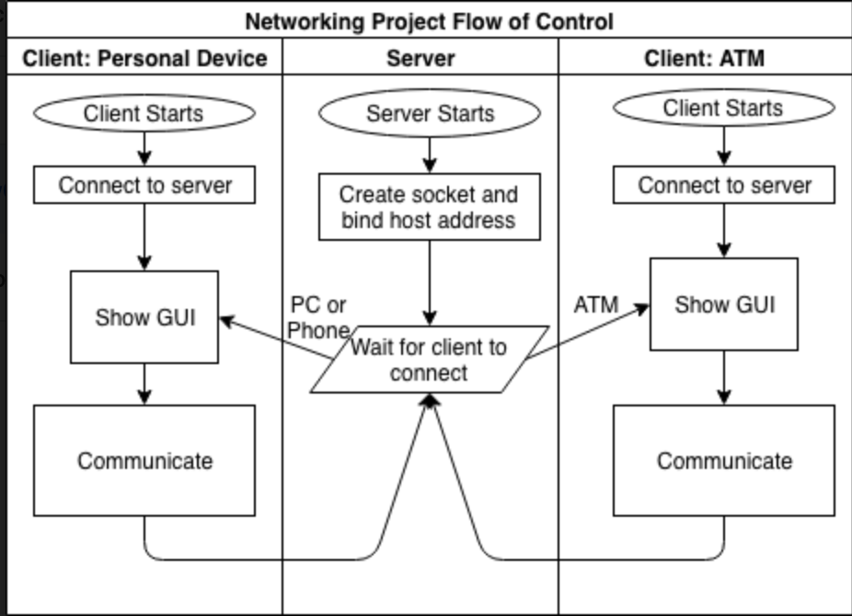 There are a number of ways that this could be used. One way is on a phone or a PC to manage a bank account. Many banks have an app for mobile for people to check their balance or transfer funds between accounts. This project is only on a local router, but if the ability to use it over the Internet were added, it would be possible to accomplish this. However, a more ready use for this program would he on an ATM. ATM's allow people to do a variety of things, such as withdraw money. A few more buttons would make it possible for this to be done.

The steps to use this program are as follows.