PENETRATION TESTING REPORT
FOOTPRINTING & NETWORK SCANNING PHASES
W2-PM1 & W2-PM5 | CYBERSECURITY | NETWORKWALKS
Pentester Name (Cybersecurity Intern) | Myat Hsu Hnin
Program/Batch | Networkwalks Cybersecurity & Ethical Hacking Internship ( B083 )
Date | 18 September 2026
Modules completed | W2-PM1 (Multiple Kali Tools)  W2-PM5 (Zenmap Scanning)  W2-PM-Final ( Pentest Report )
Client/Target | 1. Networkwalks (secured written permission already)  2. My own local LAN Network
Permission secured from client? | Yes
Phases covered | Phase 1: Reconnaissance & Footprinting  Phase 2: Scanning & Network Discovery  Phase 3-5: In Progress

1. Liability Disclaimer
I have performed these activities only on the systems & devices where I had secured written permission or the devices/systems that I own myself. All these materials are for education and research purpose only. Do not use anything from here to break the law. The instructor, the authors and Networkwalks are not responsible for what you do with this knowledge. Every action you take is your own responsibility. Misuse can lead to criminal charges, heavy fines, loss of your job and a permanent record. In most countries unauthorised access is a crime even when nothing is damaged.

2. Introduction
This report covers footprinting the networkwalks.com domain using multiple Kali Linux tools (W2-PM1) and scanning my own local network with Zenmap (W2-PM5). One module covers the footprinting phase and the other covers the scanning phase, so together they show how an attacker moves from gathering public information to mapping live hosts and open services on a network. It is the Week 2 part of my ongoing internship program at Networkwalks.
All commands were run in Kali Linux (footprinting) and on a Windows PC with Zenmap installed (scanning). Every step below includes the exact command used, the result I observed, a screenshot as evidence, and a short note on why the finding matters from an attacker's point of view.

3. Tools Used
The table below lists each tool used in this report and its purpose.
Tool | Purpose
Kali Linux & Windows | Operating systems used for reconnaissance and scanning activities
WHOIS | Find domain registration details (owner, dates, name servers).
WhatWeb | Fingerprint web technologies (server, CMS, plugins, IP).
Nslookup | Resolve the domain name to its IP address using DNS.
curl -I | Read the HTTP response headers of the website.
Wafw00f | Detect whether a Web Application Firewall protects the site.
DNSRecon | Enumerate DNS records (NS, MX, SPF, TXT, SRV).
Zenmap (Nmap GUI) | Scan local hosts/subnet to identify open ports and services.

4. Activities Performed

4.1 Footprinting & Reconnaissance
I performed reconnaissance against the networkwalks.com domain using six Kali Linux tools: WHOIS, WhatWeb, Nslookup, Curl, Wafw00f and DNSRecon. Each tool was used to collect a different type of information about the target.
WHOIS: I ran whois networkwalks.com to obtain publicly available domain registration information. The results showed the domain is registered with GoDaddy.com, LLC, created on 6 November 2019 and set to expire on 6 November 2027, with name servers NS6135.HOSTGATOR.COM and NS6136.HOSTGATOR.COM. The registrant contact details were privacy-protected via Domains By Proxy, LLC, and the domain has clientTransferProhibited, clientUpdateProhibited, clientRenewProhibited and clientDeleteProhibited status locks.
WhatWeb: I then used WhatWeb to identify technologies used by the website. The results identified an Apache web server running WordPress 7.1 with WordPress Download Manager 3.3.58, jQuery 3.7.1, Bootstrap 7.1, and the server IP address 192.232.216.135. The scan also showed the site redirects from HTTP to HTTPS and exposes a Google Tag Manager script and an admin contact email address in the page metadata.
Nslookup: Using nslookup against the Google public DNS resolver (8.8.8.8), I resolved the domain name to its IP address. The result confirmed 192.232.216.135, matching the IP identified by WhatWeb.
Curl: I used curl with the -I option to inspect the HTTP response headers. The response returned HTTP/2 200, an Apache server header, and a link header exposing the WordPress REST API endpoint /wp-json/, along with cookie, caching and referrer-policy headers.
Wafw00f: Next, I used Wafw00f to determine whether a Web Application Firewall was protecting the website. The result identified the site is behind ModSecurity (SpiderLabs) WAF.
DNSRecon: Finally, I used DNSRecon to enumerate DNS records for networkwalks.com. The results identified the SOA/NS records (ns6135.hostgator.com, ns6136.hostgator.com), an MX record pointing to mail.networkwalks.com (192.232.216.135), an SPF/TXT record authorising 50.87.144.87 and websitewelcome.com to send mail, a Google site-verification TXT record, and 8 SRV records for _autodiscover._tcp pointing to cPanel's email autodiscovery service.

4.2 Network Scanning with Zenmap
For the second activity, I used Zenmap (the Nmap GUI) to perform network scanning against my own local network. I ran two separate Quick Scans: one against my local subnet, 192.168.56.0/24, and one against the loopback address, 127.0.0.1, to check open ports on my own machine from both a network and a local perspective.
Scan 1 - Local subnet (192.168.56.0/24): Using the command nmap -T4 -F 192.168.56.0/24, Zenmap scanned all 256 addresses in the subnet. One host, 192.168.56.1, was found up (0.00029s latency), with 96 closed TCP ports and 4 open TCP ports: 80/tcp (http), 135/tcp (msrpc), 139/tcp (netbios-ssn) and 445/tcp (microsoft-ds). The full scan completed in 11.82 seconds.
Scan 2 - Loopback (127.0.0.1): Using the command nmap -T4 -F 127.0.0.1, Zenmap scanned the local loopback address. The host localhost (127.0.0.1) was found up (0.00035s latency), with 97 closed TCP ports and 3 open TCP ports: 80/tcp (http), 135/tcp (msrpc) and 445/tcp (microsoft-ds). This scan completed in 0.29 seconds and did not show port 139, which the subnet scan did report on 192.168.56.1.
After completing the scans, I opened the Topology section in Zenmap and saved the network topology in PDF format. The topology diagram shows my machine ("localhost") connected to two host entries discovered during scanning: localhost (127.0.0.1) and 192.168.56.1, reflecting the two interfaces/addresses scanned above.
Note: Because both scans were run against my own machine (via loopback and via its host-only/VirtualBox adapter address), only a single live host was returned per scan rather than multiple distinct devices. The open ports (HTTP, MSRPC, NetBIOS-SSN and Microsoft-DS/SMB) reflect local services and shares running on my own PC.

5. Risk Analysis / Impact
Based on the information collected during the footprinting and network scanning activities, I identified the following potential risks.
# | Risk / Finding | Evidence / Observation | Potential Impact | Risk Level
1 | Web technology information exposed | WhatWeb identified Apache, WordPress 7.1 and WordPress Download Manager 3.3.58, plus JQuery 3.7.1 version and other headers | Attackers may target known vulnerabilities in identified software versions | ● Medium
2 | Server IP address identifiable | Nslookup resolved networkwalks.com to 192.232.216.135 | Provides information about the network location of the web service | ● Low
3 | HTTP technical information exposed | curl -I returned response headers including a link header exposing the /wp-json/ REST API endpoint | May assist technology fingerprinting and further enumeration | ● Low
4 | WAF technology identifiable | Wafw00f identified the site is behind ModSecurity (SpiderLabs) WAF | Reveals information about the web application's security architecture | ● Low
5 | DNS infrastructure information exposed | DNSRecon identified SOA/NS records, an MX record, a TXT/SPF record and 8 SRV (autodiscover) records | DNS information can help build a broader infrastructure profile | ● Medium
6 | Local network hosts and open services visible | Zenmap quick scans identified HTTP (80), MSRPC (135), NetBIOS-SSN (139, subnet scan only) and Microsoft-DS/SMB (445) open on the scanned host(s) | Exposed SMB/RPC/NetBIOS services are common targets for lateral movement and exploitation if left unpatched | ● Medium

Risk level key: ● Critical ● Medium ● Low
The risks above are observations from the footprinting and scanning exercises, not confirmed vulnerabilities.
The practical exercises primarily involved information gathering and host/port discovery. No exploitation or vulnerability validation was performed as part of these two modules.
Therefore, the presence of information such as a software version, IP address, DNS record or open port does not by itself mean that the system is vulnerable. Further authorized security testing would be required to confirm any actual vulnerability.

6. Recommendations
Based on the observations from these activities, I recommend the following security improvements:
- Review publicly exposed technology information - Organizations should regularly review what information about their web technologies, CMS and plugins is publicly visible.
- Keep software updated - WordPress, WordPress Download Manager and other web technologies should be regularly updated and reviewed against current security advisories.
- Review HTTP headers - HTTP response headers should be reviewed to determine whether unnecessary technical information (such as the /wp-json/ endpoint) is being exposed.
- Review DNS records regularly - DNS records, including SRV and TXT entries, should be checked periodically to ensure that only required information and services are publicly exposed.
- Properly configure and monitor the WAF - Keep the WAF (ModSecurity) enabled and tuned, since it already blocks naive attacks.
- Close or restrict unnecessary local services - MSRPC, NetBIOS-SSN and Microsoft-DS/SMB should be disabled or firewalled off from untrusted networks unless they are required, since they are common targets for lateral movement.
- Perform regular internal network discovery - I should periodically scan my own network to identify active devices and open ports.
- Investigate unknown devices - Any unexpected device discovered during network scanning should be investigated and verified.
- Maintain network documentation - Network topology and device/port information should be documented and updated regularly.
- Perform security testing with authorization - Reconnaissance and scanning should only be performed against systems and networks where appropriate authorization has been provided.

7. Conclusion
During Week 2 of my Cybersecurity & Ethical Hacking internship, I completed practical activities covering footprinting, reconnaissance and network scanning.
In the footprinting activity, I used six Kali Linux tools to collect information about the networkwalks.com domain. I learned how WHOIS can provide domain registration information, WhatWeb can identify web technologies such as WordPress and its plugins, Nslookup can resolve domain names to IP addresses, Curl can inspect HTTP headers and expose API endpoints, Wafw00f can identify a WAF such as ModSecurity, and DNSRecon can enumerate DNS, mail and service records.
In the network scanning activity, I used Zenmap to run Quick Scans against my local subnet and my loopback address. This identified my machine as a live host on both, discovering open ports for HTTP, MSRPC, NetBIOS-SSN and Microsoft-DS/SMB, and I generated a network topology diagram of the scanned hosts.
The exercises showed me that information gathering is an important part of cybersecurity. Even before attempting to exploit a system, a security professional can learn a significant amount about an environment by carefully analyzing publicly available information and network scan responses.
I also learned that technical findings should be documented clearly. A good cybersecurity report should explain what was performed, what was discovered, what the observation means, what risk it may create, and what can be done to reduce that risk.
Finally, I learned that reconnaissance and scanning must always be performed within an authorized scope. These activities were completed as part of the assigned educational cybersecurity lab, against a domain for which permission was already secured and against my own local network.

8. Evidences Collected
1. WHOIS lookup - networkwalks.com
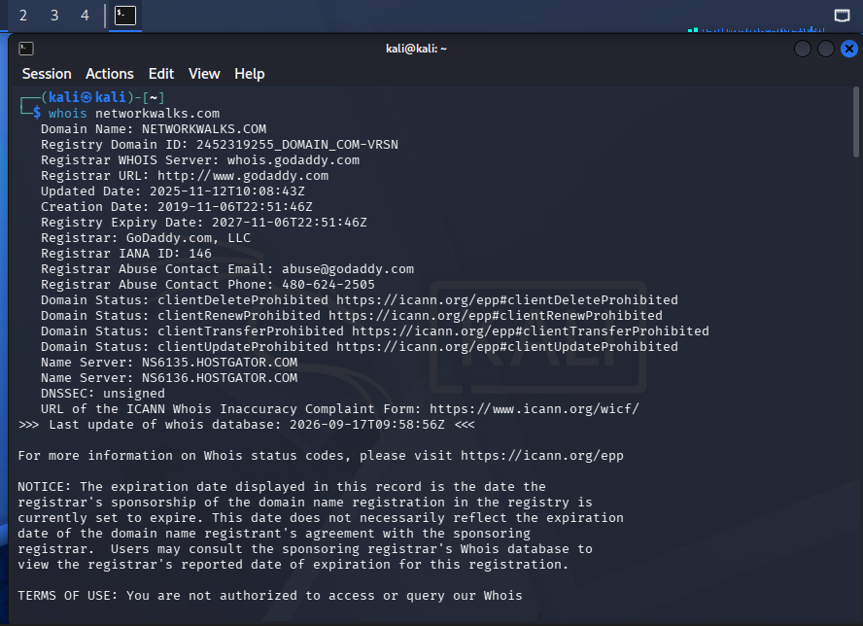
2. WhatWeb scan - networkwalks.com
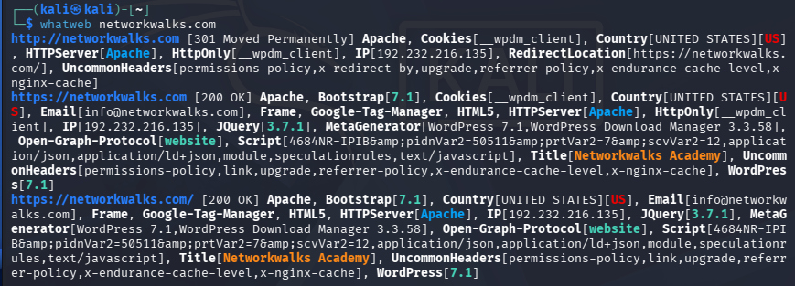
3. Nslookup - networkwalks.com
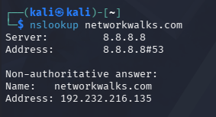
4. Curl -I HTTP headers - networkwalks.com
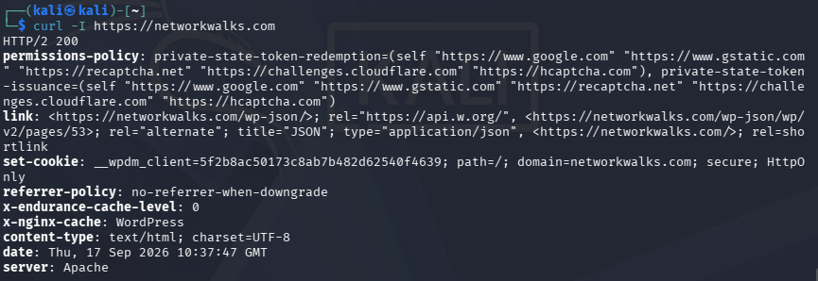
5. Wafw00f - networkwalks.com
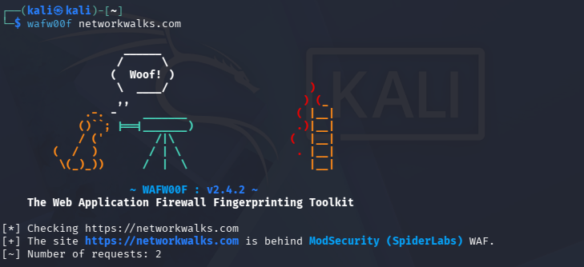
6. DNSRecon - networkwalks.com
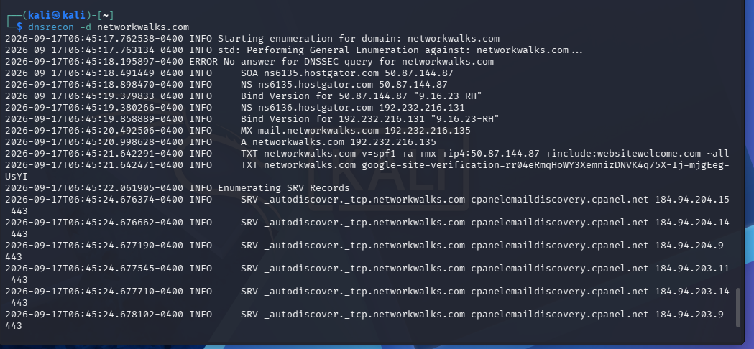

7. Zenmap Quick Scan - 192.168.56.0/24
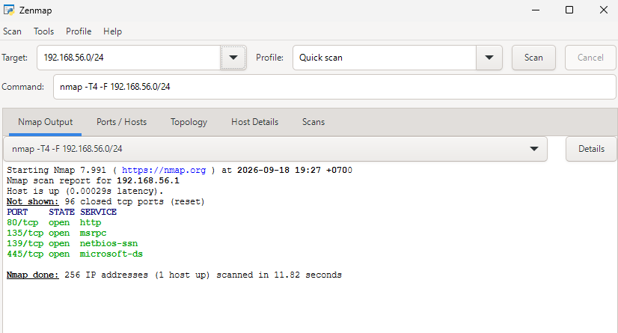
8. Zenmap Quick Scan - 127.0.0.1 (loopback)
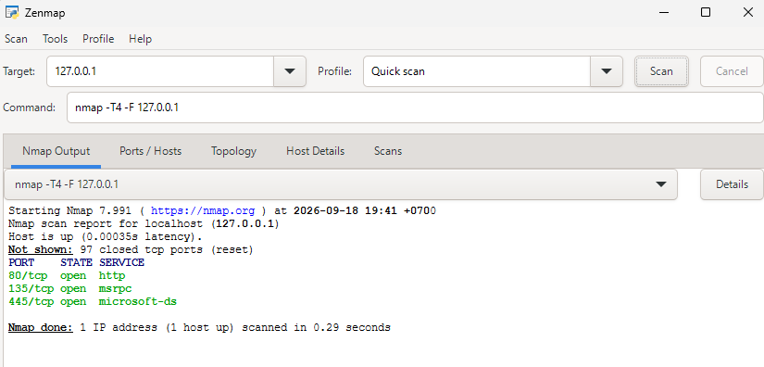

9. Zenmap Network Topology
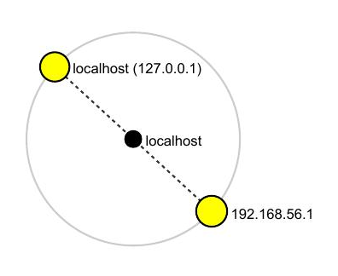

-End-
Author
Myat Hsu Hnin (Lana)
Cybersecurity Professional Intern, Networkwalks
Project Information
Program Name: Cybersecurity program at Networkwalks | Week: 02 | B083

