Report

Prepare:

Choose (Array size N as follow size) N=1m,N=1.5m,N=2m and t(separate number of threads) from 512,1024,2048 for this experiment.

Observation:

1. Performance of Different t on N=1.5m, cutoff is incremented by a factor of 10000 to 1500000

threads=512

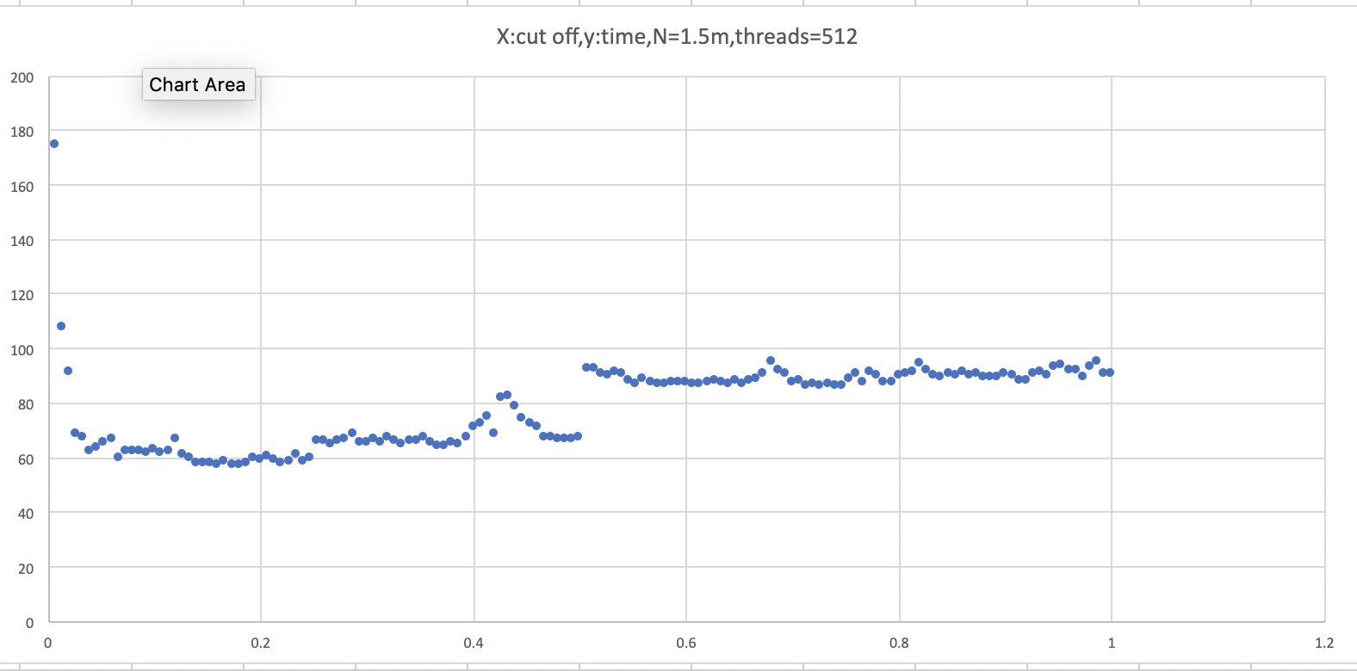

threads=1024

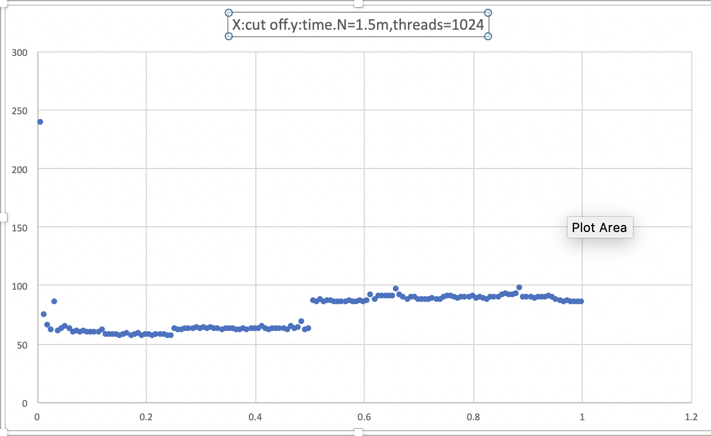

threads=2048

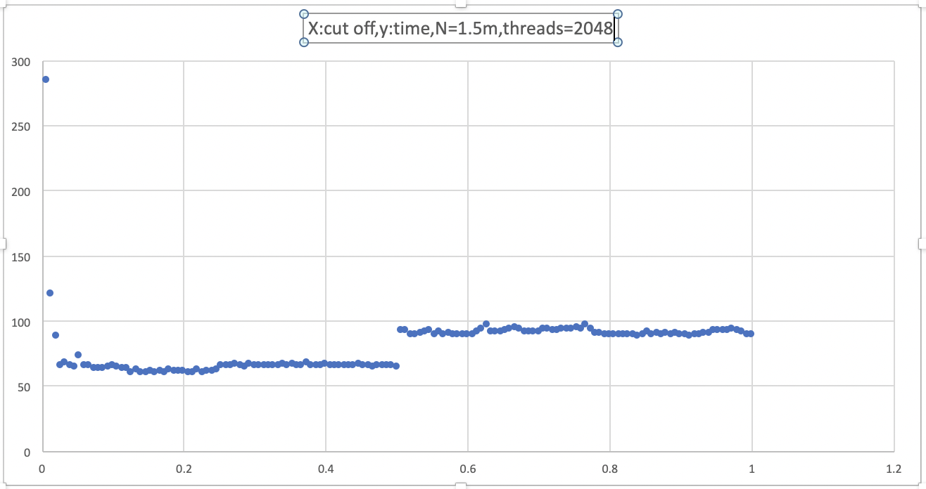

1. Performance of different N on threads=1024

N=1M, cutoff is incremented by a factor of 10000 to 1000000

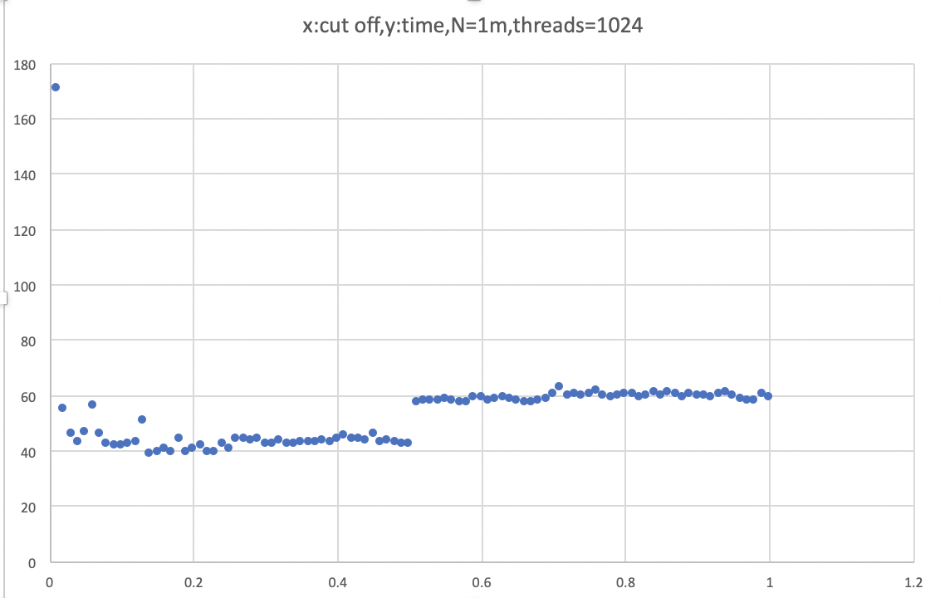

N=1.5M,cutoff is incremented by a factor of 10000 to 1500000



M=2M, cutoff is incremented by a factor of 10000 to 2000000

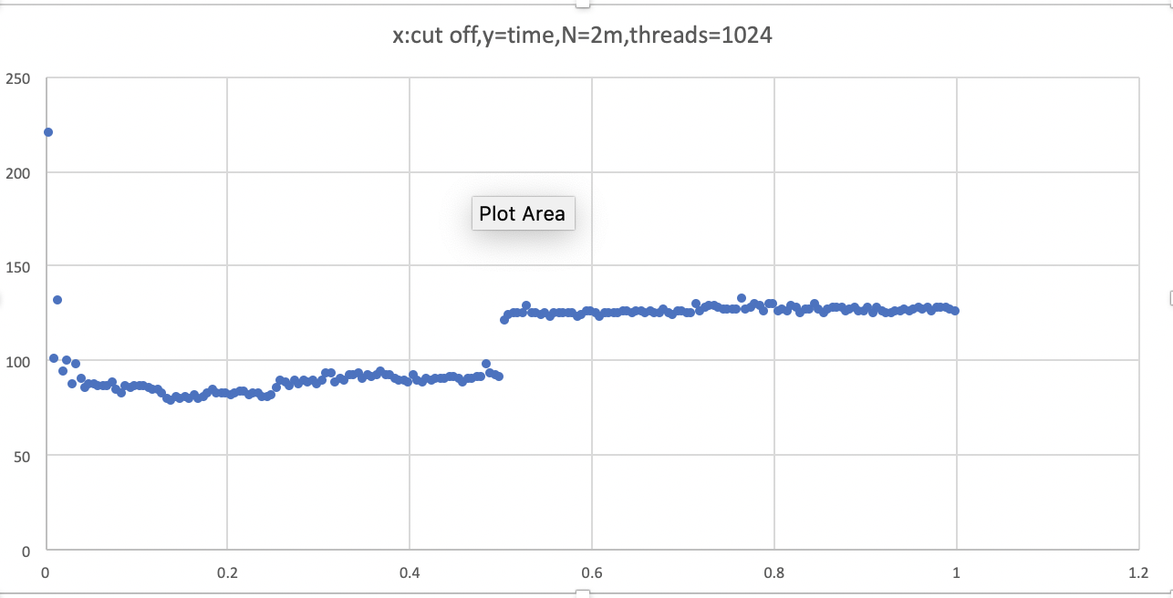

Conclusion:

The efficacy of this method of parallelizing sort can be concluded as following:

0<cutoff<N/4: best;

N/4<cutoff<N/2: good;

N/2<cutoff<N: general.

And the ideal number of separate threads in this case should be 1024.