Make-your-case.net user manual

Make-your-case.net aims at channeling debates towards clarity of thought and expression. It does that in a number ways:
- The layout forces you to make short statements
- There is a separation between a statement entered and beliefs in the truth of that statement. In other words, when you enter a statement, it doesn't mean you believe it's true. You can concentrate on the clarity of the statement and defer to convince other people about its truth or falsehood.
- You can use one short statement as support or attack for an other statement. You have to explicitly indicate what you consider the link between the two statements to be.
- You can compare your opinion with other people's opinion, and zooming in on the premises should help you narrow down the domain of disagreement with other participants.

Underlying concepts
User:
Users log in using their email and are identified on screen by their 'screen name'. You can change your screen name by using the command bar at the top of the screen:
'Go to' > 'Control panel' > 'My Account'
Don't change your screen name and email at the same time, or the system will get confused.
Statement (=Thesis):
Users can enter statements, which makes them owners of those statements. You can in theory enter any text you want for a statement, but the intended use is to enter text that you can debate about, i.e. claims, i.e. sentences that can be true or false. The application calls them theses.
Opinion:
Users can enter opinions about statements. They range from 0% meaning “I believe this statement is false” to 100% meaning “I believe this statement is true”. 50% would mean something like “I don't know / I have no opinion (yet)”.

Perspective:
Rather than associating opinions to Theses and Users, the system associates opinions to Theses and so-called 'Perspectives'. Users own perspectives. When a user logs in for the first time, the system creates a default perspective for that user, and all opinions entered by that user will be under hir/her default perspective. A user can however create extra perspectives to record and group opinions that are not necessarily his / hers. It's like practicing a chess-game: You also think about what your opponent is going to do.

Example
So for example in the table below, we have users Mary, Oliver and John.
John has entered a thesis: “Darwin was a eugenicist”
Oliver has entered two theses: “9/11 was an inside job” and “Free Trade agreements are good”

John believes his own thesis to be true: This is indicated by the TRUE entry at the intersection between thesis “Darwin was...” and perspective “John's default perspective”.
Oliver believes only one of his own theses: “9/11 is an inside job”, but doesn't believe in his other thesis, “Free trade agreements are good”. In addition, Oliver doesn't believe in John's statement on Darwin.

Mary agrees with Oliver on Darwin.

Now Oliver is in the process of dissecting the world bank's story. To that end he has created a new perspective: “Worldbank” and entered what he thinks is their opinion on free trade agreements. Oliver is doing the same thing with 911 debunker literature.

 | -----Thesis owners ----> | Oliver | John | Oliver
\/ Perspective  \/ owners \/  \/ | ----------Theses -------->  \/ Perspectives \/ | 9/11 inside job | Darwin was a eugenicist | Free trade is good
Mary | Mary's default perspective |  | FALSE
Oliver | Oliver's default perspective | TRUE | FALSE | FALSE
John | John's default perspective |  | TRUE
Oliver | Worldbank(oliver) |  |  | TRUE
Oliver | 911 debunker(oliver) | FALSE

'Implications':
In order to explain your beliefs, you can enter implications in the system that link one statement to another. Say for example that Mary doesn't believe that “Darwin was a eugenicist” because she believes that “Darwin never uttered the phrase 'Survival of the fittest'”, and she considers that to be a good argument. Then she can enter the utterance thesis into the system as a premise to the eugenicist thesis, and indicate what she thinks is the logical link between the two. On the other hand John has an argument for his position, namely “Some of Charles Darwin's relatives were eugenicists”. In turn he doesn't believe that Darwin never said “survival of the fittest”. The section below illustrates how that works with the system in practice:

Practical usage of the application
Views:
The application has two views to look at the data, and a number of entry forms. The two views are the “Focus view” where you focus on one statement and its linked statements, and the other view is the “List” view which lists all currently entered statements with opinions.

For example in the situation where only John has entered two statements, and Mary has given her opinions about them, the focus view could look as follows:

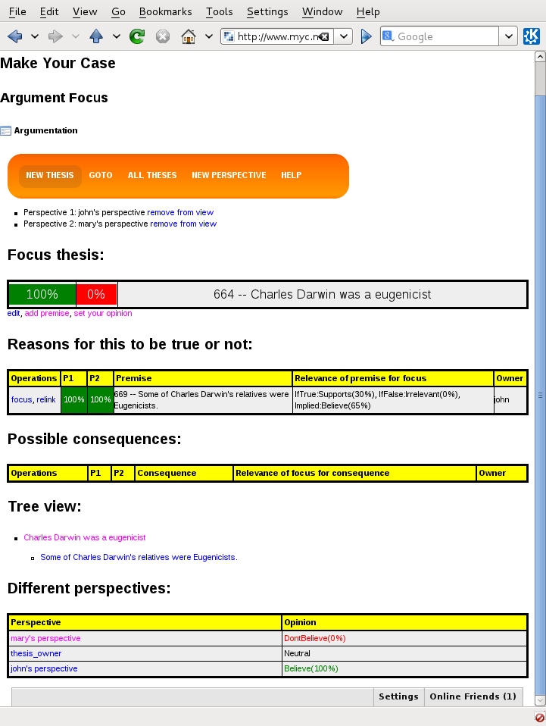

Below the orange menu, you see two selected perspectives, which you can add by clicking one of the links in the 'Different perspectives' table at the bottom.

The opinions of these selected perspectives will be shown on the left of every thesis.

In this case: Mary and John both believe that relatives of Darwin were Eugenicists, but Mary doesn't believe Charles himself was.

If you click 'all theses' in the menu at the top of the focus view, you get to see a table with all statements entered up to now:
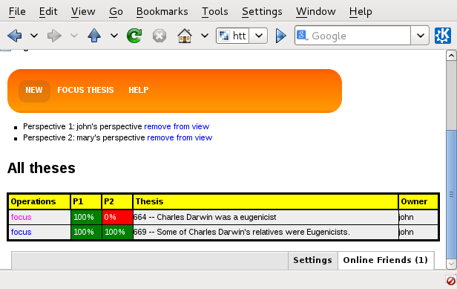

By clicking 'focus thesis' on the menu, you go back to the thesis you last focused on, or alternatively you can focus on a new thesis by clicking on the focus link to the left of every thesis listed.

The columns P1 and P2 are shorthand for the two perspectives currently selected and listed under the menu.

Entry forms:
Let's suppose Mary wants to enter her argument for not believing that Charles was a eugenicist. She heard somewhere that Charles never uttered the phrase 'survival of the fittest' and that it was Galton who came up with that phrase. She considers that to be a relevant rebuttal of John's thesis, and so she clicks the 'add premise' link below the focus thesis. (Note that you currently need to select one and only one perspective that you own to do that). She gets to the following form, and enters here 'premise' (which is actually a rebuttal):

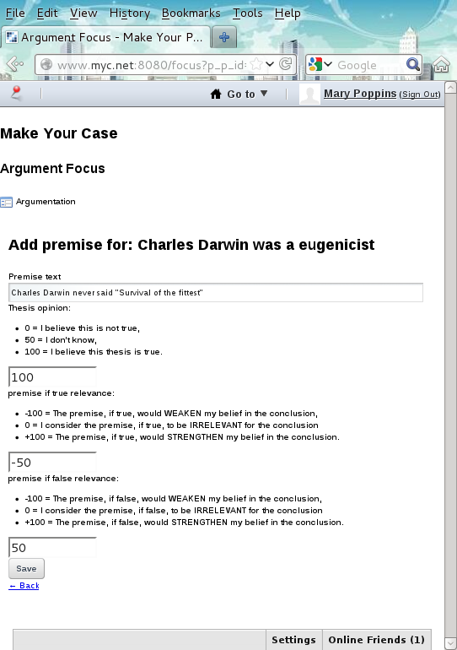

Mary enters the text for her new thesis, and declares to believe it to be true. She then, through the negative number, indicates that she considers this statement to be a rebuttal of the 'Charles Darwin was a eugenicist' thesis. In case she ever changes her mind about the truth of her premise, she also needs to enter the implicative value of the premise in case it would be false. Pressing the 'Save' button brings her back to the focus screen:

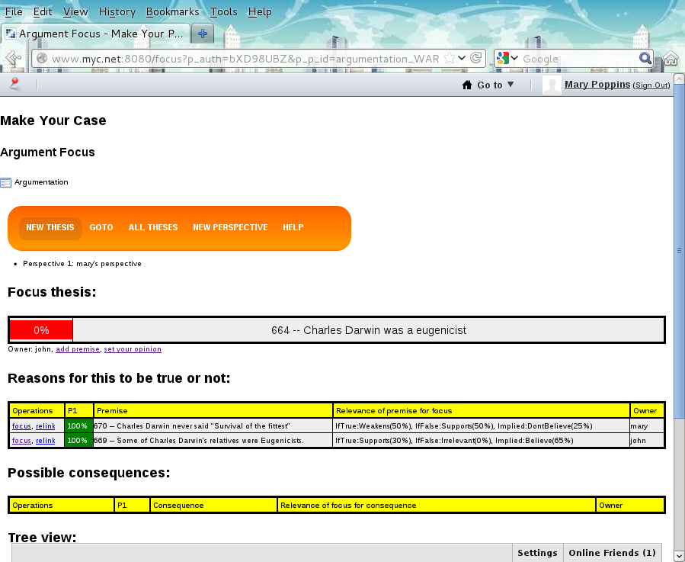

Mary's premise received a new thesis id: 670.

John believes that Mary's statement is actually not true. He focuses on statement 670, presses 'set your opinion' and enters 0%, declaring that he doesn't believe it. To make his point he adds a premise to 670, giving a reference to Darwin using that soundbite:

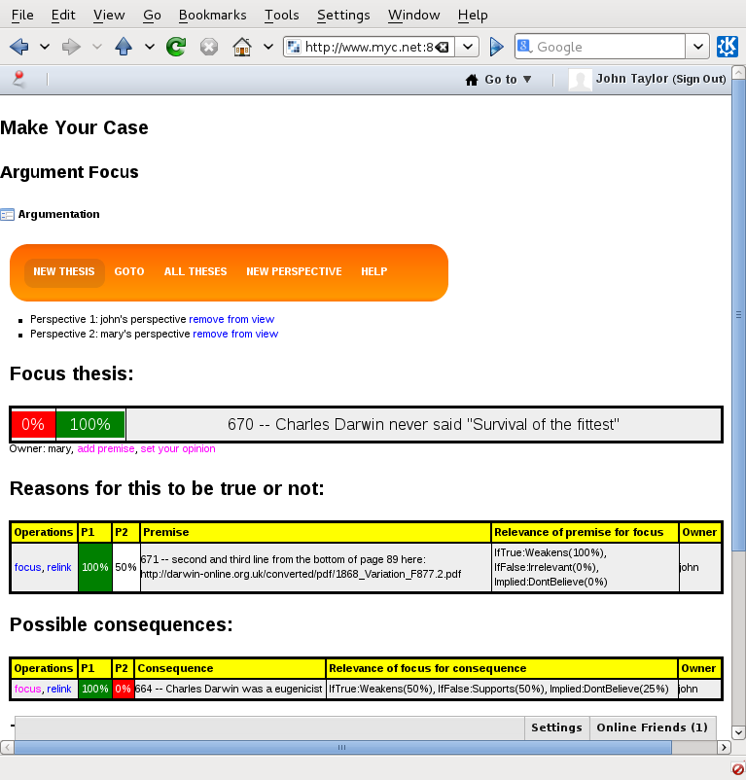
John's statement 671 is syntactically not a claim, but Mary gets the point so she changes her opinion about the quote. However she's still not convinced about Charles being a eugenicist, because she considers the thesis about his relatives to be irrelevant.

The situation then looks like this:

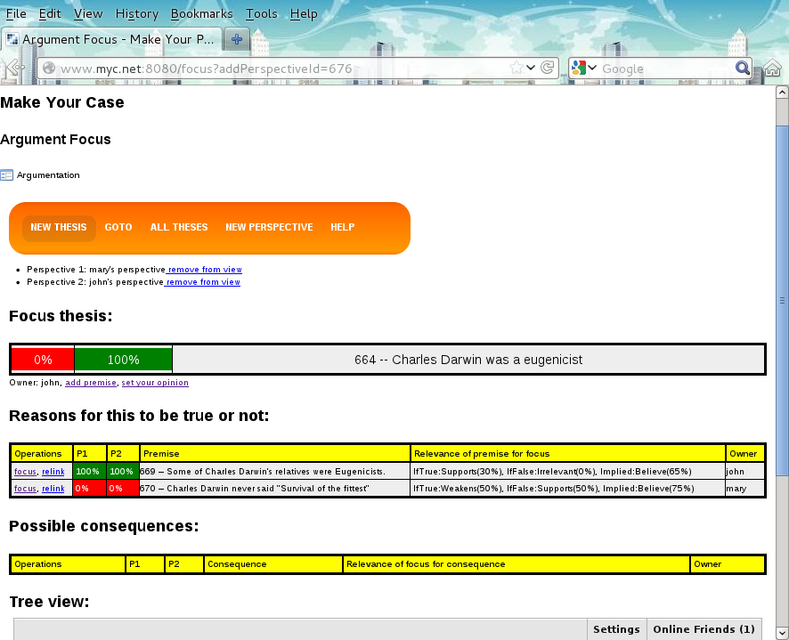
Both John and Mary agree about the premises, but don't agree on the conclusion.

The disagreement seems to be about the relevance of the premises for the conclusion.

This reason for disagreement (different views on relevance) can currently not be visualized with the application: The relevance is currently not linked to a perspective, so that the system cannot show two different perceived relevances. It's a feature that is on the todo list.

If you want to enter opinions from a different perspective, click 'new perspective' in the orange menu, and enter your desired name for the new perspective. That new perspective then gets listed at the bottom of the focus page, from where you can add it to the view. Make sure it's actually the ONLY perspective in the view when you want to enter opinions under that perspective.

This is a prototype application
The system has a number of limitations, among others:
- You can't delete theses / perspectives yet.
- You can't search for theses (use the total list as an alternative).
- You can't link pre-existing theses yet.
- If you put up an opinion about a thesis, then the owner of the thesis can edit that thesis after you entered your opinion, and it will look as if you have an opinion about the edited version, which you possibly don't.
- Implications are not perspective-dependent.
- No notification-emails sent.
- Etc.

The source code will be put up on github under gpl for interested programmers to join in the fun.

Bye, Olivier

