# HW5

Problem 1: (applying median filtering and removing small regions) trying threshold tau = 2.0; only showing first 4 images here

Tau = 5.

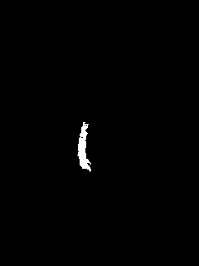

Tau = 10.

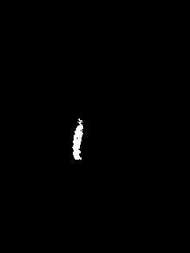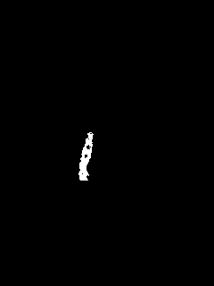

With tau = 5.0, the results are optimal hence the same threshold will be used for the following problem.

Problem 2: MEI and MHI results are below,

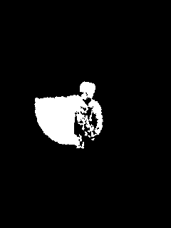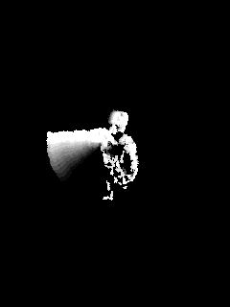

Moments:

MEI: [0.08722013960860057, 0.00041496852353821895, -0.011775202957566505, 0.008408659691687592, 0.12284102921948692, -0.006071683150264452, 0.003988965805995655]

MHI: [0.12183027371438664, 0.027301226307252305, 0.017811965660829654, 0.035814736622998465, 0.30047266245283566, 0.012759722363312836, -0.04330896564539259]

Problem 3:

The motion of the 4 sides is detected and shown to be moving either vertically or horizontally which is not exactly the direction the whole geometry is moving. Because the spatial derivates window is not large enough to detect the whole box moving.

Only the top left and bottom right edges show the correct moving directions. The other two edges have the opposite directions (I don’t know why)

