YUVAINTERN – PYTHON DEVELOPER INTERNSHIP
TASK 2: CORE PYTHON CONCEPTS AND PRACTICAL PROJECTS
Student Name: [T.Nandhini]
Course: B.Tech – Computer Science and Engineering (AI & ML)
Internship Role: Python Developer Intern
Internship Duration: 8 Weeks
Organization: YuvaIntern

1. INTRODUCTION
Python is a high-level, interpreted, general-purpose programming language known for its simple syntax and readability. It is widely used in software development, data science, artificial intelligence, machine learning, and web development.
This task focuses on learning Python fundamentals and applying programming concepts through practical exercises and mini-projects.
2. OBJECTIVES
- Understand Python fundamentals and syntax.
- Learn variables and different data types.
- Perform operations using Python operators.
- Implement conditional statements and loops.
- Create and use functions.
- Understand Python data structures.
- Learn object-oriented programming.
- Handle exceptions effectively.
- Perform file handling operations.
- Develop practical Python applications.
3. SOFTWARE AND TOOLS USED
Tool | Purpose
Python 3.14 | Programming language
Visual Studio Code | Code editor
Git | Version control
GitHub | Repository management
Windows 11 | Operating system

4. PYTHON FUNDAMENTALS
This section covers the basic concepts of Python programming.
Topics covered:
- Variables
- Data types
- Strings
- Numbers
- Type conversion
- Variable scope
- User-defined variables and values
Practical exercises were performed to understand how Python stores and processes information.
5. OPERATORS
Python operators are used to perform operations on values and variables.
Types covered:
- Arithmetic operators
- Comparison operators
- Logical operators
- Assignment operators
- Membership operators
These operators were implemented through practical programs.
6. CONDITIONAL STATEMENTS
Conditional statements allow programs to make decisions based on conditions.
Topics covered:
- if statement
- if-else statement
- if-elif-else statement
- Nested if statements
Programs were developed to understand decision-making in Python.
7. LOOPS
Loops are used to execute a block of code repeatedly.
Topics covered:
- for loop
- while loop
- break statement
- continue statement
- Nested loops
Practical programs were executed to understand repetition and iteration.
8. FUNCTIONS
Functions are reusable blocks of code that perform specific tasks.
Topics covered:
- Function definition
- Function calling
- Parameters and arguments
- Return statements
- Default arguments
- Keyword arguments
- Recursive functions

9. DATA STRUCTURES
Python provides different data structures to store and organize information.
The following were practiced:
- Lists
- Tuples
- Sets
- Dictionaries
Operations such as adding, removing, accessing, and updating elements were implemented.
10. OBJECT-ORIENTED PROGRAMMING
Object-oriented programming organizes code using classes and objects.
Concepts covered:
- Classes and objects
- Constructors
- Inheritance
- Polymorphism
- Encapsulation
Practical programs were developed to understand object-oriented programming concepts.
11. EXCEPTION HANDLING
Exception handling helps manage runtime errors and prevents unexpected program termination.
Topics covered:
- try and except blocks
- Handling multiple exceptions
- finally block
- raise statement
Different examples were executed to understand error handling.

12. FILE HANDLING
File handling allows Python programs to create, read, write, and update files.
Operations performed:
- Creating files
- Writing data into files
- Reading file contents
- Appending data to files
These operations were practiced using Python file handling methods.
13. PRACTICAL PROJECTS
Three practical projects were developed as part of this task.
13.1 Student Marks Management System
This project manages student marks and calculates academic results using Python programming concepts.
13.2 Contact Management System
This project helps manage contact information, including adding and displaying contact details.
13.3 Library Management System
This project demonstrates basic library operations, including managing book information and records.
14. PRACTICE PROGRAMS
The following practice programs were implemented:
- Even or Odd Number
- Factorial
- Prime Number
- Palindrome
- Fibonacci Series
These exercises improved logical thinking and programming skills.

15. TESTING AND SCREENSHOTS
All developed Python programs were executed using Visual Studio Code.
Screenshots of program execution were captured and organized in the project folder.
Test cases were prepared to verify the expected behavior of the programs.
PROGRAM EXECUTION SCREENSHOTS
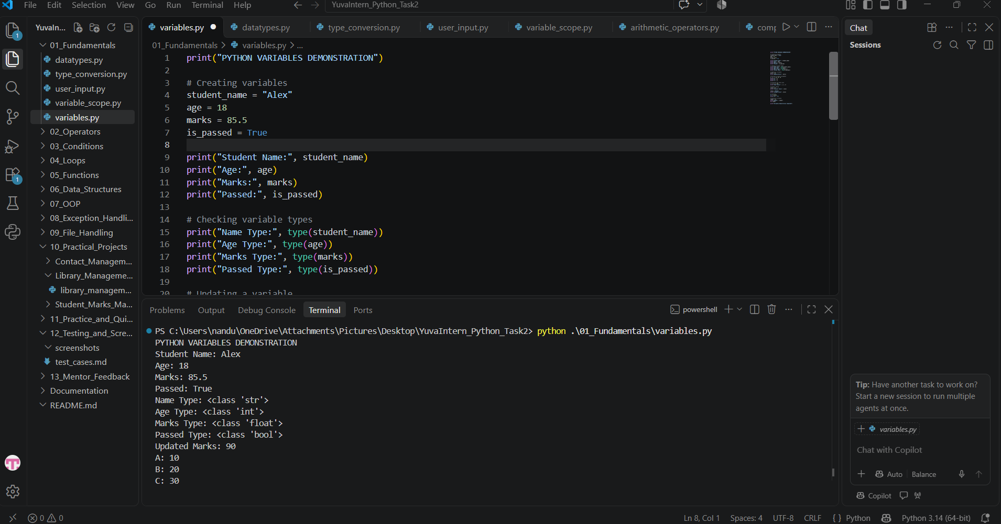
Figure 1: Execution of Python Variables Program
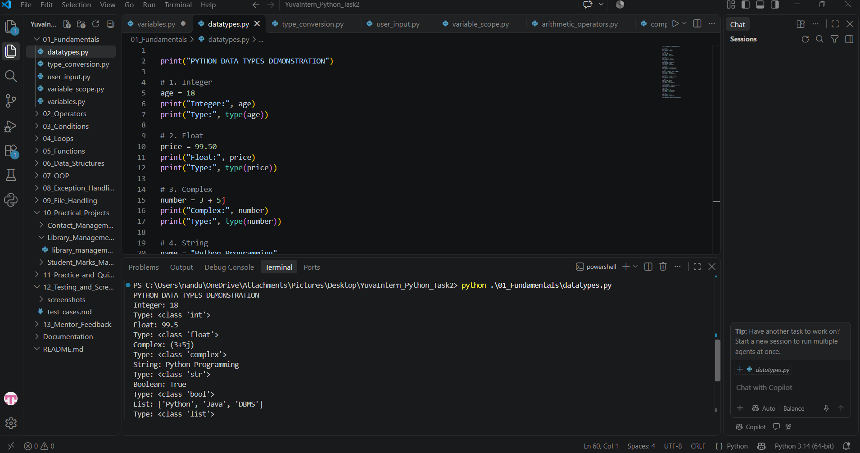Figure 2: Execution of Python Data Types Program
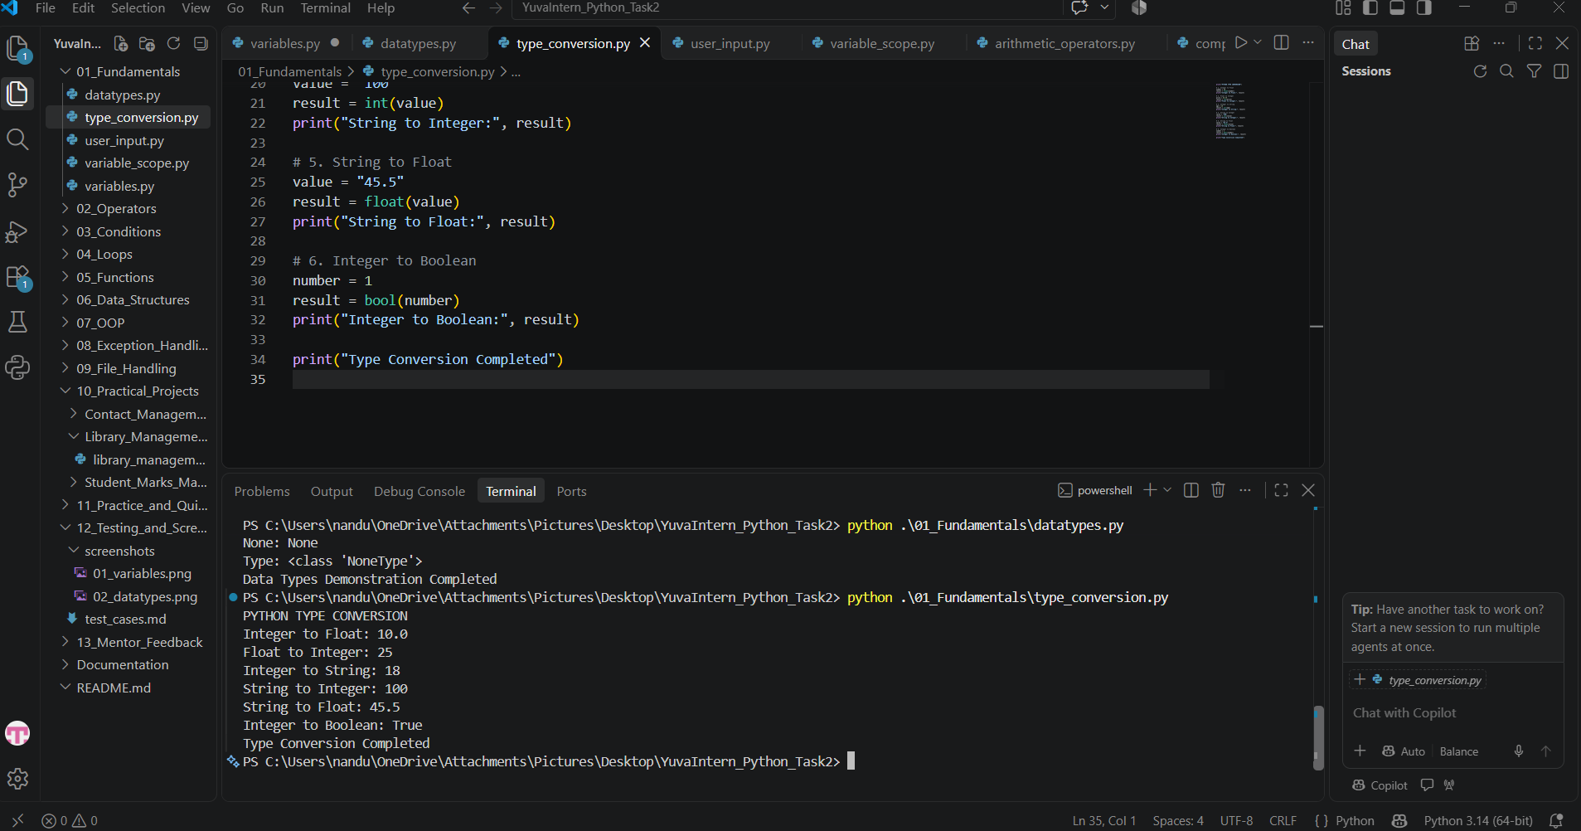
Figure 3: Type Conversion
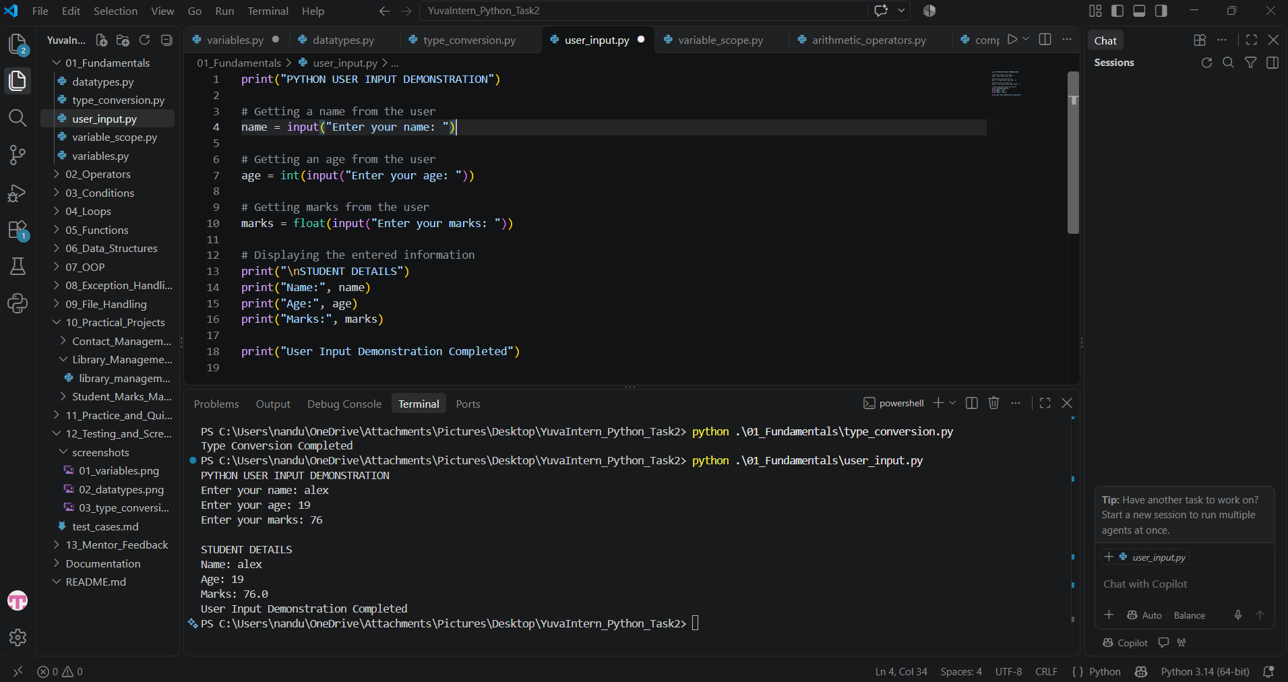
Figure 4: Arithmetic Operators
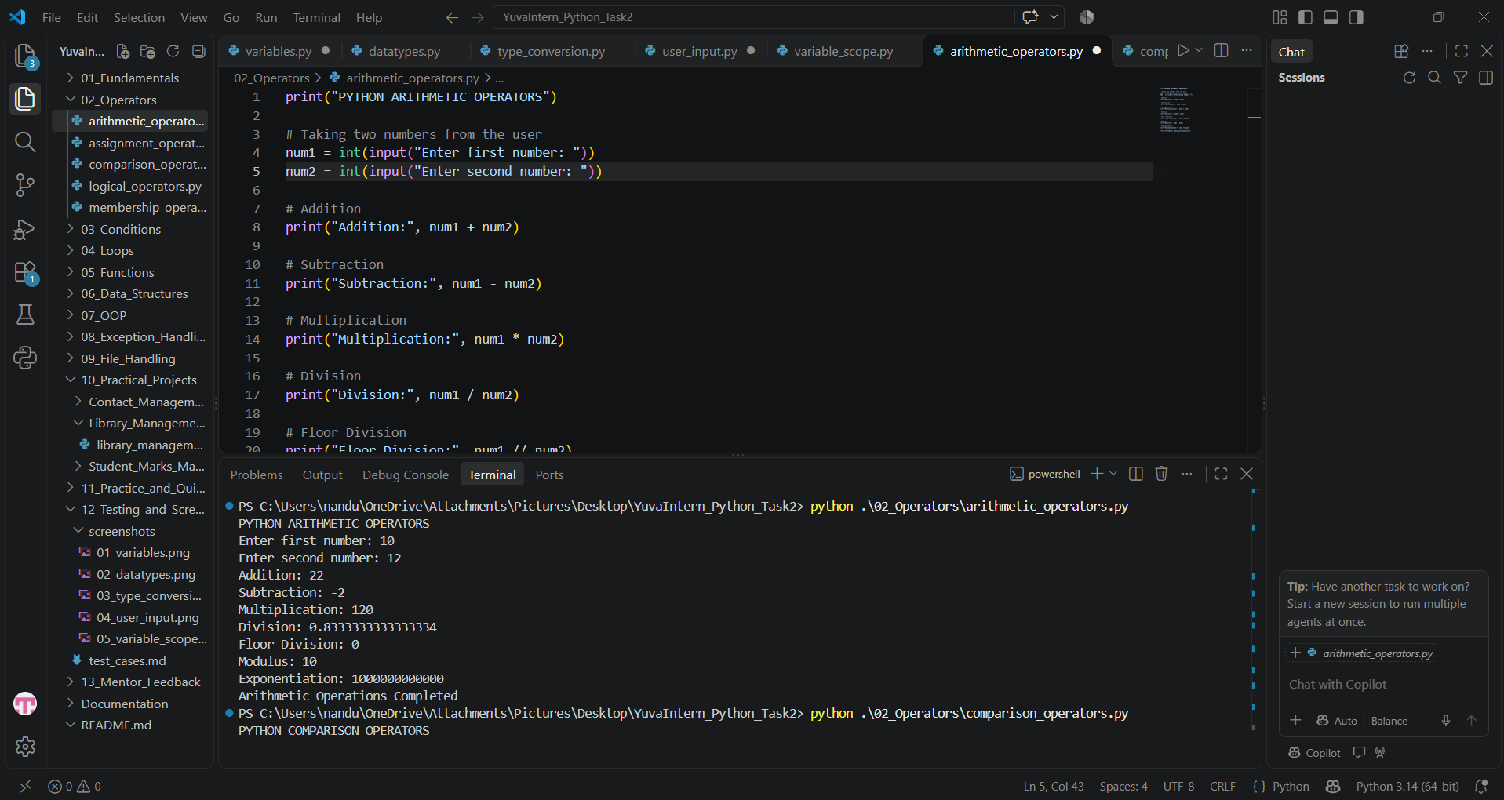
Figure 5: For Loop
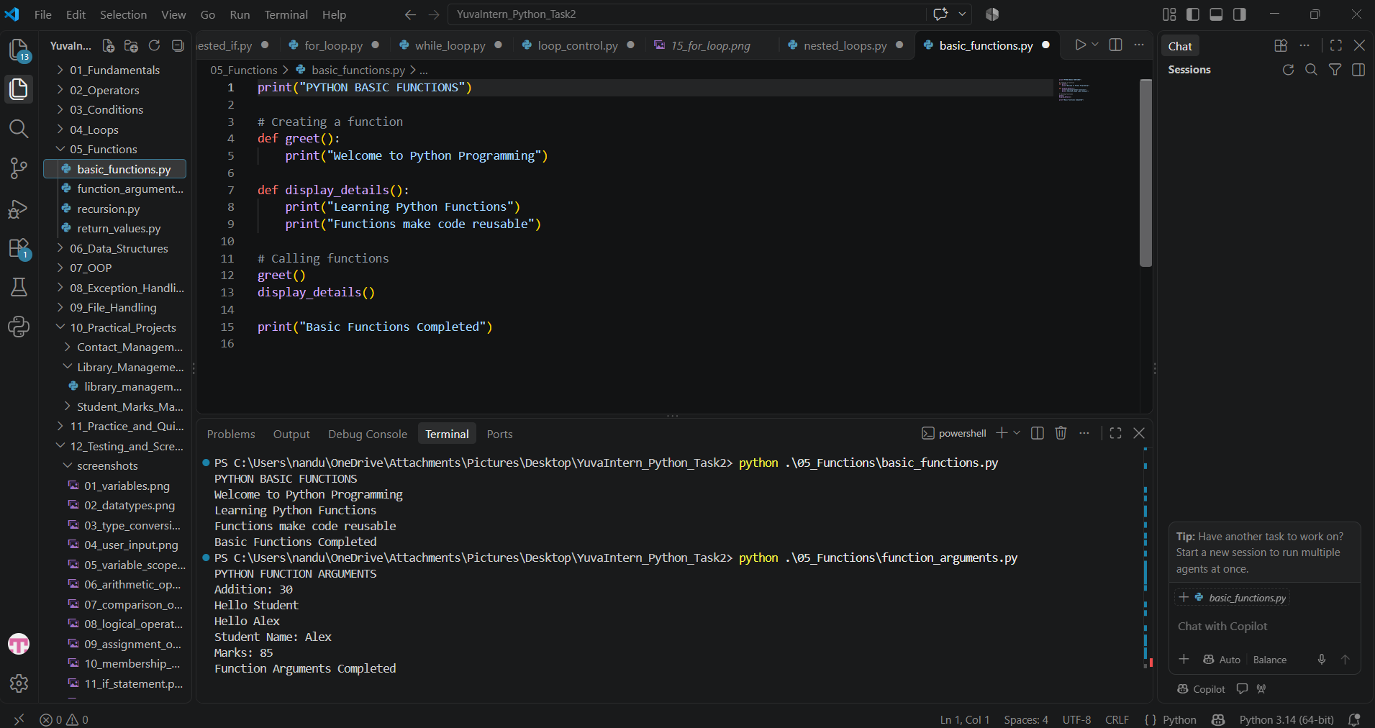
Figure 6: Functions
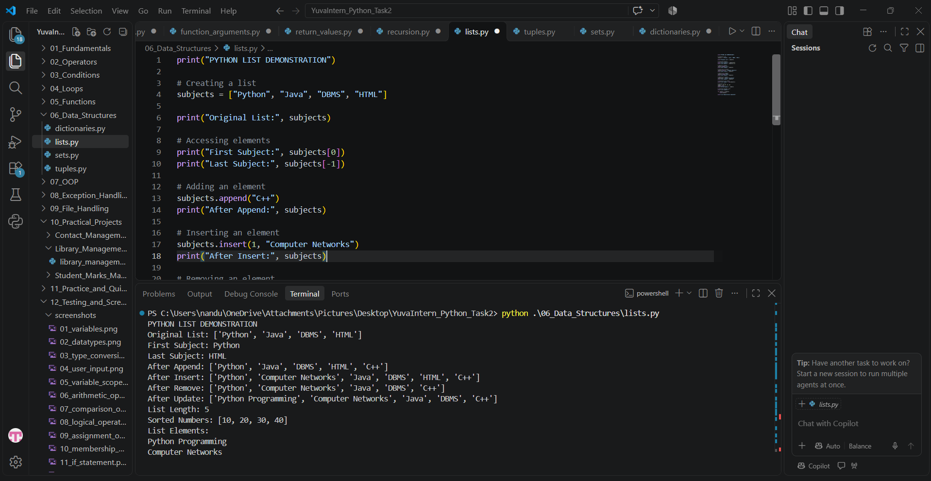
Figure 7: Lists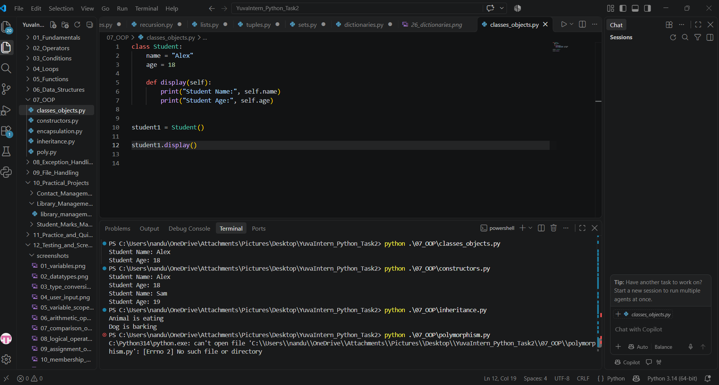
Figure 8: Classes and Objects
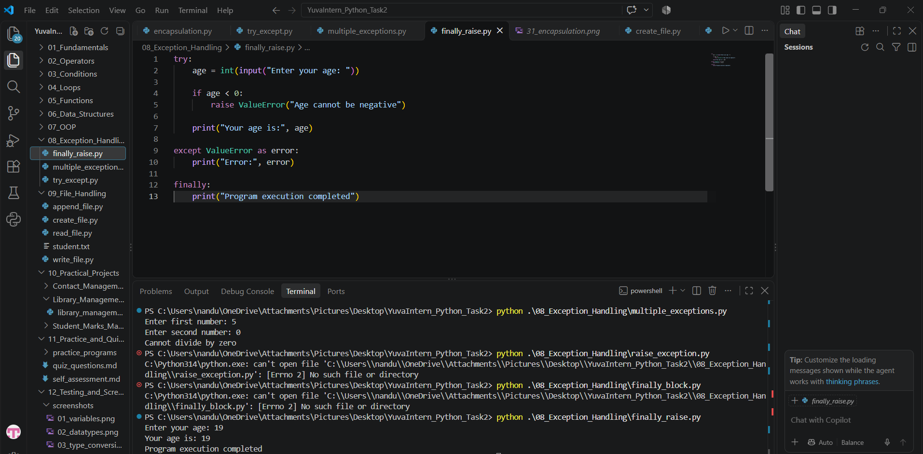
Figure 9: Exception Handling
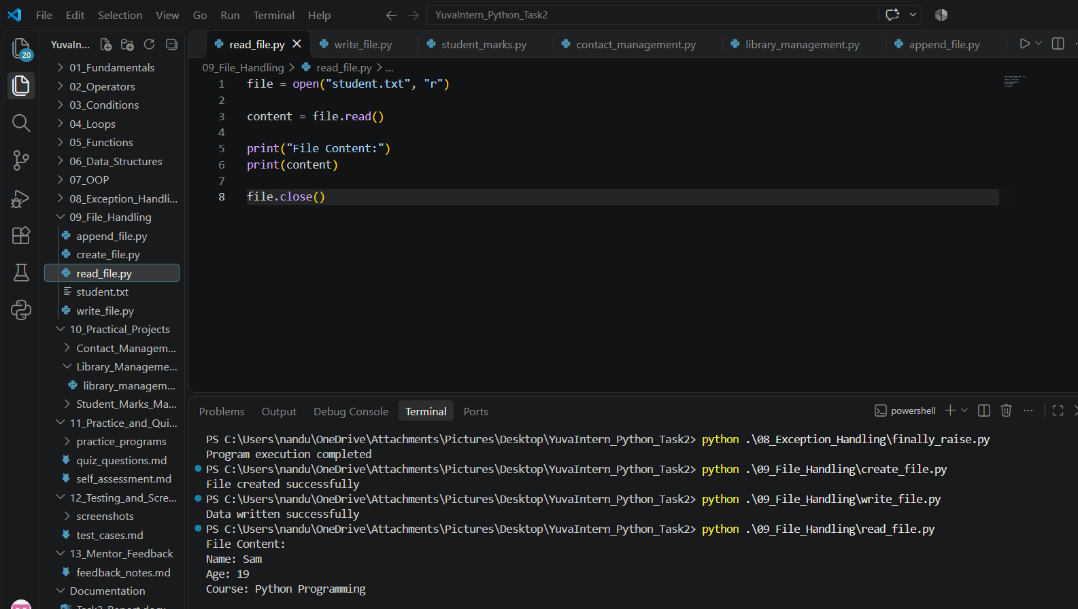
Figure 10: File Handling
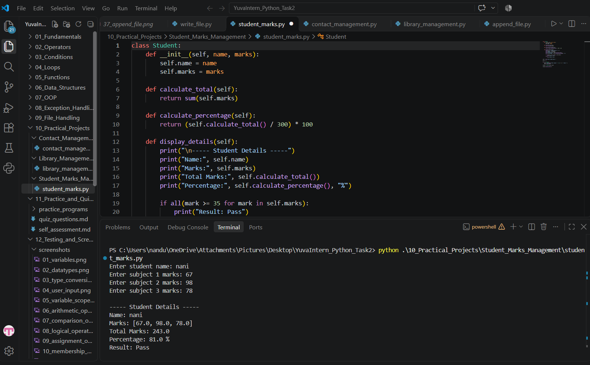
Figure 11: Student Marks Project
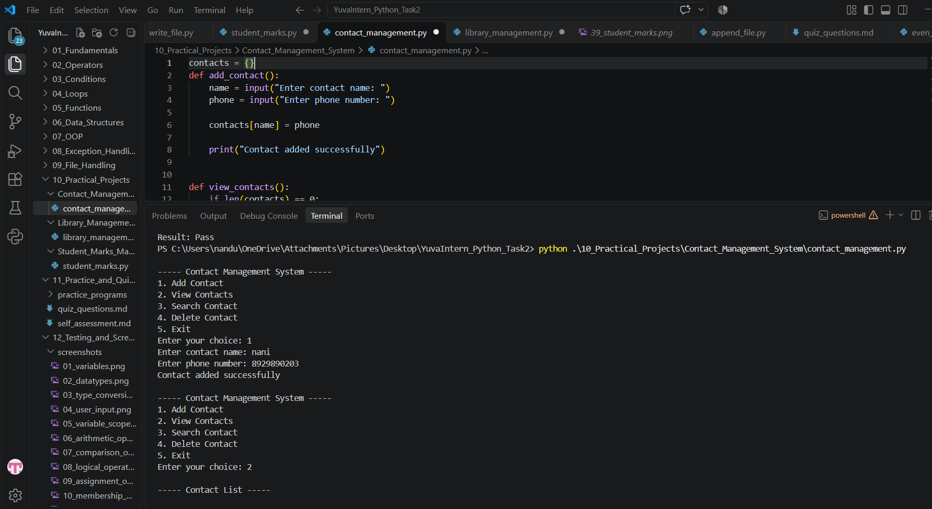
Figure 12: Contact Management Project
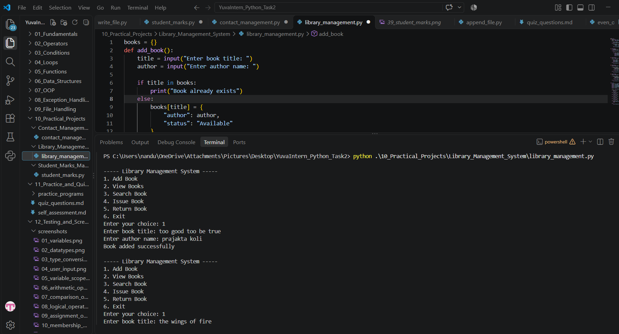
Figure 13: Library Management Project

16. LEARNING OUTCOMES
Through this task, I gained practical experience in:
- Python programming fundamentals.
- Writing and executing Python programs.
- Using loops and functions.
- Working with Python data structures.
- Implementing object-oriented programming.
- Handling runtime exceptions.
- Performing file operations.
- Developing basic real-world applications.
- Debugging and testing programs.
17. VERSION CONTROL USING GIT AND GITHUB
Git and GitHub were used to manage the project files, track changes, and maintain the project repository online. Git helped maintain version history, while GitHub provided an online platform to store and share the project.
Git Commands and Their Explanations
- git init
Initializes a new Git repository in the project folder. It creates the necessary repository information to start tracking changes.
- git status
Displays the current status of the working directory and shows modified, staged, and untracked files.
- git add .
Adds all changes in the current project directory to the staging area.
- git add -A
Stages all changes, including new files, modified files, and deleted files.
- git commit -m "message"
Saves the staged changes as a commit with a meaningful message. This helps maintain a record of project updates.
- git branch -M main
Renames the current branch to main.
- git remote add origin repository_url
Connects the local Git repository to the remote GitHub repository using its URL.
- git push -u origin main
Uploads the committed project files to the main branch of the GitHub repository and establishes the upstream tracking relationship.
- git push
Uploads new local commits to the connected GitHub repository.
Outcome
Using Git and GitHub helped organize the project, maintain version history, track modifications, and publish the completed Python internship project online.

18. CONCLUSION
The YuvaIntern Python Developer Internship – Task 2 provided me with valuable practical experience in Python programming. Throughout this task, I learned and implemented important concepts such as variables, data types, operators, conditional statements, loops, functions, data structures, and object-oriented programming.I also gained practical knowledge of exception handling and file handling by developing and executing different Python programs. Additionally, I developed three mini-projects: Student Marks Management System, Contact Management System, and Library Management System.
Using Visual Studio Code, Git, and GitHub helped me improve my coding, debugging, and project organization skills.
Overall, this internship task strengthened my programming fundamentals, logical thinking, and problem-solving abilities. It has provided me with a strong foundation for learning advanced Python concepts and building real-world software applications.
END OF REPORT

