Birhan Energies
What 35 Years of Brent Crude Prices Tell Us About Shocks, Shifts, and Uncertainty
Change Point Analysis of Brent Oil Prices
Oil markets move on headlines — a war, an OPEC decision, a pandemic — but knowing that a price shock happened is different from being able to say when the market’s underlying behavior actually changed, and by how much. This project applies Bayesian change point detection to 35 years of daily Brent crude prices (1987–2022) to find and quantify a structural break, then asks a harder question: does the data support pinning that break to a single cause, or is the real picture messier than that?

The data
The dataset covers 9,011 daily Brent price observations, from 1987-05-20 to 2022-11-14 (slightly beyond the originally stated end date of Sep 2022 — the source file simply extends further; noted as a minor data quality quirk rather than a problem). Prices range from $9.10 to $143.95 per barrel, with a mean of $48.42.
Alongside the price series, we compiled a structured dataset of 15 major events spanning the full history — wars, OPEC policy shifts, sanctions, and market shocks — categorized and dated, to compare against whatever the statistical model finds.

Getting the data ready
Two real data-quality issues surfaced during preparation, both handled before modeling:
- Inconsistent date formats. The source CSV silently switches from DD-Mon-YY (e.g. 20-May-87) to "Mon DD, YYYY" (e.g. "Apr 22, 2020") partway through, around April 2020. Pandas’ format='mixed' parsing handled this correctly.
- Non-stationarity. An Augmented Dickey-Fuller test confirmed the raw price series is non-stationary (p ≈ 0.29 — fails to reject a unit root), as expected for a trending price series. Daily log returns, by contrast, are strongly stationary (p ≈ 0.0000), making them the statistically appropriate input for the change point model rather than raw prices.
Log returns also revealed clear volatility clustering — periods of noticeably higher day-to-day variance clustered around 2008-09, 2014-16, and 2020, consistent with known crisis periods rather than random noise.

The model
We built a single change-point Bayesian model in PyMC:
- tau — the unknown break point, with a discrete prior over every day in the series
- mu_1, mu_2 — the average daily log return before and after tau
- sigma — a shared volatility parameter
- A Normal likelihood, with the mean switched between mu_1 and mu_2 depending on where each day falls relative to tau
Getting this to converge properly took real iteration. The default sampler for a discrete tau over ~9,000 candidate days mixes poorly — it’s a random walk over a huge space and simply doesn’t explore it in a reasonable number of iterations. Switching to a CategoricalGibbsMetropolis step (which samples tau from its exact conditional distribution each iteration, rather than taking small local steps) brought convergence from clearly broken (r_hat = 1.56 for tau) down to acceptable (r_hat = 1.02), with divergences dropping from 440 to 15.

What the model found
The dominant signal points to late March–April 2020: the primary mode of the posterior distribution for tau sits at April 21, 2020, with 20.4% of the posterior mass concentrated around March 13, 2020. This aligns closely with two real events in our researched dataset:
- Saudi-Russia oil price war begins (March 8, 2020) — just 5 days before the secondary posterior peak
- WTI futures turn negative (April 20, 2020) — one day before the primary detected change point
Quantitatively, the average daily log return shifted from roughly +0.00006 before the break to +0.00065 after it — a large relative change, though it’s worth being precise about what this means: daily log returns are naturally tiny and noisy, so this reflects a shift in the distribution of daily moves (including a much wider swing during the post-break period) more than a simple "prices went up." The posterior gives roughly a 63% probability that the mean return increased after the break point — meaningful evidence, not a certainty.
Rather than stopping there, we also examined the full shape of the tau posterior instead of only its single mode. Two secondary candidate change points emerged:
- ~6.3% mass around July 2022 — roughly five months after Russia’s invasion of Ukraine (Feb 24, 2022), plausible as a delayed sanctions and supply-disruption effect
- ~4.7% mass around September 1987 — early in the series, likely an artifact of limited data at the start of the sample rather than a genuine economic signal

Correlation, not proof
It’s tempting to read "the model found a change point near event X" as proof that X caused the shift. It doesn’t. A detected tau is a statistical break in the data’s behavior — the model has no knowledge of real-world events. The alignment between our detected change point and the 2020 oil price war / negative-futures crash is a strong, plausible hypothesis, made more credible by how tightly the dates line up and how well-known that crisis is — but establishing actual causation would require a counterfactual framework (e.g. synthetic control methods) that’s beyond this project’s scope. We treat the model’s output as a lead worth investigating, not a verdict.
This also motivates the more honest framing above: rather than reporting only the single most probable date, presenting the top few candidate regions by posterior mass gives a fuller — and more defensible — picture of what a single change-point model can and can’t tell us about a 35-year series that almost certainly contains more than one real structural break.

The dashboard
To make these results explorable rather than static, we built a small full-stack dashboard: a Flask API serving the processed price series, event data, and model results, and a React frontend visualizing all three together.
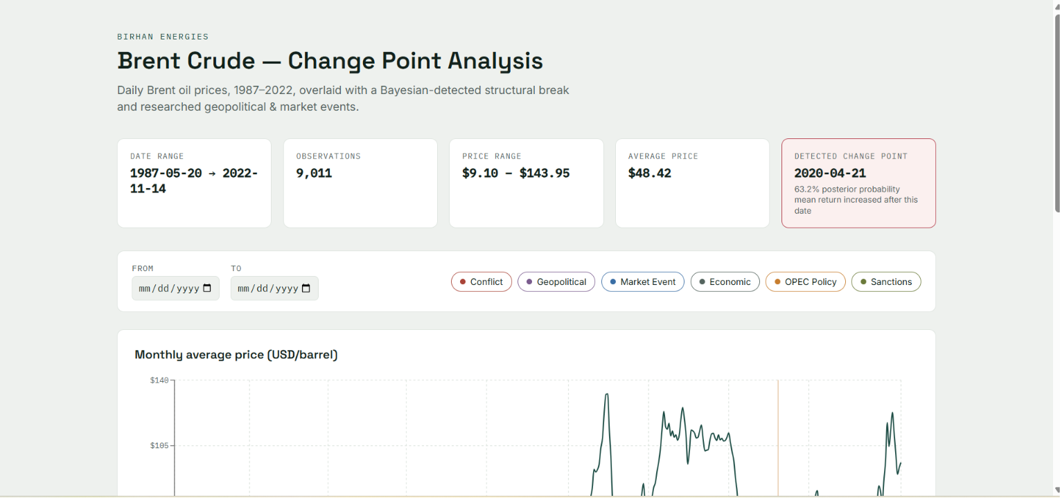
Dashboard overview: summary stats and header
The main chart overlays the monthly-averaged price series with a dashed reference line at the detected change point, alongside thin reference lines for every researched event — colored by category so patterns (e.g. conflicts clustering vs. sanctions clustering) are easy to spot visually.
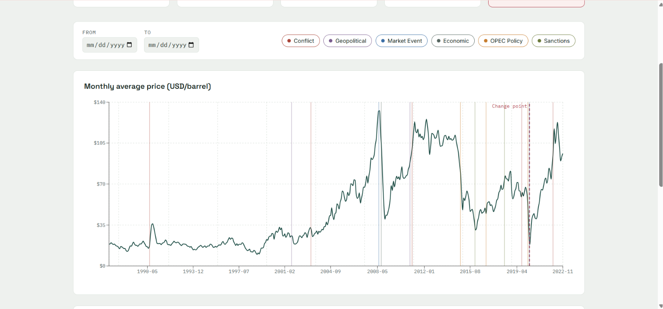
Price chart with change point overlay, correctly positioned at April 2020
Users can filter by date range and toggle event categories on/off, with a scrollable event list underneath giving the full description of each event.
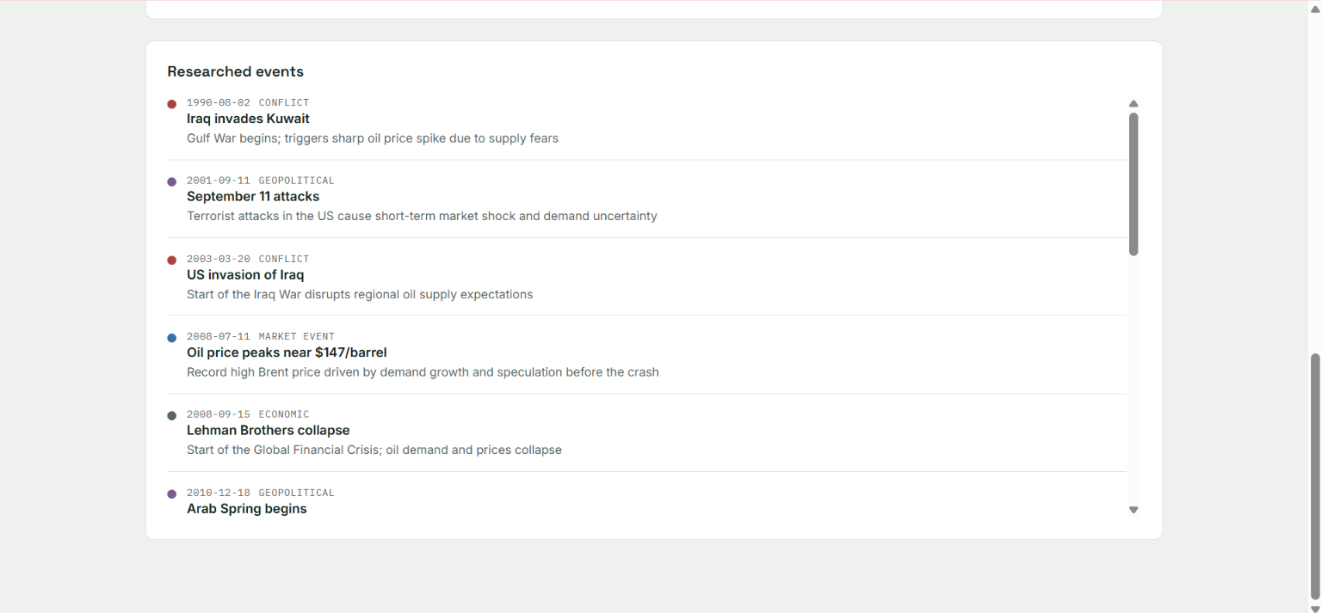
Filterable event list

Limitations
- Single change point only. The model assumes exactly one structural break exists. Given the visibly multi-regime nature of oil prices over 35 years (1990, 2008, 2014-16, 2020, 2022 are all visible shocks in the raw data), a multiple change-point model — or a Markov-switching model that explicitly models "calm" vs. "volatile" regimes — would likely capture the full picture more faithfully. This is the most direct next step.
- Shared volatility parameter. sigma is shared across the whole series in this model, even though volatility clustering is visibly present in the EDA. Letting sigma switch alongside the mean would better match the data’s real behavior.
- Residual convergence softness. While the model’s primary parameters converged well, mu_2 retained a slightly elevated r_hat (~1.08) in our best run — a signal that some uncertainty in the "after" regime’s exact parameters remains, consistent with the multimodality discussed above.
- No macroeconomic controls. The model uses price history alone. Incorporating GDP, inflation, or exchange rate data (as suggested in the brief’s advanced extensions) could help separate oil-specific shocks from broader macroeconomic movements.

Future work
- Extend to a multiple change-point model (e.g. via a Dirichlet process prior over breakpoints, or a fixed-K model compared across several values of K using model comparison).
- Let volatility (sigma) switch alongside the mean, or move to an explicit Markov-switching model with "calm" and "volatile" states.
- Bring in exogenous variables (global GDP, USD exchange rate indices, natural gas prices) to build a genuinely explanatory — rather than purely descriptive — model.
- Explore a counterfactual / synthetic control approach for the strongest candidate events, to move from correlation toward a more rigorous causal estimate.

