Kibana Setup Document

Introduction:

Kibana is an open source data visualization plugin for Elastic-search. It provides visualization capabilities on top of the content indexed on an Elastic-search cluster. Users can create bar, line and scatter plots, or pie charts and maps on top of large volumes of data

Hardware Requirement

RAM | 4 GB
Operating System | Ubuntu 18.04(64 bit),16.04, and Centos 7
CPU | 2 core
DISK | SSD

Step1: Installation Dependency

(java 8 is required)
Java is required for the Elastic stack deployment. Elasticsearch requires Java 8. It is recommended to use the Oracle JDK 1.8

Install java using following command

sudo apt install openjdk-8-jre

Install apt repository

sudo apt-get install apt-transport-https

Install apache2 or Nginx server for ssl setup

sudo apt-get install apache2 or sudo apt-get install nginx

Install common packages
sudo apt-get install curl zip wget

Install mysql driver and server
sudo apt-get install mysql-client mysql-server

Step2: Install and configure Elastic-search
Elasticsearch is an open source search engine based on Lucene, developed in java. It provides a distributed and multi tenant full-text search engine with an HTTP Dashboard web-interface (Kibana) and JSON documents scheme. Elastic-search is a scalable search engine that can be used to search for all types of documents, including log file. Elastic-search is the heart of the 'Elastic Stack' or ELK Stack.

In this step, we will install and configure Elasticsearch. Install Elasticsearch from the elastic repository and configure it to run on the localhost IP.

- Before installing Elasticsearch, add the elastic repository key to the serve

wget -qO - https://artifacts.elastic.co/GPG-KEY-elasticsearch | sudo apt-key add -

- Save the repository definition to /etc/apt/sources.list.d/elastic-7.x.list:
echo "deb https://artifacts.elastic.co/packages/7.x/apt stable main" | sudo tee -a /etc/apt/sources.list.d/elastic-7.x.list

- Install the Elasticsearch Debian package with:

sudo apt-get update && sudo apt-get install elasticsearch

- Once Elasticsearch is finished installing, use your preferred text editor to edit Elasticsearch's main configuration file, elasticsearch.yml.
Here, we'll use nano:

sudo nano /etc/elasticsearch/elasticsearch.yml

Note: Elasticsearch's configuration file is in YAML format, which means that indentation is very important! Be sure that you do not add any extra spaces as you edit this file.

Elasticsearch listens for traffic from everywhere on port 9200.

Edit elasticsearch.yml file which is located at /etc/elasticsearch/elasticsearch.yml

network.host: localhost or IP

Save and close elasticsearch.yml by pressing CTRL+X, followed by Y and then ENTER if you're using nano. Then, start the Elasticsearch service with systemctl.

sudo systemctl start elasticsearch

Next, run the following command to enable Elasticsearch to start up every time your server boots:

sudo systemctl enable elasticsearch

You can test whether your Elasticsearch service is running by sending an HTTP request:
curl -X GET "localhost:9200" or curl -X GET "your_server_ip:9200"

Step3 : Installing and Configuring the Kibana Dashboard

Kibana is a data visualization interface for Elasticsearch. Kibana provides a pretty dashboard (web interfaces), it allows you to manage and visualize all data from Elasticsearch on your own. It's not just beautiful, but also powerful.

In this step, we will install and configure Kibana
Install Kibana with this apt command:
sudo apt-get install -y kibana
Now edit the kibana.yml configuration file.
nano /etc/kibana/kibana.yml

Uncomment the server.port, server.hos and elasticsearch.url lines.
server.port: 5601
server.host: "localhost"
elasticsearch.url: "http://localhost:9200" or ip:9200

Save the file and exit vim.

sudo systemctl enable kibana
sudo systemctl start kibana

Kibana will run on port 5601 as node application.

Step4: Installing and Configuring the Logstash
In this step, we will install and configure Logsatash to centralize server logs from client sources with filebeat, then filter and transform all data (Syslog) and transport it to the stash (Elasticsearch).

Install logstash using following command
sudo apt-get install -y logstash

Configure /etc/logstash/logstash.yml file
Open this file and find http.host
update with your IP
http.host : 127.0.0.1 # server_ip

Pictorial representation of logstash
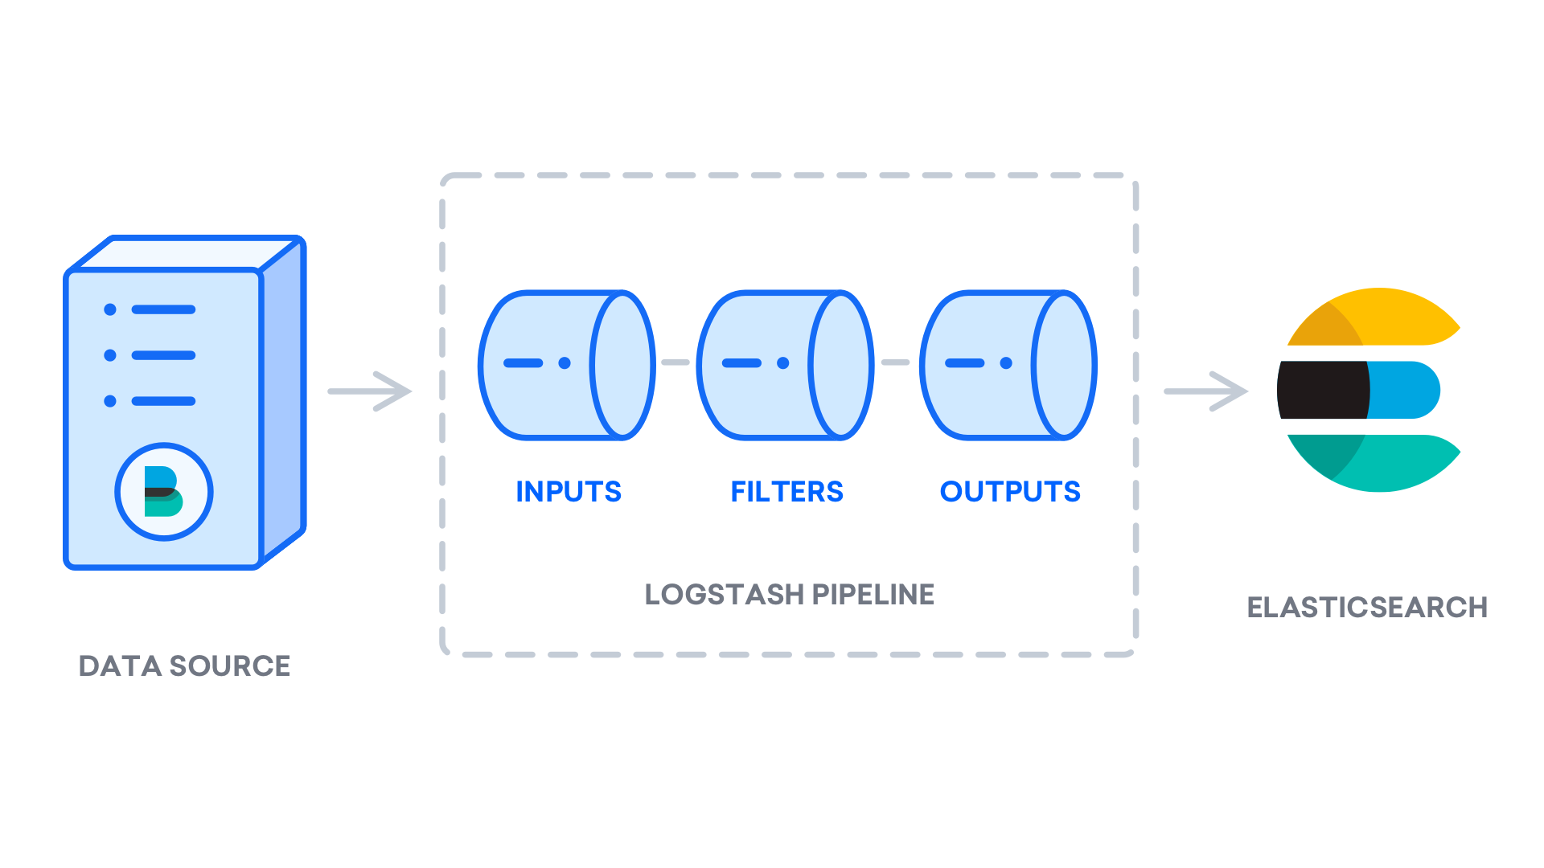
Logstash configuration files are in the JSON-format, and reside in /etc/logstash/conf.d. The configuration consists of three sections:

- input.conf
- filter.conf
- output.conf

configuration file looks like as followed

Input configuration:

input {
beats {
port => 5044
}
}

Filter Configuration:

This filter is used to parse incoming system logs to make them structured and usable by the predefined Kibana dashboards

filter {
if [fileset][module] == "system" {
if [fileset][name] == "auth" {
grok {
match => { "message" => ["%{SYSLOGTIMESTAMP:[system][auth][timestamp]} %{SYSLOGHOST:[system][auth][hostname]} sshd(?:\[%{POSINT:[system][auth][pid]}\])?: %{DATA:[system][auth][ssh][event]} %{DATA:[system][auth][ssh][method]} for (invalid user )?%{DATA:[system][auth][user]} from %{IPORHOST:[system][auth][ssh][ip]} port %{NUMBER:[system][auth][ssh][port]} ssh2(: %{GREEDYDATA:[system][auth][ssh][signature]})?",
"%{SYSLOGTIMESTAMP:[system][auth][timestamp]} %{SYSLOGHOST:[system][auth][hostname]} sshd(?:\[%{POSINT:[system][auth][pid]}\])?: %{DATA:[system][auth][ssh][event]} user %{DATA:[system][auth][user]} from %{IPORHOST:[system][auth][ssh][ip]}",
"%{SYSLOGTIMESTAMP:[system][auth][timestamp]} %{SYSLOGHOST:[system][auth][hostname]} sshd(?:\[%{POSINT:[system][auth][pid]}\])?: Did not receive identification string from %{IPORHOST:[system][auth][ssh][dropped_ip]}",
"%{SYSLOGTIMESTAMP:[system][auth][timestamp]} %{SYSLOGHOST:[system][auth][hostname]} sudo(?:\[%{POSINT:[system][auth][pid]}\])?: \s*%{DATA:[system][auth][user]} :( %{DATA:[system][auth][sudo][error]} ;)? TTY=%{DATA:[system][auth][sudo][tty]} ; PWD=%{DATA:[system][auth][sudo][pwd]} ; USER=%{DATA:[system][auth][sudo][user]} ; COMMAND=%{GREEDYDATA:[system][auth][sudo][command]}",
"%{SYSLOGTIMESTAMP:[system][auth][timestamp]} %{SYSLOGHOST:[system][auth][hostname]} groupadd(?:\[%{POSINT:[system][auth][pid]}\])?: new group: name=%{DATA:system.auth.groupadd.name}, GID=%{NUMBER:system.auth.groupadd.gid}",
"%{SYSLOGTIMESTAMP:[system][auth][timestamp]} %{SYSLOGHOST:[system][auth][hostname]} useradd(?:\[%{POSINT:[system][auth][pid]}\])?: new user: name=%{DATA:[system][auth][user][add][name]}, UID=%{NUMBER:[system][auth][user][add][uid]}, GID=%{NUMBER:[system][auth][user][add][gid]}, home=%{DATA:[system][auth][user][add][home]}, shell=%{DATA:[system][auth][user][add][shell]}$",
"%{SYSLOGTIMESTAMP:[system][auth][timestamp]} %{SYSLOGHOST:[system][auth][hostname]} %{DATA:[system][auth][program]}(?:\[%{POSINT:[system][auth][pid]}\])?: %{GREEDYMULTILINE:[system][auth][message]}"] }
pattern_definitions => {
"GREEDYMULTILINE"=> "(.|\n)*"
}
remove_field => "message"
}
date {
match => [ "[system][auth][timestamp]", "MMM d HH:mm:ss", "MMM dd HH:mm:ss" ]
}
geoip {
source => "[system][auth][ssh][ip]"
target => "[system][auth][ssh][geoip]"
}
}
else if [fileset][name] == "syslog" {
grok {
match => { "message" => ["%{SYSLOGTIMESTAMP:[system][syslog][timestamp]} %{SYSLOGHOST:[system][syslog][hostname]} %{DATA:[system][syslog][program]}(?:\[%{POSINT:[system][syslog][pid]}\])?: %{GREEDYMULTILINE:[system][syslog][message]}"] }
pattern_definitions => { "GREEDYMULTILINE" => "(.|\n)*" }
remove_field => "message"
}
date {
match => [ "[system][syslog][timestamp]", "MMM d HH:mm:ss", "MMM dd HH:mm:ss" ]
}
}
}
}

Output Configuration:
Output configuration. Essentially, this output configures Logstash to store the Beats data in Elasticsearch, which is running at localhost:9200, in an index named after the Beat used

- output.conf

output {
elasticsearch {
hosts => ["localhost:9200"]
manage_template => false
index => "%{[@metadata][beat]}-%{[@metadata][version]}-%{+YYYY.MM.dd}"
}
}
Test Logstash configuration with this command:
sudo -u logstash /usr/share/logstash/bin/logstash --path.settings /etc/logstash -t
output will be Configuration OK
If your configuration test is successful, start and enable Logstash to put the configuration changes into effect:

sudo systemctl start logstash
sudo systemctl enable logstash

Step4: Installing and Configuring Filebeat

The Elastic Stack uses several lightweight data shippers called Beats to collect data from various sources and transport them to Logstash or Elasticsearch

Filebeat: collects and ships log files.
Install Filebeat using following command:
sudo apt install filebeat
Configure Filebeat to connect to Logstash. Open the Filebeat configuration file:
sudo nano /etc/filebeat/filebeat.yml

comment out the following lines by preceding them with a #;
...
#output.elasticsearch:
# Array of hosts to connect to.
#hosts: ["localhost:9200"]
...

Uncomment the lines output.logstash: and hosts: ["localhost:5044"] by removing the #

output.logstash:
hosts: ["localhost:5044"]

Let's enable it:

sudo filebeat modules enable system
You can see a list of enabled and disabled module:
sudo filebeat modules enable system

To load the template, use the following command:

sudo filebeat setup --template -E output.logstash.enabled=false -E 'output.elasticsearch.hosts=["localhost:9200"]'

Output
Loaded index template

Now you can start and enable Filebeat:

sudo systemctl start filebeat
sudo systemctl enable filebeat

To verify that Elasticsearch is indeed receiving this data, query the Filebeat index with this command:

curl -XGET 'http://localhost:9200/filebeat-*/_search?pretty'

Step5 : Sync and configure Mysql with logstash
Create mysql.conf file inside etc/logstash/mysql.conf
Insert following code:

Note : download location : https://dev.mysql.com/downloads/connector/j/

/usr/share/java/mysql-connector-java-8.0.16.jar → this represent path of jdbc file
jdbc:mysql://localhost:3306/kibana → here kibana is database name

input {
jdbc {
jdbc_driver_library => "/usr/share/java/mysql-connector-java-8.0.16.jar"
jdbc_driver_class => "com.mysql.jdbc.Driver"
jdbc_connection_string => "jdbc:mysql://localhost:3306/kibana"
jdbc_user => "root"
jdbc_password => "password"
statement => "SELECT * from kibana"
jdbc_validate_connection => true
tracking_column => "id"
use_column_value => true
tracking_column_type => "numeric"
clean_run => true
jdbc_pool_timeout => 10
jdbc_paging_enabled => true
jdbc_page_size => 10000
}
}
output{
elasticsearch {
hosts => ["localhost:9200"]
index => "kibana_dashboard" // name of index
user => "elastic"
password => "password"
}
stdout { codec => rubydebug { metadata => true } }
# stdout { codec => dots }
}

Finally, you can run logstash command which will pull all mysql data and create index for you to create custom kibana dashboard.

Command to run logstash :

/usr/share/logstash/bin/logstash -f /etc/logstash/mysql.conf

Above command will create log file of mysql data.

Kibana is all set now. You can browse kibana dashboard using url :

localhost:5601 or server_ip:5601

Exploring Kibana Dashboards

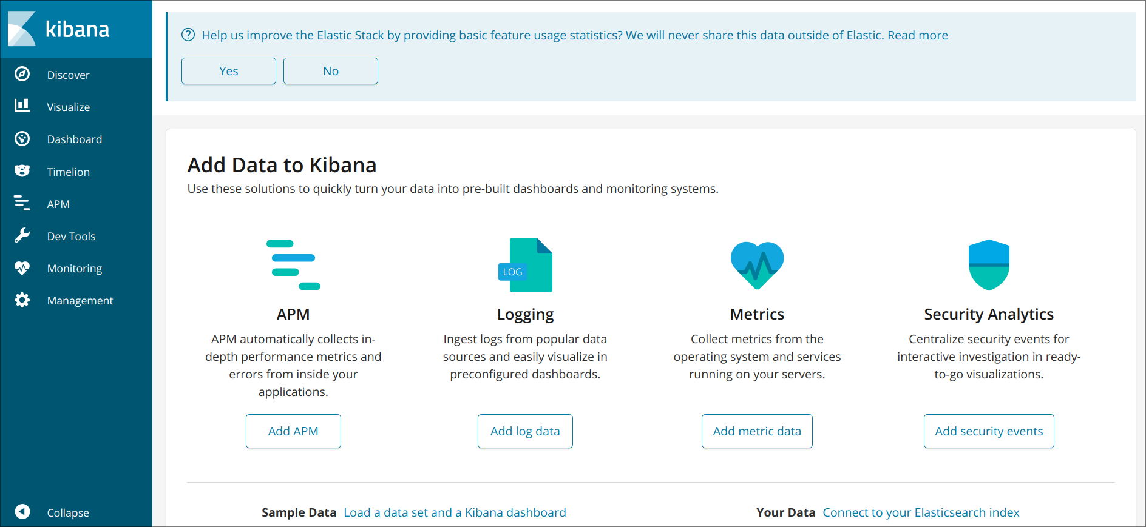
Go to management menu → index patter → create index pattern

Following page will be appear
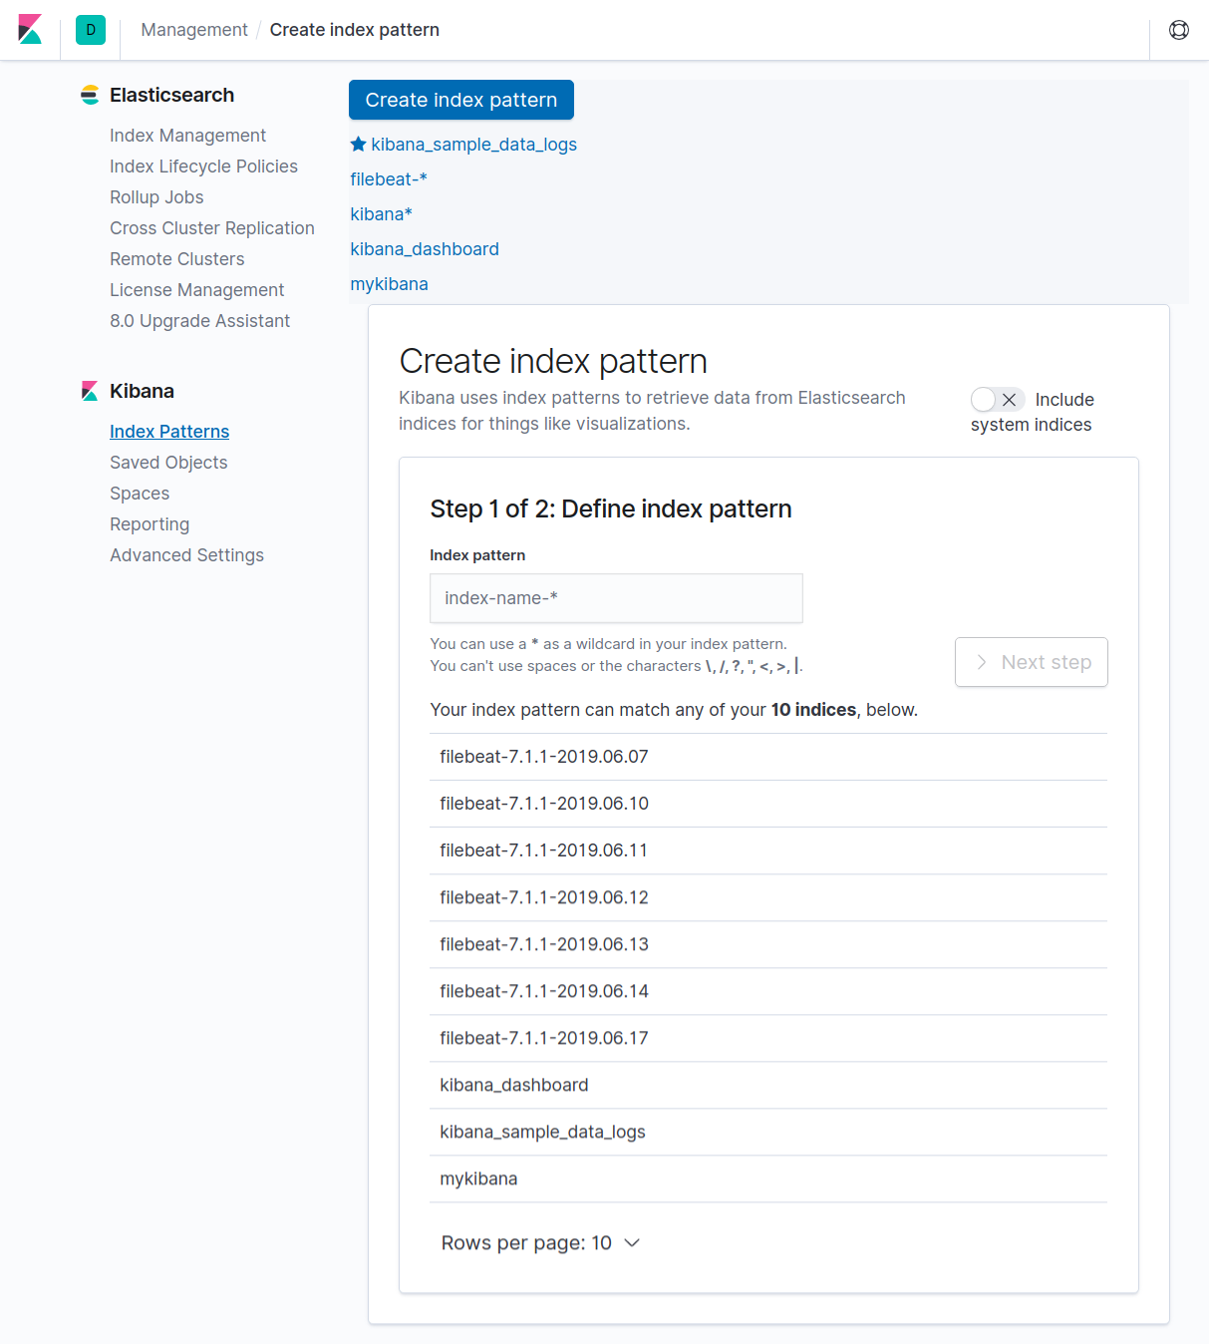
Search your index and click on next

Configure filter and click on create Index Pattern
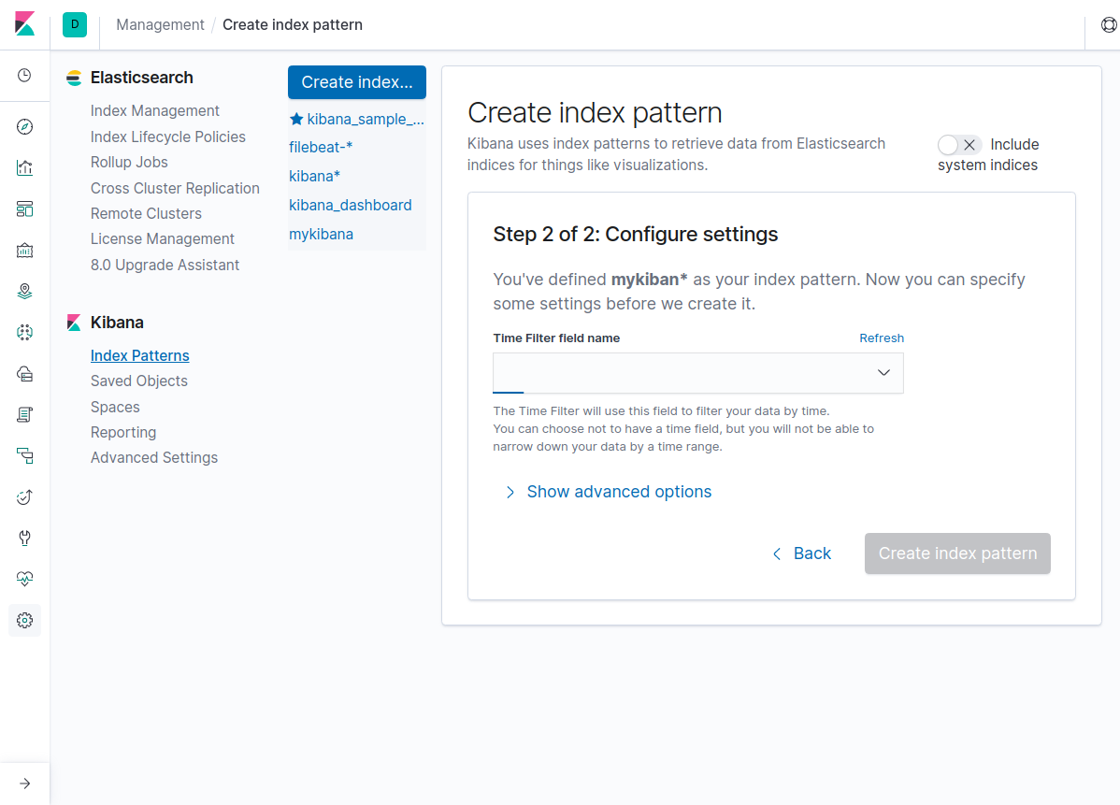
Now Click on Visualization menu

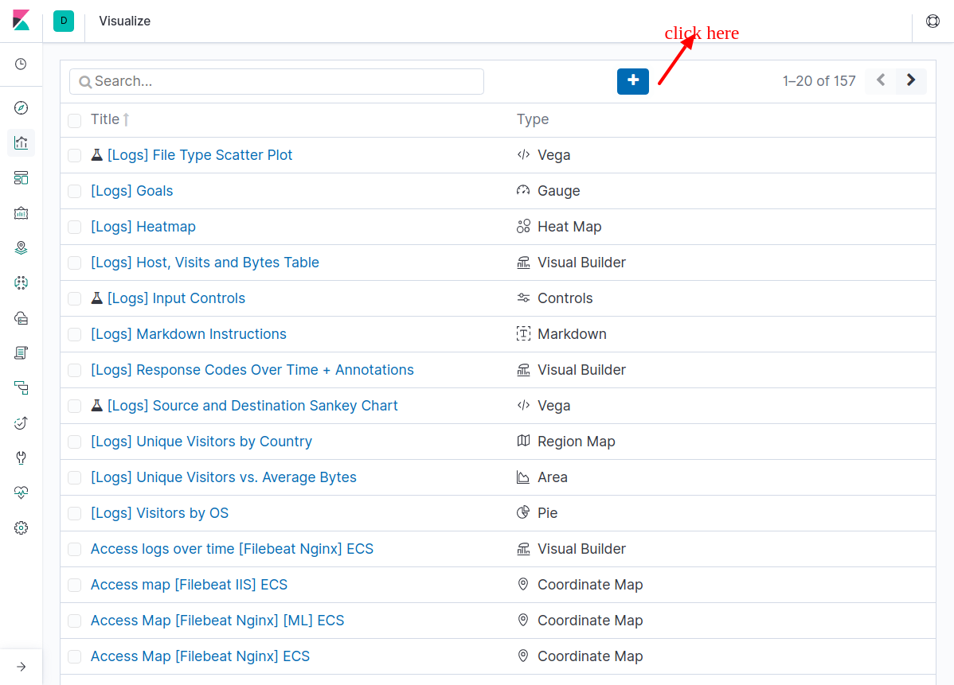
Click on + icon to create your visualization

Select Visualization type

Click on visualization type and choose your index
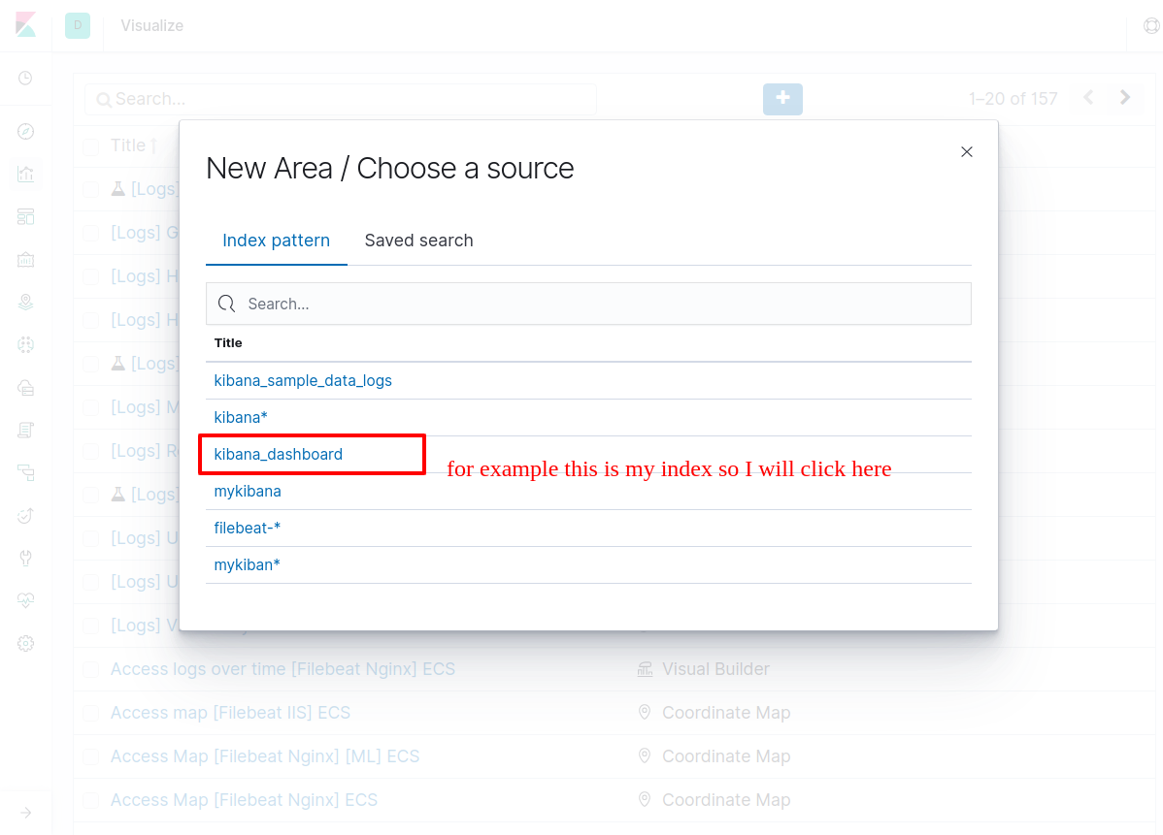
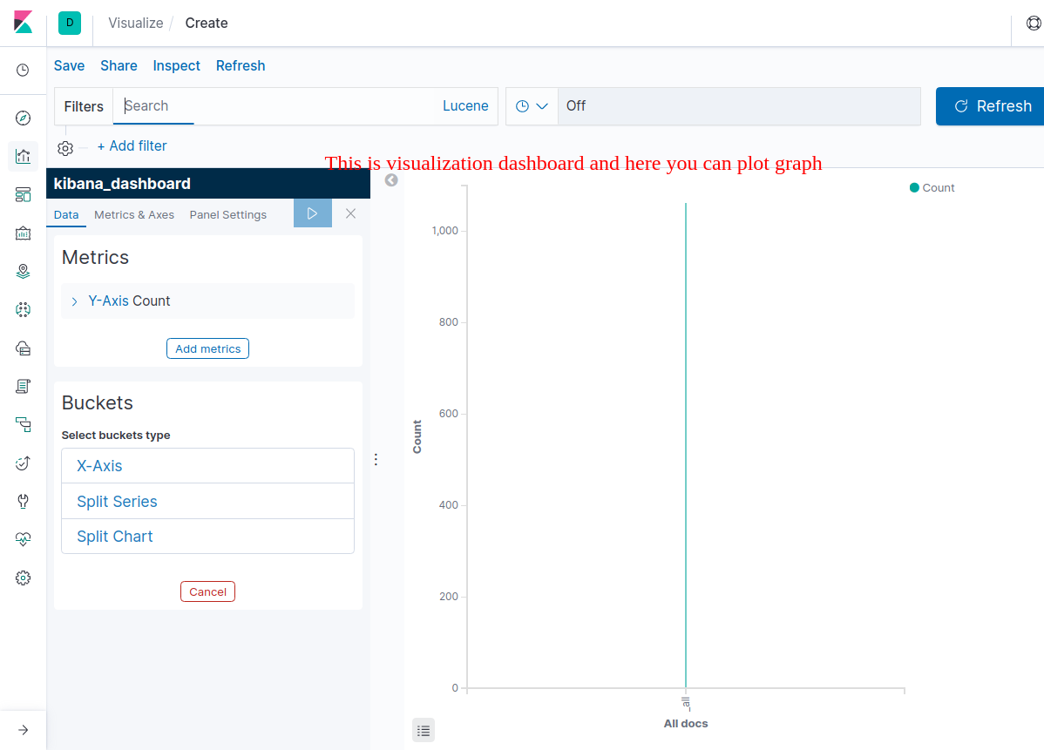
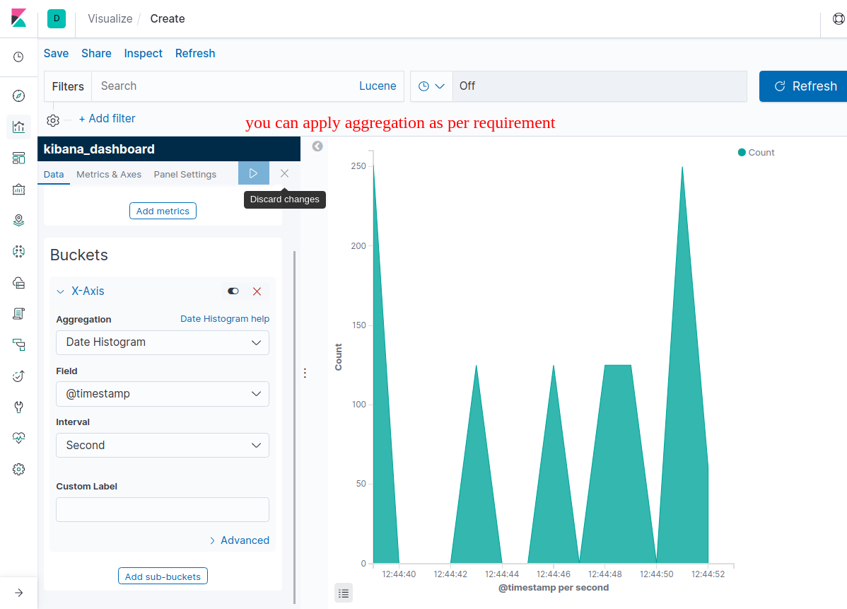
Now click now save button to save graph
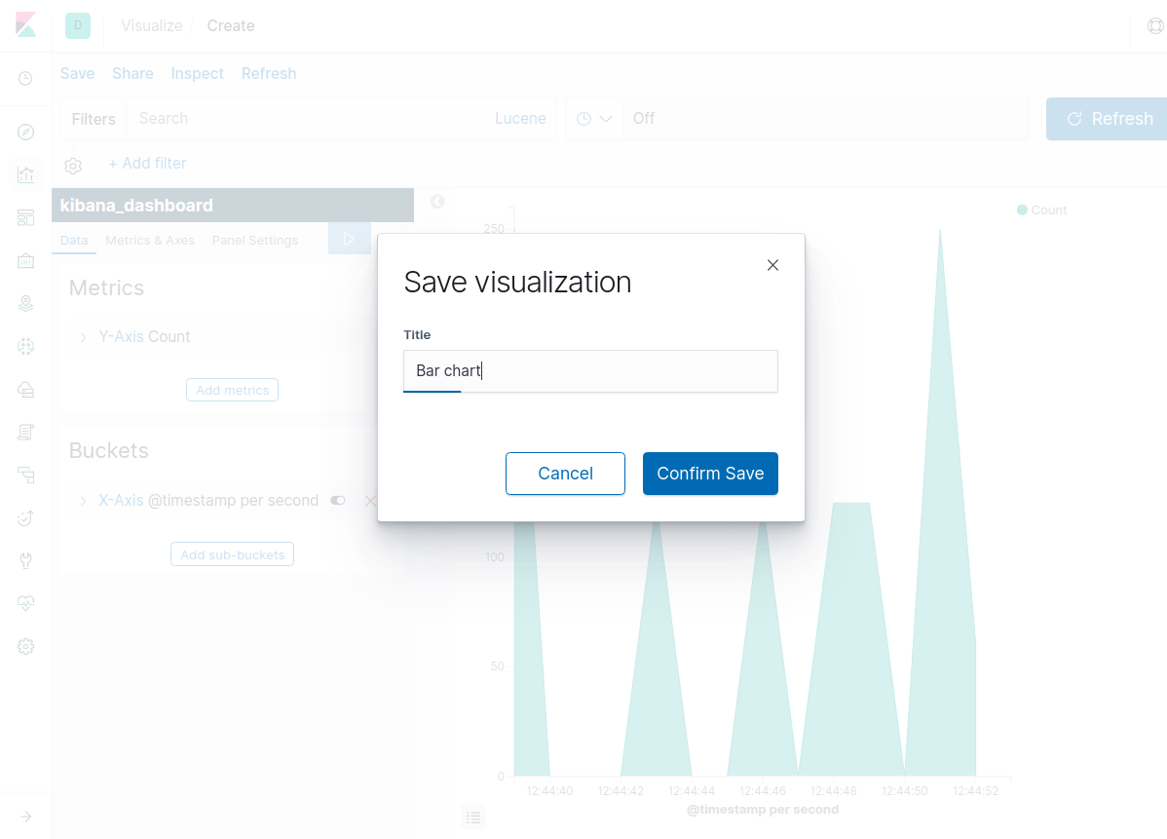
Once you done. Now you create your dashboard.
Goto dashboard menu then following page will appear

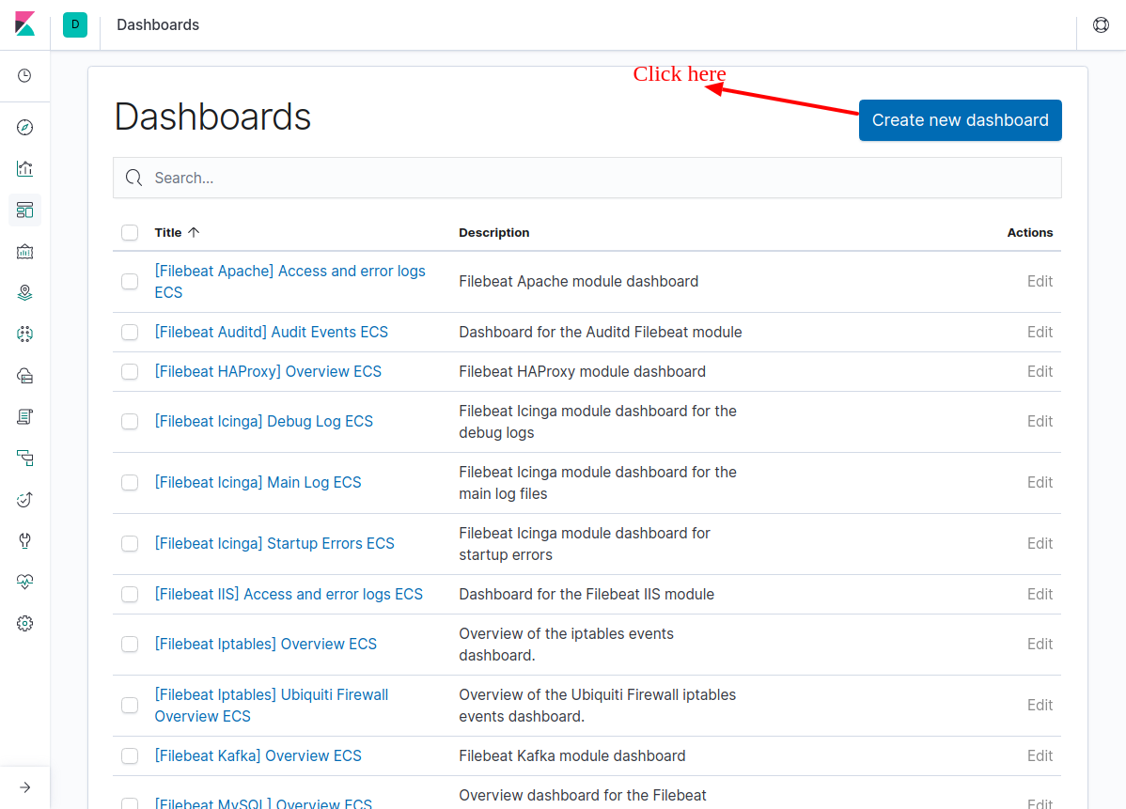
Click on create new dashboard

As soon as you ll start selecting visualization, Your dashboard will creates and this will looks like following image.

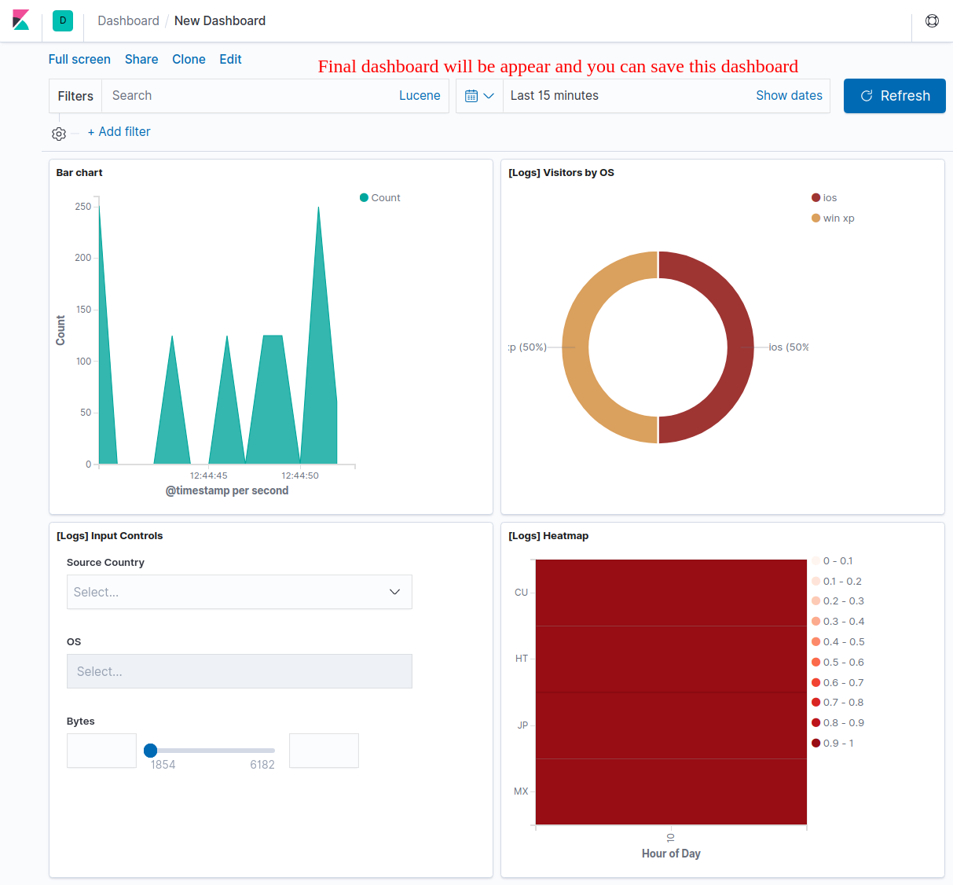
Thank you !
Kundan roy

