1.Download jenkins war from jenkins website

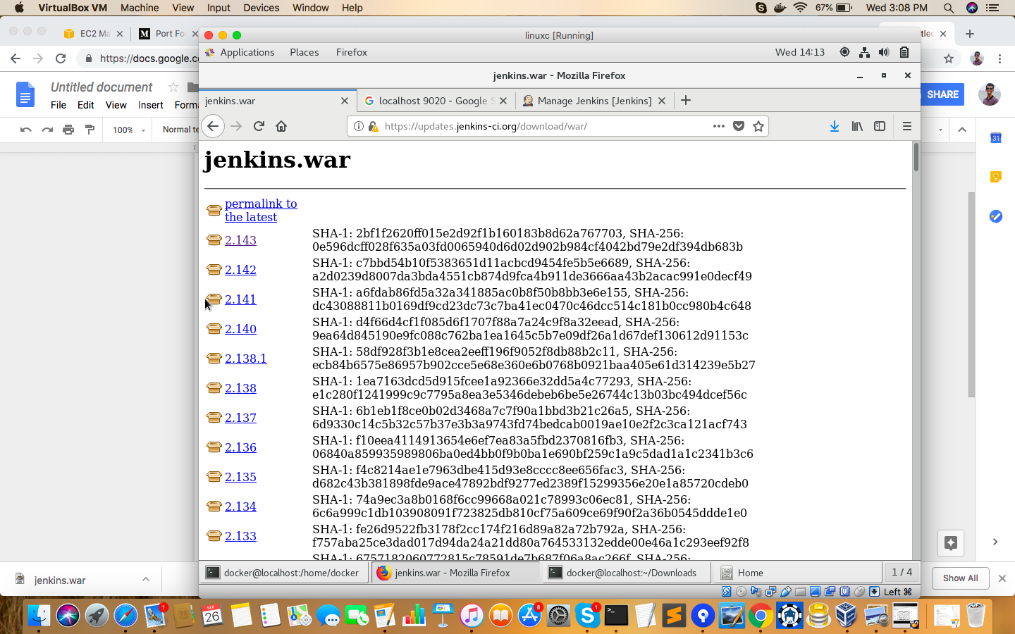

2.Run the The following command:

Navigate to the directory where the war file is located

Nohup java -jar jenkins.war --httpPort=9020&

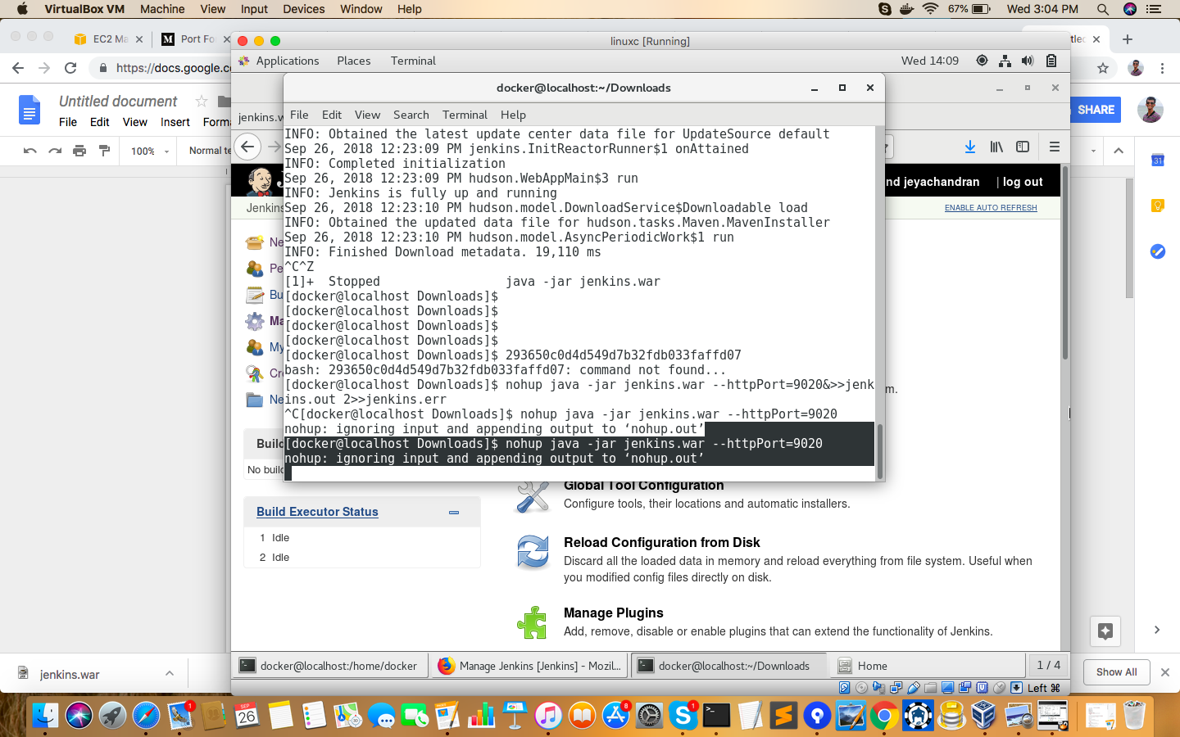

3.Navigate to manage jenkins and click on configure global security

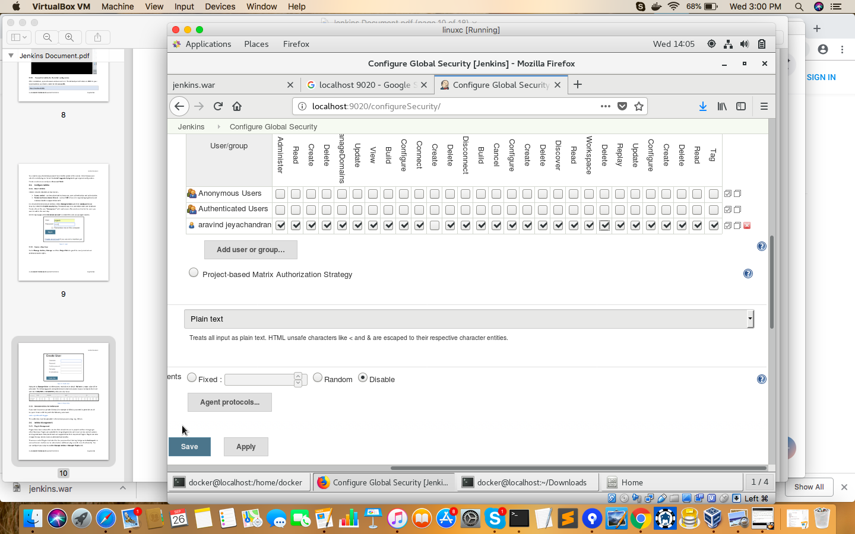

4.

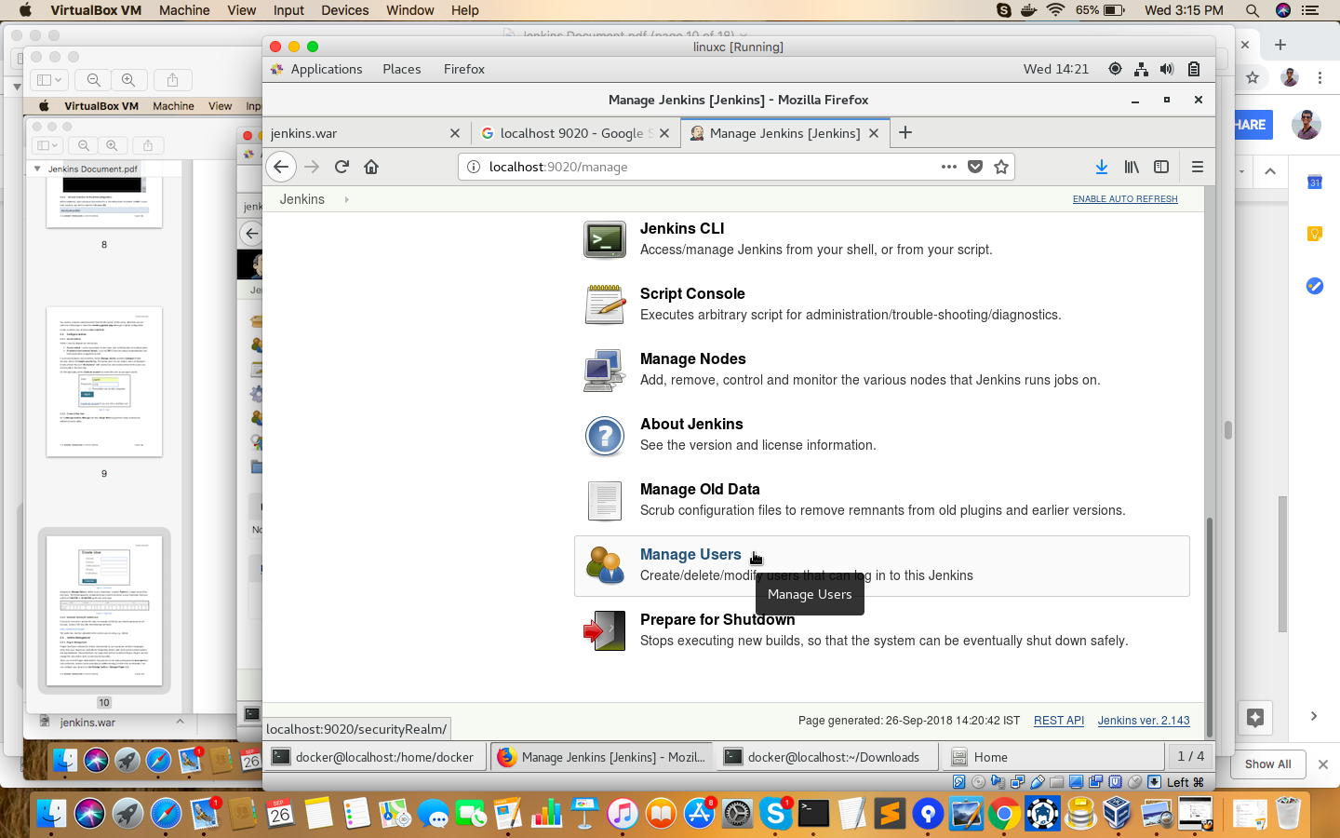

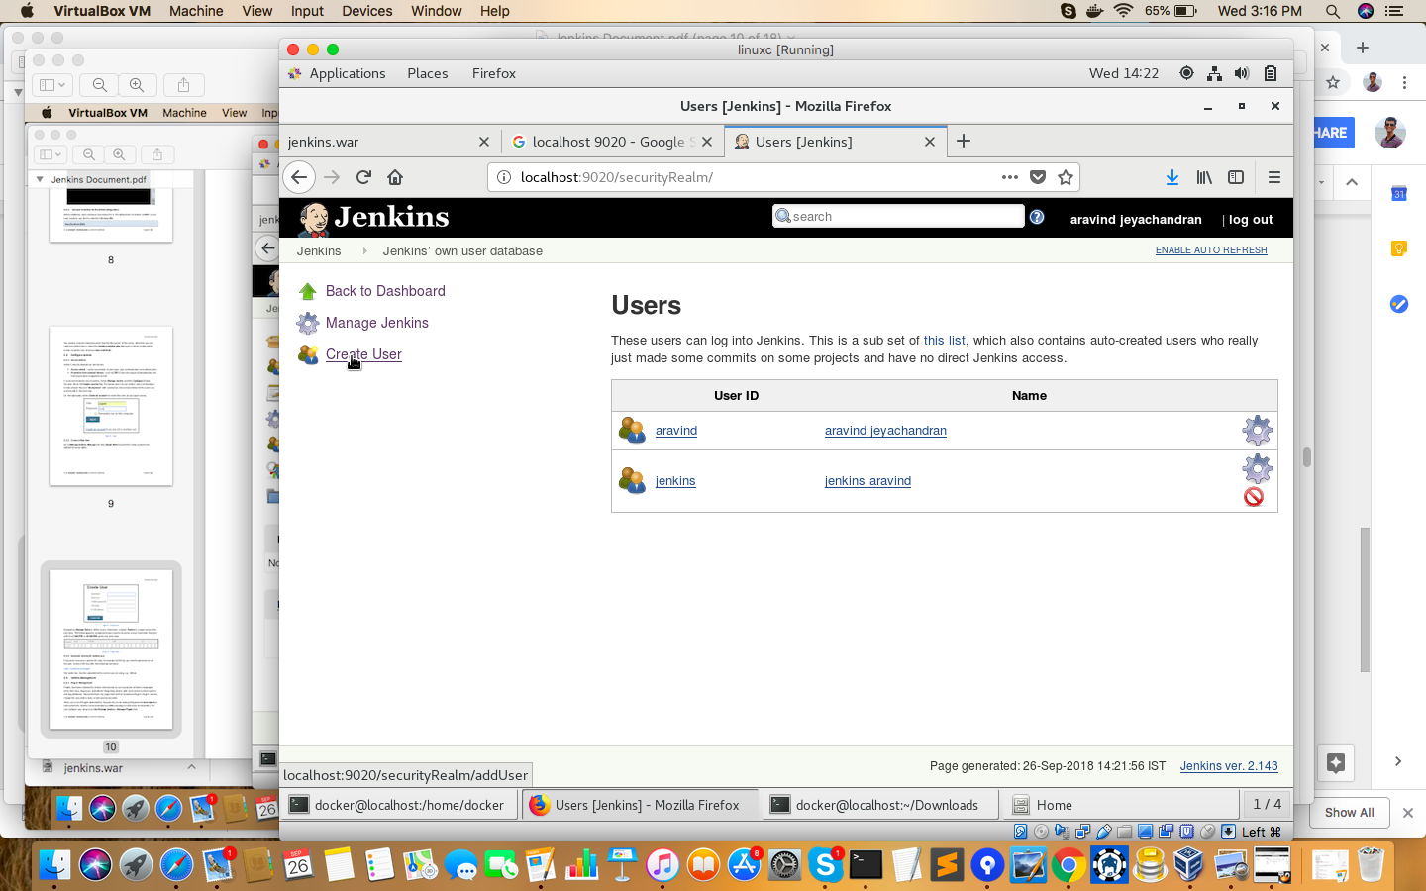

Creating user

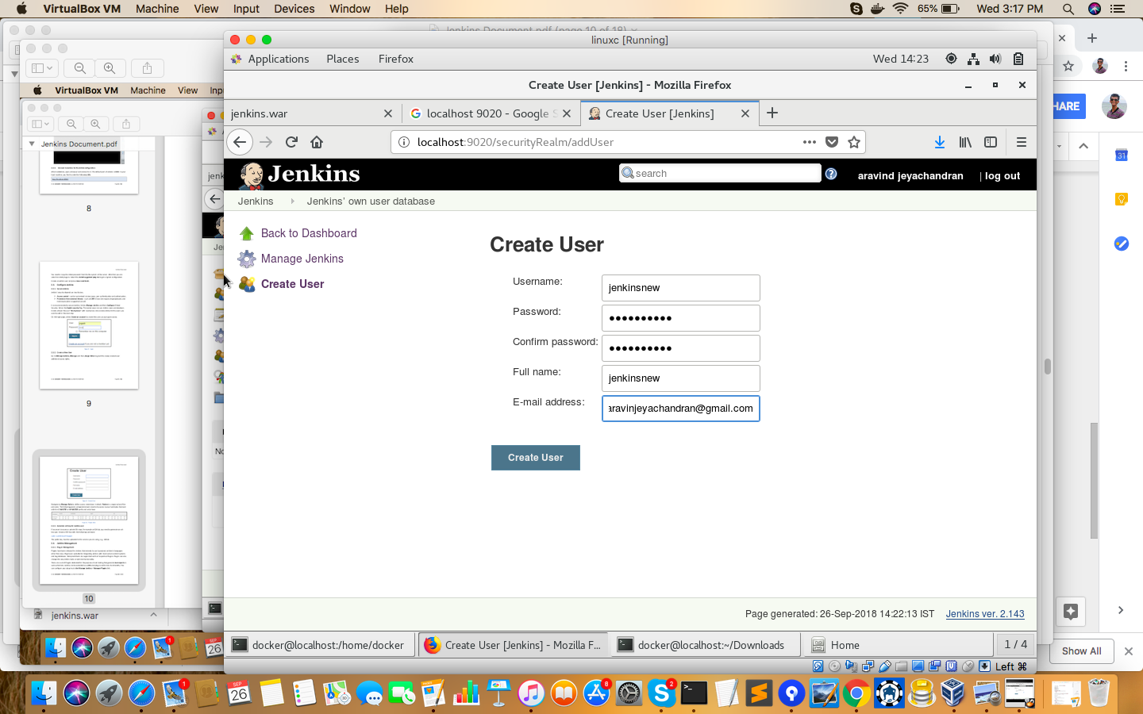

Typing the username password