******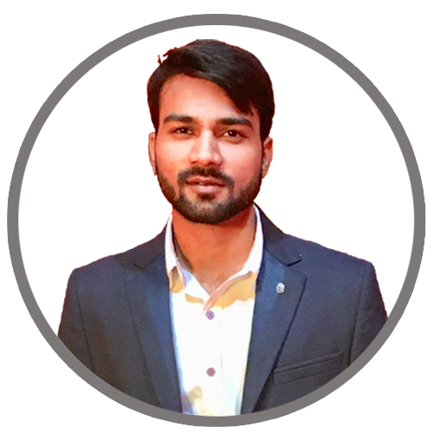**

**.** Graphic Design

**.** Wordpress

**.** PHP (Basic)

**.** Html5, Css3, Bootstrap, JavaScript

. Git + Github

**TOOLS USED**

. MS Excel, MS Word

. Adobe Photoshop

. Illustrator

. CorelDraw

**TECHNICAL PROFICIENCY**

**SKILLS**

for end-to-end responsive templates

I have developed my skills on related

**.** In my time of working as a freelancer,

tools as well such As : Adobe Photoshop

/ Illustrator/ CorelDraw:

**.** Frontend web developer responsible

**June 2019 - Feb 2021**

**FREELANCING**

**B.TECH (MECHANICAL ENGINEERING)**

**MOHD SHARIQ**

**2011**

**2011 to 2013**

**2014 to 2018**

B.Tech. | BRCM COLLEGE OF ENGG. & TECH. (MDU), BAHAL, BHIWANI12th | SRS YEDAV IC, KASGANJ (UP BOARD)10th | AZAD GANDHI IC, KASGANJ (UP BOARD)

**Coding**

**Stock marketing**

**Playing table tennis**

**Browsing information**

**Traveling**

B-820 4th Floor, Lift wali gali,New Ashok Nagar - 110096

er.shariq057@gmail.com

+918449474542

**Address**

**Email**

**Phone**

**HOBBIES**

To present the company with my best efforts to implement my technical knowledge and skills as well as learning from the qualified and well trained professional of the company

**EXPERIENCE**

**EDUCATION**

**CONTACT**

**PROFILE**