D2 Proposal Extractor — Production Timeout Diagnosis
Read-only diagnosis · 2026-05-31
Verdict: The failure is a clean stage failure at the D2 wall-clock backstop (asyncio.wait_for, 90s), fired while the Agent SDK stream had not yet yielded a ResultMessage. The best-supported explanation is genuine model/SDK-work latency on this document's slow tail (same input that once completed in ~72s now sometimes needs >90s). Docling adds job time but is not inside that 90s bucket. SDK subprocess hang remains possible but is not separable from slow completion with current prod logs. D3/D4 did not run on these walks; D2 is isolated and uniquely hard-fails on timeout.

What failed (prod evidence)
Attempt | Report ID | Job ID | Error
1 | 1f35153d-5277-46e1-9ca6-2d2a2c37eafa | 3e765004-fff3-40ca-b538-ed2764558883 | extract: Proposal extractor exceeded 90s timeout
2 | 39805e82-d47e-4255-bba0-2b691449ea2e | e4e6ee07-ec96-4974-8d50-ed136fbc2ad3 | Same

- Timeout raised in extract_proposal_text → ProposalExtractorError(STOP_TIMEOUT)
- Normalized to StageFailure → mark_job_failed(..., event=pipeline_exception)
- Stack frame at proposal_extractor.py:303 — inside async for message in query_fn(...), before any ResultMessage
- Post-hardening clean failure — not a stuck worker
Smoke-walk polling (POLL_SECONDS=12):
- Attempt 1: ~2 polls in classify, ~8 in extract → ~96s+ visible in extract
- Attempt 2: ~1 poll in classify, ~7 in extract → ~84s+ visible in extract

Wall-clock breakdown
Sequence diagram (phase boundaries):
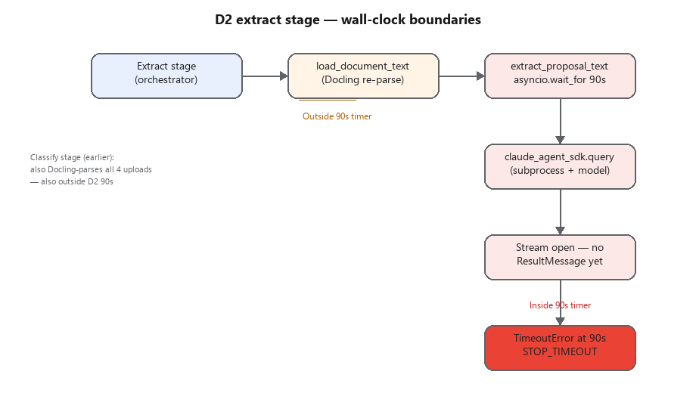
Phase | In 90s timer? | Evidence
S3 fetch + temp write | No | document_intake.load_document_text before extract_and_persist_proposal
Docling parse (proposal) | No | Same — runs in pipeline before D2
SDK spawn + model + structured JSON | Yes | asyncio.wait_for(_run_extractor_query, timeout=TIMEOUT_SECONDS)
Persist / dispatch | No | Only after D2 returns or raises

Classify stage also Docling-parses all four uploads (3× .docx + 1× .xlsx) before extract; that time is outside the D2 90s but adds total job latency.
Gap: Prod DB agent_trace_json and proposal_extractor start log lines were not available from this environment, so the 90s cannot be split into spawn vs TTFT vs generation on prod.

Document characteristics
Metric | Value
File size | 41,503 bytes
Docling text | 12,993 chars (~1,545 words)
Truncated? | No (MAX_INPUT_CHARS=120,000)
Content hash | 422b2e10… — matches recorded gate fixture
Structure | Markdown tables, logframe-style indicators, VfM section
Model task | Large structured extraction: 2 objectives + activities + 16 indicators via json_schema

Recorded successful gate run on this exact hash:
- model_used: haiku
- latency_ms: 72,363 (~72.4s SDK-reported duration)
- output_tokens: 12,904 (~13k structured JSON)
- Headroom at 90s ceiling: ~17.6s
Decision log D-033 documented bimodal behavior: successes at 72–74s, failures >80s at a 75s ceiling; 90s was chosen as margin. Prod now hits the slow tail above even 90s.
Local Docling (same file): first parse in cold process ~74s (model load); warm re-parse ~0.3–9s. Affects classify/extract preamble, not the error string.

Which timeout fired?
Layer | Value | Applies to D2?
asyncio.wait_for in extract_proposal_text | ME_CLASSIFIER_TIMEOUT_SECONDS default 90 | Yes — this fired
API_TIMEOUT_MS in SDK subprocess env | 90,000 ms | Parallel inner ceiling
dispatch_stage(per_call_timeout_seconds=…) | Not passed for D2 | No extra dispatch timeout
Worker ME_WORKER_JOB_TIMEOUT_SECONDS | 3600 | No — job failed at ~2 min

Prod env: ME_CLASSIFIER_MODEL=haiku; no ME_CLASSIFIER_TIMEOUT_SECONDS override.

Candidate causes — separated

1. Genuine model latency — PRIMARY (strongest evidence)
- Same document hash as a 72.3s successful extraction with ~13k output tokens.
- D-033: instrumented bimodal latency; 90s was a bet on covering the slow tail — prod shows it is not always sufficient.
- Failures align with exact 90s backstop, reproducible across two runs.

2. SDK subprocess overhead / hang — possible, not proven
- D2 uses claude_agent_sdk.query (CLI subprocess); timeout fires while still awaiting stream messages.
- Same signature as hang or slow model; no prod evidence of subprocess exit code or partial stream events.
- D-033 noted timeouts were wall-time long poles, not structured-output retry subtypes — slightly favors slow completion.

3. Document-handling cost — contributing, not the 90s trigger
- Docling is explicitly outside asyncio.wait_for in the code path.
- Re-parsing at extract adds seconds (warm) to minutes (cold worker) but does not consume the 90s D2 budget.
- Cost driver is LLM structured output volume, not parse failure.

4. Environment difference — contributing amplifier
- Same model (haiku) and timeout defaults as gate/dev.
- Smoke walk uploads 4 docs vs earlier 3-doc prod success — extra classify Docling load before D2.
- Attempt 2 reached extract faster than attempt 1 — consistent with warm Docling / worker state.

D3/D4 on the same run?
No. Proposal is first in upload order; D2 hard-fails the stage. D3/D4 never executed.
Agent | On 90s timeout
D2 proposal | Hard fail — ProposalExtractorError → stage failure
D3 grant-terms | 2×90s retry → degraded (D-035)
D4 indicator | 2×90s retry → degraded (D-036)

What would settle remaining ambiguity (read-only)
- agent_trace_json on failed jobs (stages.classify.completed_at vs failure.at) — needs DB access inside Railway network.
- Worker logs with proposal_extractor start filename=… chars=12993 correlated with failure ~90s later.
- SDK-level observation: time of first stream message vs ResultMessage.duration_ms on read-only replay.
Without those, cause 1 and 2 are observationally identical at the 90s boundary.

Recommended fix direction (diagnosis only — no changes made)
Priority | Fix class | Rationale
1 | Resilience parity with D3/D4 | D-035-style bounded retry + degraded continuation; orchestrator already continues on degraded extraction.
2 | D2-specific timeout budget | Separate env (e.g. ME_PROPOSAL_TIMEOUT_SECONDS) above 90s; 72s typical / >90s tail.
3 | Output/latency reduction | Shrink structured payload to cut ~13k output tokens.
4 | Runtime path (longer-term) | Messages API migration for D2 (as D1/E1/E3); removes subprocess uncertainty.
Lower | Docling caching classify→extract | Improves total job time; won't fix pure >90s model tail alone.

Bottom line
Why D2 exceeds 90s on prod for this document: The Agent SDK extraction for this FCDO proposal sometimes requires more than 90 seconds of wall-clock work to finish streaming structured output. That is expected slow-tail behavior for this agent (documented in D-033, observed at 72.3s on success), now manifesting above the current ceiling. Docling and classify overhead add job latency but are not what triggers the error. Subprocess hang cannot be excluded but is less likely than slow completion given prior instrumentation and identical input hash. D2 alone hard-fails where sibling extractors would degrade and continue.
Scope: Read-only diagnosis. No code, config, env, timeout, or deploy changes.

