Assignment-10

1. Write a query that produces all pairs of salespeople who are living in same city. Exclude combinations of salespeople with themselves as well as duplicate rows with the order reversed.

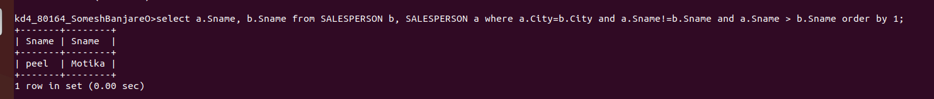

2. Write a query that produces names and cities of all customers with the same rating as Hoffman.

