Assignment-14

1. Write a command that puts the following values, in their given order, into the salespeople table: city-San Jose, name-Blanco, comm-NULL, Snum-1100.

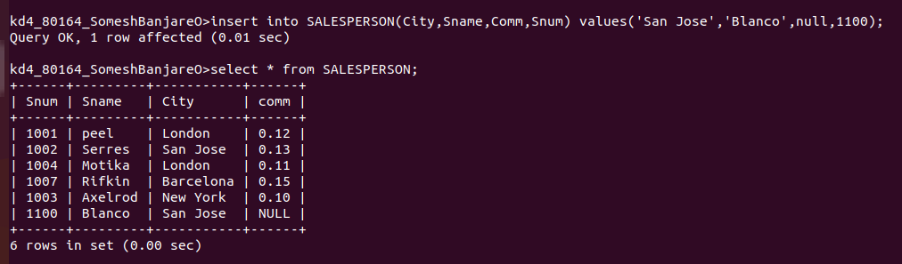

2. Write a command that removes all orders from customer Clemens from the orders table.

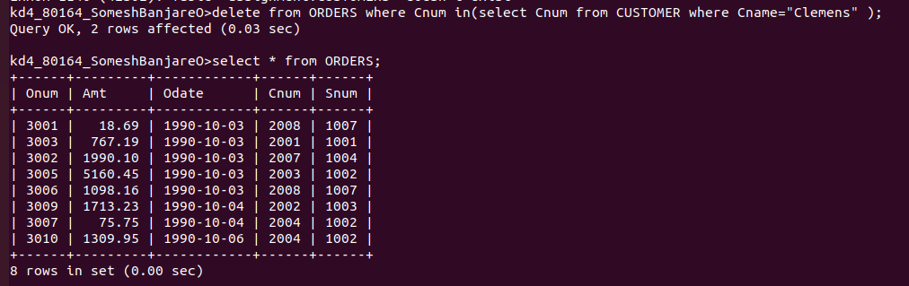

3. Write a command that increases the rating of all customers in Rome by 100;

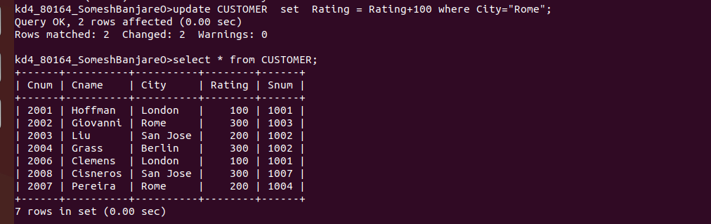
4. Salesperson Serres has left the company. Assign her customers to Motika.

