Assignment-6
Using special Operatores in Conditions.

1. Write two different queries that would produce all orders taken on October 3rd or 4th, 1990.

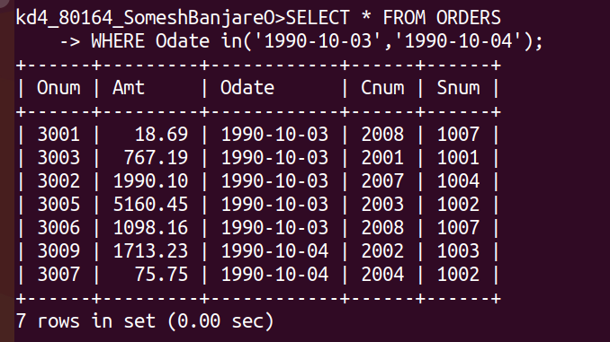
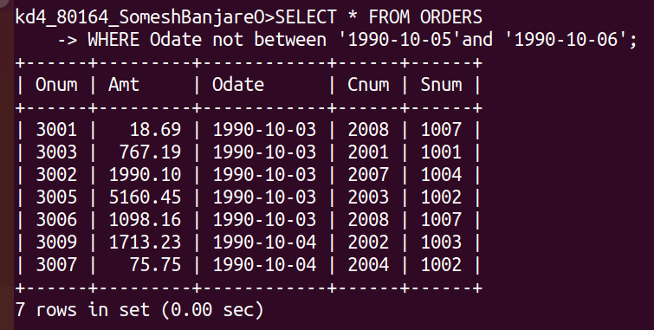
2. Write a query that selects all of the customers serviced by Peel or Motika.

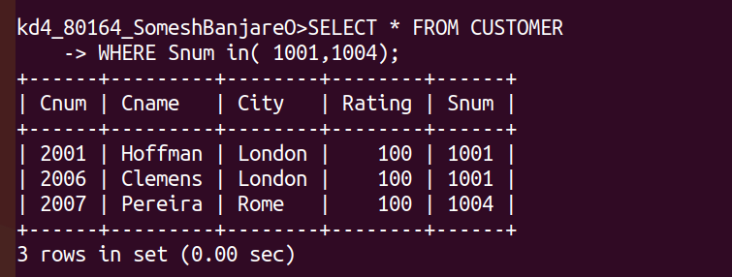
3. Write a query that will produce all the customers whoose names begin with a letter from ‘A’ to ‘G’.

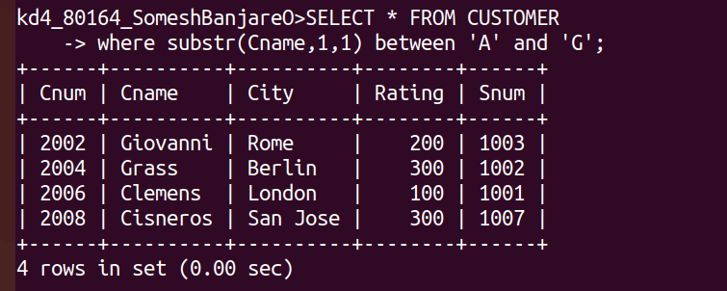
4. Write a query that selects all customers whose names begin with letter ‘C’.

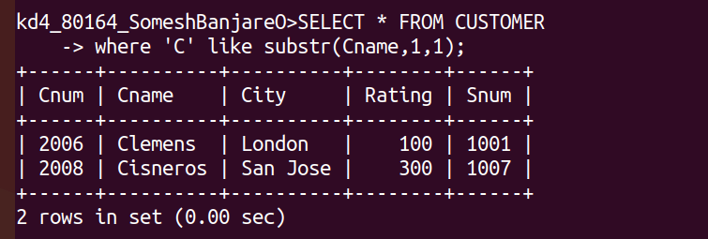
5. Write a query that selects all orders except those with zeroes or NULLs in the amt field.

