Assignment-4
1. Write a select command that produces the order number, amount, and date for all rows in the Orders table.

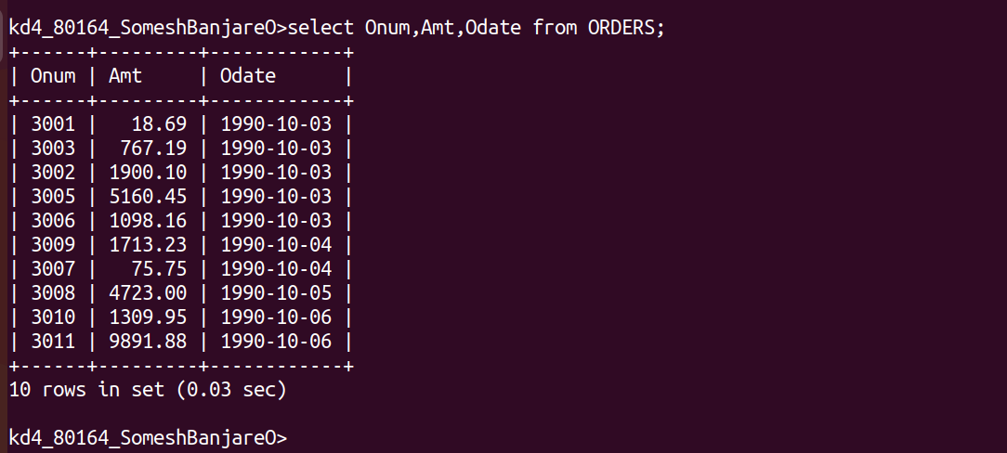
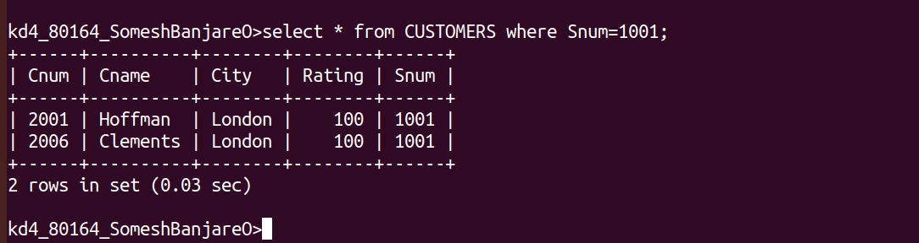
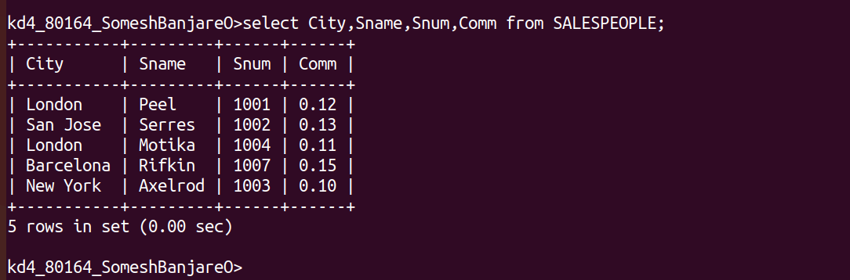
2. Write a query that produces all rows from the Customers table for which the Salesperson’s number is 1001.
3. Write a query that displays the Salespeople table with the columns in the followinhg order : city, sname, snum, comm.
4. Write a select command that produces the rating followed by the name of each customer in San Jose.

