Assignment-8
1. Assume each salesperson has a 12% commission. Write a query on the ordders table that will produce the order number, the salesperson number, and the amount of the salesperson’s commision for that order.

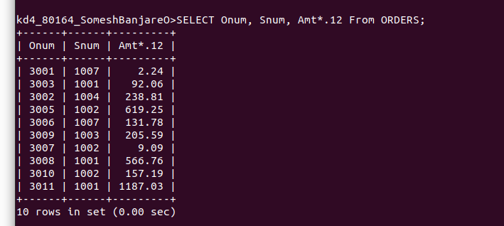
2. Write a query on the Customers table that will find the highest rating in each city. Put the output in this form:
For the city(city), the highest rating is :
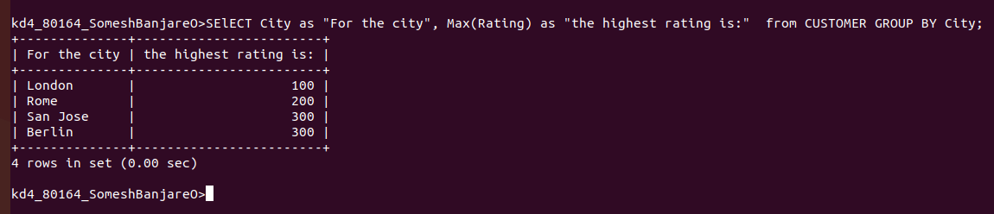

3. Write a query that lists customers in descending order of rating. Output the rating field first, followed by the customers’s name and number.



4. Write a query that totals the orders for each day and places the results in descending order.



