Assignment-11

1. Write a query that produces a subquery to obtain all orders for the customer named Cisneros. Assume you do not know his customer number(cnum).

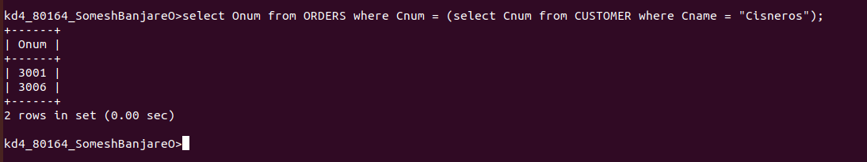

2. Write a query that produces the names and ratings of all customers who have above average orders.

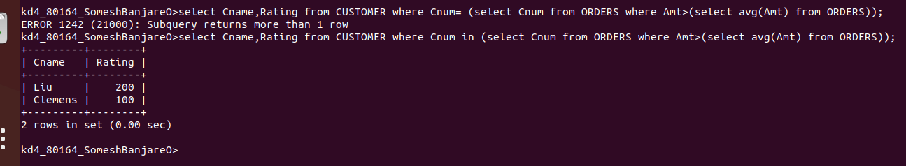

3. Write a query that selects the total amount in orders for each salesperson for whom this total is greater than the amount of the largest order in the table.

