Assignment-12

1. Write a query that selects all customers whose ratings are equal to or greater than ANY of Serres’ .

2. Write a query using ANY or ALL that will find all salespeople who have no customers located in their city.

3. Write a query that selects all orders for amounts greater than any for the customers in London.

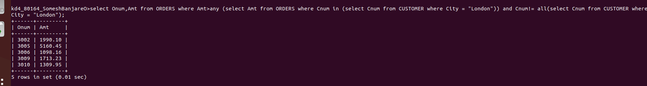
using min



