Assignment-5
1. Write a query that will give all orders for more tha Rs. 1000.

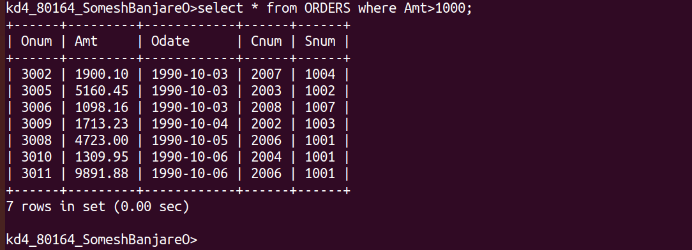
2. Write a query that will give you the names and cities of all salespeople in London with a commission above .10.

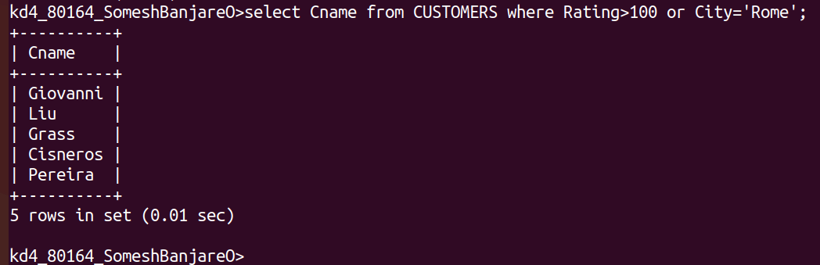
3. Write a query on the Customers table whose output will exclude all customers with a rating <= 100, unless they are located in Rome.

4. What will be the output of the following query

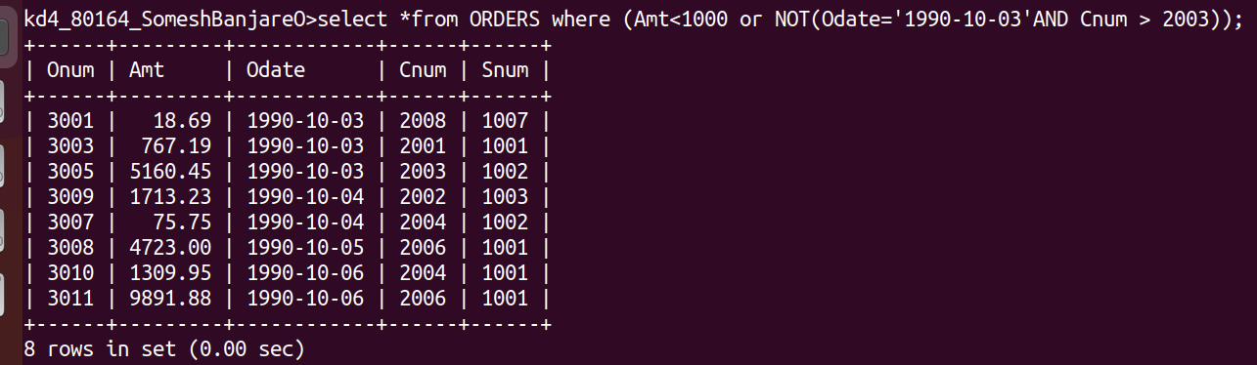
5. What will be the output of the following query?

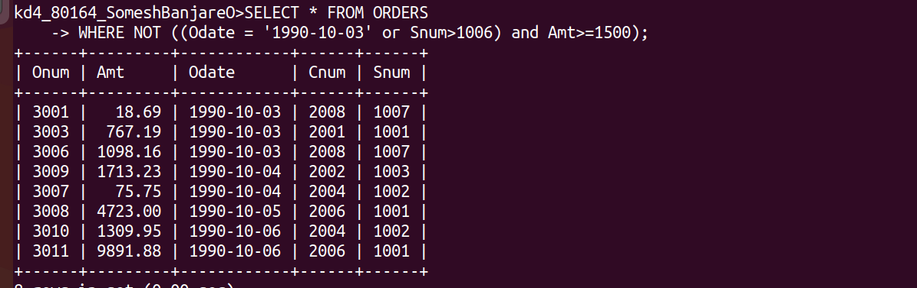
6. What is simpler way to write this query

